  - OpenAPI/Swagger with Laravel

What is Swagger UI?
Swagger UI is an open-source, interactive tool that visualizes and allows users to interact with APIs defined using the OpenAPI specification (formerly known as Swagger specification). It is a web-based UI that makes it easy to explore, test, and document APIs.

Steps
We will give our Students-API Laravel application a UI that gives users & developers the ability to interact with the API. This will be done by following these simple steps:
1 | Install packages with:  composer require darkaonline/l5-swagger -W
2 | Publish the config with:  php artisan vendor:publish --provider="L5Swagger\L5SwaggerServiceProvider"
3 | Add Swagger API annotation to the base controller class
4 | Add Swagger API annotation to the StudentsController class
5 | Include the Swagger API documentation above each API action method
6 | Generate Swagger documentation with:  php artisan l5-swagger:generate
7 | Visit /api/documentation
8 | (optional) Make /api/documentation the home page by editing web.php so that the / route does a redirect:  Route::get('/', function () {  return redirect('/api/documentation');  });

Getting Started
Start with 20260311_laravel-sqlite-api.zip file.
Download and extract the above file into a working directory.
In the root folder of the project, execute this command to restore all the required packages:
01
composer install
Note that this application uses SQLite

Clear the server’s route cache with:
02
php artisan route:cache
php artisan route:clear
Start the web server with:
03
php artisan serve
Point your browser to http://localhost:8000/api/students. You should see a JSON array of students:
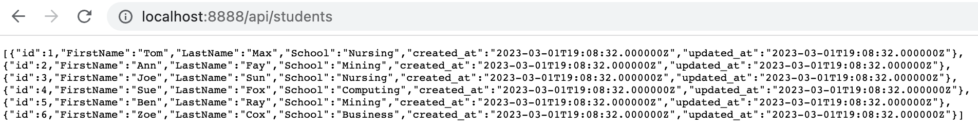

Step #1
04
Install this package:
composer require darkaonline/l5-swagger -W

Step #2
05
Add a service provider with:
php artisan vendor:publish --provider="L5Swagger\L5SwaggerServiceProvider"
Visit http://localhost:8000/api/documentation and you will see that a page is being served:
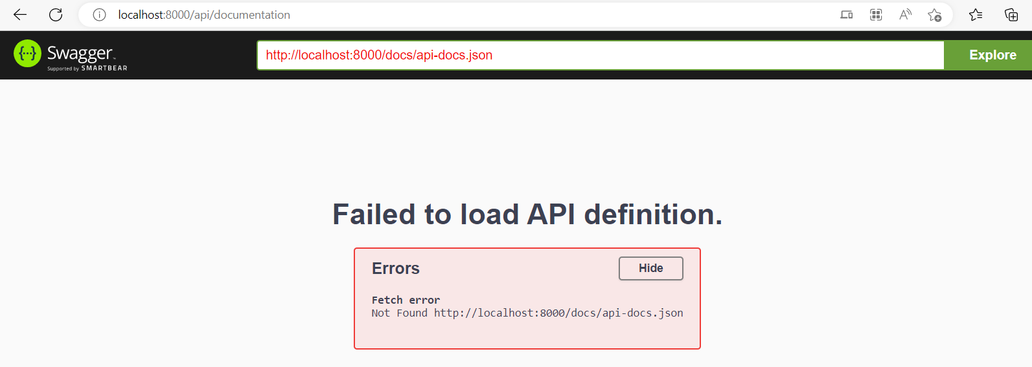
It does not work because there is some more that needs to be done.

Step #3
Paste the following swagger documentation (in the form of comments) at top of the abstract base Controller class in file app/Http/Controllers/Controller.php:
06
use OpenApi\Attributes as OA;

#[OA\Info(
title: "Laravel Students API",
version: "1.0.0",
description: "API for managing students",
contact: new OA\Contact(email: "admin@example.com")
)]

Step #4
07
Add the following to StudentsController.php class:
use OpenApi\Attributes as OA;

#[OA\Tag(name: "Students", description: "Student management endpoints")]
#[OA\Schema(
schema: "Student",
properties: [
new OA\Property(property: "id", type: "integer", example: 1),
new OA\Property(property: "FirstName", type: "string", example: "John"),
new OA\Property(property: "LastName", type: "string", example: "Doe"),
new OA\Property(property: "School", type: "string", example: "BCIT"),
new OA\Property(property: "created_at", type: "string", format: "date-time"),
new OA\Property(property: "updated_at", type: "string", format: "date-time"),
]
)]
#[OA\Schema(
schema: "StudentRequest",
required: ["FirstName", "LastName", "School"],
properties: [
new OA\Property(property: "FirstName", type: "string", example: "John"),
new OA\Property(property: "LastName", type: "string", example: "Doe"),
new OA\Property(property: "School", type: "string", example: "BCIT"),
]
)]

Step #5
Add this swagger documentation at the top of the index() method in app/Http/Controllers/api/StudentsController.php:
08
#[OA\Get(
path: "/api/students",
tags: ["Students"],
summary: "Get all students",
responses: [
new OA\Response(
response: 200,
description: "List of all students",
content: new OA\JsonContent(
type: "array",
items: new OA\Items(ref: "#/components/schemas/Student")
)
)
]
)]

Step #6
Generate Swagger documentation with:
09
php artisan l5-swagger:generate
Now we can visit http://localhost:8000/api/documentation and should see some serious API documentation.
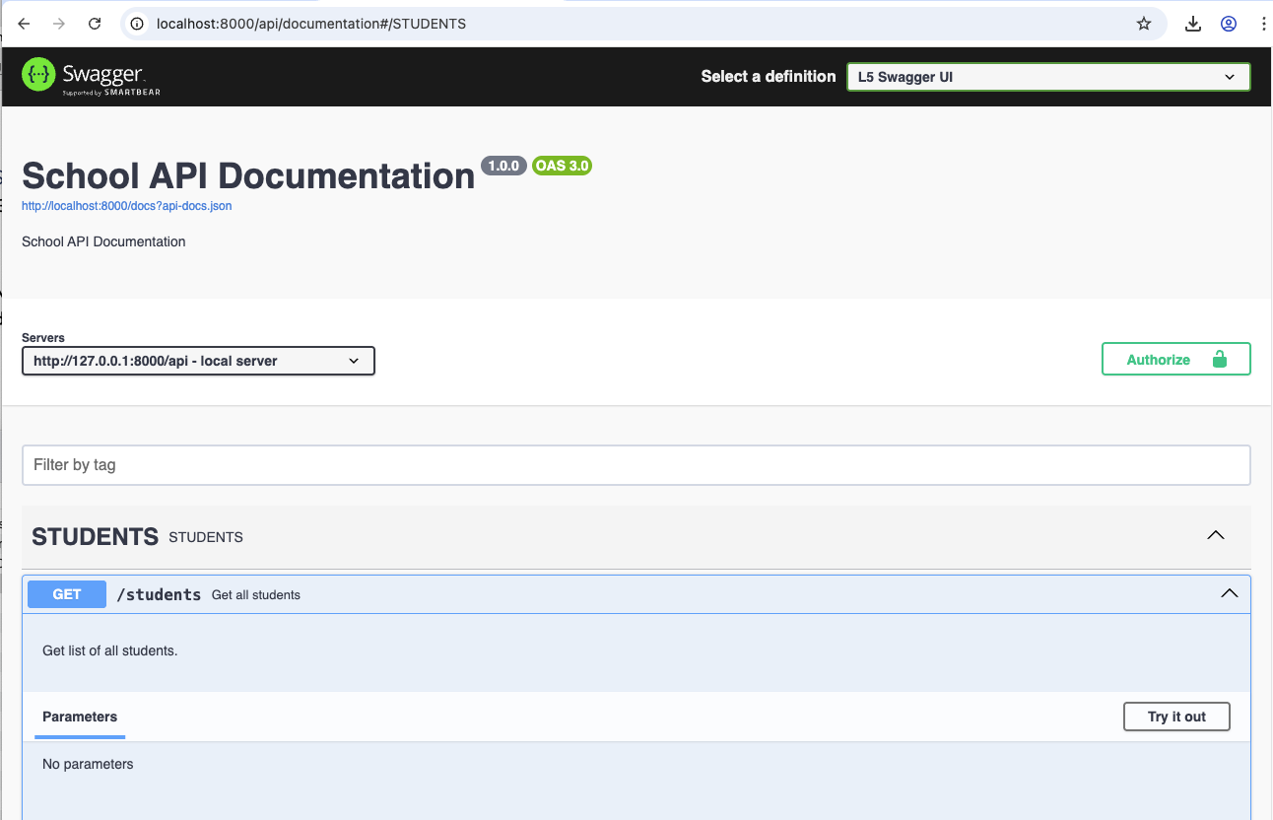
We can test our API without having to use a tool like postman. Let us light up documentation for all the other methods store(), show(), update(), and destroy() by adding the respective code above these methods:
10

store()
#[OA\Post(
path: "/api/students",
tags: ["Students"],
summary: "Create a new student",
requestBody: new OA\RequestBody(
required: true,
content: new OA\JsonContent(ref: "#/components/schemas/StudentRequest")
),
responses: [
new OA\Response(
response: 201,
description: "Student created successfully",
content: new OA\JsonContent(ref: "#/components/schemas/Student")
),
new OA\Response(response: 422, description: "Validation error")
]
)]
11

show()
#[OA\Get(
path: "/api/students/{id}",
tags: ["Students"],
summary: "Get a student by ID",
parameters: [
new OA\Parameter(name: "id", in: "path", required: true, description: "Student ID", schema: new OA\Schema(type: "integer"))
],
responses: [
new OA\Response(
response: 200,
description: "Student details",
content: new OA\JsonContent(ref: "#/components/schemas/Student")
),
new OA\Response(response: 404, description: "Student not found")
]
)]
12

update()
#[OA\Put(
path: "/api/students/{id}",
tags: ["Students"],
summary: "Update a student",
parameters: [
new OA\Parameter(name: "id", in: "path", required: true, description: "Student ID", schema: new OA\Schema(type: "integer"))
],
requestBody: new OA\RequestBody(
required: true,
content: new OA\JsonContent(ref: "#/components/schemas/StudentRequest")
),
responses: [
new OA\Response(
response: 200,
description: "Update result",
content: new OA\JsonContent(
properties: [new OA\Property(property: "success", type: "boolean")]
)
),
new OA\Response(response: 404, description: "Student not found"),
new OA\Response(response: 422, description: "Validation error")
]
)]
13

destroy()
#[OA\Delete(
path: "/api/students/{id}",
tags: ["Students"],
summary: "Delete a student",
parameters: [
new OA\Parameter(name: "id", in: "path", required: true, description: "Student ID", schema: new OA\Schema(type: "integer"))
],
responses: [
new OA\Response(
response: 200,
description: "Delete result",
content: new OA\JsonContent(
properties: [new OA\Property(property: "success", type: "boolean")]
)
),
new OA\Response(response: 404, description: "Student not found")
]
)]
Update Swagger documentation by regenerating with:
14
php artisan l5-swagger:generate

Step #7
If you refresh your browser, the swagger page looks like this:
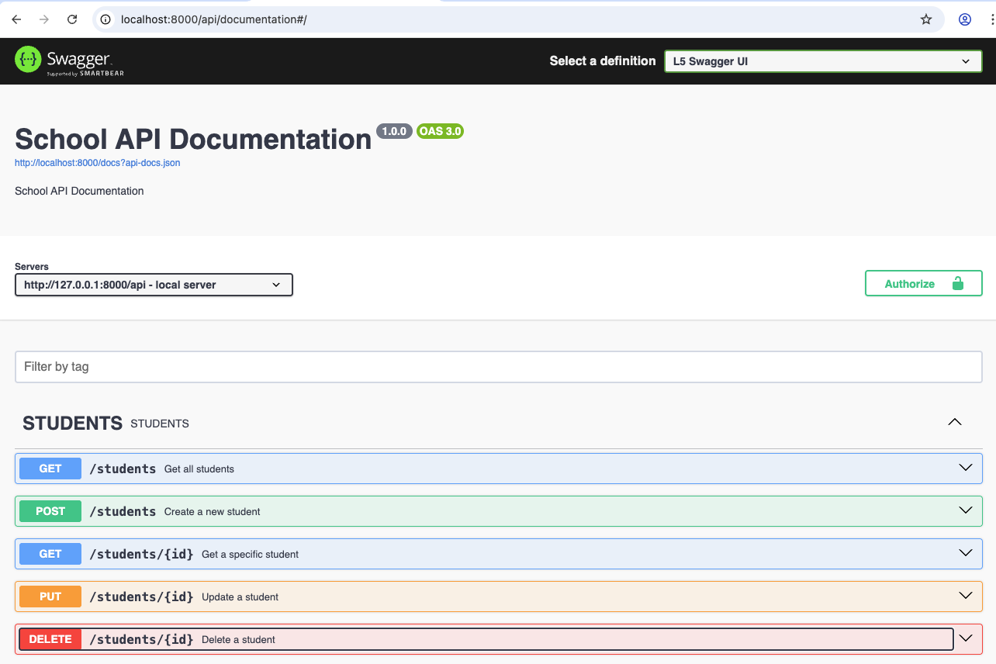

Step #8 (Optional)
You can set L5_SWAGGER_GENERATE_ALWAYS to true in your .env file so that documentation is automatically generated. You will need to restart your web server for this to take effect.
Edit config/l5-swagger.php file and set proper value for the ‘title’ property that better represents your API:
15
'title' => 'Students Swagger UI',
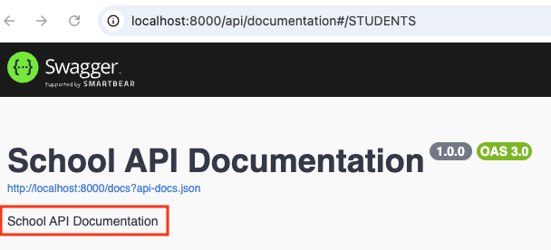
Also, you can make /api/documentation the home page by editing web.php so that the / (root) route does a redirect:
16
Route::get('/', function () {
return redirect('/api/documentation');
});

References:
https://swagger.io
https://github.com/DarkaOnLine/L5-Swagger

