Blade Components / Config files / working with DBs

Setup Database
docker run -d -p 3333:3306 --name mdb -e MYSQL_ROOT_PASSWORD=secret mariadb:10.7.3
Create a database named school in MariaDB.
Download and extract: mysql-students_START.zip
01
composer install
php artisan migrate
php artisan migrate:refresh --seed
php artisan serve

Blade Components
Create a new folder named components under resources/views.
Copy resources/views/layouts/master.blade.php into that new folder.
In the resources/views/components/master.blade.php, replace @yield('content') with:
{{ $content }}
resources/views/components/master.blade.php looks like this:
<!DOCTYPE html>
02
<html lang="{{ str_replace('_', '-', app()->getLocale()) }}">
<head>
<meta charset="utf-8">
<meta name="viewport" content="width=device-width, initial-scale=1">
<link rel="stylesheet" href="https://cdn.jsdelivr.net/npm/bootstrap@5.1.3/dist/css/bootstrap.min.css" >
<title>Students love Laravel - @yield('title')</title>
</head>
<body>
<div class="container">
{{ $content }}
</div>
</body>
</html>
In welcome.blade.php replace @extends('layouts.master') with <x-master> and close this tag at the bottom of the document. Note that master is the name of the component that you just created.
Instead of section we will use slot. Therefore, also in resources/views/welcome.blade.php, replace @section('content') with <x-slot name='content'> and close the tag at the bottom just before </x-master>.
Also, REPLACE:
03
Laravel with MySQL
WITH
04
<x-slot name='title'>Laravel with MySQL</x-slot>
resources/views/welcome.blade.php eventually looks like this:
05
<x-master>
<x-slot name='content'>
<span style="font-size:xx-large;">
<x-slot name='title'>Laravel with MySQL</x-slot>
</span>
<p>
<a href="{{ route('students.index') }}">Students</a>
</p>
</x-slot>
</x-master>

Accessing configuration values
In the .env file, there are settings like, for example, APP_NAME=Laravel.
06
Note this code in config/app.php:
'name' => env('APP_NAME', 'Laravel'),
This means that the variable name exposes the application APP_NAME to the entire application. Therefore, we can access the app.name variable in our code. In resources/views/components/master.blade.php , REPLACE:
07
<title>Students love Laravel - @yield('title')</title>
WITH:
08
<title>{{ config('app.name') }} - {{ $title }}</title>
Here app is the name of the config file, and name is the property in that config file.
Just above {{ $content }}, add this h2 markup:
09
<h2>{{ $title }}</h2>
Refresh the browser:
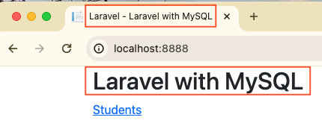
Here is the refined master.blade.php component:
10
<!DOCTYPE html>
<html lang="{{ str_replace('_', '-', app()->getLocale()) }}">
<head>
<meta charset="utf-8">
<meta name="viewport" content="width=device-width, initial-scale=1">
<link rel="stylesheet" href="https://cdn.jsdelivr.net/npm/bootstrap@5.1.3/dist/css/bootstrap.min.css" >
<title>{{ config('app.name') }} - {{ $title }}</title>
</head>
<body>
<div class="container">
<h2>{{ $title }}</h2>
{{ $content }}
</div>
</body>
</html>

Working with databases
Three ways to access data:
- Using raw SQL queries
- Query Builder
- Eloquent ORM
11
Let us create a DataController.
php artisan make:controller DataController

Raw Query
Add a view file in resources/views/data/raw.blade.php with content:
@extends('layouts.master')

@section('title', 'Raw Query')
12

@section('content')

@endsection
Add the following function to DataController:
13
use Illuminate\Support\Facades\DB;

. . . . .
14
public function raw() {
$students = DB::select('SELECT * FROM students');
dd($students);
}
What is dd()?
dd is a Laravel command that stands for "Dump and Die."
Add the following to routes/web.php:
15
use App\Http\Controllers\DataController;
. . . . . . .
Route::get('raw', [DataController::class, 'raw'])->name('data.raw');
Point your browser to /raw. You should see the following array:
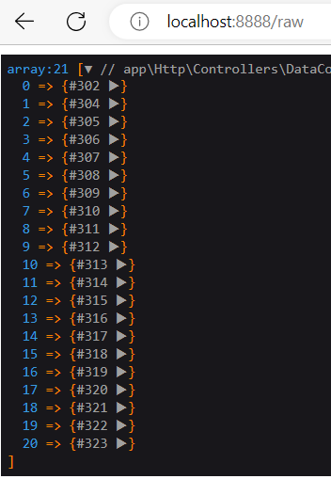

Query Builder
Add a view file in resources/views/data/qbuilder.blade.php with content:
@extends('layouts.master')
16

@section('title', 'Query Builder')

@section('content')

@endsection
Add the following function to DataController:
public function qbuilder() {
17
$students = DB::table('students')
->select(['FirstName','LastName','School'])
->whereNotNull('School')
->orderBy('FirstName')
->get();

dd($students);
}
18
Add the following to routes/web.php:
Route::get('qbuilder', [DataController::class, 'qbuilder'])->name('data.qbuilder');
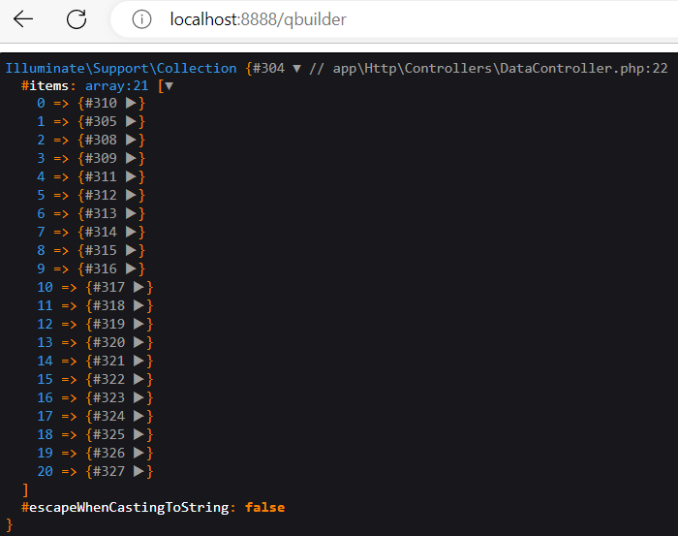
Point your browser to /qbuilder. You should see the following collection:

Eloquent ORM
Add a view file in views/data/elo.blade.php with content:
@extends('layouts.master')
19
@section('title', 'Eloquent ORM')

@section('content')

@endsection
Add the following function to DataController:
20
use App\Models\Student;
. . . . . .
public function elo() {
$students = Student::all();
dd($students);
}
Add the following to routes/web.php:
21
Route::get('elo', [DataController::class, 'elo'])->name('data.elo');
Point your browser to /elo. You should see the following collection:
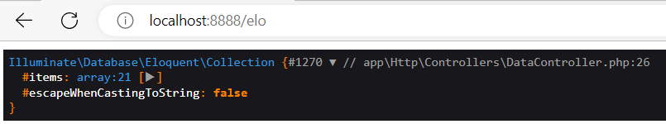
You can iterate through the collection. In the DataController, comment out “dd($students);”
Replace it with:
22
foreach($students as $item) {
echo $item->FirstName . "<br />";
}
When you refresh your browser, you will see:
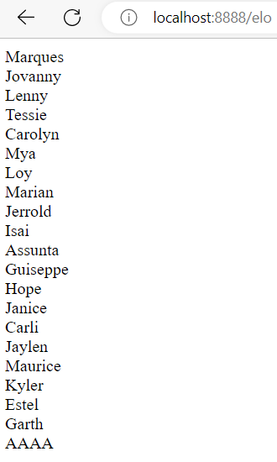
Comment out “$users = Student::all();” and replace it with:
23
$students = Student::select(['FirstName','LastName','School'])
->whereNotNull('School')
->where('FirstName', 'LIKE', 'A%')
->orderBy('FirstName')
->get();
If you want to know the actual query that is being sent to the database, you can do the following:
24
DB::enableQueryLog();

$students = Student::select(['FirstName', 'LastName', 'School'])
->whereNotNull('School')
->where('FirstName', 'LIKE', 'A%')
->orderBy('FirstName')
->get();

echo "<pre>";
print_r(DB::getQueryLog());
echo "</pre>";
Output looks like this:
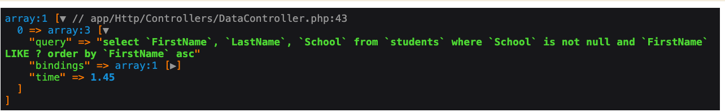
You get the same results, except the output is sorted by FirstName.
This is how you insert a Student record in the database:
25
$student = new Student();
$student->FirstName = "Jane";
$student->LastName = "Bond";
$student->School = "International Espionage";
$student->save();

