Session-based Authentication

Setup new project
01
composer create-project laravel/laravel breeze-session-auth-sqlite
cd breeze-session-auth-sqlite

Add authentication with Laravel Breeze
Built in features
- Register
- Login
- Logout
- Password Reset
Breeze uses Tailwind CSS for styling. Laravel UI (github.com/laravel/ui/tree/3.x) uses bootstrap with authentication.
03
composer require laravel/breeze --dev
php artisan breeze:install
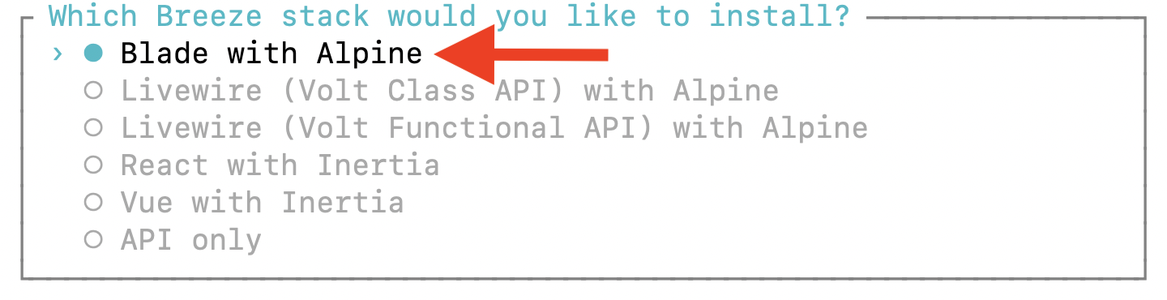
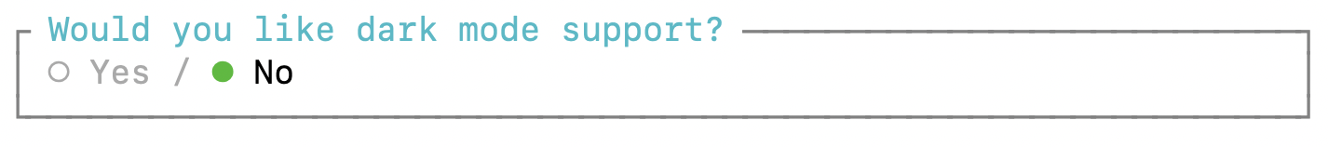
04
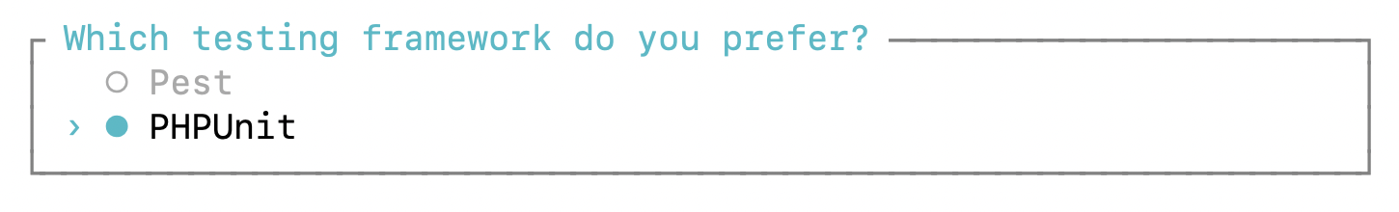
05
Start the web server with:
06
php artisan serve
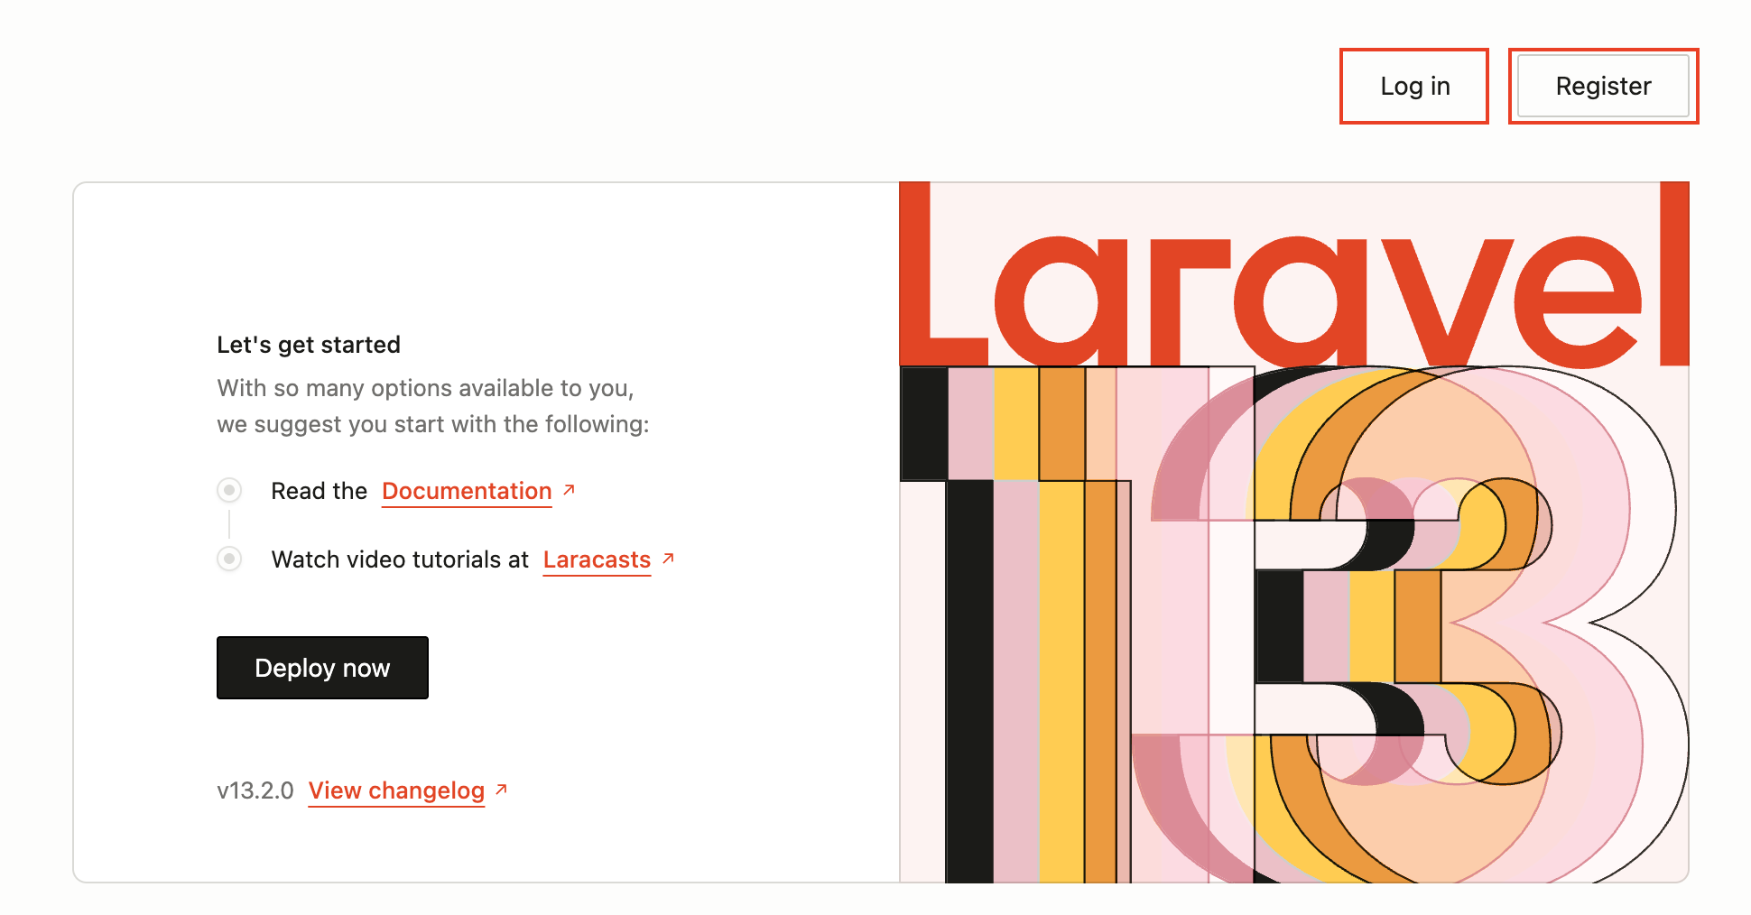

What happened?
07
Look into /routes/web.php.
Route::get('/', function () {
return view('welcome');
});

Route::get('/dashboard', function () {
return view('dashboard');
})->middleware(['auth', 'verified'])->name('dashboard');

Route::middleware('auth')->group(function () {
Route::get('/profile', [ProfileController::class, 'edit'])->name('profile.edit');
Route::patch('/profile', [ProfileController::class, 'update'])->name('profile.update');
Route::delete('/profile', [ProfileController::class, 'destroy'])->name('profile.destroy');
});

require __DIR__.'/auth.php';
This means that the /dashboard route is secured. If you try to go to /dashboard, you will be challenged to login:
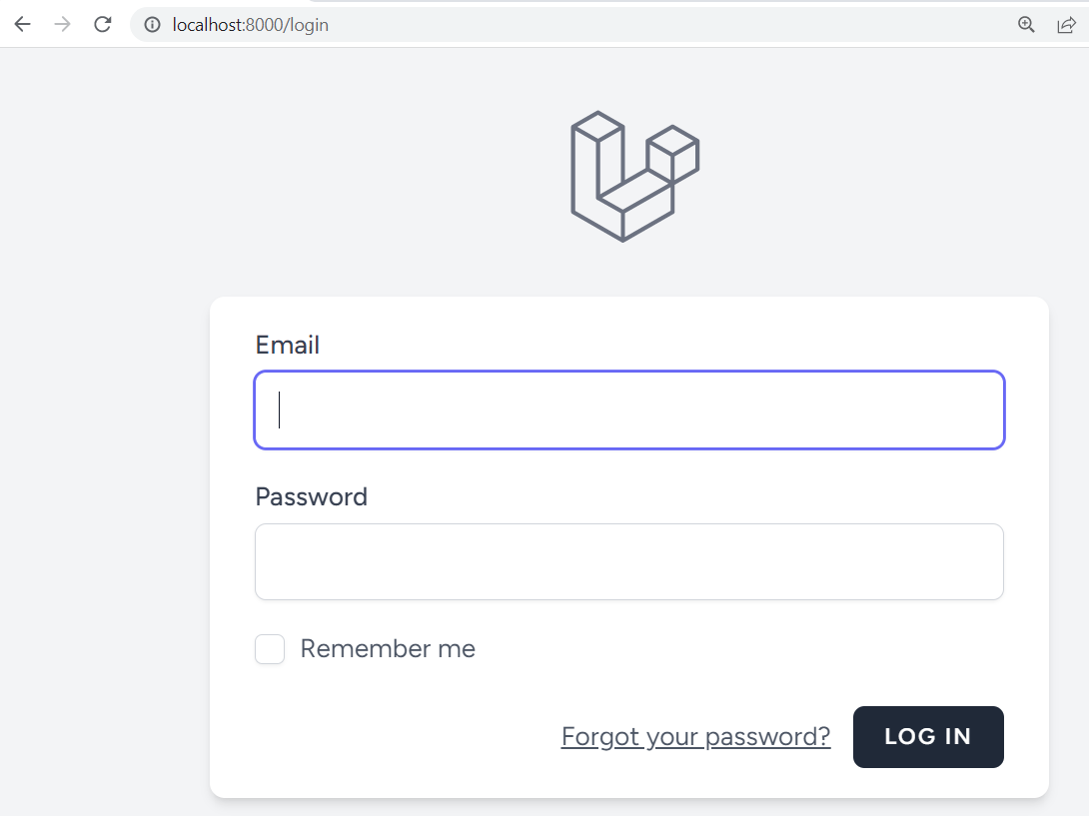
Once you login successfully, you can access the dashboard page:
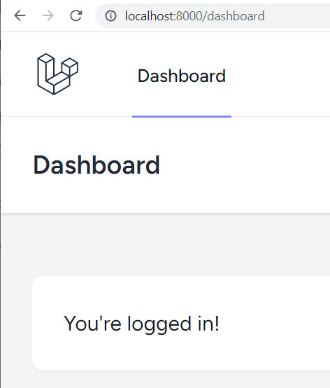
All authentication routes can be found in /router/auth.php:
08
Route::middleware('guest')->group(function () {
Route::get('register', [RegisteredUserController::class, 'create'])
->name('register');

Route::post('register', [RegisteredUserController::class, 'store']);

Route::get('login', [AuthenticatedSessionController::class, 'create'])
->name('login');

Route::post('login', [AuthenticatedSessionController::class, 'store']);

Route::get('forgot-password', [PasswordResetLinkController::class, 'create'])
->name('password.request');

Route::post('forgot-password', [PasswordResetLinkController::class, 'store'])
->name('password.email');

Route::get('reset-password/{token}', [NewPasswordController::class, 'create'])
->name('password.reset');

Route::post('reset-password', [NewPasswordController::class, 'store'])
->name('password.store');
});

Route::middleware('auth')->group(function () {
Route::get('verify-email', EmailVerificationPromptController::class)
->name('verification.notice');

Route::get('verify-email/{id}/{hash}', VerifyEmailController::class)
->middleware(['signed', 'throttle:6,1'])
->name('verification.verify');

Route::post('email/verification-notification', [EmailVerificationNotificationController::class, 'store'])
->middleware('throttle:6,1')
->name('verification.send');

Route::get('confirm-password', [ConfirmablePasswordController::class, 'show'])
->name('password.confirm');

Route::post('confirm-password', [ConfirmablePasswordController::class, 'store']);

Route::put('password', [PasswordController::class, 'update'])->name('password.update');

Route::post('logout', [AuthenticatedSessionController::class, 'destroy'])
->name('logout');
});
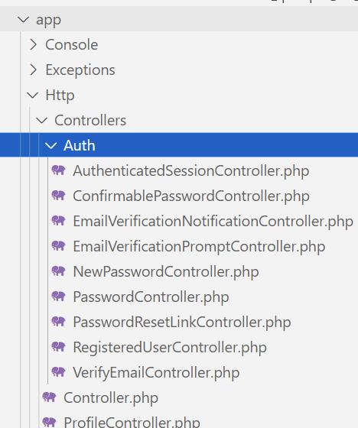
Controllers are at /app/Http/Controllers/Auth:

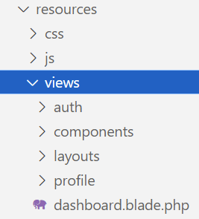
Views are at folders /resources/views/auth, /resources/views/components, /resources/views/profile, & /resources/views/layouts + file named /resources/views/dashboard.blade.php:

Database Model
Our custom database model will be an org-registry with the following columns:
09
orgName
orgType (Example: coffee shop, gas station, bakery, hospital, etc …)
street
city
postalCode
province
country
phone
email
Create a model with:
10
php artisan make:model Org -m
In /database/migrations, edit the Org migrations file that was created and update the schema in the up() method with the below highlighted code:
11
Schema::create('orgs', function (Blueprint $table) {
$table->id();
$table->foreignId('user_id')->constrained();
$table->string('orgName');
$table->string('orgType');
$table->string('street');
$table->string('city');
$table->string('postalCode');
$table->string('province');
$table->string('country');
$table->string('phone');
$table->string('email');
$table->timestamps();
});
Notice the user_id foreign key above.
Apply migration with:
12
php artisan migrate

Seeding Users
php artisan make:seeder UsersTableSeeder
13
14
Add these at top of /database/seeders/UsersTableSeeder.php:
use App\Models\User;
use Illuminate\Support\Facades\Hash;
Add the following code to the run() method in /database/seeders/UsersTableSeeder.php:
15
$pwd = 'P@$$w0rd';
// Seed user 1
$email = 'aa@aa.aa';
$user = User::where('email', '=',$email)->first();
if ($user === null) {
$user = User::create([
'name' => 'aa',
'email' => $email,
'password' => Hash::make($pwd),
]);
}

// Seed user 2
$email = 'bb@bb.bb';
$user = User::where('email', '=', $email)->first();
if ($user === null) {
$user = User::create([
'name' => 'bb',
'email' => $email,
'password' => Hash::make($pwd),
]);
}
Edit the DatabaseSeeder.php file run() method and add the following code to the run() method:
16
$this->call(UsersTableSeeder::class);
Run the following command from a terminal window:
17
php artisan migrate:refresh --seed

Seeding database with random data
To create a fake Org seeder factory:
18
php artisan make:factory OrgFactory
Edit /database/factories/OrgFactory.php, make definition() method look like this:
public function definition(): array {
// note that users 1=test@example.com, 2=aa and 3=bb
return [
'user_id' => $this->faker->randomElement([1,2,3]),
'orgName' => $this->faker->company(),
'orgType' => $this->faker-> jobTitle(),
19
'street' => $this->faker->streetAddress(),
'city' => $this->faker->city(),
'postalCode' => $this->faker->postcode(),
'province' => $this->faker->state(),
'country' => $this->faker->country(),
'phone' => $this->faker->phoneNumber(),
'email' => $this->faker->email(),
];
}
In /database/seeders/DatabaseSeeder.php, append the following statement to the run() method:
20
\App\Models\Org::factory(20)->create();
20.5
In the app/Models/Org.php file, make these changes:
use Illuminate\Database\Eloquent\Factories\HasFactory;
. . . .
class Org extends Model
{
use HasFactory;
}
Seed the database Org table with data by running the following terminal command:
21
php artisan migrate:refresh --seed
Note: To seed a specific migration, you can enter this command:
php artisan migrate:refresh --seed --path=/database/migrations/2026_03_05_220459_create_orgs_table.php

Creating required controller
php artisan make:controller OrgController --resource
22

Creating the views
Under /resources/views, create a new folder named orgs. Inside the new orgs folder, create a file named index.blade.php.
Copy contents of dashboard.blade.php and paste it into /resources/views/orgs/index.blade.php.
23
Replace {{ __('Dashboard') }} with {{ __('Organizations') }}.
24
Also, for the moment, replace {{ __("You're logged in!") }} with {{ __("All organizations") }}

Create required routes
Add this to /routes/web.php:
use App\Http\Controllers\OrgController;
25
Also, in /routes/web.php, add the following route:
Route::resource("/org", OrgController::class )->middleware(['auth']);
Note that the above code creates routes for: get/store/destroy/post etc…
In addition, we are using the auth middleware to restrict all /org pages.
26
Add the following to the OrgController index() method:
use App\Models\Org;
use Illuminate\Support\Facades\Auth;

. . . .
public function index() {
echo(Auth::id());
$orgs = Org::where('user_id', Auth::id())->latest('updated_at')->get();
return view("orgs.index", ['orgs' => $orgs]);
}
In /resources/views/orgs/index.blade.php replace the entire <div class="p-6 text-gray-900"> block with:
27
<table>
@foreach($orgs as $item)
<tr>
<td>{{ $item->id }}</td>
<td>{{ $item->orgName }} {{ $item->LastName }}</td>
<td>{{ $item->orgType }}</td>
<td>{{ $item->street }}</td>
<td>{{ $item->city }}</td>
<td>{{ $item->postalCode }}</td>
<td>{{ $item->province }}</td>
<td>{{ $item->country }}</td>
<td>{{ $item->phone }}</td>
<td>{{ $item->email }}</td>
</tr>
@endforeach
</table>
Login with aa@aa.aa and P@$$w0rd. Then, point your browser to /org. The output looks like this:
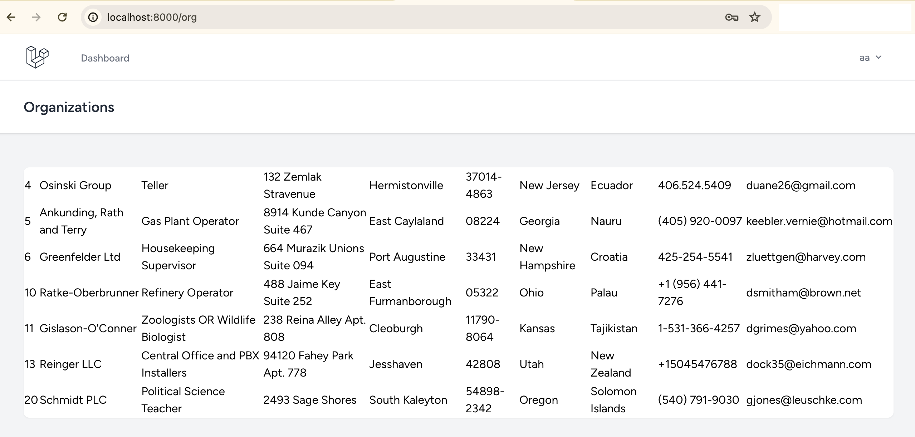
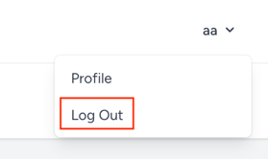
Now, if we logout we will be directed to the standard Laravel home page. We need to be directed to our new Organizations landing page. Therefore, edit routes/web.php and change:
28
Route::get('/', function () {
return view('welcome');
});
TO
Route::get('/', function () {
//return view('welcome');
return redirect('/org');
});
If you test the app, and you try to access /org, you will be redirected to the login page. After you login you will find yourself at the /org page.

Eloquent Relationships

Relationships
- Posts tables <=> Likes table
- Students table <=> Subjects table
- Users table <=> Comments table

Eloquent Relationships
- One to one
- One to many
- One of many
- Many to many
- Custom types
Let us assume that our User model has a one-to-many relationship with the Org model.
Go to the app/Models/User.php model file and add a new function named orgs() as follows:
29
public function orgs() {
return $this->hasMany(Org::class);
}
You must also define the inverse relationship between Org and User. Go to the app/Models/Org.php model file and add this user() function (note that function name user() is singular):
30
public function user() {
return $this->belongsTo(User::class);
}

Query & Save relationships.
In OrgController.php, you can comment out (or delete) the first statement in index() and replace it with the highlighted statement shown below:
31
public function index() {
// $orgs = Org::where('user_id', Auth::id())->latest('updated_at')->get();
$orgs = Auth::user()->orgs()->latest('updated_at')->get();
return view("orgs.index", ['orgs' => $orgs]);
}
Alternatively, you can use the following highlighted statement:
32
public function index() {
// $orgs = Org::where('user_id', Auth::id())->latest('updated_at')->get();
// $orgs = Auth::user()->orgs()->latest('updated_at')->get();
$orgs = Org::whereBelongsTo(Auth::user())->latest('updated_at')->get();
return view("orgs.index", ['orgs' => $orgs]);
}
If we have a show() method that displays the orgs for a user, you can enter a query that looks like this:
33
public function show(Org $org) {
if (!$org->user->is(Auth::user())) {
return abort(403);
}

return view(orgs.show)->with('org', $org);
}
If we have a create() method that inserts the org for a user, you can enter a query that looks like this:
34
public function store(Request $request) {

$request->validate([
'orgName' => 'required|max:120',
'street' => 'required|max:120',
'city' => 'required|max:60',
'postalCode' => 'required|max:10',
'province' => 'required|max:60',
'country' => 'required|max:60',
'phone' => 'required|max:15',
'email' => 'required|max:120'
]);

Auth::user()->orgs()->create([
'uuid' => Str::uuid(),
'orgName' => $request->orgName,
'street' => $request->street,
'city' => $request->city,
'postalCode' => $request->postalCode,
'province' => $request->province,
'country' => $request->country,
'phone' => $request->phone,
'email' => $request->email
]);

return to_route('orgs.index');
}

