Intro to Laravel

Pre-requisites
- PHP
- Enable the following php.ini settings:
  - extension_dir="ext"
  - extension=openssl
  - extension=mbstring
  - extension=fileinfo
  - extension=zip
  - extension=pdo_mysql
- Composer – If you do not have Composer yet, download and install it for your operating system from https://getcomposer.org

Creating a Laravel project
Inside a suitable working directory, run the following command to create a Laravel project called laravel-rocks:
01
composer create-project laravel/laravel laravel-rocks
Be patient because it takes about 2-3 minutes (depending on your hardware) for all the necessary packages to be installed for a working Laravel project. The project is created in a new directory named laravel-rocks.
Change directory to the project folder with:
02
cd laravel-rocks
You will notice the presence of a vendor folder. This folder contains all the downloaded packages for the project. Also, notice the presence of a .gitignore file with the following content:
/.phpunit.cache
/node_modules
/public/build
/public/hot
/public/storage
/storage/*.key
/storage/pail
/vendor
.env
.env.backup
.env.production
.phpactor.json
.phpunit.result.cache
Homestead.json
Homestead.yaml
npm-debug.log
yarn-error.log
/auth.json
/.fleet
/.idea
/.nova
/.vscode
/.zed
The vendor folder is included in the. gitignore file. This means that the vendor folder can be restored at any time. The following composer command restores the vendor folder:
03
composer install
The root folder of your web application is the public directory. Therefore, to start your Laravel web application, do the following:
04
cd public
php -S localhost:8888
05
Alternatively, the preferred way is to start the Laravel server in the app’s root folder is with the following command:
php artisan serve --port=8888
NOTE: If you do not enter “--port=888” the default port number is 8000.
Point your browser to http://localhost:8888 and you will see the following page:
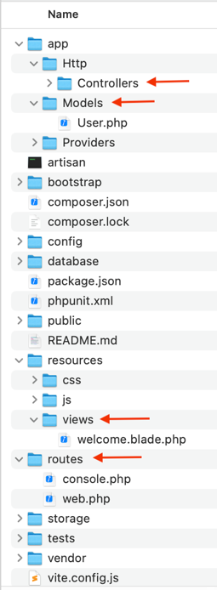
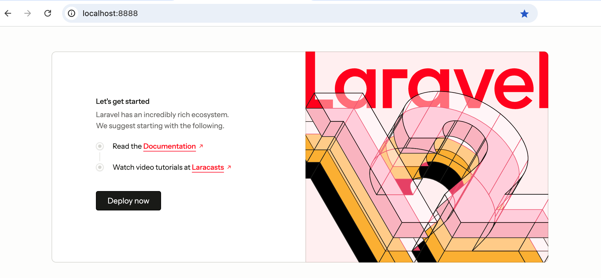
The main folders of special interest are:
app/Http/Controllers | Contains controller files
app/Models | Contains Models
resources/views | Views
routes | Routes
Let us start with Views. In the resources/views folder you will find files with extension .blade.php. The Laravel internal templating engine will handle any file with extension .blade.php. The Laravel blade templating engine allows you to create views without mixing PHP and HTML.
The default view that comes with Laravel is resources/views/welcome.blade.php.

Creating your own blade template
Create a folder named layouts under resources/views. In the resources/views/layouts folder, create a file named master.blade.php with the following content:
<!DOCTYPE html>
06
<html lang="{{ str_replace('_', '-', app()->getLocale()) }}">
<head>
<meta charset="utf-8">
<meta name="viewport" content="width=device-width, initial-scale=1">
<title>Laravel</title>
</head>
<body>
@yield('content')
</body>
</html>
The above file will serve as a template file inside which other views will get injected. The injection point is @yield('content').
Replace content of resources/views/welcome.blade.php with the following:
07
@extends('layouts.master')

@section('content')
<span style="color:white; background:tomato;font-size:xx-large;">
Helloooooo Laraveeeeel
</span>
@endsection
Your page will now look like this:
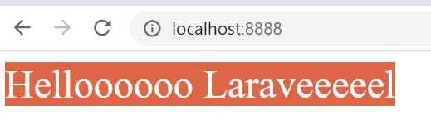
Use {{ …. }} to display data in a Laravel view. For example, add the following code to welcome.blade.php just before @endsection:
08
<p>{{ 22/7 }}</p>
After refreshing your page, it will look like this:
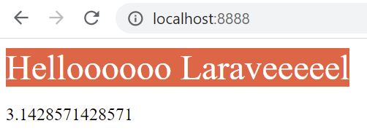

Adding bootstrap
Add the following style to master.blade.php right before </head>:
09
<link rel="stylesheet" href="https://cdn.jsdelivr.net/npm/bootstrap@5.3.3/dist/css/bootstrap.min.css" />
Also, surround @yield('content') with the bootstrap container class so it looks like this:
10
<div class="container">
@yield('content')
</div>
Refresh your page and you will notice some improvement in the font and layout.

Partial views
Partial views are pieces of PHP markup that can be imported multiple times on one page or multiple times on many pages. As an example, let us add a partial view that represents a bootstrap menu.
Create folder resources/views/partials. Inside this new folder, add a file named header.blade.php with content:
<nav class="navbar navbar-light bg-light">
11
<div class="container">
<a href="#" class="navbar-brand">Laravel Guide</a>
<ul class="nav d-flex">
<li class="nav-item"><a href="#" class="nav-link">Products</a></li>
<li class="nav-item"><a href="#" class="nav-link">About us</a></li>
</ul>
</div>
</nav>
Add the following to master.blade.php just after the opening <body> tag:
12
@include('partials.header')
Refresh the page and you will note the following:
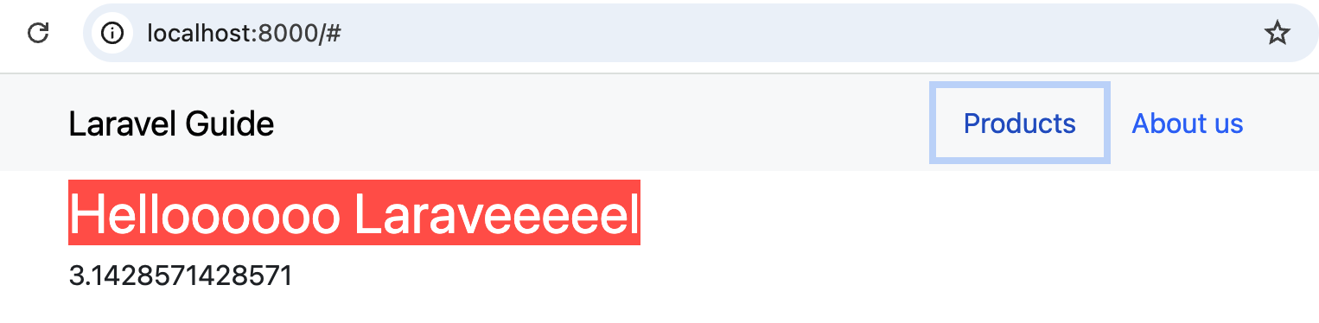

Control structures
Laravel control structures are conditional statements or loops. Replace welcome.blade.php with the following:
@extends('layouts.master')

@section('content')
13
<div class='row'>
<div class="col-md-12">
<h1>Control Structures</h1>
@if(true)
<p>display if true</p>
@else
<p>display if false</p>
@endif
<hr />
@for($i=0; $i<5; $i++)
<p>{{ $i+1 }}. iteration<p>
@endfor
</div>
</div>
@endsection
Refresh the page to reveal the following:
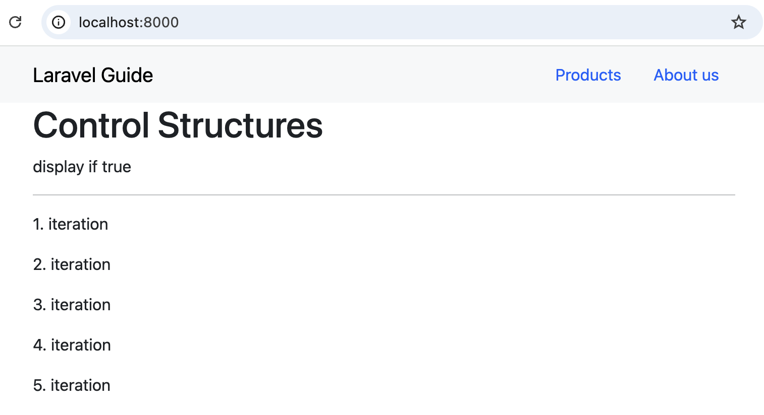

Comments in view blades
{{-- . . . . . . . . --}} are used to comment code in view blades. Example:
@extends('layouts.master')

@section('content')
14
<div class='row'>
<div class="col-md-12">
<h1>Control Structures</h1>
{{-- @if(true)
<p>display if true</p>
@else
<p>display if false</p>
@endif --}}
<hr />
@for($i=0; $i<5; $i++)
<p>{{ $i+1 }}. iteration<p>
@endfor
</div>
</div>
@endsection

Cross site scripting attack protection
Adding {{ . . . . . . }} protects markup from cross site scripting by handling any markup literally without processing the tags. Example, add the following to welcome.blade.php just after @endfor:
<hr />
<h2>XSS</h2>
<div>
15
<p>{{ "<script>alert('hello 1');</script>" }}</p>
<p>{!! "<script>alert('hello 2');</script>" !!}</p>
</div>
In the first paragraph, JavaScript is processed and in the second it is ignored.

Custom CSS files
You can add custom CSS files to the public folder. Under public create a folder named css and add to it a file named styles.css with the following:
.quote {
font: 400 72px "Arizonia", Helvetica, sans-serif;
color: #5f75f4;
16
text-align: center;
}

.post-title { color: #5f75f4; }
Import styles.css into master.blade.php with this markup:
17
<link rel="stylesheet" href="css/styles.css">
Replace welcome.blade.php with the following:
@extends('layouts.master')
18
@section('content')
<div class="row">
<div class="col-md-12">
<p class="quote">Beautiful British Columbia</p>
</div>
</div>
<div class="row">
<div class="col-md-12 text-center">
<h1 class="post-title">Natural Beauty</h1>
<p>The North of British Columbia is a less visited area of Canada,
but it offers so much in the way of pure, unadulterated natural beauty.</p>
<p><a href="#">Read more...</a></p>
</div>
</div>
<hr>
<div class="row">
<div class="col-md-12 text-center">
<h1 class="post-title">Vancouver Island & Victoria</h1>
<p>Vancouver Island offers one of the world’s most divergent ecosystems on the planet.</p>
<p><a href="#">Read more...</a></p>
</div>
</div>
<hr>
<div class="row">
<div class="col-md-12 text-center">
<h1 class="post-title">Whale and Orca spotting</h1>
<p>British Columbia is one of only a few destinations where you can experience a three hour whale watching boat trip! </p>
<p><a href="#">Read more...</a></p>
</div>
</div>
@endsection
The home page now looks like this:
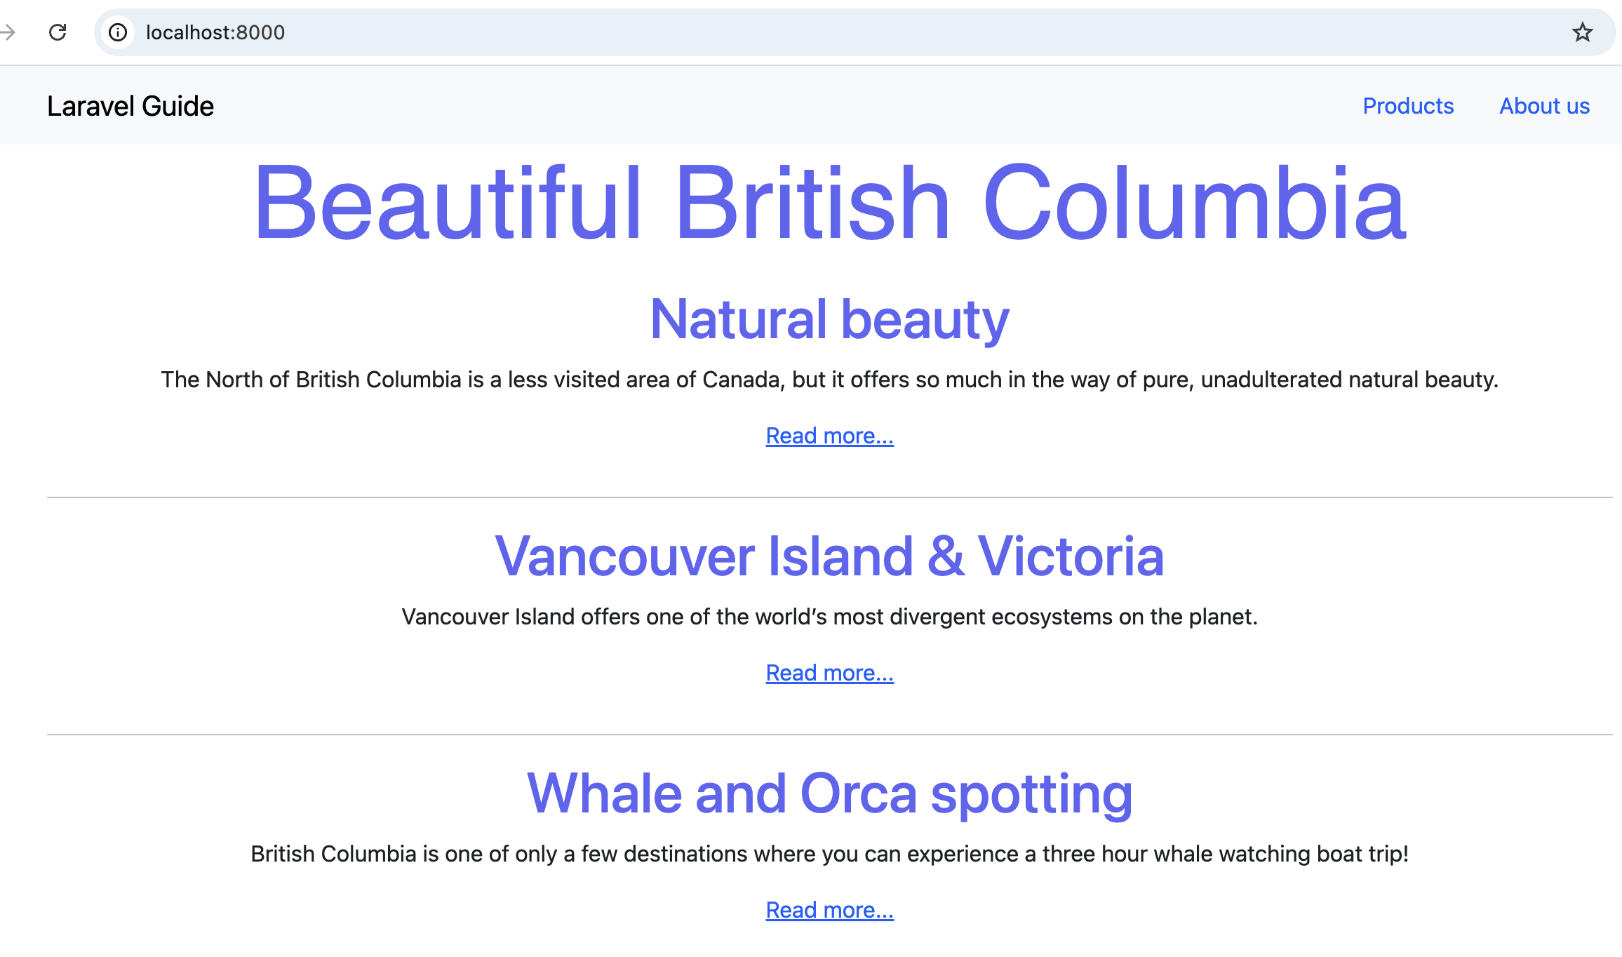
In master.blade.php, replace the custom CSS link statement with the following:
19
<link rel="stylesheet" href="{{URL::to('css/styles.css')}}">
ALSO <link rel="stylesheet" href="{{ asset('css/styles.css') }}"><link>
This is better so the asset is found with absolute addressing.
Your browser Page Source would display this:
Add the following google font to master.blade.php:
20
<link href='http://fonts.googleapis.com/css?family=Arizonia' rel='stylesheet' type='text/css'>
