Laravel JWT
We will restrict access to the students api app that we developed earlier so that only authenticated users have access to the various endpoints. Therefore, start with the laravel.sqlite-api app.

Install and set up JWT
We will install and set up the Laravel JWT authentication package. Let’s use php-open-source-saver/jwt-auth.
Install the newest version of the package using this command:
composer require php-open-source-saver/jwt-auth
01
Next, we need to make the package configurations public. Copy the JWT configuration file from the vendor to config/jwt.php with this command:
php artisan vendor:publish --provider="PHPOpenSourceSaver\JWTAuth\Providers\LaravelServiceProvider"
02
Now, we need to generate a secret key to handle the token encryption. To do so, run this command:
php artisan jwt:secret
03
This will update the .env file (close to the bottom) with something like this:
JWT_SECRET=gobeldy-goooop
04
This key will be used to sign our tokens.

Configure AuthGuard
Inside config/auth.php, we will make a few changes to configure Laravel to use the JWT AuthGuard to power the application’s authentication.
First, we will add api information to the guards section of the file (around line 40):
'guards' => [
'web' => [
'driver' => 'session',
'provider' => 'users',
],
'api' => [
05
'driver' => 'jwt',
'provider' => 'users',
],
],
In this code, we are telling the API guard to use the JWT driver and to make the API guard the default.
Now, we can use Laravel’s inbuilt authentication mechanism, with jwt-auth handling the heavy lifting!

Modify User Model
To implement the PHPOpenSourceSaverJWTAuthContractsJWTSubject contract on our User model, we will use two methods: getJWTCustomClaims() and getJWTIdentifier().
Make the following changes to app/Models/User.php:
- Uncomment the following use statement:
06
use Illuminate\Contracts\Auth\MustVerifyEmail;
- Add the following use statements at the top:
use PHPOpenSourceSaver\JWTAuth\Contracts\JWTSubject;
use Laravel\Sanctum\HasApiTokens;
07
- Inside the User class, add this statement:
08
use HasApiTokens;
- Add the following methods to the User class:
/**
* Get the identifier that will be stored in the subject claim of the JWT.
*
* @return mixed
*/
public function getJWTIdentifier() {
09
return $this->getKey();
}

/**
* Return a key value array, containing any custom claims to be added to the JWT.
*
* @return array
*/
public function getJWTCustomClaims() {
return [];
}

Create AuthController
We need a controller to handle the core authentication process.
Run this command to generate the AuthController:
php artisan make:controller api/AuthController
10
Replace the api/AuthController class with the following:
<?php

namespace App\Http\Controllers\api;

use \Illuminate\Routing\Controller;
11
use Illuminate\Http\Request;
use Illuminate\Support\Facades\Auth;
use Illuminate\Support\Facades\Hash;
use App\Models\User;

class AuthController extends Controller
{
public function __construct() {
$this->middleware('auth:api', ['except' => ['login','register']]);
}

public function login(Request $request) {

$request->validate([
'email' => 'required|string|email',
'password' => 'required|string',
]);
$credentials = $request->only('email', 'password');

if (Auth::attempt($credentials)) {
$user = Auth::user();
$token = $request->user()->createToken('Super Safe Token')->plainTextToken;
return response()->json([
'status' => 'success',
'user' => $user,
'authorisation' => [
'token' => $token,
'type' => 'bearer',
]
]);
} else {
return response()->json([
'status' => 'error',
'message' => 'Unauthorized',
], 401);
}
}

public function register(Request $request){

$request->validate([
'name' => 'required|string|max:255',
'email' => 'required|string|email',
'password' => 'required|string|min:6',
]);

$user = User::create([
'name' => $request->name,
'email' => $request->email,
'password' => Hash::make($request->password),
]);

Auth::login($user);
return response()->json([
'status' => 'success',
'message' => 'User created successfully',
'user' => $user,
'authorisation' => [
'type' => 'bearer',
]
]);
}

public function logout() {
Auth::logout();
return response()->json([
'status' => 'success',
'message' => 'Successfully logged out',
]);
}

public function refresh() {
return response()->json([
'status' => 'success',
'user' => Auth::user(),
'authorisation' => [
'token' => Auth::refresh(),
'type' => 'bearer',
]
]);
}

public function user() {
return Auth::user();
}
}
In the above code:
Method | What?
constructor | We establish this function in our controller class so that we can use the auth:api middleware within it to block unauthenticated access to certain methods within the controller, except /api/login & /api/register.
login | Authenticate user with email and password. When user is successfully authenticated, the Auth facade attempt() method returns the JWT token. The generated token is retrieved and returned as JSON with the authorization object
register | Creates the user record and logs-in the user with token generations
logout | Invalidates the user Auth token
refresh | Invalidates the user Auth token and generates a new token
Add this statement at the top of routes/api.php:
12
use App\Http\Controllers\api\AuthController;
Add these routes to the same routes/api.php file:
Route::controller(AuthController::class)->group(function () {
Route::post('login', 'login');
Route::post('register', 'register');
13
Route::post('logout', 'logout');
Route::post('refresh', 'refresh');
});

CORS
php artisan config:publish cors
14
In config/cors.php, change the value of supports_credentials at the bottom of the file to true.
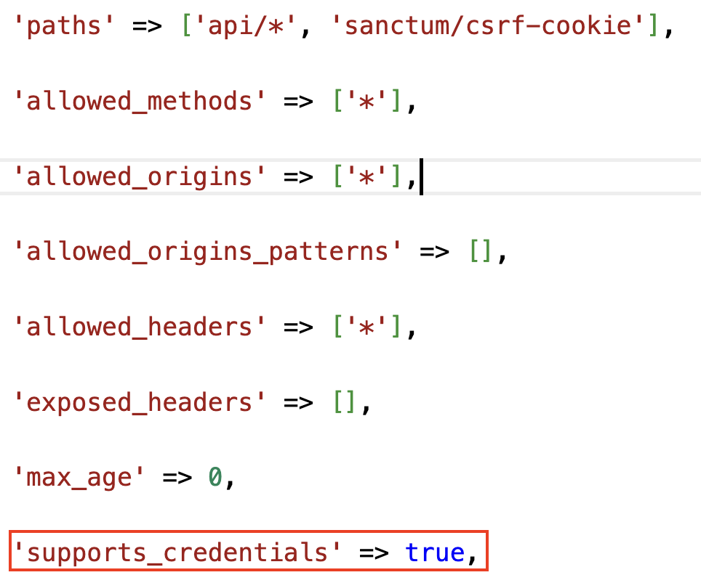

Test JWT Authentication
We will need to restrict all the student endpoints so that only authenticated requests can interact with them. In routes/api.php, add this code:
15
Route::middleware('auth:sanctum')->group(function() {
# all the routes that require authentication go here
});
Move the following routes in routes/api.php into the above block:
16
Route::get('students', [StudentsController::class, 'index']);
Route::get('students/{student}', [StudentsController::class, 'show']);
Route::post('/students', [StudentsController::class, 'store']);
Route::put('students/{student}', [StudentsController::class, 'update']);
Route::delete('students/{student}', [StudentsController::class, 'destroy']);
Therefore, the eventual code would look like this:
17
Route::middleware('auth:sanctum')->group(function() {
Route::get('students', [StudentsController::class, 'index']);
Route::get('students/{student}', [StudentsController::class, 'show']);
Route::post('/students', [StudentsController::class, 'store']);
Route::put('students/{student}', [StudentsController::class, 'update']);
Route::delete('students/{student}', [StudentsController::class, 'destroy']);
});

Clear Cache
At this point it is very important to clear the cache so that the system does not think that the API routes are unprotected. Stop the web server then run these commands before restarting the web server again:
php artisan route:cache
php artisan config:clear
18
php artisan cache:clear
Start the web server with:
19
php artisan serve --port=8888

Register
Register at using POST method at http://localhost:8888/api/register
{"name": "Sam Lee", "email": "sam@lee.com", "password": "P@$$w0rd"}
20
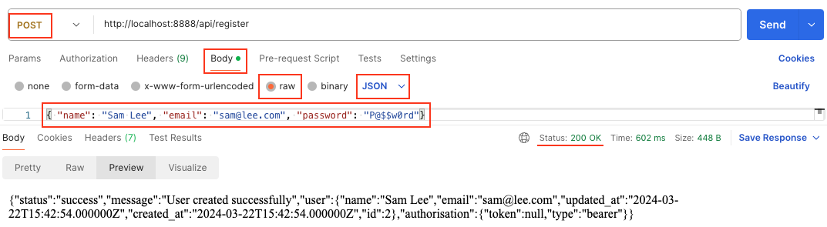

Login
Login using POST method at http://localhost:8888/api/login
21
{"email": "sam@lee.com", "password": "P@$$w0rd"}
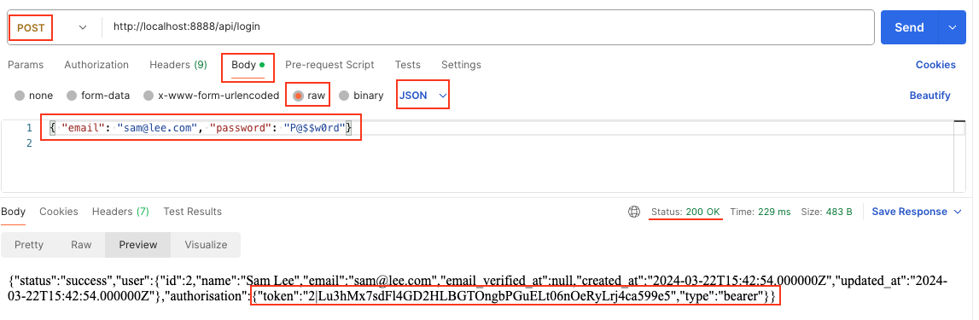
Note the token.

Using the token
If you try and access http://localhost:8888/api/students you will experience an error.
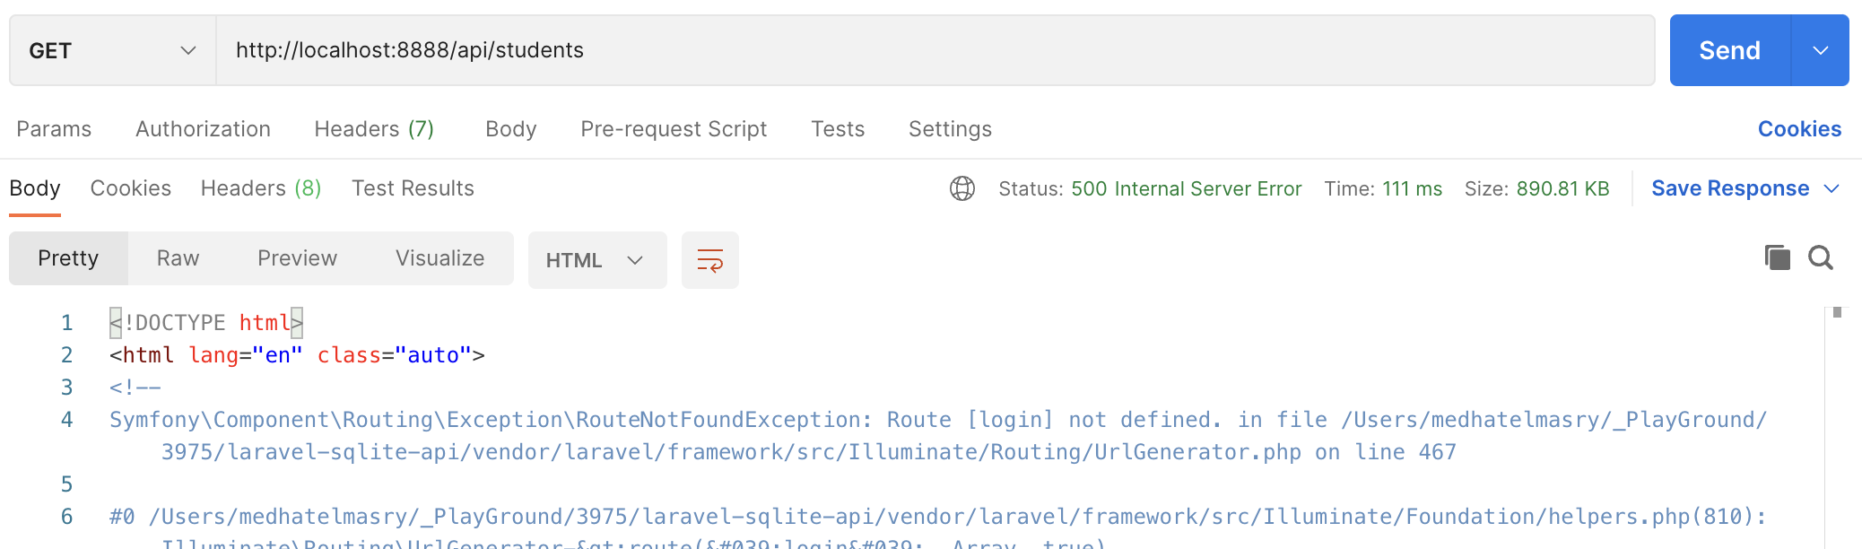
We must use a token to access the students.
- Copy the token.
- Click on Authorization
- Select ‘Bearer Token’
- Paste the token.
- Make a GET request to http://localhost:8888/api/students. You will be able to see the students
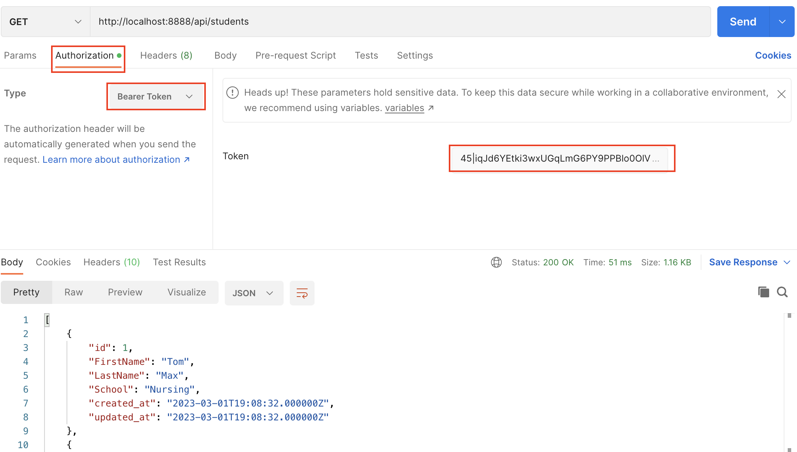
References:
https://blog.logrocket.com/implementing-jwt-authentication-laravel-9/
https://www.youtube.com/watch?v=jIzPuM76-nI&t=1455s
https://scalablescripts.medium.com/laravel-api-authentication-using-jwt-tokens-338dc4a61091
https://www.youtube.com/watch?v=KHN072K2w08

