Laravel Localization
You will start with laravel-intro.zip. Extract the ZIP file into a working directory, then run the application with:
01
composer install
php artisan serve
This is what the web app looks like:
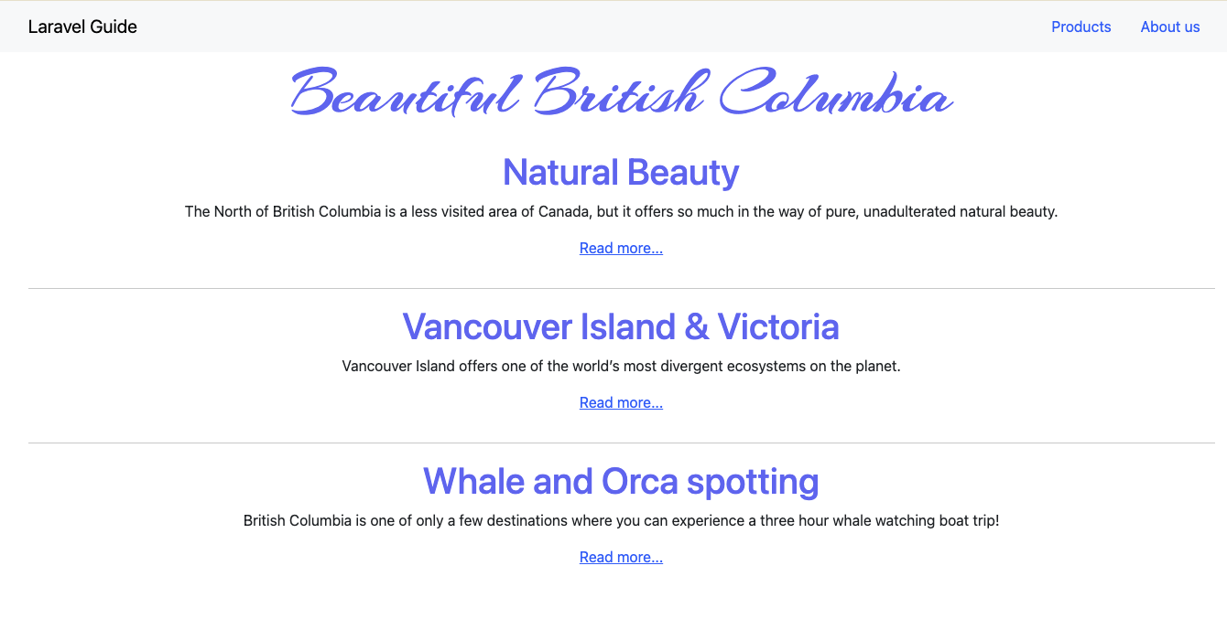
We will localize the content so that we can switch between English, French, and German.
02
Open resources >> views >> Welcome.blade.php. The code looks like this:
@extends('layouts.master')

@section('content')
<div class="row">
<div class="col-md-12">
<p class="quote">Beautiful British Columbia</p>
</div>
</div>
<div class="row">
<div class="col-md-12 text-center">
<h1 class="post-title">Natural Beauty</h1>
<p>The North of British Columbia is a less visited area of Canada,
but it offers so much in the way of pure, unadulterated natural beauty.</p>
<p><a href="#">Read more...</a></p>
</div>
</div>
<hr>
<div class="row">
<div class="col-md-12 text-center">
<h1 class="post-title">Vancouver Island & Victoria</h1>
<p>Vancouver Island offers one of the world’s most divergent ecosystems on the planet.</p>
<p><a href="#">Read more...</a></p>
</div>
</div>
<hr>
<div class="row">
<div class="col-md-12 text-center">
<h1 class="post-title">Whale and Orca spotting</h1>
<p>British Columbia is one of only a few destinations where you can experience a three hour whale watching boat trip! </p>
<p><a href="#">Read more...</a></p>
</div>
</div>
@endsection
To localize the content, replace the Welcome.blade.php with the following code:
03
@extends('layouts.master')

@section('content')
<div class="row">
<div class="col-md-12">
<p class="quote">{{ __('Beautiful British Columbia') }}</p>
</div>
</div>
<div class="row">
<div class="col-md-12 text-center">
<h1 class="post-title">{{ __('Natural Beauty') }}</h1>
<p>{{ __('The North of British Columbia is a less visited area of Canada, but it offers so much in the way of pure, unadulterated natural beauty.') }}</p>
<p><a href="#">{{ __('Read more...') }}</a></p>
</div>
</div>
<hr>
<div class="row">
<div class="col-md-12 text-center">
<h1 class="post-title">{{ __('Vancouver Island & Victoria') }}</h1>
<p>{{ __('Vancouver Island offers one of the world’s most divergent ecosystems on the planet.') }}</p>
<p><a href="#">{{ __('Read more...') }}</a></p>
</div>
</div>
<hr>
<div class="row">
<div class="col-md-12 text-center">
<h1 class="post-title">{{ __('Whale and Orca spotting') }}</h1>
<p>{{ __('British Columbia is one of only a few destinations where you can experience a three hour whale watching boat trip!') }}</p>
<p><a href="#">{{ __('Read more...') }}</a></p>
</div>
</div>

@endsection
Note that each piece of content is enclosed in:
04
{{ __('text text text text') }}
Me must indicate the languages that our app supports. In config >> app.php, add this code around line 83:
05
'supported_locales' => ['en', 'fr', 'de'],
The above indicated that our app will support English (en), French (fr) and German (de).
06
The other already existing settings suggest the default locale is English.
'locale' => env('APP_LOCALE', 'en'),
'fallback_locale' => env('APP_FALLBACK_LOCALE', 'en'),
'faker_locale' => env('APP_FAKER_LOCALE', 'en_US'),
We need to provide the translations in JSON files. Create a folder named lang under resources. In the resources/lang folder add these files:

fr.json
07
{
"Beautiful British Columbia": "Belle Colombie-Britannique",
"Natural Beauty": "Beauté naturelle",
"The North of British Columbia is a less visited area of Canada, but it offers so much in the way of pure, unadulterated natural beauty.": "Le nord de la Colombie-Britannique est une région moins visitée du Canada, mais elle offre tant de beauté naturelle pure et non altérée.",
"Read more...": "Lire la suite...",
"Vancouver Island & Victoria": "Île de Vancouver et Victoria",
"Vancouver Island offers one of the world’s most divergent ecosystems on the planet.": "L'île de Vancouver offre l'un des écosystèmes les plus diversifiés au monde.",
"Whale and Orca spotting": "Observation des baleines et des orques",
"British Columbia is one of only a few destinations where you can experience a three hour whale watching boat trip!": "La Colombie-Britannique est l'une des rares destinations où vous pouvez vivre une excursion en bateau de trois heures pour observer les baleines !"
}

de.json
08
{
"Beautiful British Columbia": "Schönes British Columbia",
"Natural Beauty": "Natürliche Schönheit",
"The North of British Columbia is a less visited area of Canada, but it offers so much in the way of pure, unadulterated natural beauty.": "Der Norden von British Columbia ist ein weniger besuchtes Gebiet Kanadas, bietet jedoch so viel an reiner, unverfälschter natürlicher Schönheit.",
"Read more...": "Weiterlesen...",
"Vancouver Island & Victoria": "Vancouver Island & Victoria",
"Vancouver Island offers one of the world’s most divergent ecosystems on the planet.": "Vancouver Island bietet eines der weltweit unterschiedlichsten Ökosysteme.",
"Whale and Orca spotting": "Wal- und Orca-Beobachtung",
"British Columbia is one of only a few destinations where you can experience a three hour whale watching boat trip!": "British Columbia ist eines der wenigen Ziele, an denen Sie eine dreistündige Walbeobachtungstour erleben können!"
}
In routes/web.php, comment out the default router (/) and replace it with this code:
09
Route::get('/{locale?}', function ($locale = null) {
if (isset($locale) && in_array($locale, config('app.supported_locales'))) {
app()->setLocale($locale);
}
return view('welcome');
});
Visit the site with http://localhost:8000/fr. This is what the French version of the site looks like:
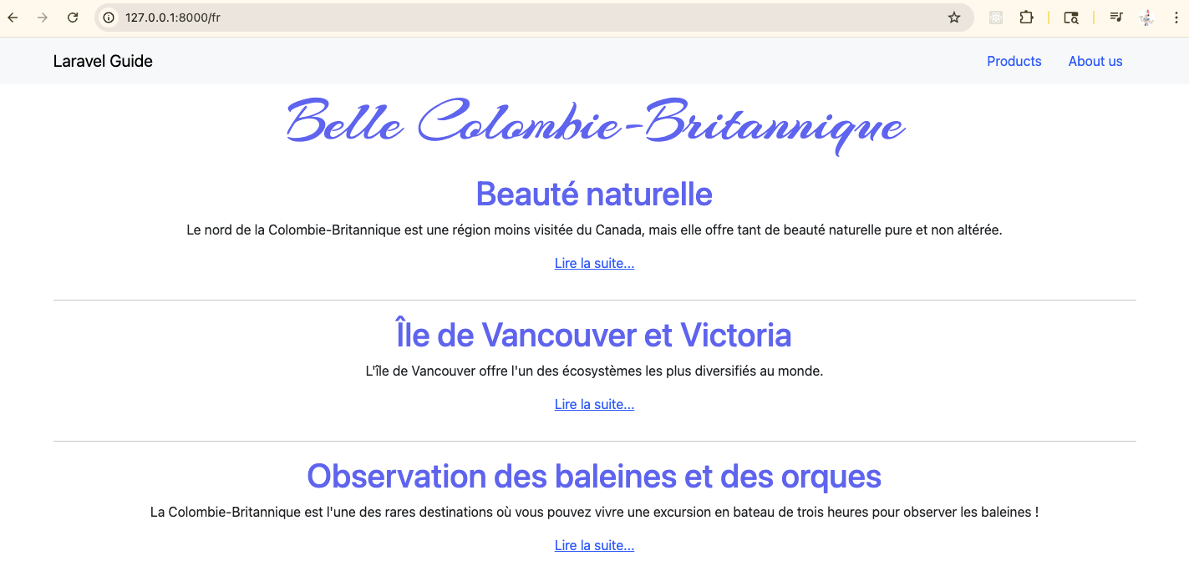
Similarly, the German version of the site looks like this:
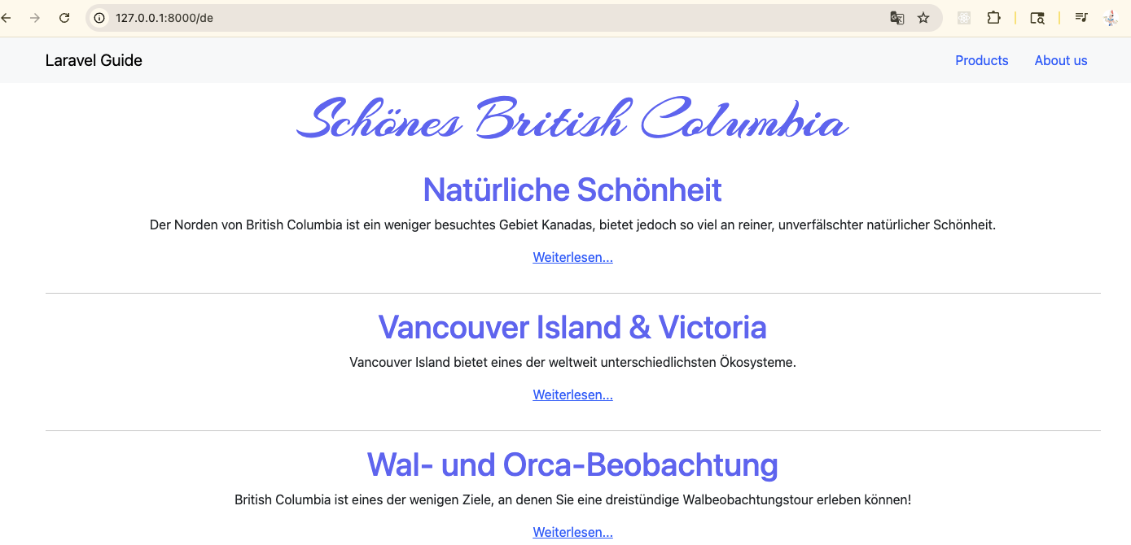
Although this works, it is not ideal. Let’s create a language switcher instead.
Under app >> Http, create a folder named Middleware. Inside this new Middleware folder, and a file named Localization.php with the following code:
10
<?php
namespace App\Http\Middleware;

use Closure;
use Illuminate\Http\Request;
use Illuminate\Support\Facades\App;
use Illuminate\Support\Facades\Session;
class Localization {
/**
* Handle an incoming request.
* @param \Illuminate\Http\Request $request
* @param \Closure $next
* @return mixed
*/
public function handle(Request $request, Closure $next) {
if (Session::has('locale')) {
App::setLocale(Session::get('locale'));
}
return $next($request);
}
}
We shall register this middleware in bootstrap/app.php. Add this code into the ->withMiddleware() block:
11
// register the localization middleware
$middleware->web(append: [
\App\Http\Middleware\Localization::class,
]);
We will change the web.php routing file so that it has only these routes:
12
// localization route
Route:: get ('language/{locale}', function ($locale) {
app()->setLocale($locale);
session()->put('locale', $locale);
return redirect()->back();
});

Route::get('/', function () {
return view('welcome');
});
We should add a language switcher. In the resources/views/partials folder, add a file named language_switcher.blade.php with this code:
13
<div class="flex justify-center pt-8 sm:justify-start sm:pt-0">
&nbsp;|&nbsp;
@foreach ($available_locales as $locale)
@if($locale === $current_locale)
<span class="ml-2 mr-2 text-gray-700">{{ strtoupper($locale) }}&nbsp;|&nbsp;</span>
@else
<a class="ml-1 underline ml-2 mr-2" href="language/{{ $locale }}">
<span>{{ strtoupper($locale) }}</span>
</a>
&nbsp;|&nbsp;
@endif
@endforeach
</div>
Add this partial view to the Welcome.blade.php page by placing this code at the bottom of the file:
14
@include('partials.language_switcher')
Go to app/Providers/AppServiceProvider.php and add this code into the boot() method:
15
view()->composer('partials.language_switcher', function ($view) {
$view->with('current_locale', app()->getLocale());
$view->with('available_locales', config('app.supported_locales'));
});
Your home page will have a language switcher at the bottom of the page.
