Laravel & SQLite database with API
composer create-project laravel/laravel laravel-sqlite-api
01
cd laravel-sqlite-api
code .
Note these DB_ settings in .env:
DB_CONNECTION=sqlite
# DB_HOST=127.0.0.1
02
# DB_PORT=3306
# DB_DATABASE=laravel
# DB_USERNAME=root
# DB_PASSWORD=
03
The default SQLite database name is set in the config/database.php file in the following section:
'sqlite' => [
'driver' => 'sqlite',
'url' => env('DB_URL'),
'database' => env('DB_DATABASE', database_path('school.sqlite')),
'prefix' => '',
'foreign_key_constraints' => env('DB_FOREIGN_KEYS', true),
'busy_timeout' => null,
'journal_mode' => null,
'synchronous' => null,
],

Rename database.sqlite to school.sqlite.
We need to run this command to create a Student model:
04
php artisan make:model Student -m
-m means give me a migration
This creates a migration in database/migrations:
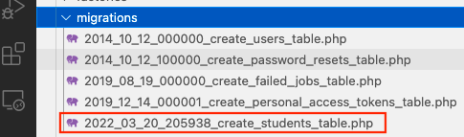
The content of this new migrations file is:
<?php

use Illuminate\Database\Migrations\Migration;
use Illuminate\Database\Schema\Blueprint;
use Illuminate\Support\Facades\Schema;

return new class extends Migration
{
/**
05
* Run the migrations.
*
* @return void
*/
public function up() {
Schema::create('students', function (Blueprint $table) {
$table->id();
$table->timestamps();
});
}

/**
* Reverse the migrations.
*
* @return void
*/
public function down() {
Schema::dropIfExists('students');
}
};
Add columns make and model to the Up() method so it looks like this:
public function up() {
Schema::create('students', function (Blueprint $table) {
$table->id();
06
$table->string('FirstName');
$table->string('LastName');
$table->string('School');
$table->timestamps();
});
}
To apply the migrations, type:
07
php artisan migrate
Respond with Yes to this message:
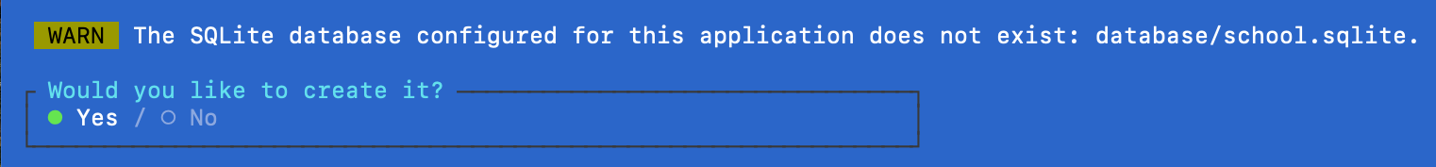
At this stage, you will notice that the SQLite database is created in the database folder:
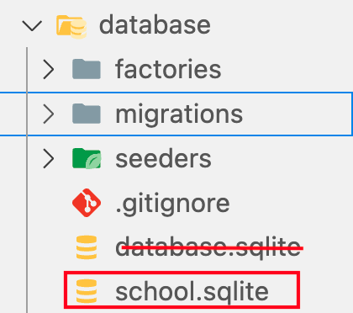
NOTE: Go ahead and delete database.sqlite
There is no data in the students table:
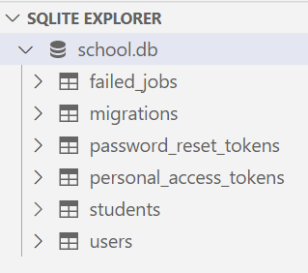

Seeding data
We will add sample (seed) data to the students table.
To create a seeder:
08
php artisan make:seeder StudentSeeder
This creates for us a new StudentSeeder.php file in the database/seeders folder that looks like this:
<?php

namespace Database\Seeders;

use Illuminate\Database\Console\Seeds\WithoutModelEvents;
use Illuminate\Database\Seeder;
09
class StudentSeeder extends Seeder {
/**
* Run the database seeds.
*/
public function run(): void {
//
}
10
}
Download sample students data from https://gist.github.com/medhatelmasry/bd83812406665cd7584bb994f6e7704e and place the file named students.csv into the database/data directory.
Add this import to database/seeders/StudentSeeder.php:
11
use App\Models\Student;
Add the following code into the run() method of database/seeders/StudentSeeder.php:
Student::truncate();

$csvFile = fopen(base_path("database/data/students.csv"), "r");

$firstline = true;
while (($data = fgetcsv($csvFile, 2000, ",")) !== FALSE) {
if (!$firstline) {
Student::create([
12
"FirstName" => $data['1'],
"LastName" => $data['2'],
"School" => $data['3'],
]);
}
$firstline = false;
}
fclose($csvFile);
Edit the DatabaseSeeder.php file and add the following code to the run() method:
13
$this->call(StudentSeeder::class);

Run the following command from a terminal window to seed the students table in the database with some sample data:
14
php artisan migrate:refresh --seed
Upon inspection of the SQLite database, you will find that it has been populated with data:
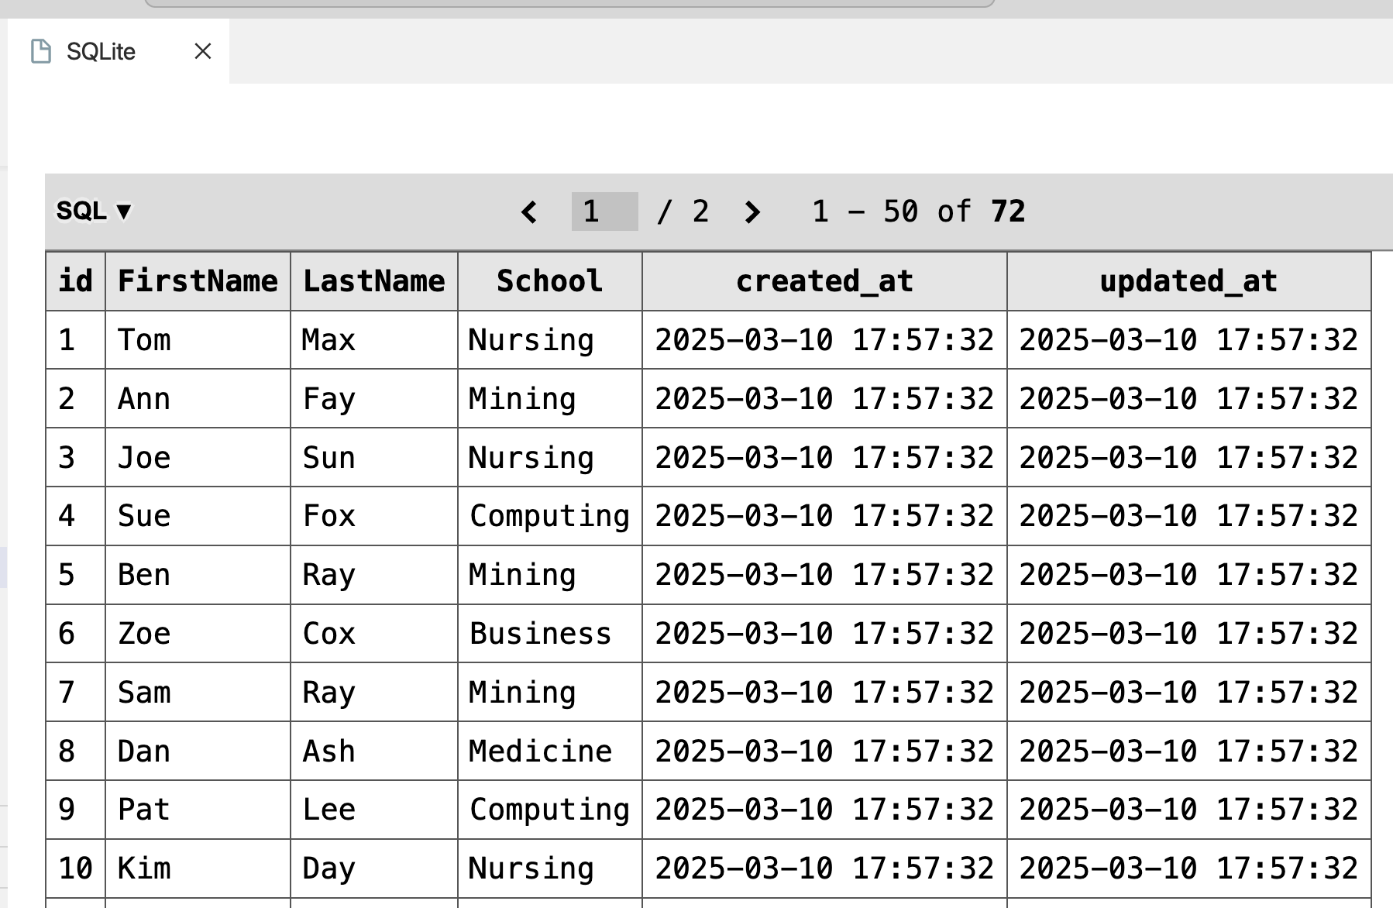
Create the api.php routes file
In a terminal window, run the following artisan command to create routes/api.web:
15
php artisan install:api
This creates a file: routes/api.php.
16
In app/Models/User.php, add these statements above the class declaration:
use Laravel\Sanctum\HasApiTokens;
use Illuminate\Notifications\HasApiTokens;
The GET students endpoint
Edit routes/api.php. Add the following to the top of the file:
18
use App\Models\Student;
Add this route to retrieve all students using the GET method:
19
Route::get('students', function() {
return Student::all();
});
Start your web app:
20
php artisan serve --port 8888
You should see some data in your browser at localhost:8888/api/students
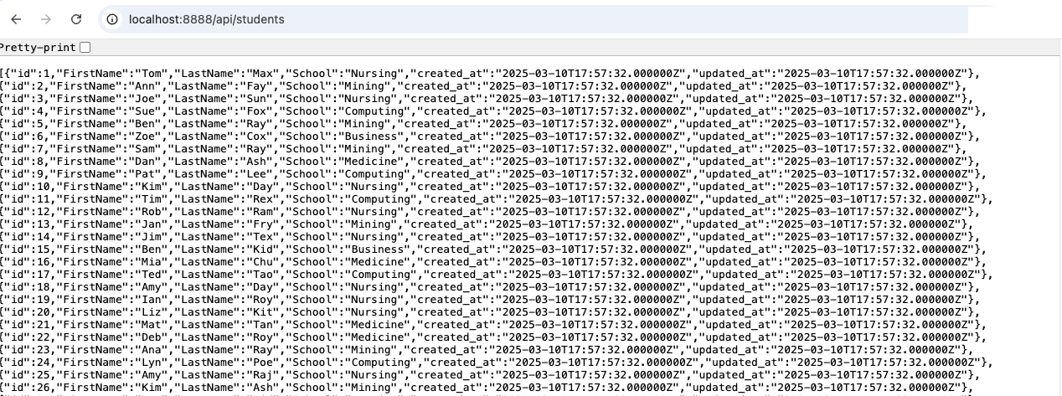
GET student by id endpoint
Add this route to retrieve student data by id using the GET method:
21
Route::get('/students/{id}', function ($id) {
return Student::find($id);
});
To try the above endpoint, you can simply point your browser to http://localhost:8888/api/students/3. You should get the following response:

Create student endpoint
To save data, there is one more step we need to do. Edit app/Models/Student and add the following array inside the Student class:
protected $fillable = [
22
'FirstName',
'LastName',
'School'
];
The above code specifies that the fields FirstName, LastName and School can be populated with data.
Edit routes/api.php. Add this route to create a student using the POST method:
Route::post('students', function() {
return Student::create([
23
'FirstName' => request('FirstName'),
'LastName' => request('LastName'),
'School' => request('School'),
]);
});
Let us try the POST method with our http://localhost:8888/api/students endpoint in postman.
{
"FirstName": "Gary",
24
"LastName": "Smith",
"School": "Nursing"
}
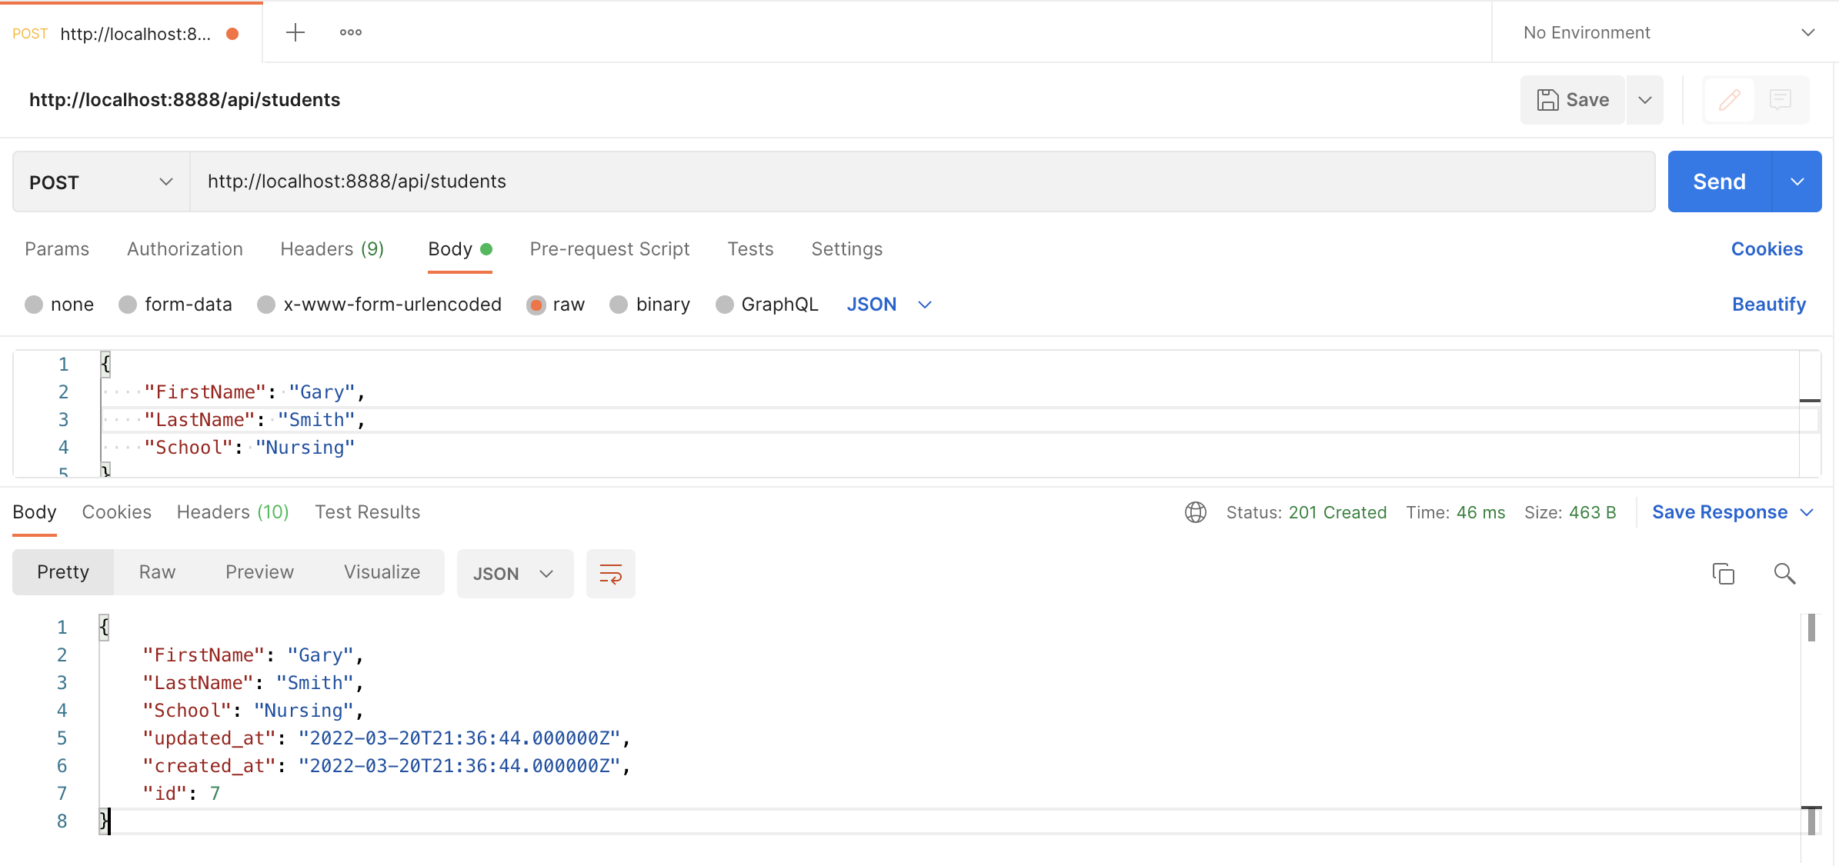
You can provide some validation. Add the following inside the route:
Route::post('students', function() {
// validate the input
request()->validate([
'FirstName' => 'required',
25
'LastName' => 'required',
'School' => 'required',
]);

return Student::create([
'FirstName' => request('FirstName'),
'LastName' => request('LastName'),
'School' => request('School'),
]);
});
Attempt to add data with missing School, and you will experience the Laravel home page:
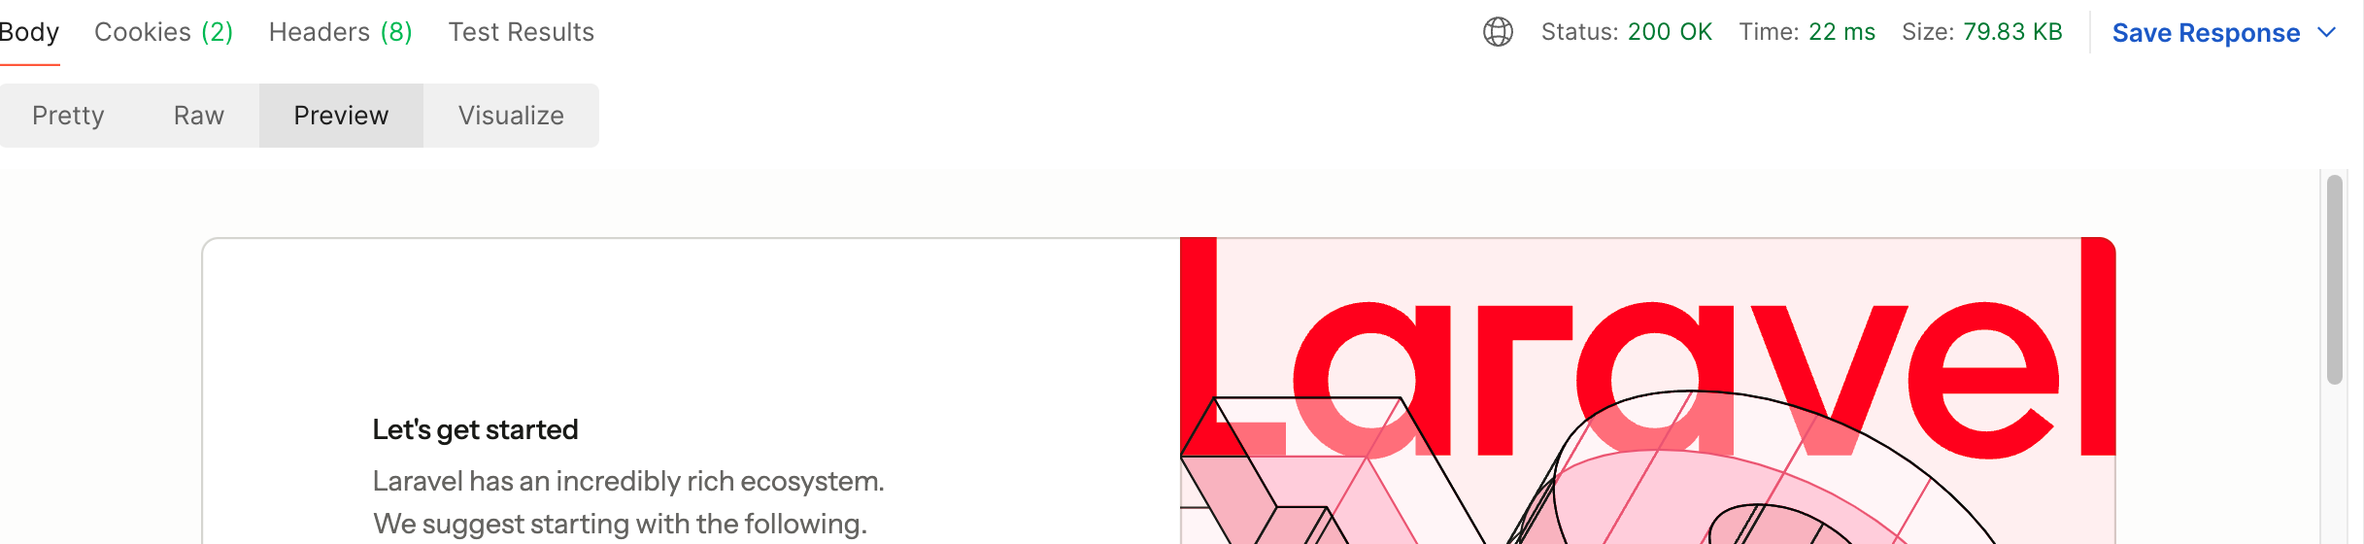

Update student endpoint
In routes/api.php, add this route to update a student using the PUT method:
Route::put('students/{student}', function(Student $student) {
request()->validate([
'FirstName' => 'required',
'LastName' => 'required',
26
'School' => 'required',
]);

$isSuccess = $student->update([
'FirstName' => request('FirstName'),
'LastName' => request('LastName'),
'School' => request('School'),
]);

return [
'success' => $isSuccess
];
});
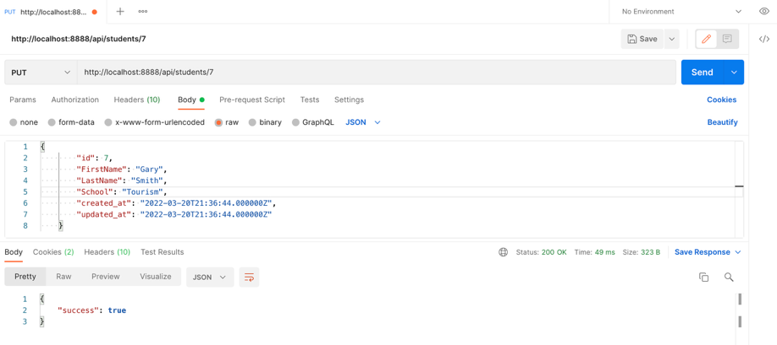
Test the PUT endpoint in Postman.

Delete student endpoint
Edit routes/api.php. Add this route to delete a student using the DELETE method:
Route::delete('students/{student}', function(Student $student) {
$isSuccess = $student->delete();
return [ 'success' => $isSuccess ];
27
});
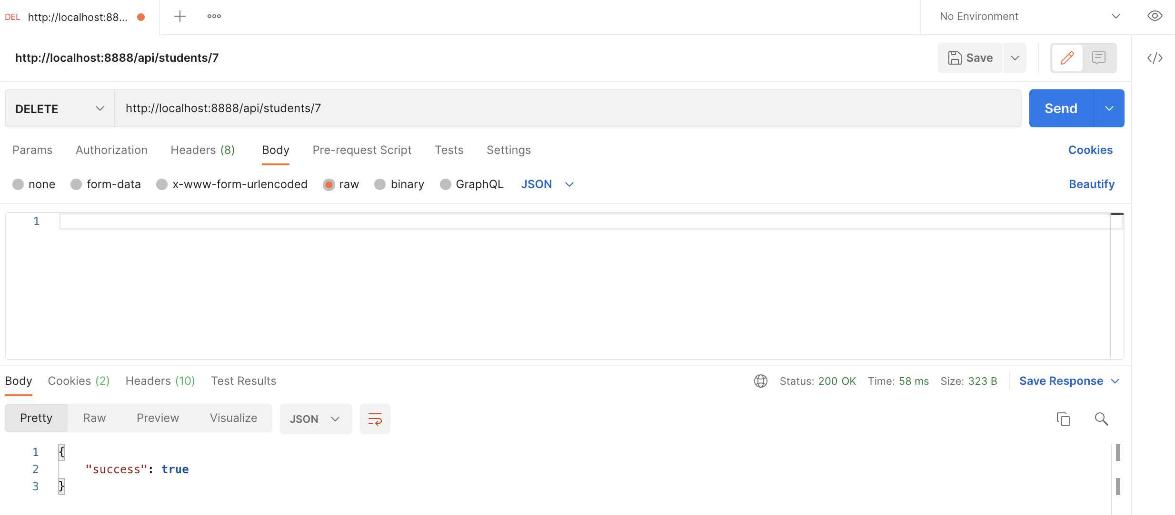
Ideally, all this logic should be in your controller. Therefore, let’s create a StudentsApiController with:
28
php artisan make:controller api/StudentsController --api --model=Student
Change the methods in the new app/Http/controllers/StudentApiController.php as follows:

index() method:
public function index() {
29
return Student::all();
}

store() method:
public function store(Request $request) {
// validate input
request()->validate([
'FirstName' => 'required',
'LastName' => 'required',
'School' => 'required',
30
]);

return Student::create([
'FirstName' => request('FirstName'),
'LastName' => request('LastName'),
'School' => request('School'),
]);
}

show() method
public function show(Student $student) {
31
return $student;
}

update() method:
public function update(Request $request, Student $student) {
// validate input
request()->validate([
'FirstName' => 'required',
32
'LastName' => 'required',
'School' => 'required',
]);

$isSuccess = $student->update([
'FirstName' => request('FirstName'),
'LastName' => request('LastName'),
'School' => request('School'),
]);

return [
'success' => $isSuccess
];
}

destroy() method
public function destroy(Student $student) {
$isSuccess = $student->delete([
'FirstName' => request('FirstName'),
'LastName' => request('LastName'),
'School' => request('School'),
33
]);

return [
'success' => $isSuccess
];
}
In api.php, replace “use App\Models\Student;” with:
34
use App\Http\Controllers\api\StudentsController;
Comment out (or delete) all the previous student routes in api.php and replace them with the following:
Route::get('students', [StudentsController::class, 'index']);
35
Route::get('students/{student}', [StudentsController::class, 'show']);
Route::post('students', [StudentsController::class, 'store']);
Route::put('students/{student}', [StudentsController::class, 'update']);
Route::delete('students/{student}', [StudentsController::class, 'destroy']);
Alternatively, you can replace all the above statements with the following single statement:
Route::resource('students', StudentsController::class);
If you need to restrict which routes are generated, you can use:
Route::resource('students', StudentsController::class)->only(['index', 'show', 'store', 'update', 'destroy']);
Or exclude specific routes:
Route::resource('students', StudentsController::class)->only(['index', 'show', 'store', 'update', 'destroy']);

CORS
By default, Laravel enables CORS for all HTTP methods (by using the “*” value).
To prove that our application passes the CORS test, create a file named show.html and add to it the following content:
36
<!DOCTYPE html>
<html lang="en">
<head>
<link rel="stylesheet" href="https://cdn.jsdelivr.net/npm/bootstrap@5.0.2/dist/css/bootstrap.min.css">
<title>Read student data from API</title>
</head>
<body>
<div id="place" class="container">
<h1 class="text-center">Read student data from API</h1>
</div>

<script>
const data_url = "http://localhost:8888/api/students"

async function getData(data_url) {
var response = await fetch(data_url);
if (!response.ok) {
// Catch errors
throw new Error(`Error. Status: ${response.status}`);
};
var data = await response.json(); // JSON data
await renderTable(data);
};

function renderTable(data) {
const pprod = document.querySelector("#place");
const table = document.createElement("table");
let rows =
`<thead><tr>
<th>Id</th>
<th>Name</th>
<th>School</th>
</tr></thead>`
for (let row of data) {
rows +=
`<tr>
<td>${row.id}</td>
<td>${row.FirstName} ${row.LastName}</td>
<td>${row.School}</td>
</tr>`
}
table.innerHTML = rows
pprod.appendChild(table);
table.className = ("table table-striped")
}

getData(data_url);
</script>
</body>

</html>
Double-click on show.html in the file system and you should see the following page:
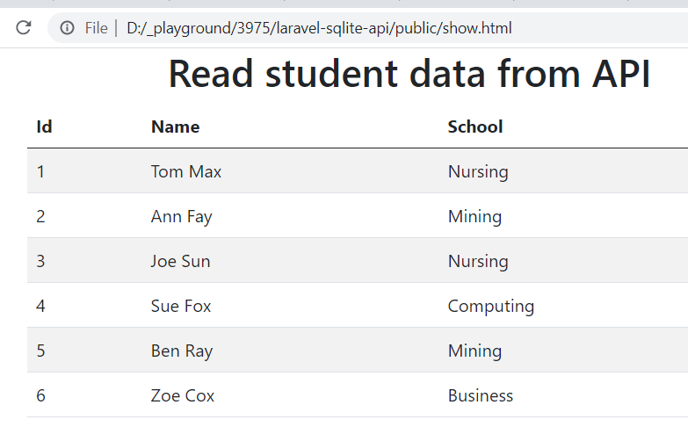

Improved Students API Controller
We have a small problem with the students-controller. With show, update, and destroy methods – if a student id is not found it loads the home page. It is more desirable that a gentle JSON object be returned with a message that the data is not found. Therefore, replace the entire StudentsController.php with this code:
<?php
37

namespace App\Http\Controllers\api;

use App\Http\Controllers\Controller;
use App\Models\Student;
use Illuminate\Http\Request;

{
/**
* Display a listing of the resource.
*/
public function index()
{
return Student::all();
}

/**
* Store a newly created resource in storage.
*/
public function store(Request $request)
{
// validate input
request()->validate([
'FirstName' => 'required',
'LastName' => 'required',
'School' => 'required',
]);

$student = Student::create([
'FirstName' => request('FirstName'),
'LastName' => request('LastName'),
'School' => request('School'),
]);

return response()->json($student, 201);
}

/**
* Display the specified resource.
*/
public function show($id)
{
$student = Student::find($id);

if (!$student) {
return response()->json(['message' => 'Student not found'], 404);
}

return response()->json($student);
}

/**
* Update the specified resource in storage.
*/
public function update(Request $request, $id)
{
$student = Student::find($id);

if (!$student) {
return response()->json(['message' => 'Student not found'], 404);
}

// validate input
request()->validate([
'FirstName' => 'required',
'LastName' => 'required',
'School' => 'required',
]);

$isSuccess = $student->update([
'FirstName' => request('FirstName'),
'LastName' => request('LastName'),
'School' => request('School'),
]);

return response()->json([
'success' => $isSuccess,
'data' => $student
]);
}

/**
* Remove the specified resource from storage.
*/
public function destroy($id)
{
$student = Student::find($id);

if (!$student) {
return response()->json(['message' => 'Student not found'], 404);
}

$isSuccess = $student->delete();

return response()->json([
'success' => $isSuccess
]);
}
}

