Laravel & MySQL database (students)
01
Start MySQL database server in a docker container:
docker run -d -p 3333:3306 --name mysql -e MYSQL_ROOT_PASSWORD=secret mariadb:10.7.3
Create a Laravel web app.
04
composer create-project laravel/laravel mysql-laravel-students
cd mysql-laravel-students
code .
php artisan serve --port 8888
Edit .env settings file. Find DB_ settings and make them have these values:
DB_CONNECTION=mysql
DB_HOST=127.0.0.1
05
DB_PORT=3333
DB_DATABASE=school
DB_USERNAME=root
DB_PASSWORD=secret
Note that there are some files in the database/migrations folder:
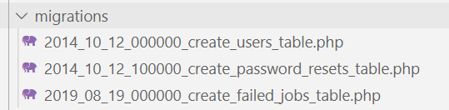
Use these commands to reset cache:
php artisan config:clear
php artisan cache:clear
We need to create a model that represents the student database table schema. The model is responsible for inserting, updating, and deleting data.
To understand how artisan can help us create a model, type:
06
php artisan help make:model
We need to run this command to create a Student model:
07
php artisan make:model Student -m
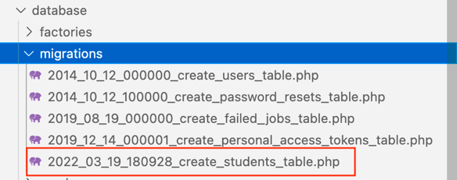
-m means give me a migration
This creates a migration in database/migrations:

The content of this new file is:
<?php

use Illuminate\Database\Migrations\Migration;
use Illuminate\Database\Schema\Blueprint;
use Illuminate\Support\Facades\Schema;
08

return new class extends Migration
{
/**
* Run the migrations.
*
* @return void
*/
public function up()
{
Schema::create('students', function (Blueprint $table) {
$table->id();
$table->timestamps();
});
}

/**
* Reverse the migrations.
*
* @return void
*/
public function down()
{
Schema::dropIfExists('students');
}
};
Add columns FirstName, LastName and School to the Up() method so it looks like this:
public function up() {
Schema::create('students', function (Blueprint $table) {
$table->id();
$table->string('FirstName');
09
$table->string('LastName');
$table->string('School');
$table->timestamps();
});
}
To apply the migrations, type:
php artisan migrate
10
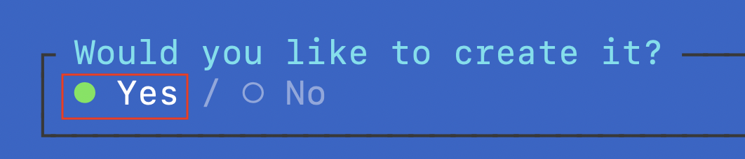
You will notice Student.php in folder: app >> Models:
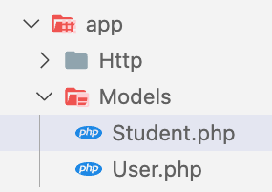
The content of Student.php looks like this:
<?php
namespace App\Models;

use Illuminate\Database\Eloquent\Model;

class Student extends Model
{
//
}
We shall use a utility named tinker to add some dummy data. In a terminal window at the root of the solution, type:
11
php artisan tinker
You can write any PHP command in the tinker command line interface.
To get all the student data, type:
12
\App\Models\Student::all();
The above command returns an empty result-set:
13
=> Illuminate\Database\Eloquent\Collection {#4058
all: [],
}
Let us create some students in the database. Type the following in tinker:
$s1 = new \App\Models\Student();
$s1->FirstName='Ann';
$s1->LastName='Fox';
14
$s1->School='Business';
$s1->save();

$s2 = new \App\Models\Student();
$s2->FirstName='Tom';
$s2->LastName='Lee';
$s2->School='Mining';
$s2->save();

\App\Models\Student::all();
Now we know that we have persisted data in the MySQL database.
= Illuminate\Database\Eloquent\Collection {#5054
all: [
App\Models\Student {#5055
id: 1,
FirstName: "Ann",
LastName: "Fox",
School: "Business",
created_at: "2024-03-21 02:09:56",
updated_at: "2024-03-21 02:09:56",
},
App\Models\Student {#5809
id: 2,
FirstName: "Tom",
LastName: "Lee",
School: "Mining",
created_at: "2024-03-21 02:10:06",
updated_at: "2024-03-21 02:10:06",
},
],
}
To exit tinker, type exit.

Listing students
Add a controller with the following command:
15
php artisan make:controller StudentsController --resource --model=Student
This creates a controller in app/Http/Controllers:
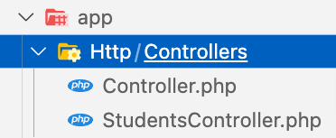
Update index() action method as shown below:
public function index()
16
{
$data = Student::all();
// dd($data);
return view("students.index", ['students' => $data]);
}
Create a folder named layouts under resources/views. In the resources/views/layouts folder, create a file named master.blade.php with the following content:
<!DOCTYPE html>
<html lang="{{ str_replace('_', '-', app()->getLocale()) }}">
<head>
<meta charset="utf-8">
<meta name="viewport" content="width=device-width, initial-scale=1">
<link rel="stylesheet" href="https://cdn.jsdelivr.net/npm/bootstrap@5.1.3/dist/css/bootstrap.min.css" >
<title>Students love Laravel - @yield('title')</title>
</head>
17
<body>
<div class="container">
@yield('content')
</div>
</body>
</html>
Replace content of resources/views/welcome.blade.php with the following:
18
@extends('layouts.master')

@section('content')
<span style="font-size:xx-large;">Laravel with MySQL</span>
@endsection
Create folder resources/views/students.
Create a view file resources/views/students/index.blade.php with the following content:
@extends('layouts.master')

@section('title', 'Students List')

@section('content')
<h1>Students</h1>
19
<table class="table table-striped">
<tr>
<th>ID</th>
<th>Name</th>
<th>School</th>
</tr>
@foreach($students as $item)
<tr>
<td>{{ $item->id }}</td>
<td>{{ $item->FirstName }} {{ $item->LastName }}</td>
<td>{{ $item->School }}</td>
</tr>
@endforeach
</table>
@endsection
Add the following route to routes/Web.php:
20
use App\Http\Controllers\StudentsController;

Route::get('students', [StudentsController::class, 'index'])->name('students.index');
Now if you request the students page at http://localhost:8888/students you should see:
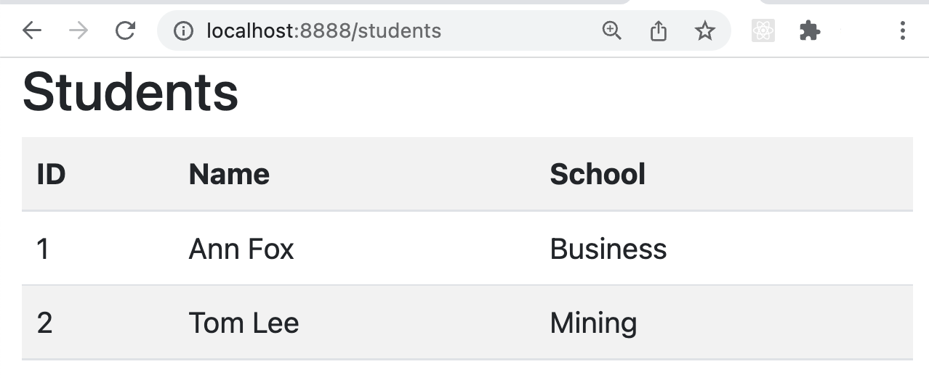
This proves that we can easily read data from our database.

Adding a new student
Add view file resources/views/students/create.blade.php with following content:
@extends('layouts.master')

@section('title', 'Add Student')

@section('content')
21
<div class="row">
<div class="col-lg-12 margin-tb">
<div class="pull-left">
<h2>Add New Student</h2>
</div>
<div class="pull-right">
<a class="btn btn-primary btn-sm" href="{{ route('students.index') }}"> Back</a>
</div>
</div>
</div>

@if ($errors->any())
<div class="alert alert-danger">
<strong>Whoops!</strong> There were some problems with your input.<br><br>
<ul>
@foreach ($errors->all() as $error)
<li>{{ $error }}</li>
@endforeach
</ul>
</div>
@endif

<form action="{{ route('students.store') }}" method="POST">
@csrf

<div class="row">
<div class="col-xs-12 col-sm-12 col-md-12">
<div class="form-group">
<strong>First Name:</strong>
<input type="text" name="FirstName" class="form-control" placeholder="First Name">
</div>
</div>

<div class="col-xs-12 col-sm-12 col-md-12">
<div class="form-group">
<strong>Last Name:</strong>
<input type="text" name="LastName" class="form-control" placeholder="Last Name">
</div>
</div>

<div class="col-xs-12 col-sm-12 col-md-12">
<div class="form-group">
<strong>School:</strong>
<input type="text" name="School" class="form-control" placeholder="School">
</div>
</div>

<div class="col-xs-12 col-sm-12 col-md-12 text-center">
<button type="submit" class="btn btn-primary btn-sm">Submit</button>
</div>
</div>

</form>
@endsection
Modify the create() action method in StudentsController so that it looks like this:
22
public function create() {
return view('students.create');
}
We need one route for /students/create (to display the create form) and another route for /students/store (to submit the create form). Therefore, add the following routes to routes/web.php:
23
Route::get('students/create', [StudentsController::class, 'create'])->name('students.create');
Route::post('students/store', [StudentsController::class, 'store'])->name('students.store');
Point your browser to http://localhost:8888/students/create. You will see this:
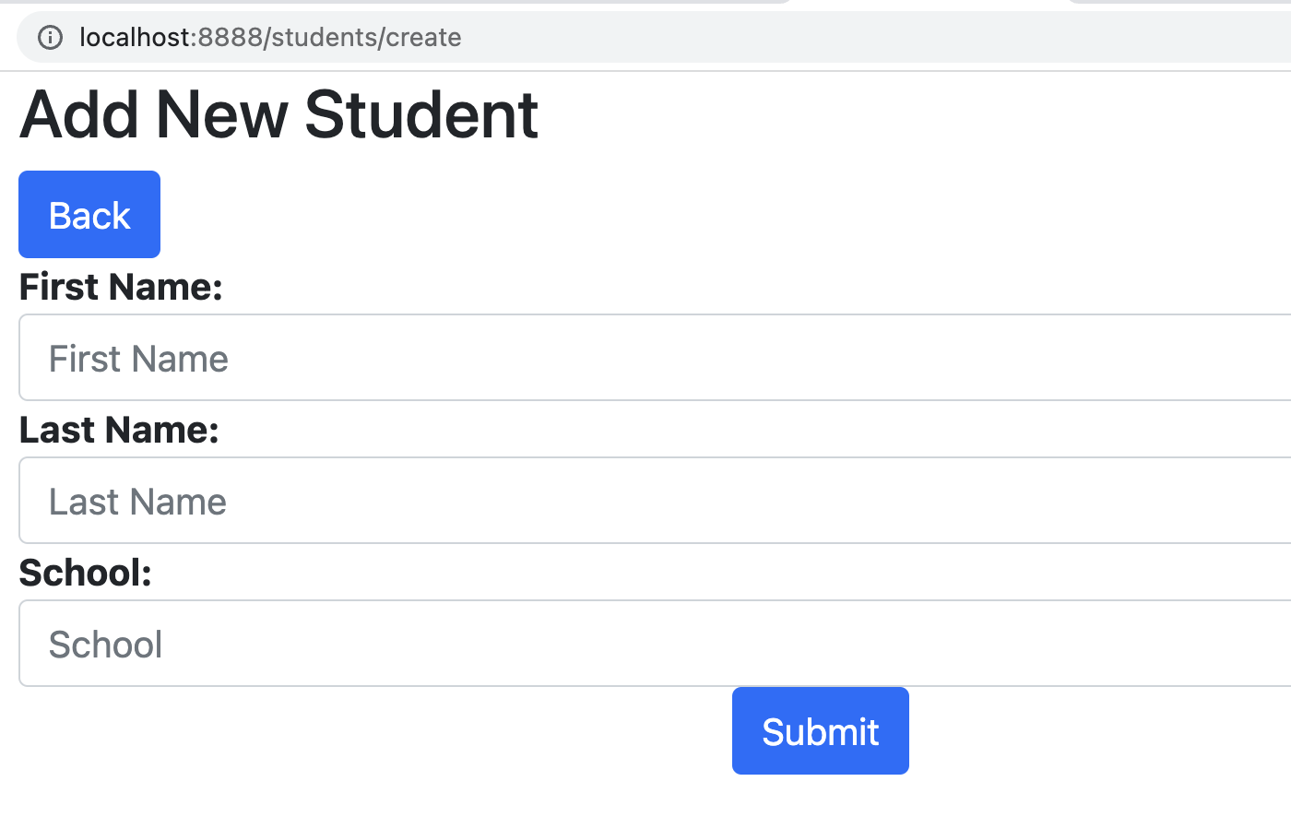
Next, in StudentController, add logic to the store() action method for saving data. Change the store() action method so it looks like this:
public function store(Request $request)
{
// validate the input
$request->validate([
24
'FirstName' => 'required',
'LastName' => 'required',
'School' => 'required',
]);

// create a new student
Student::create($request->all());

// redirect the user to the students list page and send a friendly message
return redirect()->route('students.index')
->with('success','Student created successfully.');
}
There is one more step. Edit app/Models/Student and add the following array to the class definition:
25
protected $fillable = [
'FirstName',
'LastName',
'School'
];
Try adding a student by going to http://localhost:8888/students/create.
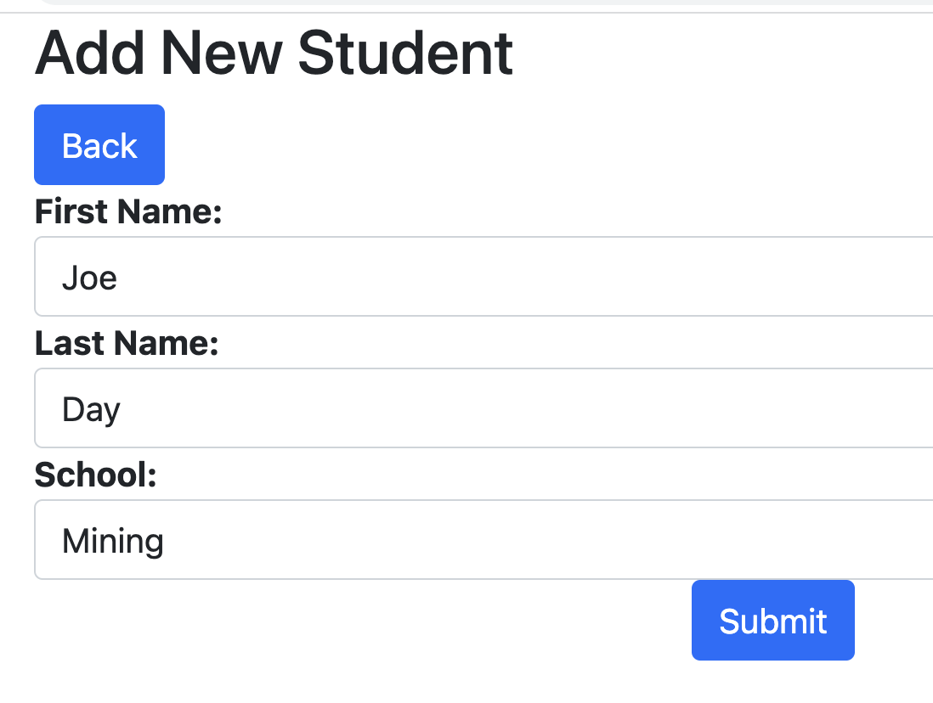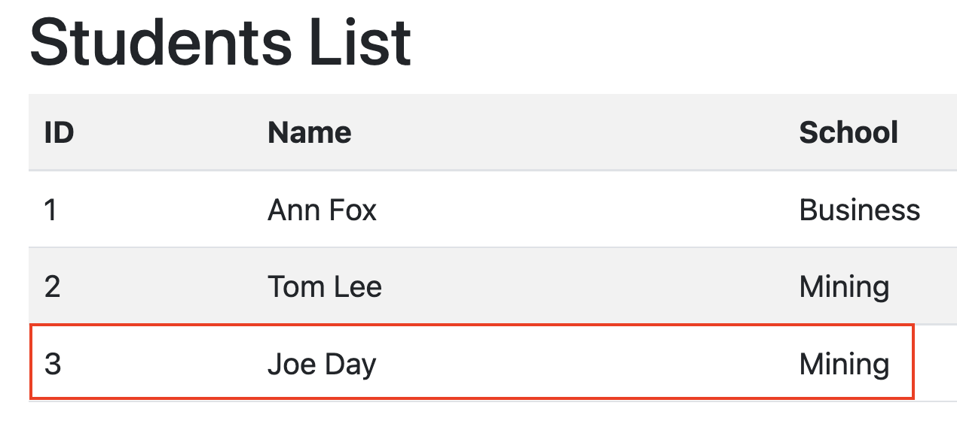
Let us add a Create button and show any alerts. Replace “<h1>Students List</h1>” in resources/views/students/index.blade.php with the following:
<div class="row">
26
<div class="col-lg-12">
<div class="pull-left">
<h2>Students List</h2>
</div>
<div class="pull-right">
<a class="btn btn-success btn-sm" href="{{ route('students.create') }}">
Create New Student
</a>
</div>
</div>
</div>

@if ($message = Session::get('success'))
<div class="alert alert-success">
<p>{{ $message }}</p>
</div>
@endif
Let’s add the remaining routes to match all the action methods in the StudentsController. Add these additional routes to routes/web.php:
27
Route::get('students/show/{id}', [StudentsController::class, 'show'])->name('students.show');
Route::get('students/edit/{id}', [StudentsController::class, 'edit'])->name('students.edit');
Route::put('students/update', [StudentsController::class, 'update'])->name('students.update');
Route::get('students/destroy/{id}', [StudentsController::class, 'destroy'])->name('students.destroy');
Also, add a new column to the table in index.blade.php as follows:
28
<td>
<a class="btn btn-info btn-sm" href="{{ route('students.show',$item->id) }}">Show</a>
<a class="btn btn-primary btn-sm" href="{{ route('students.edit',$item->id) }}">Edit</a>
<a class="btn btn-danger btn-sm" href="{{ route('students.destroy',$item->id) }}">Del</a>
</td>
The /students page now looks like this:
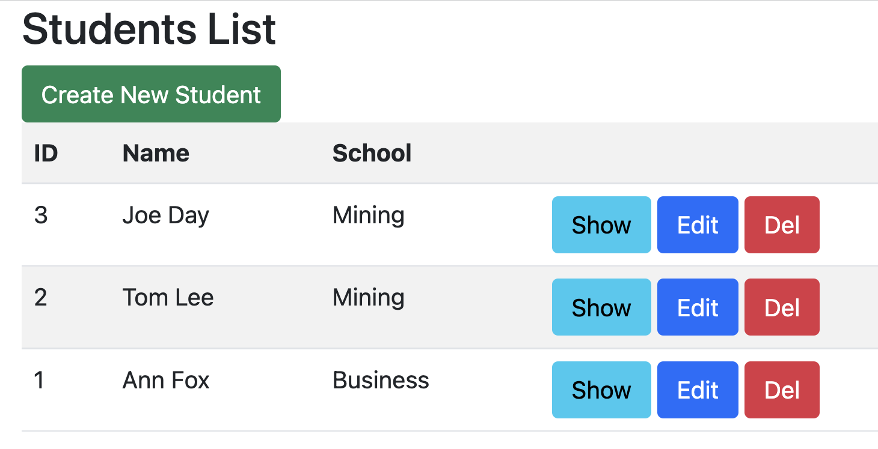
Click on “Create New Student” then click submit without entering any data. You will see validation kick in:
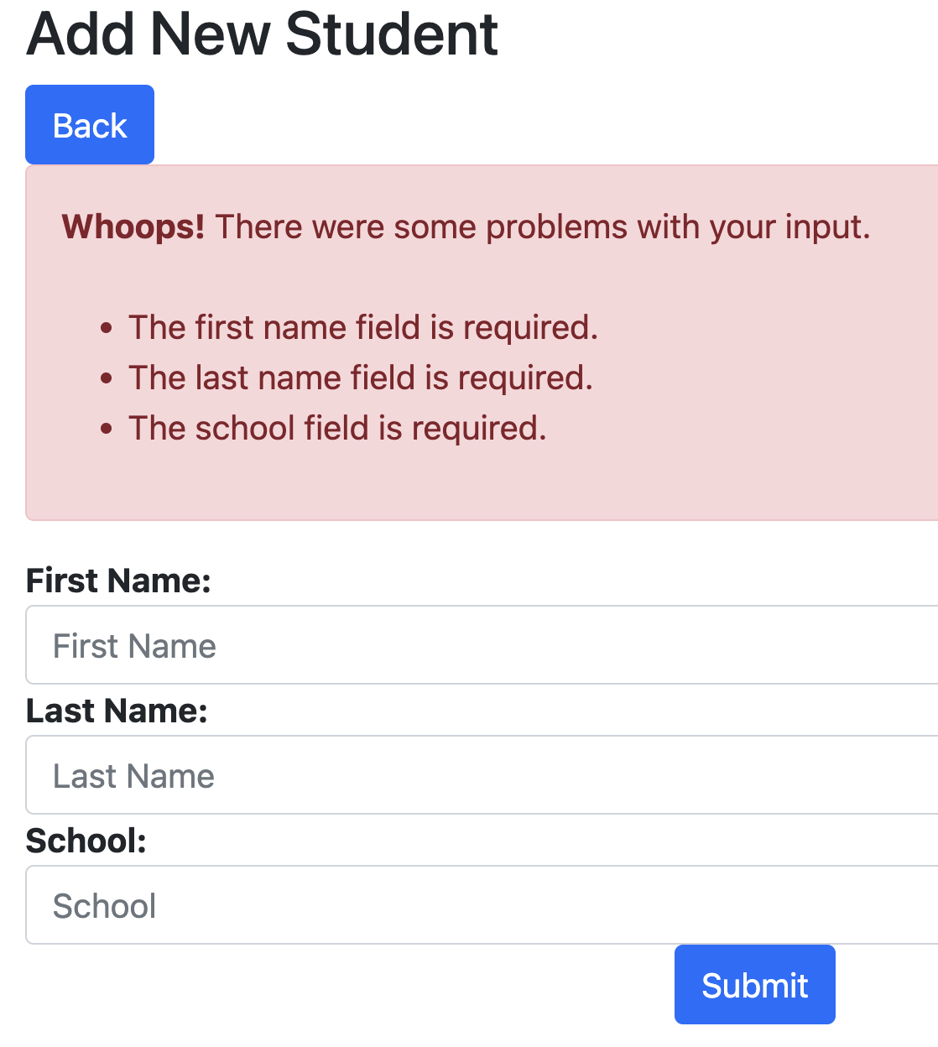
Enter some data, then click on Submit.
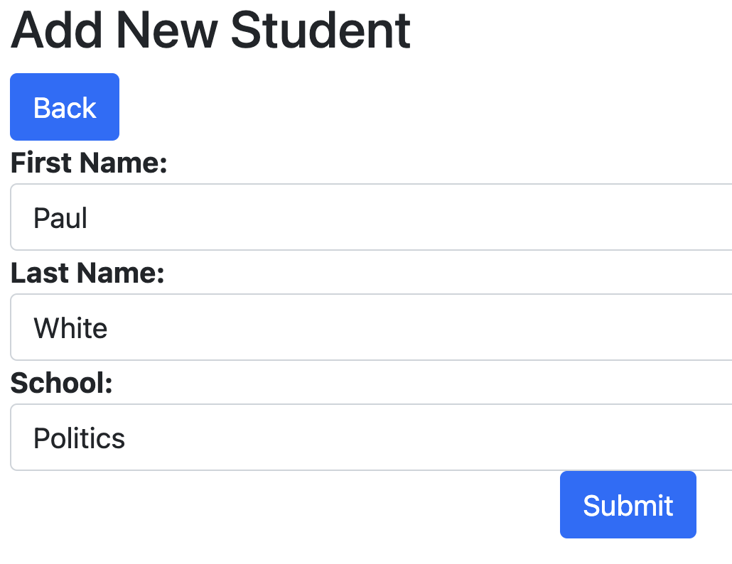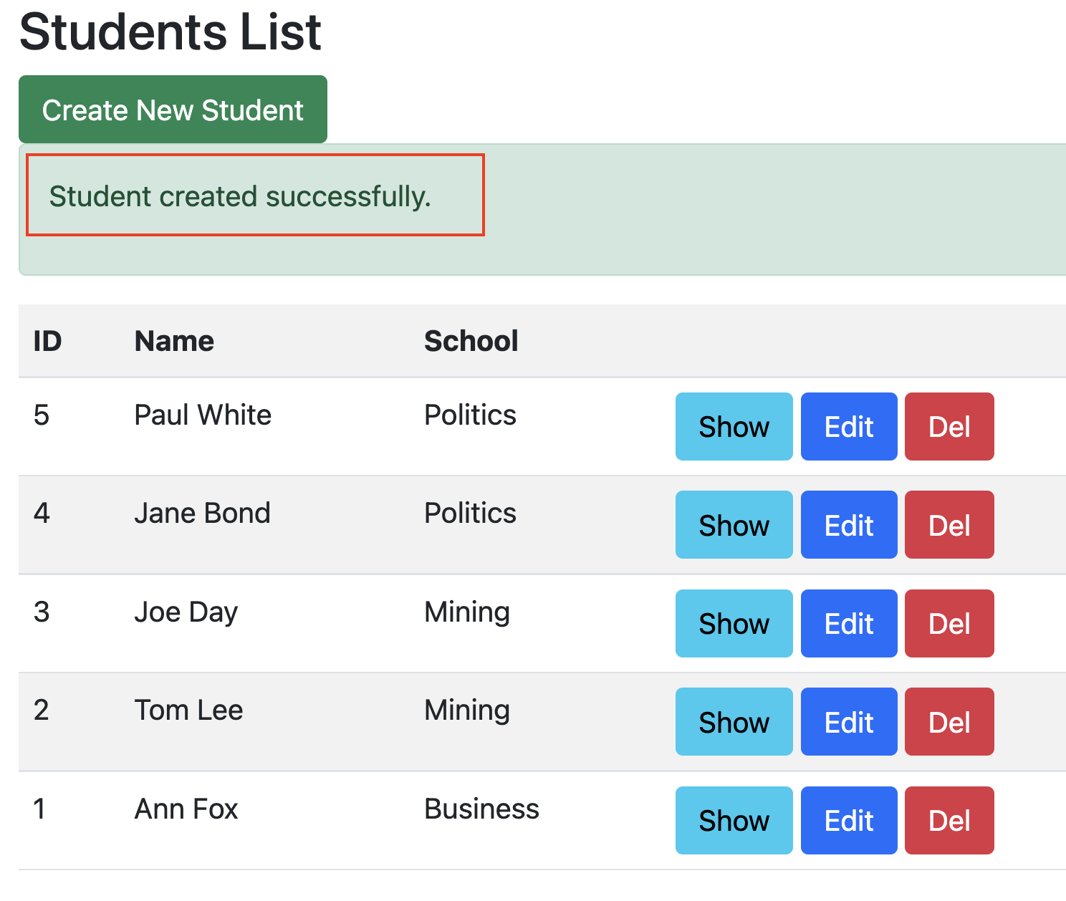
You will see a confirmation message that data was indeed saved.

Adding pagination
Update index() action method in StudentsController so it looks like this:
public function index()
29
{
$data = Student::latest()->paginate(5);
// dd($data);
return view("students.index", ['students' => $data])->with(request()->input('page'));
}
Add this below </table> in resources/views/students/index.blade.php:
30
{{ $students->links() }}
If you exceed 5 students, you will see some pagination kick-in:
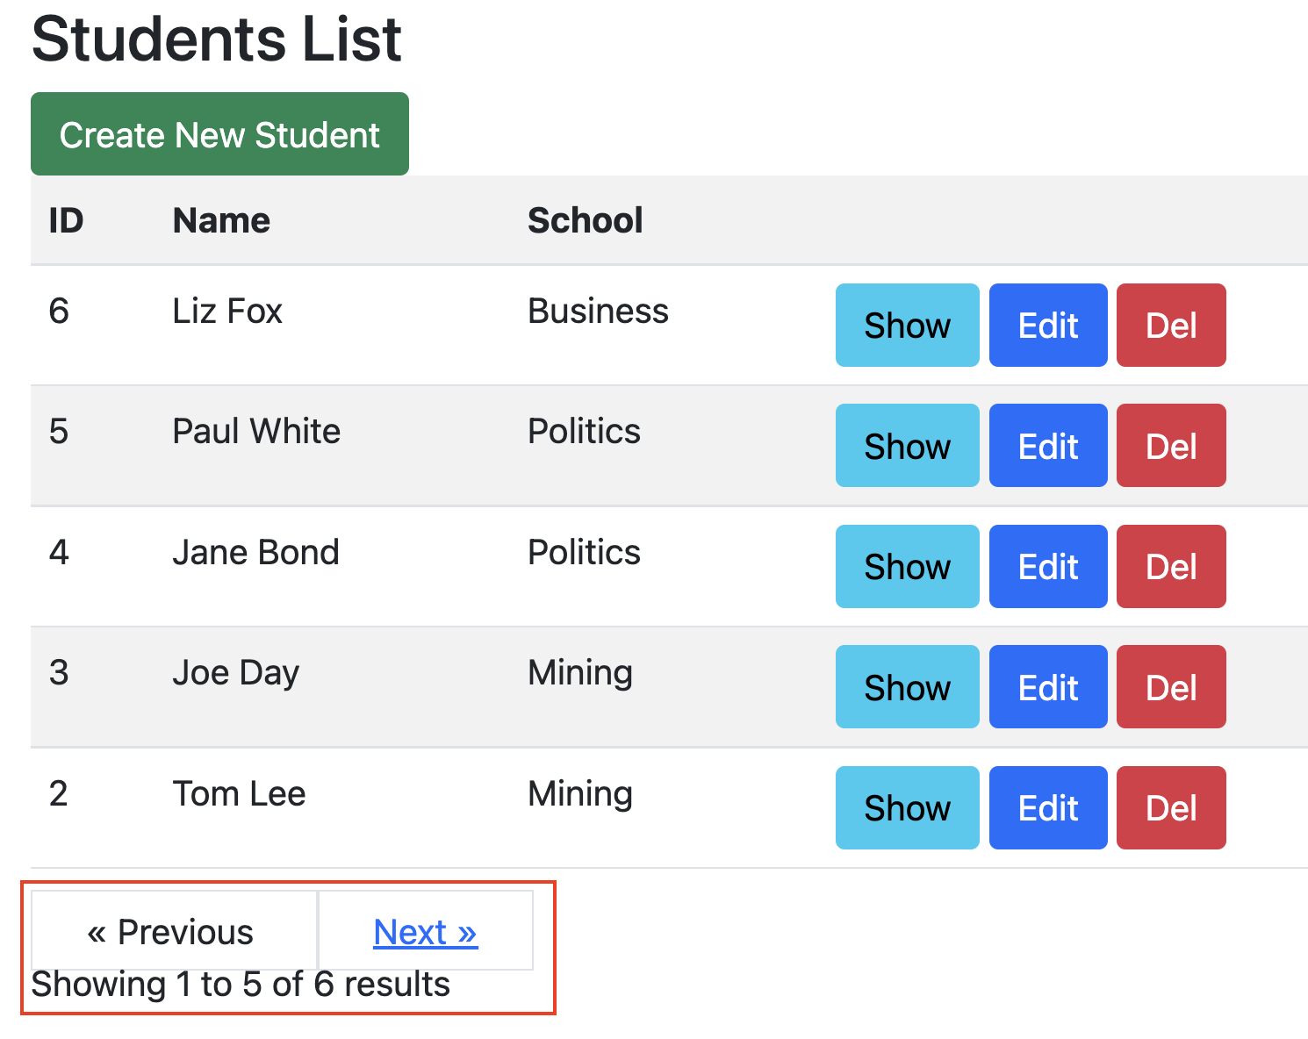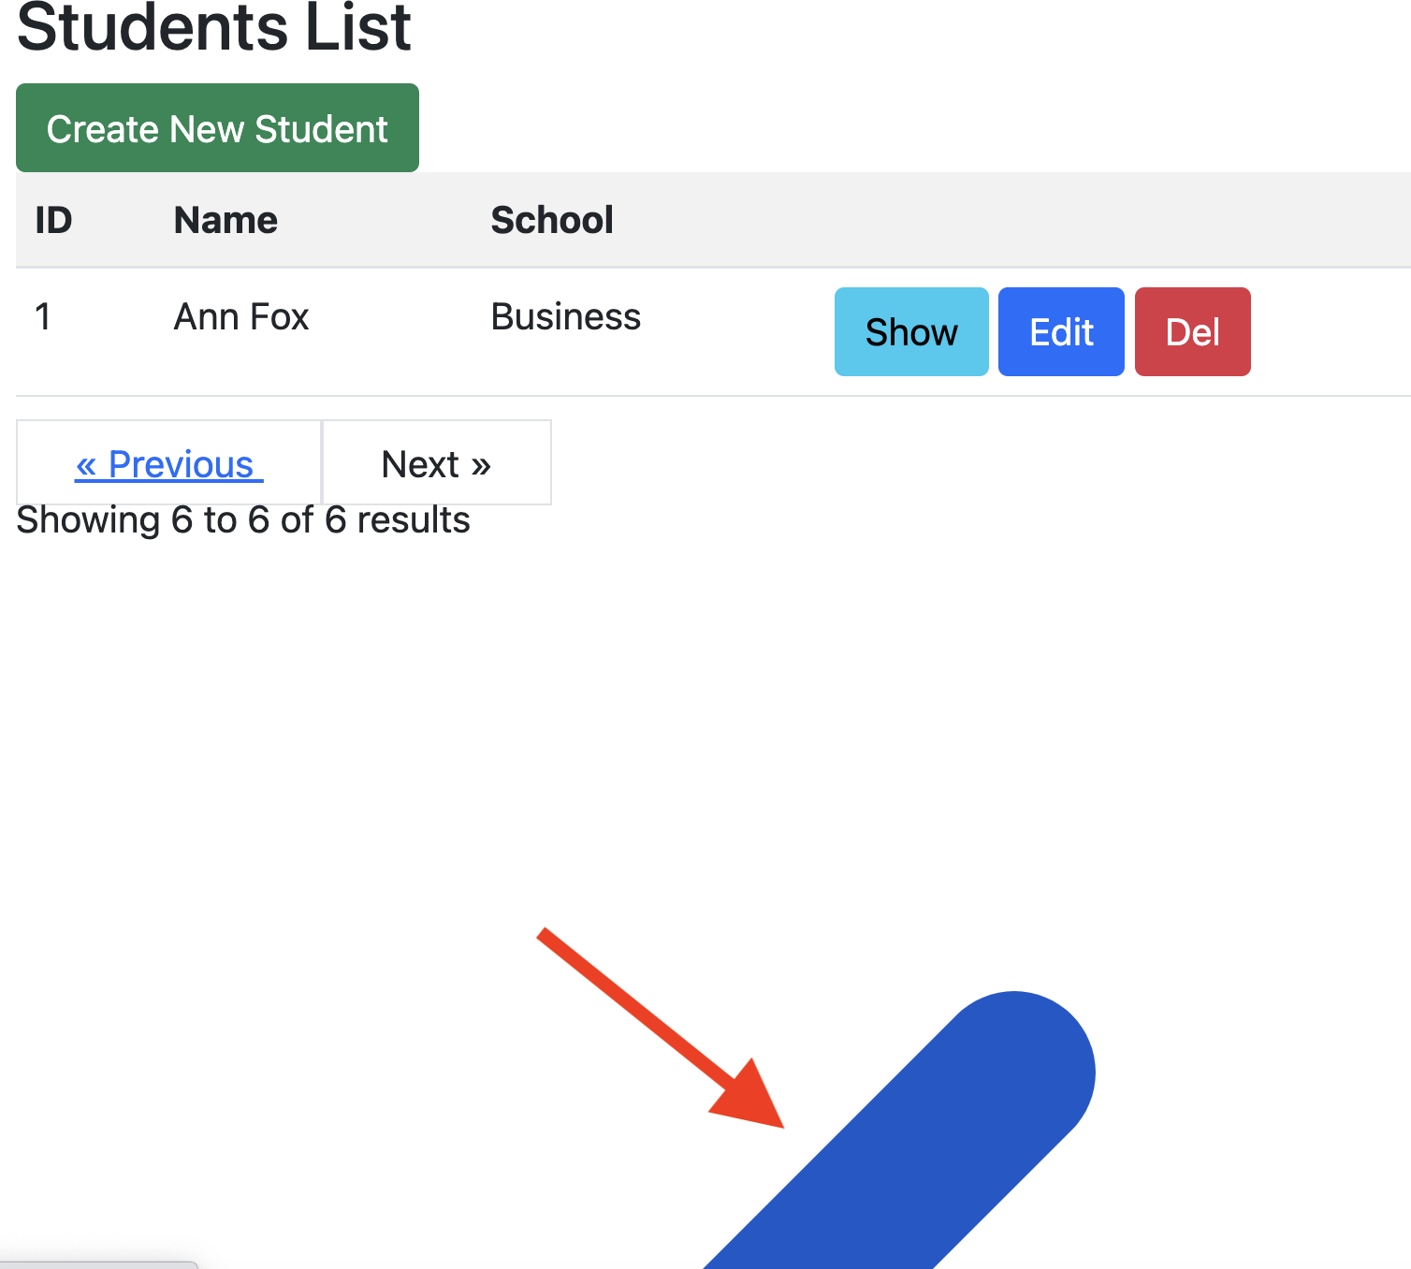
There is something weird on page 2. To fix this, edit app/Providers/AppServiceProvider.php. Add this statement at the top:
31
use Illuminate\Pagination\Paginator;
Add this statement inside the boot() method:
32
Paginator::useBootstrap();
Now the paging behaves much better:
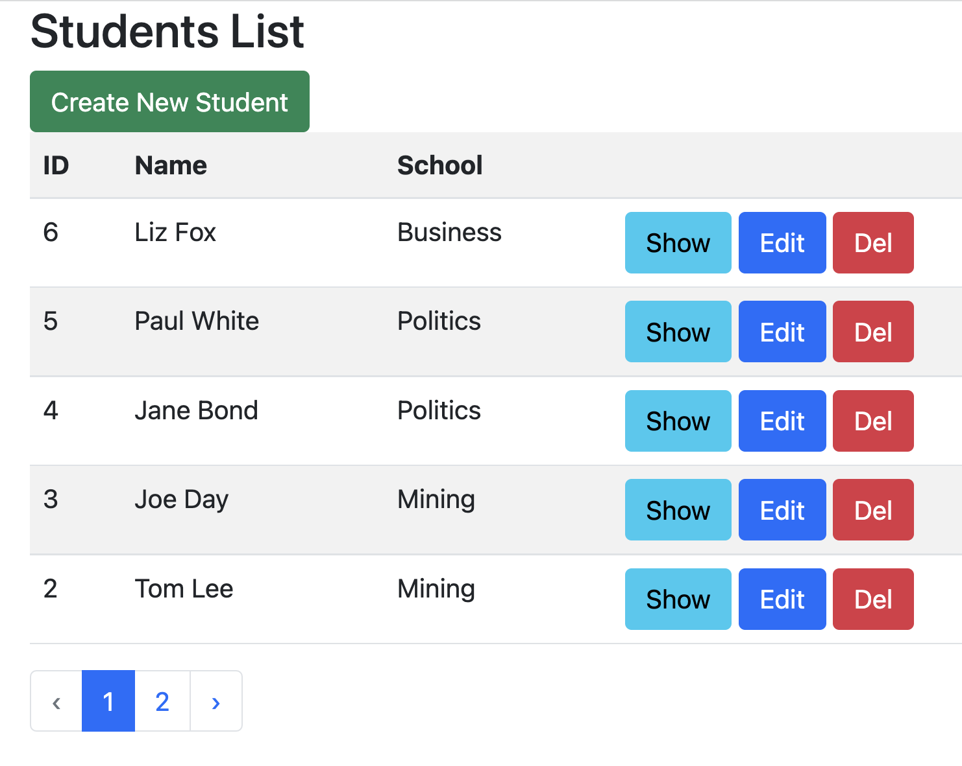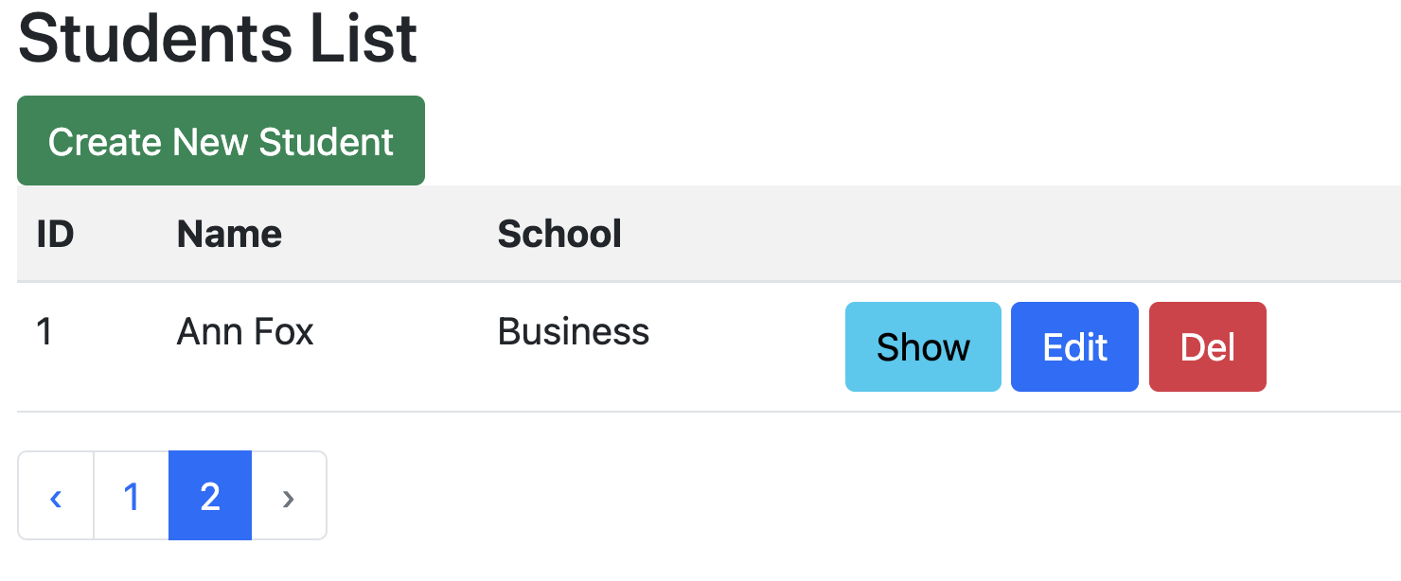

Show student detail
Edit the show() method in the StudentController so it looks like this:
public function show($id) {
33
return view('students.show', [
'student' => Student::findOrFail($id)
]);
}
Next, add view file resources/views/students/show.blade.php with following content:
@extends('layouts.master')
34
@section('title', 'Show Student')

@section('content')
<div class="row">
<div class="col-lg-12 margin-tb">
<div class="pull-left">
<h2>Show Student</h2>
</div>
<div class="pull-right">
<a class="btn btn-primary btn-sm" href="{{ route('students.index') }}">Back</a>
</div>
</div>
</div>

<div class="row">
<div class="col-xs-12 col-sm-12 col-md-12">
<div class="form-group">
<strong>Name:</strong>
{{ $student->FirstName }} {{ $student->LastName }}
</div>
</div>
<div class="col-xs-12 col-sm-12 col-md-12">
<div class="form-group">
<strong>School:</strong>
{{ $student->School }}
</div>
</div>
</div>
@endsection
Try out the show button:
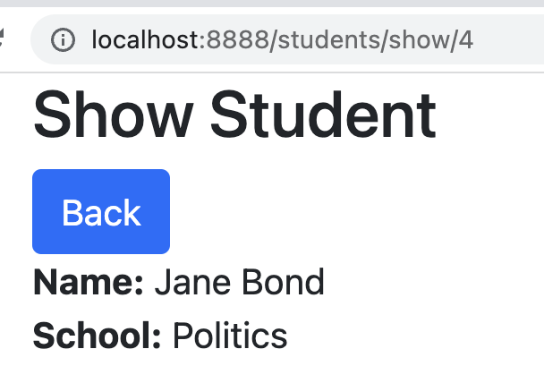

Edit student detail
Add the following to the top of StudentsController. It is used for debugging.
35
use Symfony\Component\Console\Output\ConsoleOutput;
Edit the edit() method in the StudentsController so it looks like this:
36
public function edit($id)
{
return view('students.edit', [
'student' => Student::findOrFail($id)
]);
}
Next, add view file resources/views/students/edit.blade.php with following content:
@extends('layouts.master')
37
@section('title', 'Edit Student')

@section('content')
<div class="row">
<div class="col-lg-12 margin-tb">
<div class="pull-left">
<h2>Edit Student</h2>
</div>
<div class="pull-right">
<a class="btn btn-primary" href="{{ route('students.index') }}"> Back</a>
</div>
</div>
</div>

@if ($errors->any())
<div class="alert alert-danger">
<strong>Whoops!</strong> There were some problems with your input.<br><br>
<ul>
@foreach ($errors->all() as $error)
<li>{{ $error }}</li>
@endforeach
</ul>
</div>
@endif

<form action="{{ route('students.update',$student->id) }}" method="POST">
@csrf
@method('PUT')

<input type="hidden" name="id" value="{{ $student->id }}" />
<div class="row">
<div class="col-xs-12 col-sm-12 col-md-12">
<div class="form-group">
<strong>First Name:</strong>
<input type="text" name="FirstName" value="{{ $student->FirstName }}" class="form-control" placeholder="First Name">
</div>
</div>

<div class="col-xs-12 col-sm-12 col-md-12">
<div class="form-group">
<strong>Last Name:</strong>
<input type="text" name="LastName" value="{{ $student->LastName }}" class="form-control" placeholder="Last Name">
</div>
</div>

<div class="col-xs-12 col-sm-12 col-md-12">
<div class="form-group">
<strong>School:</strong>
<input type="text" name="School" value="{{ $student->School }}" class="form-control" placeholder="School">
</div>
</div>

<div class="col-xs-12 col-sm-12 col-md-12 text-center">
<button type="submit" class="btn btn-primary btn-sm">Update</button>
</div>
</div>

</form>
@endsection
Edit the update() method in the StudentsController so it looks like this:
public function update(Request $request, Student $student) {
// Validation for required fields (and using some regex to validate our numeric value)
$request->validate([
'id' => 'required',
'FirstName' => 'required',
38
'LastName' => 'required',
'School' => 'required',
]);
$student = Student::find($request->get('id'));

// this can be used for debugging
// it displays in the console
$output = new ConsoleOutput();
$output->writeln("STUDENT OBJECT: " . $student);

// Getting values from the blade template form
$student->FirstName = $request->get('FirstName');
$student->LastName = $request->get('LastName');
$student->School = $request->get('School');
$student->save();

return redirect()->route('students.index')
->with('success','Student updated successfully');
}
Try out the edit button:
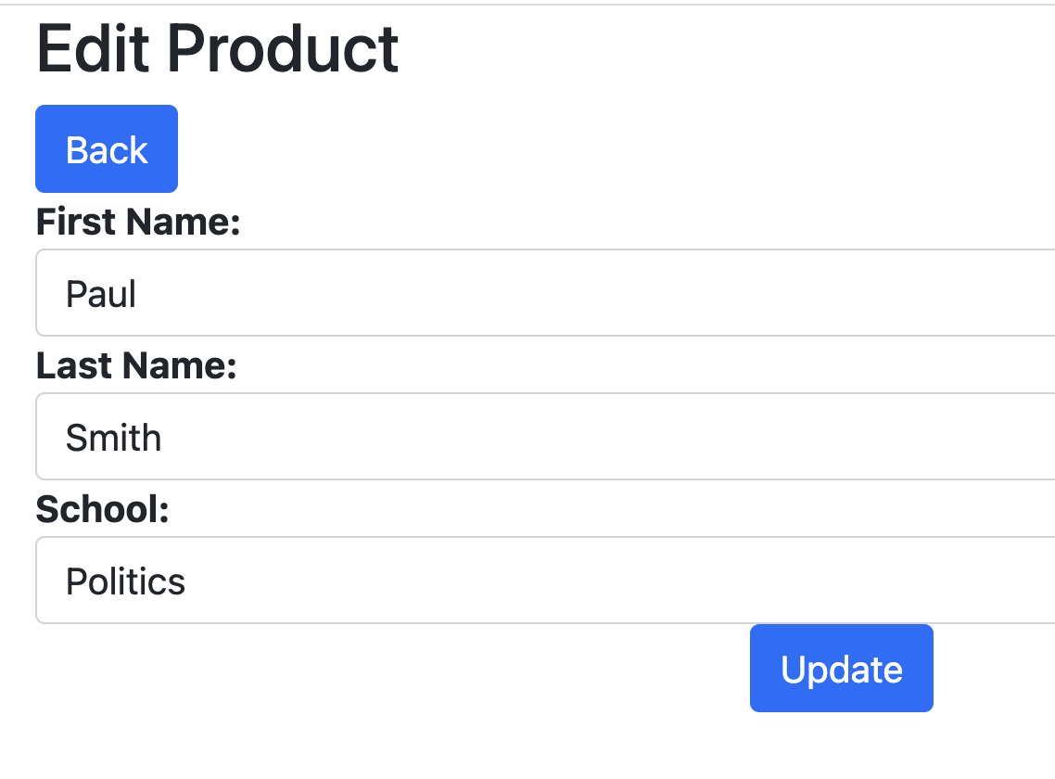
Note this debug information in the terminal window:
Debug information was generated by the following code in the update() method:
// this can be used for debugging
// it displays in the console
$output = new ConsoleOutput();
$output->writeln("STUDENT OBJECT: " . $student);

Delete student
Edit the destroy() method in the StudentsController so it looks like this:
public function destroy($id) {
39
// find the student
$student = Student::find($id);
// delete the student
$student->delete();
// redirect to students list page
return redirect()->route('students.index')
->with('success','Student deleted successfully');
}
Try it out, when you click on the delete button, the student is dropped from the list.

Refresh the database
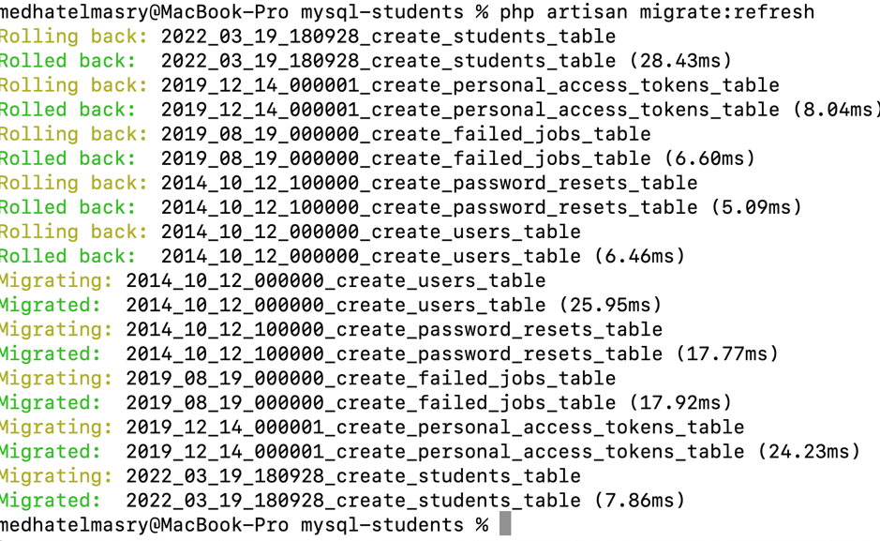
To drop all the tables in the database and re-apply the migrations, you can execute this command:
php artisan migrate:refresh
Output will look like this:

Creating seed data
40
To create a seeder:
php artisan make:seeder StudentSeeder
This creates a new StudentSeeder.php file in database/seeders folder that looks like this:
<?php
41

namespace Database\Seeders;

use Illuminate\Database\Console\Seeds\WithoutModelEvents;
use Illuminate\Database\Seeder;

class StudentSeeder extends Seeder
{
/**
* Run the database seeds.
*/
public function run(): void
{
//
}
}
Place the following code inside the run() method:
$s1 = new \App\Models\Student([
'FirstName' => 'Tom',
'LastName' => "Max",
42
'School' => 'Nursing'
]);
$s1->save();

$s2 = new \App\Models\Student([
'FirstName' => 'Ann',
'LastName' => "Fay",
'School' => 'Mining'
]);
$s2->save();

$s3 = new \App\Models\Student([
'FirstName' => 'Joe',
'LastName' => "Sun",
'School' => 'Nursing'
]);
$s3->save();

$s4 = new \App\Models\Student([
'FirstName' => 'Sue',
'LastName' => "Fox",
'School' => 'Computing'
]);
$s4->save();

$s5 = new \App\Models\Student([
'FirstName' => 'Ben',
'LastName' => "Ray",
'School' => 'Mining'
]);
$s5->save();

$s6 = new \App\Models\Student([
'FirstName' => 'Zoe',
'LastName' => "Cox",
'School' => 'Business'
]);
$s6->save();
Edit the DatabaseSeeder.php file and add the following code to the run() method:
43
$this->call(StudentSeeder::class);
Run the following command from a terminal window:
44
php artisan migrate:refresh --seed
Output will look like this:
Rolling back: 2022_03_19_180928_create_students_table
Rolled back: 2022_03_19_180928_create_students_table (11.01ms)
Rolling back: 2019_12_14_000001_create_personal_access_tokens_table
Rolled back: 2019_12_14_000001_create_personal_access_tokens_table (6.17ms)
Rolling back: 2019_08_19_000000_create_failed_jobs_table
Rolled back: 2019_08_19_000000_create_failed_jobs_table (4.41ms)
Rolling back: 2014_10_12_100000_create_password_resets_table
Rolled back: 2014_10_12_100000_create_password_resets_table (3.72ms)
Rolling back: 2014_10_12_000000_create_users_table
Rolled back: 2014_10_12_000000_create_users_table (6.59ms)
Migrating: 2014_10_12_000000_create_users_table
Migrated: 2014_10_12_000000_create_users_table (12.91ms)
Migrating: 2014_10_12_100000_create_password_resets_table
Migrated: 2014_10_12_100000_create_password_resets_table (13.22ms)
Migrating: 2019_08_19_000000_create_failed_jobs_table
Migrated: 2019_08_19_000000_create_failed_jobs_table (13.41ms)
Migrating: 2019_12_14_000001_create_personal_access_tokens_table
Migrated: 2019_12_14_000001_create_personal_access_tokens_table (20.10ms)
Migrating: 2022_03_19_180928_create_students_table
Migrated: 2022_03_19_180928_create_students_table (4.28ms)
Seeding: Database\Seeders\StudentSeeder
Seeded: Database\Seeders\StudentSeeder (20.45ms)
Database seeding completed successfully.
Start the web server:
45
php artisan serve --port 8888
http://localhost:8888/students shows the seeded data:
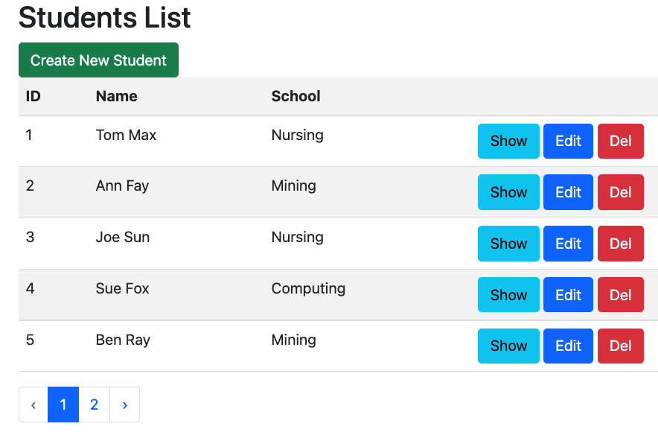

Seeding random data
46
php artisan make:factory StudentFactory
This creates database/factories/StudentFactory.php that looks like this:
<?php

namespace Database\Factories;

use Illuminate\Database\Eloquent\Factories\Factory;

/**
* @extends \Illuminate\Database\Eloquent\Factories\Factory<\App\Models\Student>
*/
class StudentFactory extends Factory
{
/**
47
* Define the model's default state.
*
* @return array<string, mixed>
*/
public function definition(): array
{
return [
//
];
}
}
Update the definition method so that it looks like this:
public function definition(): array
{
return [
48
'FirstName' => $this->faker->firstName(),
'LastName' => $this->faker->lastName(),
'School' => $this->faker->company(),
];
}
These are the fake data types:
Base
Lorem Ipsum Text
Person
Address
Phone Number
Company
Real Text
49
Date and Time
Internet
User Agent
Payment
Color
File
Image
Uuid
Barcode
Miscellaneous
Biased
Html Lorem
Reference: https://github.com/fzaninotto/Faker
There is no built-in faker data for school, so we will use company instead.
Back in database/seeders/DatabaseSeeder.php, comment out the following statement:
50
//$this->call(StudentSeeder::class);
Add this code instead to create 20 fake rows of data:
51
\App\Models\Student::factory(20)->create();
Edit app/Models/Student.php.
52
- Add this import: use Illuminate\Database\Eloquent\Factories\HasFactory;
- Add this above “protected $fillable” : use HasFactory;
Re-seed the database with data by running the following terminal command:
53
php artisan migrate:refresh --seed
Start the web server:
54
php artisan serve --port 8888
http://localhost:8888/students shows seeded data like the following:
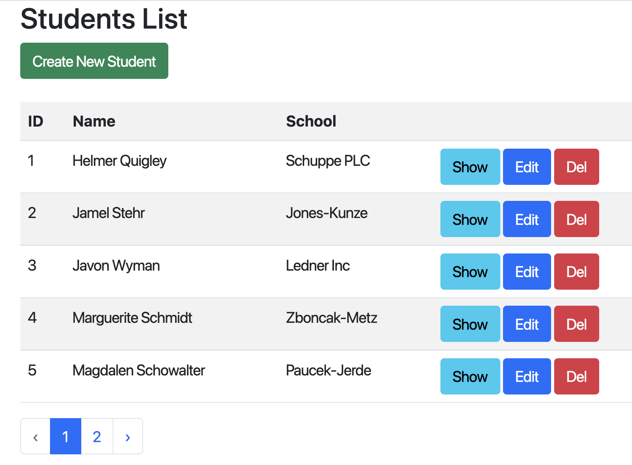
Finally, add the following link to the home page welcome.blade.php just below </span>:
<p>
55
<a href="{{ route('students.index') }}">Students</a>
</p>
