Azure Static Web Apps

Azure Static Web Apps enables developers to build and deploy full stack web applications automatically to Azure through a code repository. Azure Static Web Apps support numerous languages, frameworks, and libraries like Vue, Svelte, React, and Angular.
When using Azure Static Web Apps, the APIs that serve single-page-application (SPAs) are based on Azure Server-less Functions.
In this tutorial, we will develop an Azure Static Web Apps solution where the SPA is React.js.
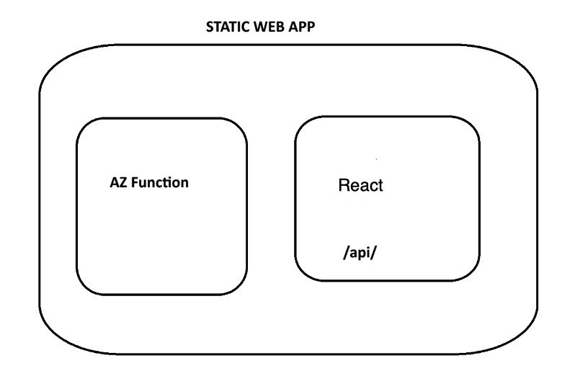

The DB
01
Start a SQL Server Docker container with:
docker run --cap-add SYS_PTRACE -e ACCEPT_EULA=1 -e MSSQL_SA_PASSWORD=SqlPassword! -p 1444:1433 --name sqldb -d mcr.microsoft.com/mssql/server:2022-latest
Add database named SchoolDB and table named Students with sample data using SQL code from this GitHub gist:
https://gist.github.com/medhatelmasry/182606844744bbe7270bb8e3a05b23dd

Getting Started
Create a folder named ts-static-web-app. Inside that folder, extract these two files:
02
AzFunctionsTS.zip
student-management-ts.zip
Rename folder AzFunctionsTS to backend.
Rename folder student-management-ts to frontend.

The directory structure will now look like this:
ts-static-web-app
|
03
|------------- backend
|------------- frontend

In the backend folder, run the following command:
04
npm install
npm run build
func start
In the frontend folder, run the following command:
05
npm install
npm run dev
Note this code in frontend/src/services/api.ts:
// Determine which API URL to use based on the current hostname
const isLocalhost = window.location.hostname === 'localhost' ||
06
window.location.hostname === '127.0.0.1';

const BASE_URL = isLocalhost
? import.meta.env.VITE_LOCAL_API_URL
: (import.meta.env.VITE_AZURE_API_URL || '/api');
Test that both the backend and frontend app can work together.
Delete the .git folder in the backend app if it exists. While in the ts-static-web-app folder, push the entire solution to GitHub.
Azure Static Web Apps will put the Azure Functions App and React.js SPA in the same website.

Azure Static Web Apps
Login into your Azure portal at https://portal.azure.com. Click on “Create a resource”.
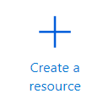
In the filter field, enter the phrase static, then choose “Static Web App”.
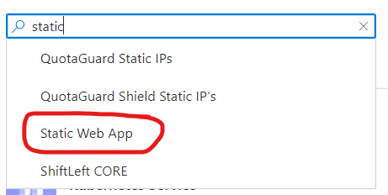
Click on Create.
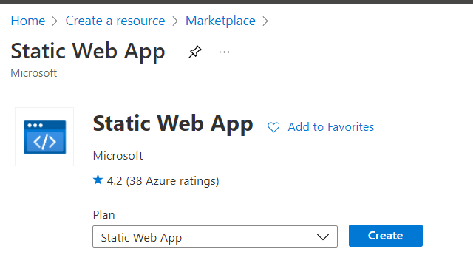
- Choose a subscription
- Create a new Resource Group
- Enter a unique name for the application
- Choose “Free: For hobby or personal projects” for Plan Type
- Choose “West US 2” data center close to you
- For deployment details, choose GitHub and “Sign in with GitHub”
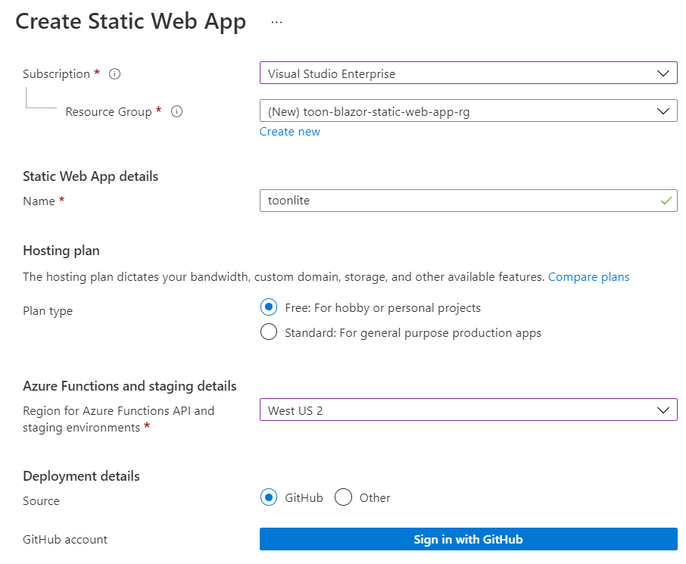
After your login into GitHub, make sure you choose the following settings:
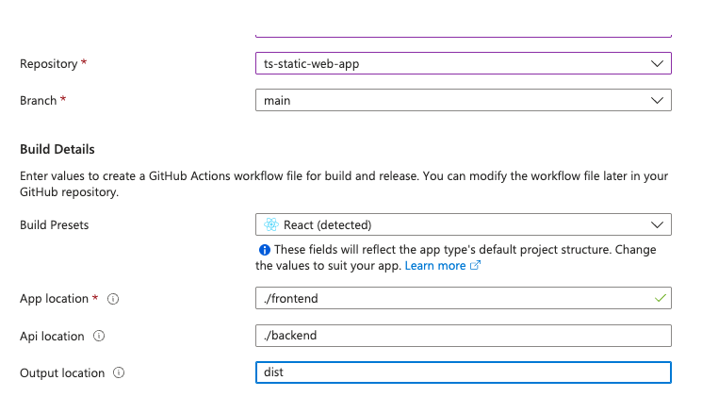
Click on “Review + create”.
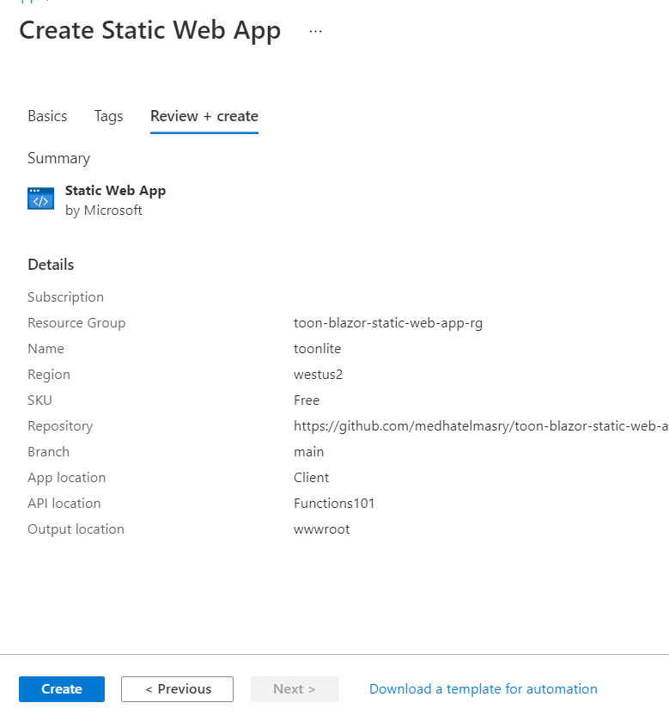
The provisioning process does not take long. Once it is complete, click on “Go to resource” to go to the main app blade.
Click on “Settings >> Environment variables” on the left-side.
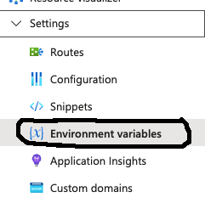
07
Add this database connection string environment variable:
Name | Value
DATABASE_CONNECTION_STRING | Server=tcp:static-web-apps-db-server.database.windows.net,1433;Initial Catalog=static-web-apps-lesson;Persist Security Info=False;uid=static-web-apps;pwd=DB0admin-user;MultipleActiveResultSets=False;Encrypt=True;TrustServerCertificate=False;Connection Timeout=30;
If you visit your GitHub repo, you should find that the app was deployed to Azure.
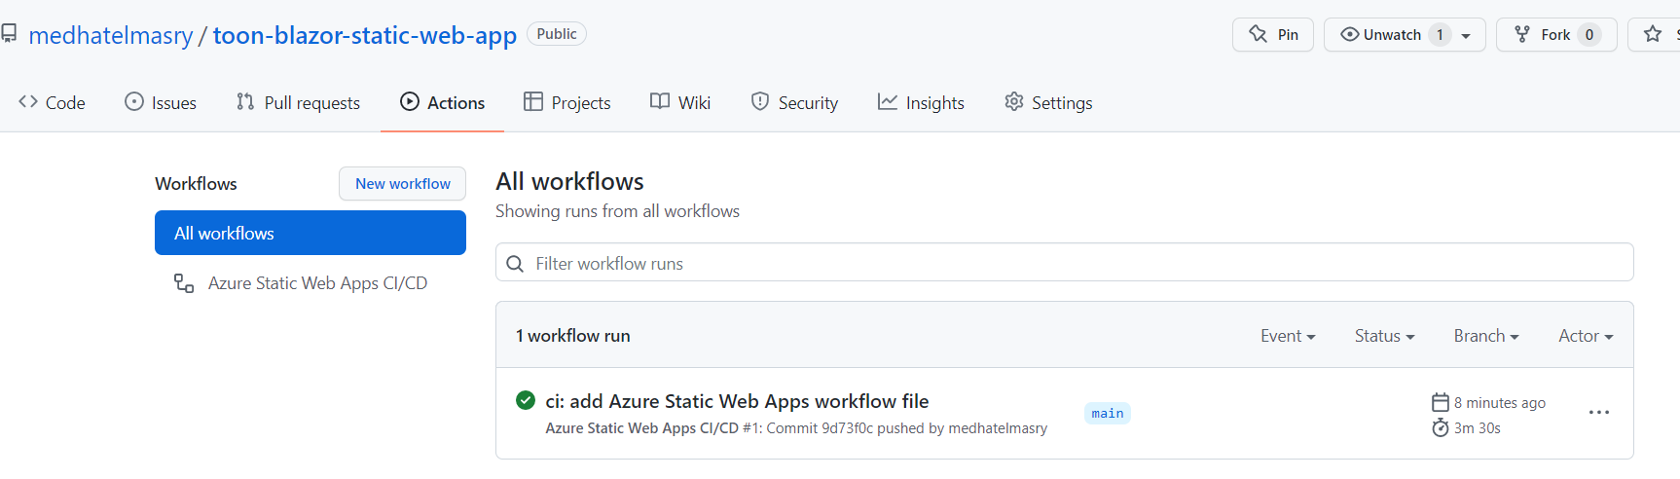
The build process may fail with this error:
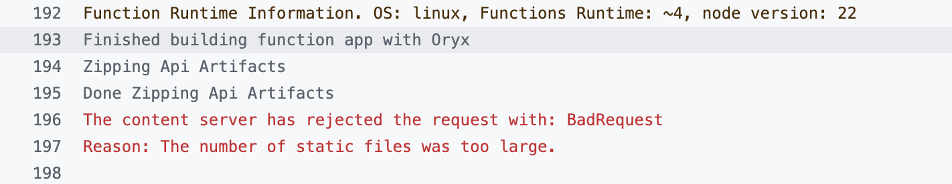
08
If that happens, make a pull of your source code. This gets the GitHub Actions .yml file and puts it into the .github/workflows folder. Edit the .yml file and add this right after: output_location: "dist"
skip_app_build: false
skip_api_build: false
# Add the following configuration to skip unnecessary files
app_build_command: "npm run build:ci"
Push your code to GitHub. This time the build and deployment should be successful.
Back in Azure, click on the site URL.
