ASP.NET MVC Code – Database First

Code Generator
Installing the code generator globally:
dotnet tool install -g dotnet-aspnet-codegenerator
You can then generate artifacts like this:
Help | dotnet aspnet-codegenerator -h
Add Controller Help | dotnet aspnet-codegenerator controller -h
Add ProcessController | dotnet aspnet-codegenerator controller -name ProcessController -outDir Controllers
Add PeopleController with views | dotnet aspnet-codegenerator controller -name PeopleController -outDir Controllers -m Person -dc ApplicationDbContext --useDefaultLayout
Add API PeopleController | dotnet aspnet-codegenerator controller -name PeopleController -outDir Controllers\api -m Person -dc ApplicationDbContext -actions -api

Let us start
mkdir AspDb
cd AspDb
dotnet new mvc --auth individual --use-local-db
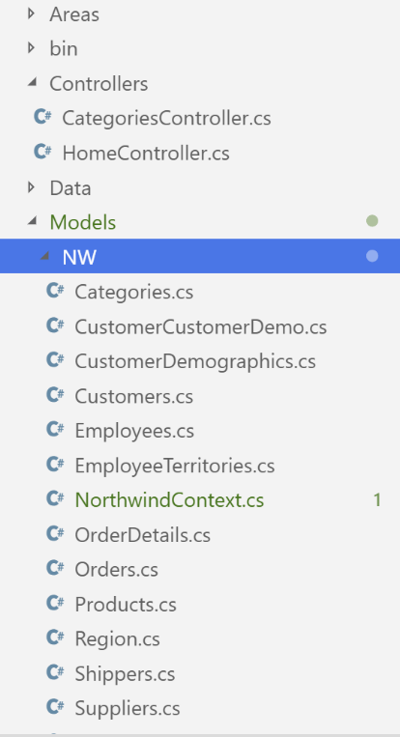
dotnet-ef dbcontext scaffold "Data Source=max.bcit.ca;Database=Northwind;Persist Security Info=True;User ID=nw;Password=N0rthG@te;" Microsoft.EntityFrameworkCore.SqlServer -c NorthwindContext -o Models/NW
NOTE: On Mac computers, you must replace " with '
In order to automatically generate controllers and views, you need to add this package you your application:
dotnet add package Microsoft.VisualStudio.Web.CodeGeneration.Design
The following code will generate the controllers and views for the Categories table in the Northwind database:
dotnet aspnet-codegenerator controller -name CategoriesController -outDir Controllers -m Categories -dc NorthwindContext –udl -scripts
I had a problem with this command when trying it out in the online lesson because I had an older version of the code generator. I needed to update it with this command:
dotnet tool update -g dotnet-aspnet-codegenerator

Start VS Code by typing the following in the terminal window:
code .
In appsettings.json, add this to ConnectionStrings block:
"NW": "Data Source=max.bcit.ca;Database=Northwind;Persist Security Info=True;User ID=nw;Password=N0rthG@te;"
Add the following to ConfigureServices() method in Startup.cs:
services.AddDbContext<NorthwindContext>(options => options.UseSqlServer(Configuration.GetConnectionString("NW")));
NOTE: You must resolve the NorthwindContext class. Do this by hitting CTRL + . on the keyboard.
Add “Categories” button to main menu. This is done by adding following to Views/Shared/_Layout.cshtml file to <ul> around line 27:
<li class="nav-item">
<a class="nav-link text-dark" asp-area="" asp-controller="Categories" asp-action="Index">Categories</a>
</li>
NOTE: It is bad practice for the connection string to be hard-coded in the Models/NW/NorthwindContext class in the OnConfiguring() method. This needs to be read from appsettings.json. Now that we pass the options (that includes the connection string) through the constructor, you can delete the entire OnConfiguring() method in Models/NW/NorthwindContext.cs.
Also, add appsettings.json to .gitignore so that this file does not find its way to any source code repo where the confidential connection string will be compromised when viewed by the public.

dotnet build
dotnet watch run
Go to https://localhost:5001/categories or click on the Categories link on the main menu.
Note that there are two separate database contexts:
ApplicationDbContext | Used for user authentication in a local database
NorthwindContext | Used to access the remote Northwind database
Stop the server by typing CTRL + C in the terminal window.
Generate an API for Products with the following command:
dotnet aspnet-codegenerator controller -name ProductsController -outDir Controllers\api -m Products -dc NorthwindContext -actions -api
dotnet build
dotnet watch run
Go to https://localhost:5001/api/products

