React Chrome Extension
Got to Chrome Web Store:
https://chrome.google.com/webstore

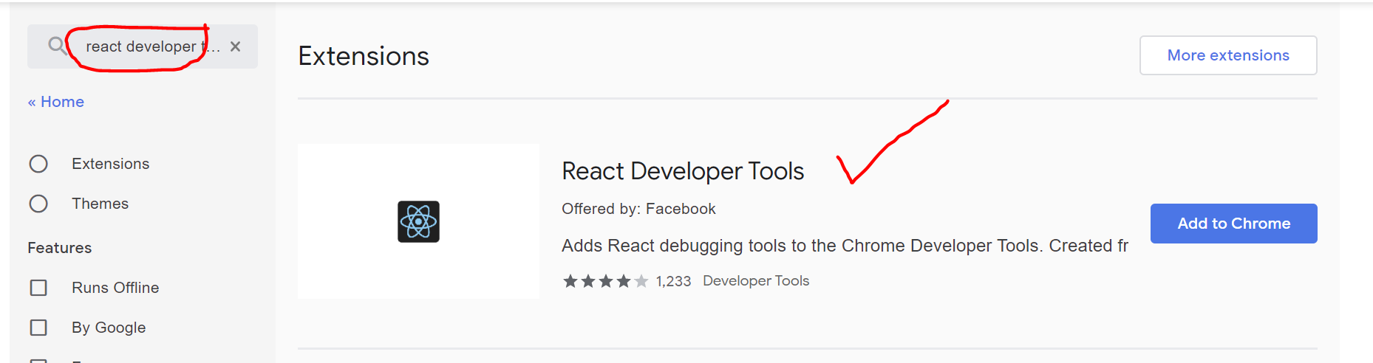
In Chrome, go to Settings >> Extensions >> React Developer Tools >> Details button
Turn “Allow access to file URLs” to ON.
This is where React Developer Tools will be found in your browser:
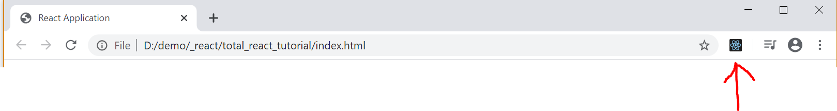
In Chrome Developer Tools you will find two new React specific tabs:
