Intro to React with Vite & Typescript
https://apipool.azurewebsites.net/api/students

Getting Started
We will generate a Typescript React application using the Vite template generator:
01
npm create vite@latest students-react-ts -- --template react-ts
cd students-react-ts
npm install
npm run dev
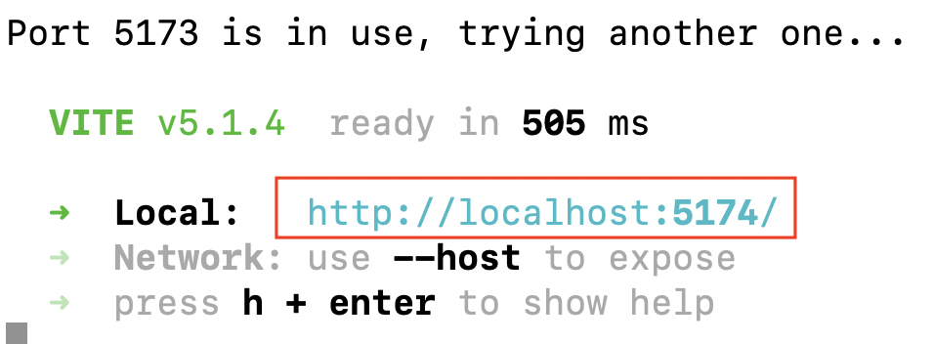
NOTE: You can use the following command to start the app in your default browser:

npm run dev -- --open
Point your browser to the address displayed. This is what the page looks like:

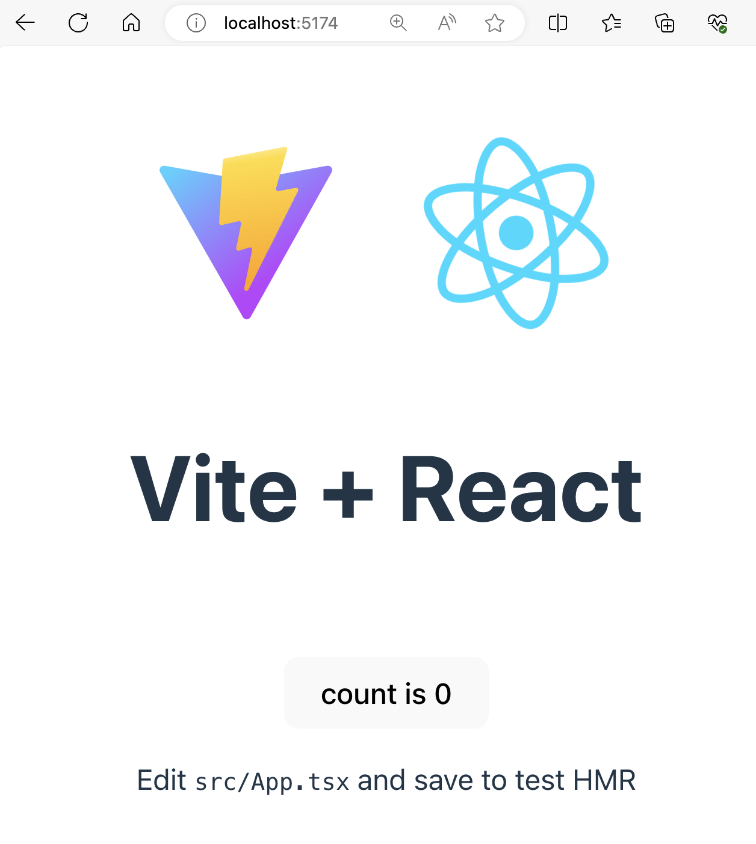
Make these changes to tsconfig.app.json:
"verbatimModuleSyntax": false
"erasableSyntaxOnly": false
Install the following packages:
02
npm install react-router-dom@6.21.1
npm install bootstrap@5.3.3 -D
Open application in VS Code.
Create /src/pages folder.
In /src/pages folder, create HomePage.tsx with content:
import {ReactNode} from "react";
03
type HomePageProps = {
title?: string;
subtitle?: string;
children: ReactNode;
};

const HomePage = ({ title = "Title", subtitle = "Subtitle", children }: HomePageProps) => {
return (
<div>
<h1>{title}</h1>
<p>{subtitle}</p>
<p>{children}</p>
</div>
);
};

export default HomePage;
Replace src/App.tsx with:
import "bootstrap/dist/css/bootstrap.css";
import HomePage from "./pages/HomePage"
04
function App() {

return (
<>
<div className="container">
<HomePage title={"Hello, welcome to students-react with TypeScript!"}
subtitle={"You can view some of your favorite students here."}>
Surely, school is fun.
</HomePage>
</div>
</>
);
}

export default App;
http://localhost:#### / shows new content:

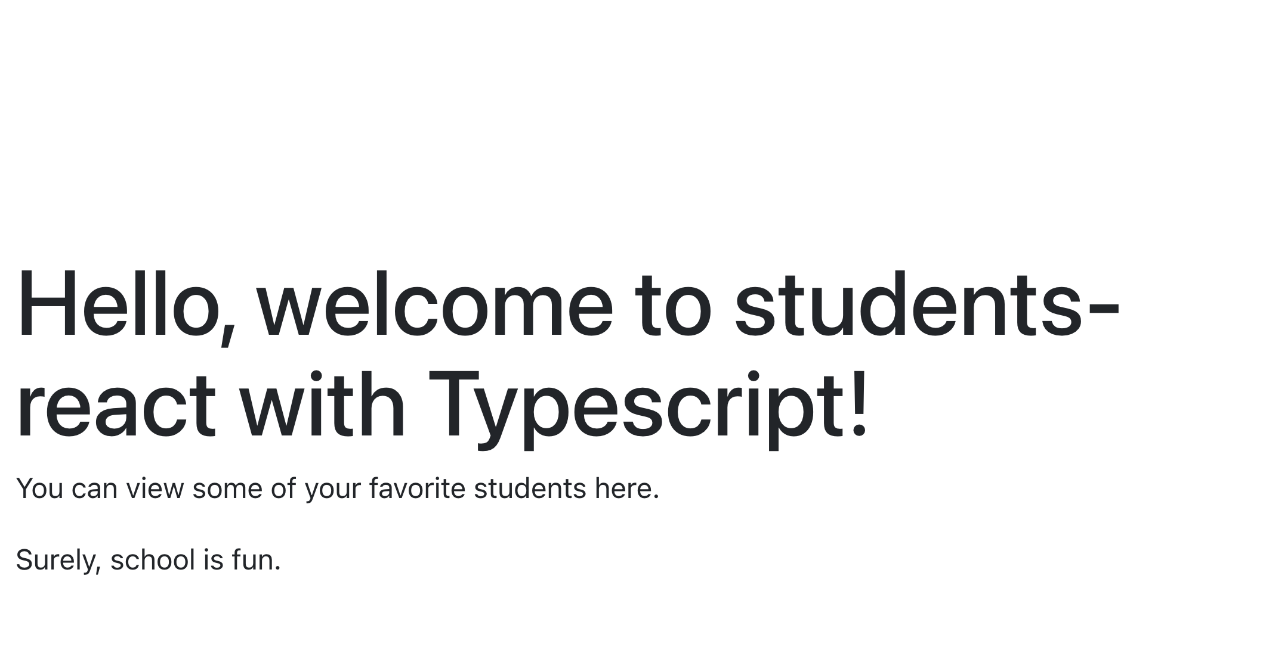
To align the text to the top-left, make the following changes:
index.css >> body >> comment out “display: flex;”
05
comment out “place-items: center;”

Routing
You might ask, where is the App component being loaded? The answer is in main.tsx. We will replace the App component in main.tsx with a routing component.
Create a folder src/routes, then add to it a file named Routes.tsx with this code:
import { createBrowserRouter } from "react-router-dom";
import HomePage from "../pages/HomePage";
06
import App from "../App";

/**
* The router configuration for the application.
*/
export const router = createBrowserRouter([
{
path: "/",
element: <App />,
children: [
{
path: "/",
element: (
<HomePage
title={"Hello, welcome to students-react with Typescript!"}
subtitle={"You can view some of your favorite students here."}
>
Surely, school is fun.
</HomePage>
),
},

],
},
]);
Note that the above routing component uses the App component for the / route. We will use this routing component in main.tsx.
Import the following into main.tsx:
07
import {router} from './routes/Routes'
import { RouterProvider } from 'react-router'
In the same main.tsx file, delete this import:
08
import App from './App.tsx'
Also, in main.tsx, replace <App /> with:
09
<RouterProvider router={router} />
Finally, in App.tsx, add the following import:
10
import { Outlet } from "react-router"
Replace the <HomePage> component with:
11
<Outlet />
Delete the HomePage import:
import HomePage from "./pages/HomePage";

Check the app in your browser, there is no change.

Let’s create three more pages. Create src/pages/AboutPage.tsx, src/pages/StudentListPage.tsx and src/pages/StudentDetailPage.tsx
Contents of AboutPage.tsx:
type AboutPageProps = {
message: string;
12
};

const AboutPage = ({message}: AboutPageProps) => {
return (
<section>
<h3>{message}</h3>
</section>
);
};

export default AboutPage;
Contents of StudentListPage.tsx:
13A
const StudentListPage = () => {
return (
<section>
<h1>Student List Page</h1>
</section>
);
};
export default StudentListPage;
Contents of StudentDetailPage.tsx:
const StudentDetailPage = () => {
14
return (
<section>
<h1>Student Detail Page</h1>
</section>
);
};
export default StudentDetailPage;
Import all new pages into routes/Routes.tsx:
15
import AboutPage from '../pages/AboutPage';
import StudentListPage from '../pages/StudentListPage';
import StudentDetailPage from '../pages/StudentDetailPage';
Append the following routes in routes/Routes.tsx in the children[] array:
{
path: "/about",
element: <AboutPage message={"Application that uses student data."} />,
},
{
path: "/list",
16
element: <StudentListPage />,
},
{
path: "/detail",
element: <StudentDetailPage />,
},
In your browser, point to:

http://localhost:????/about
17
http://localhost:????/list
http://localhost:????/detail

Navigation
We need to implement simple navigation into our web app.
Create folder src/components and add to it file NavBar.tsx with code:
import { Link } from "react-router-dom";
18
import reactLogo from "../assets/react.svg";

const NavBar = () => {
return (
<nav className="navbar navbar-expand-sm bg-primary navbar-dark">
<a className="navbar-brand" href="#">
<img src={reactLogo} width="30" height="30" alt="" />
school
</a>
<div className="collapse navbar-collapse" id="navbarSupportedContent">
<ul className="navbar-nav mr-auto">
<li className="nav-item active">
<Link className="nav-link" to="/">
Home
</Link>
</li>
<li className="nav-item">
<Link className="nav-link" to="/about">
About
</Link>
</li>
<li className="nav-item">
<Link className="nav-link" to="/list">
Student List
</Link>
</li>
</ul>
</div>
<a className="navbar-brand" href="/">
TypeScript version
</a>
</nav>
);
};

export default NavBar;
Import our new navigation into src/App.tsx:
19
import NavBar from './components/NavBar';
Add the <NavBar /> component just above <Outlet />.
20
You will see top navigation in the app:

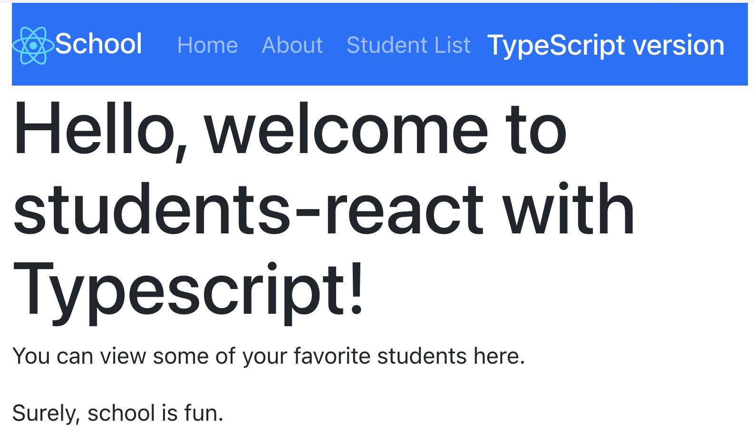

Page not found
Let’s add a NotFoundPage.tsx component to src/components folder with the following code:
21
export default function NotFoundPage() {
return <h1>404: Page Not Found</h1>;
}
Let’s add a catch-all route in routes/Routes.tsx. Add this import to the file:
22
import NotFoundPage from "../components/NotFoundPage";
Add this at the bottom of the routes list inside the children[] array:
{
path: "*",
23
element: <NotFoundPage />,
},
The user will get error code 404 if he/she tries to access an incorrect route like http://localhost:####/bad:
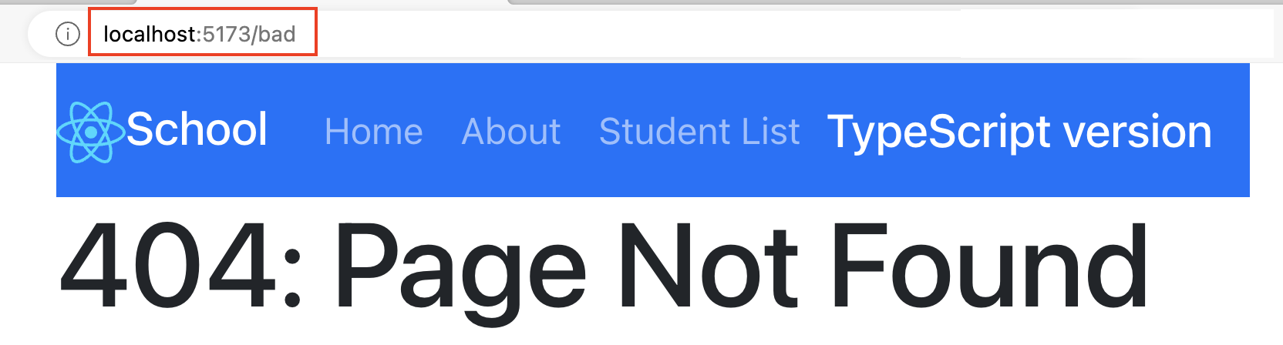

REST
We will access a REST endpoint at:
24
https://apipool.azurewebsites.net/api/students
Create a src/config folder, then add to it a file named index.ts with the following code that points to the base URL of our REST endpoint:
const Config = {
25
API_BASE_URL: `https://apipool.azurewebsites.net/api/`,
};

export default Config;
Create a src/models folder and add to it a Student class in a file named Student.ts. Add the following code to Student.ts:
export class Student {
constructor(public studentId: number, public firstName: string,
26
public lastName: string, public school: string) {

}
}

Listing students on StudentListPage
Add a file src/components/StudentList.tsx with the following code:
import { useState, useEffect } from "react";
import { Student } from "../models/Student";
import Config from "../config";
27
type Props = {
exceptId?: number;
};

const StudentList = ({ exceptId = undefined }: Props) => {

const [studentInfo, setStudentInfo] = useState([]);

const getData = async () => {
const response = await fetch(`${Config.API_BASE_URL}students/`, {
method: "GET",
headers: {
"Content-Type": "application/json",
Accept: "application/json",
},
});

const jsonData = await response.json();
setStudentInfo(jsonData);
};

useEffect(() => {
getData();
}, []);

let filteredStudents = studentInfo;

if (exceptId !== undefined) {
filteredStudents = studentInfo.filter(
(p: Student) => p.studentId !== +exceptId
);
}

return (
<div>
{filteredStudents.map((student: Student, index) => (
<h6 className="text-muted" key={index}>
{student.studentId} {student.firstName} {student.lastName}
</h6>
))}
</div>
);
};

export default StudentList;
In the above code, useState and useEffect are React hooks that manage state and side effects in functional components.
useState
useState is used to declare state variables in functional components. In this code, it is used to create a state variable studentInfo and a function setStudentInfo to update it.
const [studentInfo, setStudentInfo] = useState([]);
- studentInfo holds the current state, which is initially an empty array.
- setStudentInfo is a function that updates the studentInfo state.
useEffect
useEffect is used to perform side effects in functional components, such as data fetching, subscriptions, or manually changing the DOM. It runs after the component renders.
useEffect(() => {
getData();
console.log(studentInfo);
}, []);
- The first argument is a function that contains the side effect code. Here, it calls getData() to fetch student data and logs studentInfo to the console.
- The second argument is an array of dependencies. When any value in this array changes, the effect runs again. An empty array [] means the effect runs only once after the initial render.
In summary, useState manages the studentInfo state, and useEffect fetches data and updates the state when the component mounts.
Let us add the StudentList component to the StudentListPage so that we can display the list of students. Add the following import statement to pages/StudentListPage.tsx:
28
import StudentList from "../components/StudentList";
Add the <StudentList /> component to pages/StudentListPage.tsx right after <h1> . . . </h1>. The list of students should display:
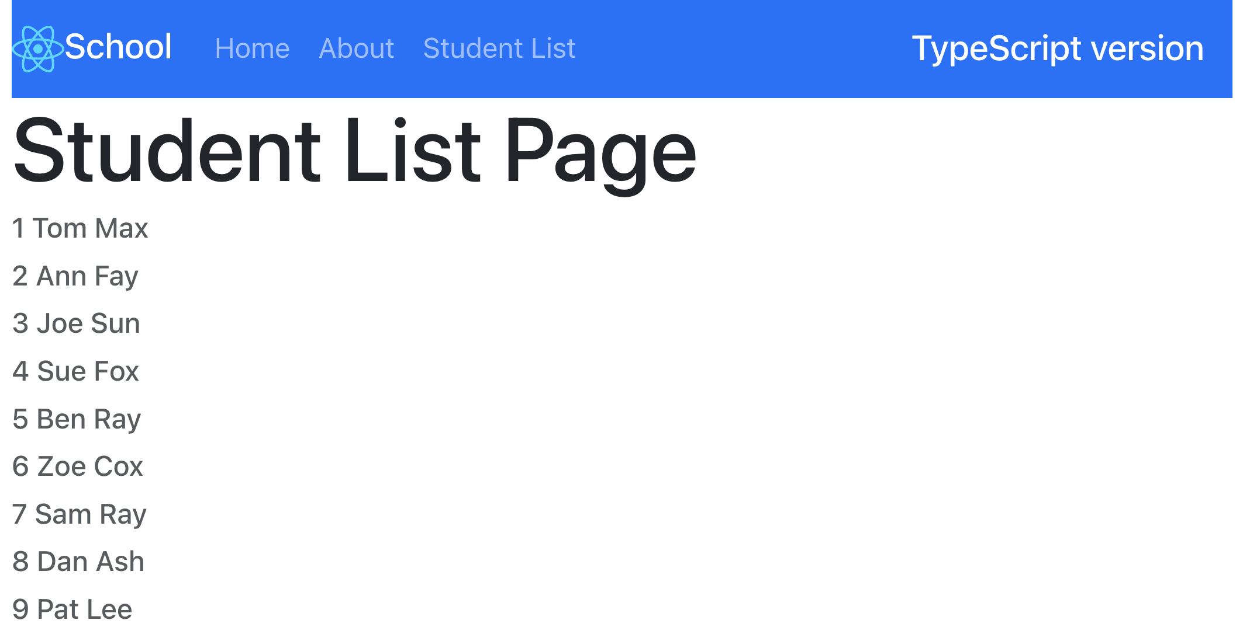

Displaying Student Details
We will enhance the StudentDetailPage.tsx page with URL parameters. In src/routes/Routes.tsx change /detail route path to:
29
path: "/detail/:id"
Change code in StudentDetailPage.js to:
import { useParams } from "react-router-dom";
import StudentList from "../components/StudentList";
import NotFoundPage from "../components/NotFoundPage";
import { useState, useEffect } from "react";
import Config from "../config/";
import { Student } from "../models/Student";

const StudentDetailPage = () => {
const { id } = useParams();
const [studentInfo, setStudentInfo] = useState<Student>({
studentId: 0,
firstName: "",
30
lastName: "",
school: "",
});

useEffect(() => {
const fetchData = async () => {
const result = await fetch(`${Config.API_BASE_URL}students/${id}`);
const body = await result.json();
//console.log(body);
setStudentInfo(body);
};
fetchData();
}, [id]);

if (studentInfo.studentId === 0) return <NotFoundPage />;

return (
<section>
<div style={{ width: "20%", float: "right" }}>
<h3>Others:</h3>
<StudentList exceptId={studentInfo.studentId} />
</div>

<h4 className="text-muted">Student ID={studentInfo.studentId}</h4>
<div>
<b>Name: </b>
{studentInfo.firstName} {studentInfo.lastName}
</div>
<div>
<b>school: </b>
{studentInfo.school}
</div>
</section>
);
};

export default StudentDetailPage;

Navigate to http://localhost:####/detail/9. This will display student with ID=9:
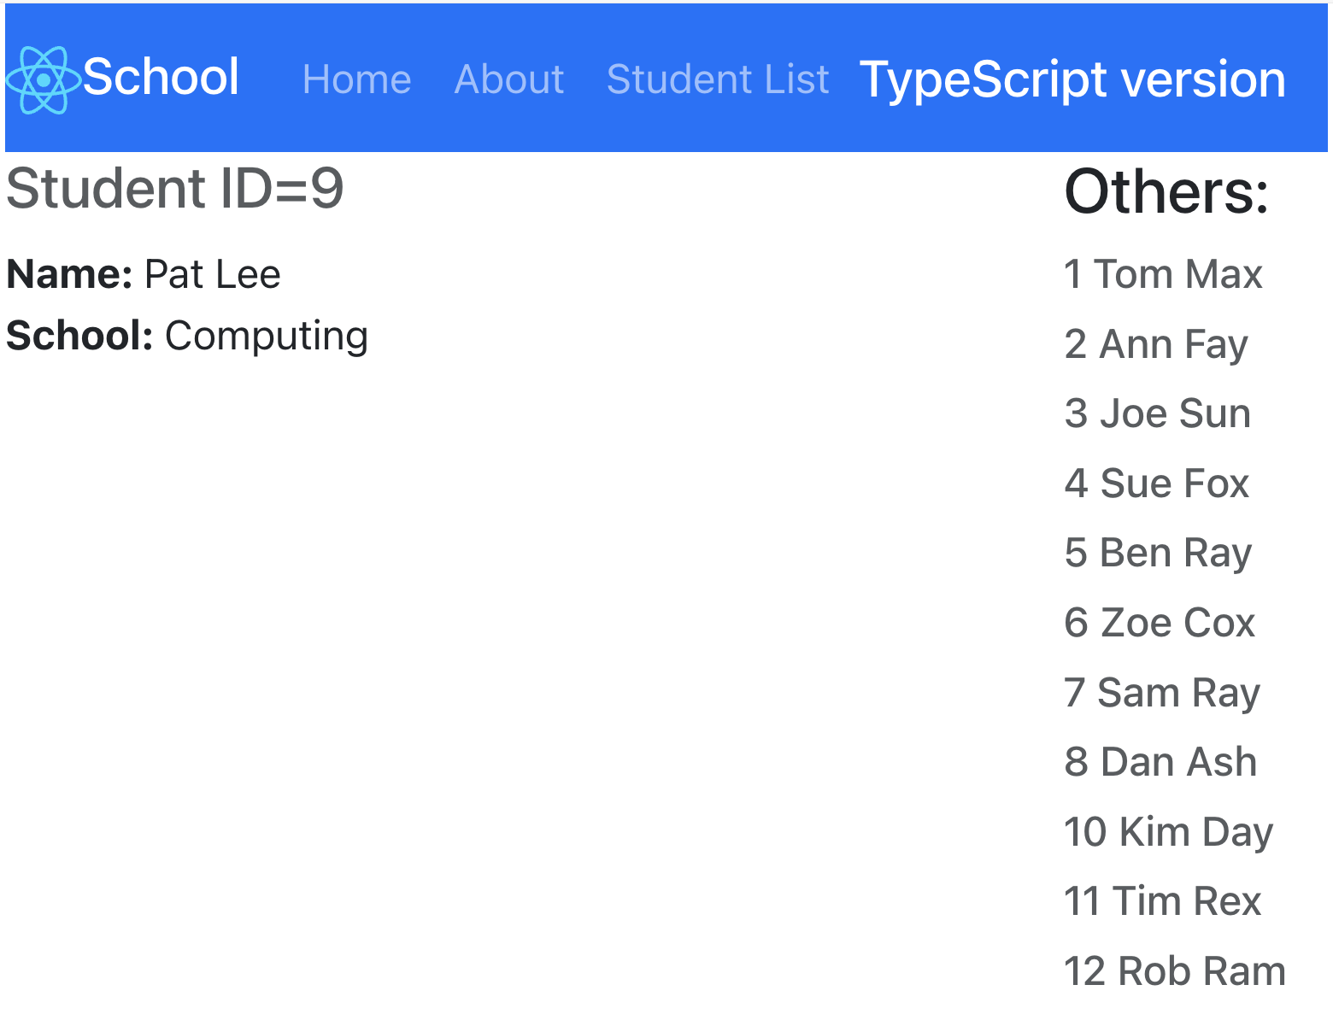
Note that whenever details of a student are displayed on the left-side, it is dropped from the list on the right-side. This is because of exceptId in <StudentList exceptId={studentInfo.studentId} />.

Making items in the list clickable
Add the following import statement to src/components/StudentList.tsx:
31
import { Link } from "react-router-dom";
In components/StudentList.tsx, surround the <h6> tag with:
32
<Link to={`/detail/${student.studentId}`}>
. . . .
</Link>
Now, whenever you click on an item in the list, details about that item are displayed.

Creating a specialized List component
Let us create a List component that specializes in the display of any list. We will use generics to develop the component and show off the power of Typescript.
Create file components/List.tsx with the following code:
import { ReactNode } from "react";
33
interface ListProps<T> {
items: T[];
render: (item: T) => ReactNode;
}

const List = <T,>({ items, render }: ListProps<T>) => {
return (
<>
{items.map((item, index) => (
<span key={index}>{render(item)}</span>
))}
</>
);
};

export default List;
This component takes a generic array of items and requires implementation of the render method. Let’s use in in src/components/StudentList.tsx. Add the following import to components/StudentList.tsx:
34
import List from "./List";
Replace <div> … </div> in components/StudentList.tsx with:
<div>
<List
35
items={filteredStudents}
render={(student: Student) => (
<Link to={`/detail/${student.studentId}`}>
<h6 className="text-muted">
{student.studentId} {student.firstName} {student.lastName}
</h6>
</Link>
)}
/>
</div>
The application behaves as expected.
Note that our List component is very flexible and can be used with any arrray containing any types of objects.

Creating a form for adding students
In src/components folder, add AddStudentForm.tsx with following code:
import { useState} from "react";
import Config from "../config/";
36
import { useNavigate } from 'react-router-dom';
import { Student } from "../models/Student";

const AddStudentForm = () => {
const [studentInfo, setStudentInfo] = useState<Student>({
studentId: 0,
firstName: "",
lastName: "",
school: "",
});

const navigate = useNavigate();

const addStudent =()=>{
const result = fetch(`${Config.API_BASE_URL}students/`,{
method:'post',
body:JSON.stringify({
firstName: studentInfo.firstName,
lastName: studentInfo.lastName,
school: studentInfo.school,
}),
headers:{'Content-Type':'application/json'}
});
result
.then(response => response.json())
.then(data => console.log(data))
.catch(error => console.error('Error:', error));

navigate('/list',{state:{refresh:true}});
}
return(
<div className="panel panel-default">
<form>
<h3>Add Student</h3>
<div className="form-group">
<label>First Name:</label>
<input className="form-control" type="text" placeholder="First Name"
value={studentInfo.firstName}
onChange={(event) => setStudentInfo({...studentInfo, firstName: event.target.value})} />
</div>
<div className="form-group">
<label>Last Name:</label>
<input className="form-control" type="text" placeholder="Last Name"
value={studentInfo.lastName}
onChange={(event) => setStudentInfo({...studentInfo, lastName: event.target.value})} />
</div>
<div className="form-group">
<label>School:</label>
<input className="form-control" type="text" placeholder="school"
value={studentInfo.school} onChange={(event) => setStudentInfo({...studentInfo, school: event.target.value})} />
</div>

<input type="submit"
onClick={() => addStudent()} className="btn btn-success" value="Add" />
</form>
</div>
);

}
export default AddStudentForm;
Import AddStudentForm into StudentDetailPage.js
37
import AddStudentForm from '../components/AddStudentForm';
Add AddStudentForm component to StudentDetailPage.js just before the closing </section> tag.
38
<div style={{ width: "50%", float: "left" }}>
<hr />
<AddStudentForm />
</div>
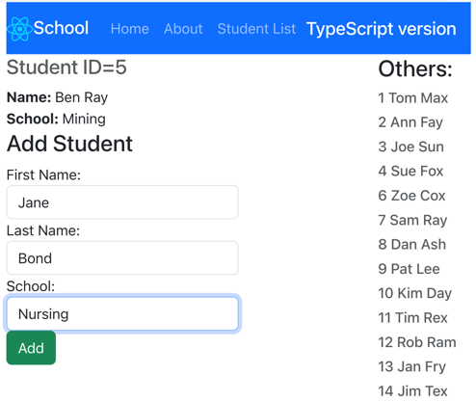

In browser, view a student and try the add form. Add data. You should see the new student appear in the list.

Azure Static Web App
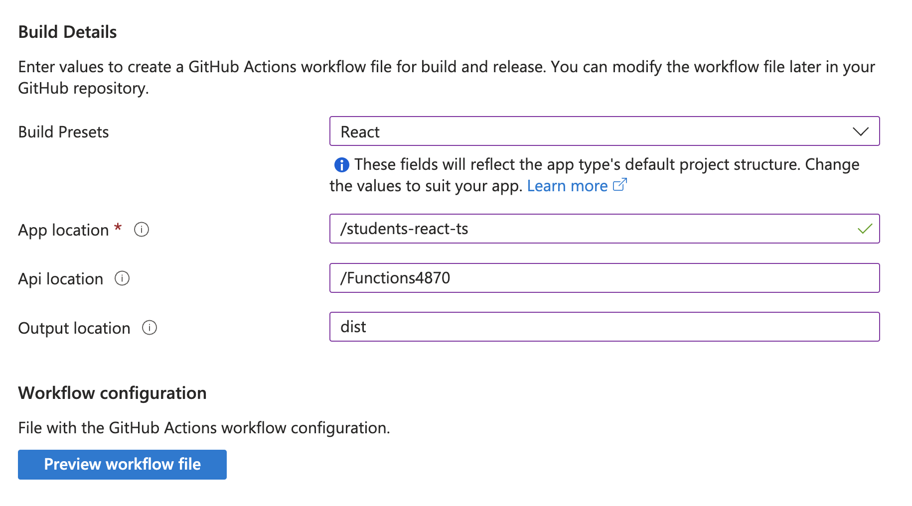
Name | Value
DATABASE_CONNECTION_STRING | Server=tcp:static-web-apps-db-server.database.windows.net,1433;Initial Catalog=static-web-apps-lesson;Persist Security Info=False;User ID=static-web-apps;Password=DB0admin-user;MultipleActiveResultSets=False;Encrypt=True;TrustServerCertificate=False;Connection Timeout=30;

