Software Diagram Specification

for

Reducing cluster in Government Hospitals

|  |  |
| --- | --- |
| *NAME* | *ID* |
| Sarkar Md Tanzim | 1420436042 |
| Md. Mushfiqur Rahman Bhuiyan | 1620379042 |
| Sourav Chandra Roy | 1420429042 |
| Durjoy Nag Prattay | 1620243042 |

North South University

23.02.2019

# Architectural Pattern:

We will use MVC architectural pattern for our project.

# Database Schema

Patient

|  |  |  |  |  |  |  |
| --- | --- | --- | --- | --- | --- | --- |
| Pfirstname | Plastname | Pid | Phone | Username | Password | DOB |

Doctor

|  |  |  |  |  |  |  |  |
| --- | --- | --- | --- | --- | --- | --- | --- |
| Dfirstname | Dlastname | Degree | Did | Phone | Email | Specialty | Dept_number |

Administration

|  |  |  |
| --- | --- | --- |
| Admin_id | Password | Dept_number |

Department

|  |  |  |
| --- | --- | --- |
| Dept_number | Dept_name | Admin_id |

Appointment

|  |  |  |
| --- | --- | --- |
| Serial | Did | Pid |

Serial_info

|  |  |  |  |  |
| --- | --- | --- | --- | --- |
| Serial | Date | Time | Room_no | Type |

Patient History

|  |  |  |  |  |
| --- | --- | --- | --- | --- |
| Pid | Serial | Did | Diagnosis | Prescription |

# UML Class Diagram

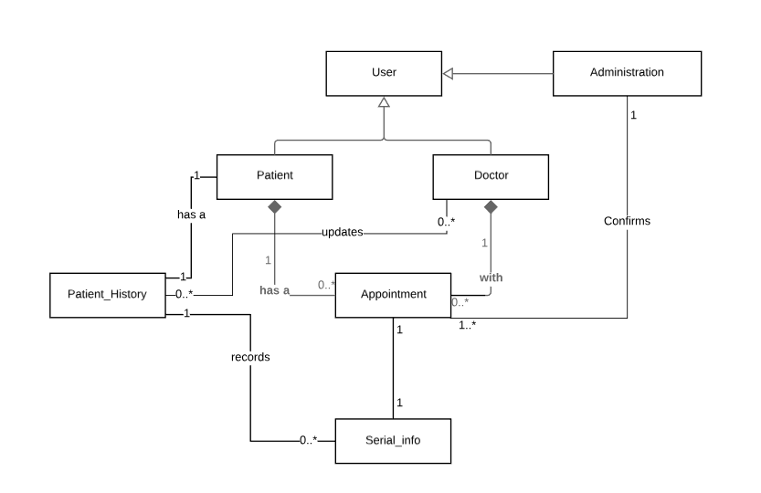

Figure: UML class diagram

# Class Description

**Class: User**

Details: It will have two sub classes. They are patient, doctor and administration. It will take users name, phone number and user name to log in our system. Patients, doctor, and admin will login through this.

Methods:

* getName()
* getPhone_number()
* getUser_name()
* logIn()
* logOut()

**Class: Patient**

Details: Patient can access to departments and select their preferred doctor to get the appointment. They will have a sub class called patient history. This class will also have a composition relation with appointment.

Methods:

* createAppointment()
* seeHistory()
* selectDepartment()
* selectDoctor()
* viewAppointmentDetail()
* cancleAppointment()

**Class: Doctor**

Details: It will be able to give patients prescription and also see the appointments.

Methods:

* writePrescription()
* viewPatientHistory()

**Class: Administration**

Details: This class will confirm the appointments and also will give access to emergency patients. It can also change the timing of a doctors visiting hours.

Method:

* confirmAppointment()
* changeAppointment()
* changeVisiting_hours()
* cancleAppointment()

**Class: Patient_History**

Details: It will hold all the previous prescriptions of the patients if any and also the serial number of the visit if they have any appointment.

Methods:

* getprescriptions()
* getSerialInfo()
* updateHistory()

**Class: Appointment**

Details: It will have all the details of the appointment for example department, doctors name, chamber no, visiting hours, time for visit.

Methods:

* isFull()
* notifyUser()
* setSerialNo()
* setVisiting_time()
* setChamber_no()
* setDoctors_name()
* setDept_name()

**Class: Serial_info**

Details: It will show the number of booked appointments for an individual doctor. It will also show if the slot is full or not.

Methods:

* getVisiting_time()
* getChamber_no()
* getDoctors_name()
* getDept_name()

**Sequence Diagram**

