Voyce.me System Design Details

This is a [Next.js](https://nextjs.org/) project bootstrapped with [create-next-app](https://github.com/vercel/next.js/tree/canary/packages/create-next-app).

**Getting Started**

First, run the development server:

npm run dev

# or

yarn dev

Open [http://localhost:3000](http://localhost:3000/) with your browser to see the result.

**Routes**

* `/` - this is home page, where added some charts with fake data

* `/login`

* `/register`

* `/pokemons` - in this page there is data fetch with pagination

**Live URL**

Deployed on [Vercel Platform](https://vercel.com/new?utm_medium=default-template&filter=next.js&utm_source=create-next-app&utm_campaign=create-next-app-readme).

[**voycemedashboard.vercel.app**](https://voycemedashboard.vercel.app/)

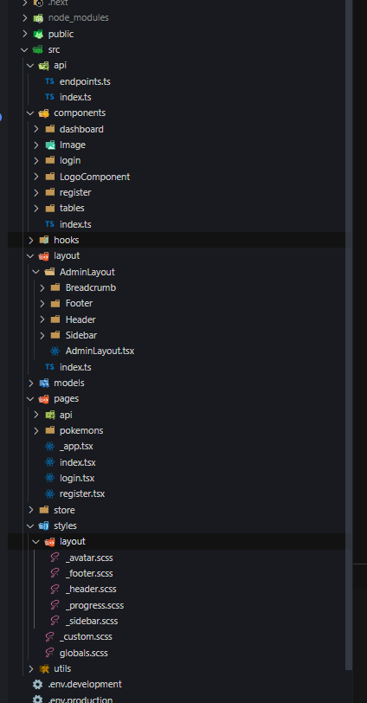Folder Structure