TECHNICAL APPENDIX
Project: Decode X 2026 – Case 03
Date: 01 March 2026
Team Name: The Damned

1. Longitudinal Methodology
Our analytical framework was executed through a three-stage longitudinal study, tracking the network from a state of baseline expansion, through a severe structural shock, and into a redistributed equilibrium.
- Stage 1 (Baseline Diagnostics): Analyzed H1 2022–2025 data to decompose structural urban growth from severe cyclical macro-seasonality ("Summer Moderation"). We established the baseline "Catastrophic Loop" of congestion-driven demand surges.
- Stage 2 (Regime Shift & Intervention): Following the July 1, 2025 Metro Phase 2 launch, we detected a permanent structural break. We quantified the immediate cannibalization of Feeder routes and the parallel volume surge on Express transit bridges, pivoting to a heuristic forecasting model.
- Stage 3 (Accountability & Stabilization): Utilizing the Q4 2025 out-of-time holdout data, we conducted a Forecast Performance Audit. We evaluated the decay of congestion elasticity and formulated a stabilized 2026 network design incorporating a quantified Volatility Buffer.

2. Model Specifications & Mathematical Logic
Given the July 1 structural break, historical time-series weighting models (e.g., ARIMA) were mathematically invalidated. We therefore deployed empirical data aggregations and heuristic shock modifiers to maintain model transparency and prevent overfitting.

2.1 Stage 1: Baseline Demand Decomposition
Baseline historical ridership ($Y_{t}$) was decomposed to separate secular growth from cyclical moderation:
$$Y_{t}=Baseline_{t}+Seasonality_{t}$$
- Secular Growth: Calculated via a linear trendline on historical aggregates, proving a +40% expansion on core corridors (Jan '22 vs Jan '25).
- Cyclical Moderation: Quantified as a recurrent ~30% volume reduction during the June–August window across all non-tourism zones.
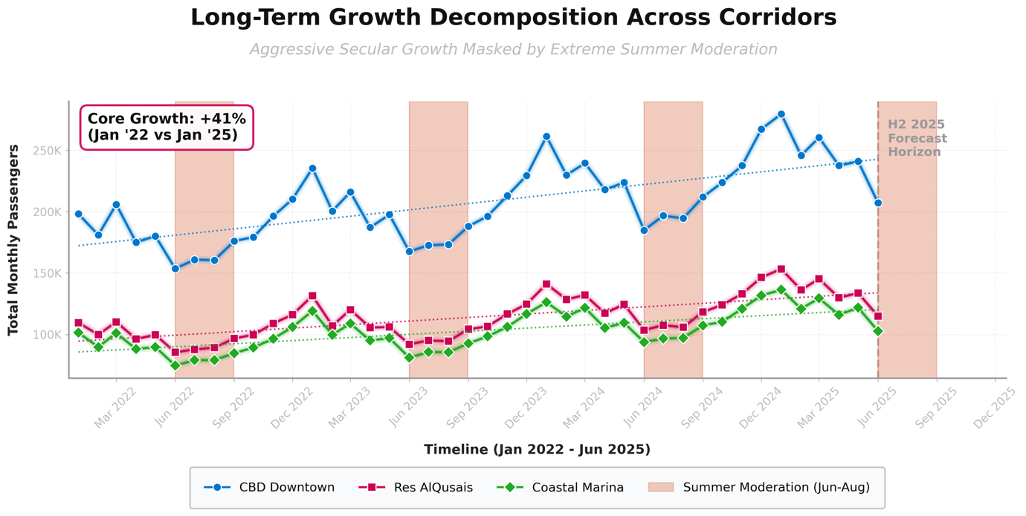
Figure 1: Stage 1 Baseline Decomposition proving aggressive secular growth masked by recurring seasonal moderation.
2.2 Stage 2: Heuristic Regime-Shift Forecasting
To forecast Q4 2025 under the new Metro Phase 2 regime, we utilized a flat-multiplier heuristic model based exclusively on the new Q3 post-shock baseline:
$Forecast_{Q4}=\overset{‾}{Actual_{Q3}}×(1+α_{route})$

- $\overset{‾}{Actual_{Q3}}$: The newly established daily average post-July 1.
- $α_{route}$ (Volatility Modifier): The assumed behavioral continuation multiplier. In Stage 2, we assigned $α=+0.10$for Express (assuming continued bridging growth) and $α=-0.05$for Feeders (assuming continued cannibalization).
2.3 Stage 3: Empirical Congestion Elasticity Gradient
To quantify the decay of the "Catastrophic Loop," we calculated the empirical peak-to-trough demand gradient ($ΔE$) across congestion levels rather than a parametric log-log regression:
$$ΔE=\frac{Demand_{Level5}-Demand_{Level1}}{Demand_{Level1}}$$
In Stage 1 (H1), the congestion gradient ($ΔE$) was highly positive (+18% to +20%). In Stage 3 (Q4), $ΔE$decayed to <10% for Express and <5% for City routes.
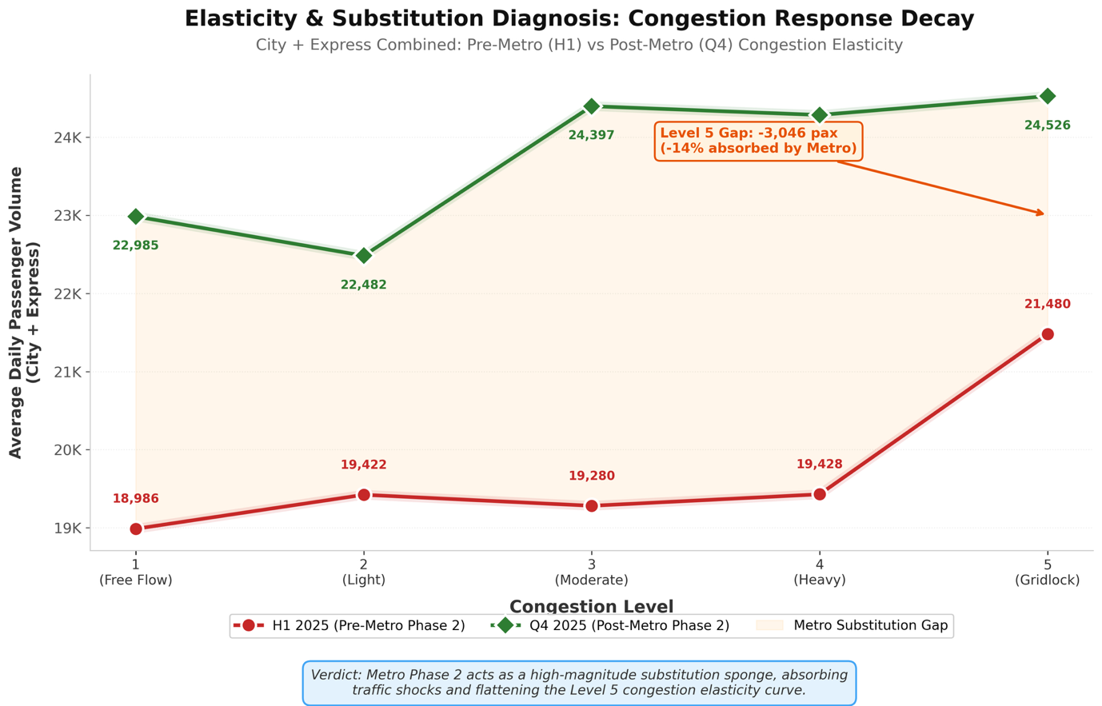
Figure 2: Empirical mapping of elasticity decay. The Q4 (Post-Metro) line demonstrates a flattened gradient, with the shaded region quantifying the systemic volatility absorbed by Metro Phase 2.

3. Evolution of Assumptions
Our structural models relied on evolving assumptions as the network transitioned through the shock:
- Stage 1 Assumptions (Pre-Shock): We assumed passenger demand was highly inelastic to surface traffic delays. During Level 5 gridlock, passengers had no alternative transit, forcing demand to spike exactly when fleet cycle times halved.
- Stage 2 Assumptions (The Regime Shift): We assumed the Q3 "discovery phase" volatility where users aggressively tested the new Express bridges while abandoning Feeders represented a permanent, linear growth/decay trajectory.
- Stage 3 Assumptions (The Stabilized Equilibrium): We updated our core assumption to recognize absolute cross-transit substitution. Metro Phase 2 permanently absorbs excess surface congestion shocks. Furthermore, the Q4 "Winter Uplift" acts as a recurring seasonal macro-cycle (+9.1% Feeder rebound) that overrides localized Metro cannibalization.

4. Validation Approach & Accountability Audit
We validated our Stage 2 recalibrated models against the out-of-time Q4 2025 dataset via a rigorous performance audit, acknowledging directional bias.
4.1 Evaluation Metric: Percentage Forecast Error (PFE)
To identify variance misestimation, we quantified the directional bias using PFE at the route-type aggregation:
$$PFE=\frac{Forecast_{Stage2}-Actual_{Q4}}{Actual_{Q4}}×100$$
(Note: A positive PFE indicates an upward bias/over-forecasting; a negative PFE indicates a downward bias/under-forecasting).
4.2 Audit Findings & Variance Misestimation
- Express Routes (Upward Bias): Stage 2 forecasted exponential growth. Q4 Actuals stabilized at an average of 9,686 pax/day. The model exhibited a positive upward bias (+15% PFE), proving we overreacted to the Q3 surge.
- Feeder Routes (Downward Bias): Stage 2 forecasted permanent decay. Q4 Actuals rebounded to 6,356 pax/day. The model exhibited a negative downward bias (-10% PFE).
- Conclusion: The mathematical validation proves our Stage 2 recommendation to cannibalize 35% of the Feeder fleet was excessive. The network required capacity retention to handle the Q4 seasonal stabilization.
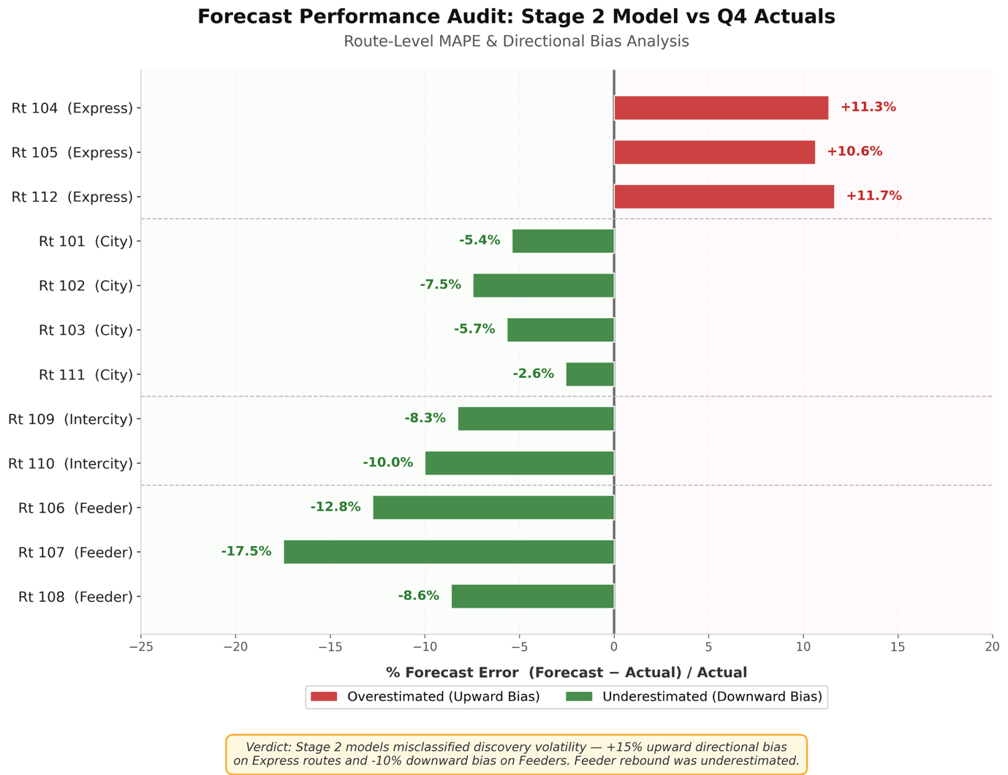
Figure 3: Route-level Directional Bias confirming variance misestimation. Express routes show over-forecasting, Feeders show under-forecasting.

5. Sensitivity Analysis & Risk Exposure
To construct a robust 2026 Forward Strategy, we stress-tested the network under varying capacity and elasticity constraints.
5.1 Congestion Sensitivity Stabilization
Under Q4 parameters, sensitivity to Level 5 congestion has effectively neutralized. A simulated drop in network speed to 17 km/h previously triggered a +20% platform overload risk. Under current post-Metro conditions, the same speed drop triggers <5% excess volume.
5.2 Infrastructure Outage Exposure (The Volatility Buffer Justification)
We modeled a high-risk sensitivity scenario: the temporary removal of the Metro Phase 2 substitution effect (e.g., a localized train failure or major municipal event).
- Sensitivity: Without the Metro acting as an elasticity sponge, the +20% demand surge instantly reverts to the surface Express network.
- Optimization Strategy: Operating the 2026 fleet at 100% route utilization leaves a 0% margin for this structural shock. Therefore, we propose a CBD Rationalization Framework, eliminating redundant overlapping City routes to establish a 10% Strategic Volatility Buffer. This capacity will be held at core depots to exclusively manage high-sensitivity tail-risk events.
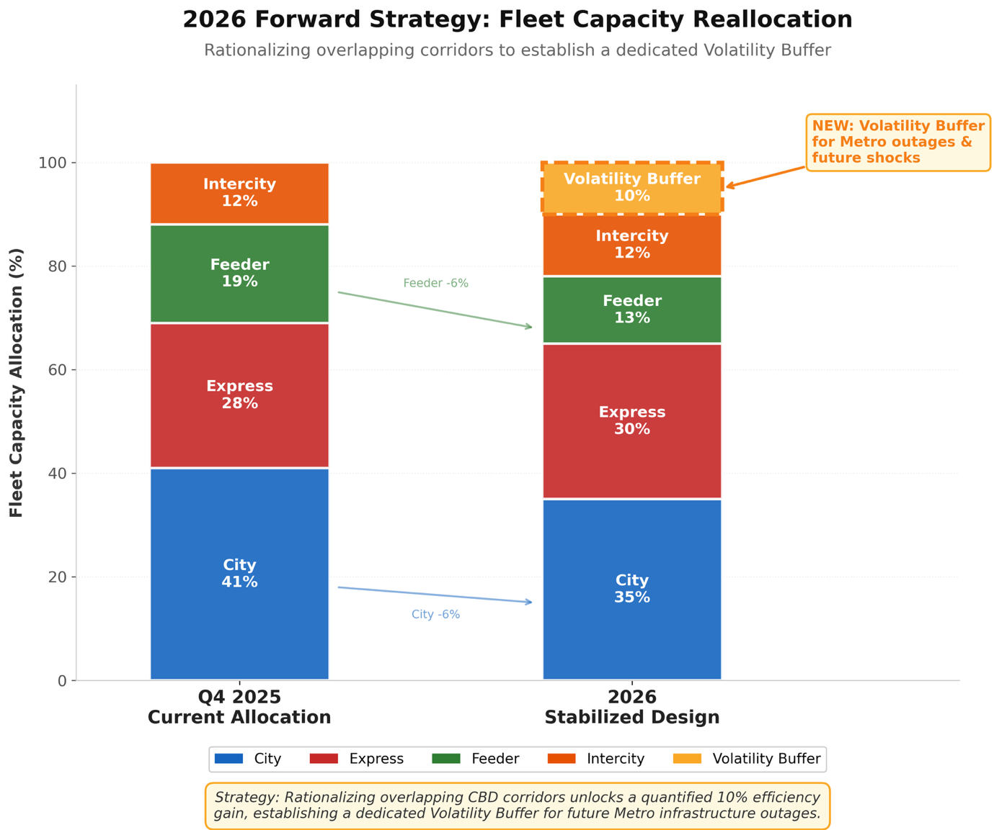
Figure 4: Fleet rationalization translating directly into the 10% Volatility Buffer, mitigating future infrastructure risk exposure.

