Task 1: Long-Term Growth Decomposition Across Corridors
(Covers Expectation: Growth decomposition)
Identified Core Finding:
Strong Secular Growth Masked by Extreme Summer Moderation
Justification:
The data identifies a structural upward trajectory in baseline demand across all zones, which is temporarily hidden by severe cyclical summer drops:
- Massive Multi-Year Expansion: Between January 2022 and January 2025, the core economic node (CBD_Downtown) grew by 41% (198K to 279K monthly passengers). The primary residential node (Res_AlQusais) grew by 40% (109K to 153K).
- Severe Summer Troughs: The system experiences a harsh ~30% drop in ridership during summer months. For example, CBD_Downtown dropped from its Jan 2024 peak (261K) to a summer trough in June 2024 (184K).
Operational Explanation:
The network's baseline demand is expanding rapidly due to steady urban population growth. However, extreme heat in the summer months drastically reduces discretionary transit and walking. Planning fleet capacity based on a "flat annual average" represents a severe operational risk; allocating based on summer numbers will cause the system to physically collapse during the winter uplift.
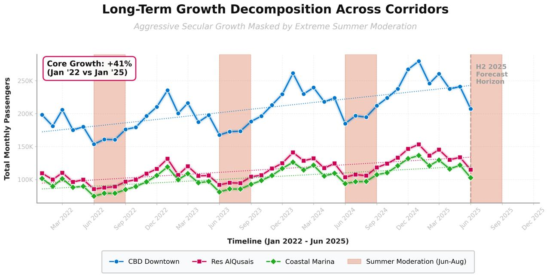
Figure 1: Long Term Growth Decomposition across Corridors
Task 2: Day-Type Divergence (Weekday vs. Weekend)
(Covers Expectation: Seasonal insight & Weekday/Weekend divergence)
Identified Core Finding:
Complete Demand Inversion Between Corporate and Tourism Zones on Weekends
Justification:
The system effectively operates as two entirely different networks depending on the day of the week:
- The Corporate Collapse: Core business corridors suffer a massive drop in weekend volume. CBD_Downtown ridership plummets by ~30% (from ~7,460 daily Mon-Fri to ~5,200 Sat-Sun). Ind_JebelAli drops by ~22%.
- The Tourism Surge: Coastal_Marina is entirely counter-cyclical. While it averages ~3,300 passengers on weekdays, demand surges by over 10% to ~3,636 on weekends.
Operational Explanation:
Commuter zones suffer "ghost town" effects on weekends, leaving high-frequency buses running empty (dead mileage). Meanwhile, tourism zones face capacity constraints as leisure travel peaks. Maintaining a static 7-day schedule results in burned cash in the CBD and lost revenue/overcrowding in the Marina.
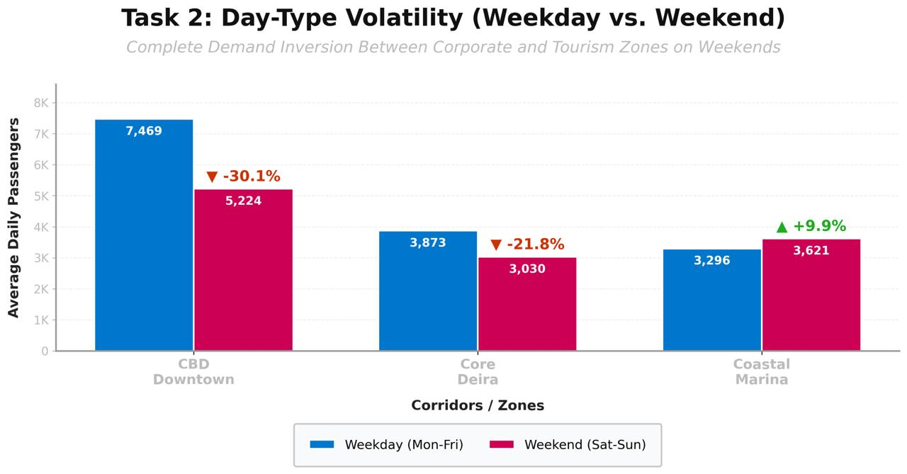
Figure 2: Volatility Weekdays vs Weekend

Task 3: Congestion Elasticity & The "Double Penalty" of Dwell Time
(Covers Expectations: Route-type comparison & Congestion elasticity)
Identified Core Finding:
The "Catastrophic Loop" - Demand Peaks Exactly When System Capacity Halves
Justification:
The network suffers from a highly dangerous inverse elasticity between traffic congestion and bus ridership, compounded by platform-level delays:
- Inverse Demand Elasticity: As Congestion worsens from Level 1 to Level 5, ridership on City routes increases by 18% (from 9,502 to 11,286 daily pax), and Feeder routes spike by 22%.
- The Double Penalty on Cycle Time:
Road Delay: During Level 5 congestion, average fleet speed plummets from ~40 km/h to ~21 km/h.
Dwell Time Stretch: The 18-22% surge in passengers forces buses to sit longer at stops. For instance, Route 102 (CBD_Downtown) already averages 2.0 minutes of dwell time at key stops. The volume surge stretches this baseline, adding minutes of purely stationary delay across the route.
Operational Explanation:
When road networks gridlock, commuters abandon private vehicles and taxis for transit. However, surface buses get caught in the exact same traffic. Because there are more passengers, boarding/alighting (dwell time) takes longer, which delays the bus further. Therefore, passenger volume peaks exactly when the fleet's effective capacity (cycle time) is halved. Headways explode, resulting in platform overcrowding, missed metro connections, and systemic failure.
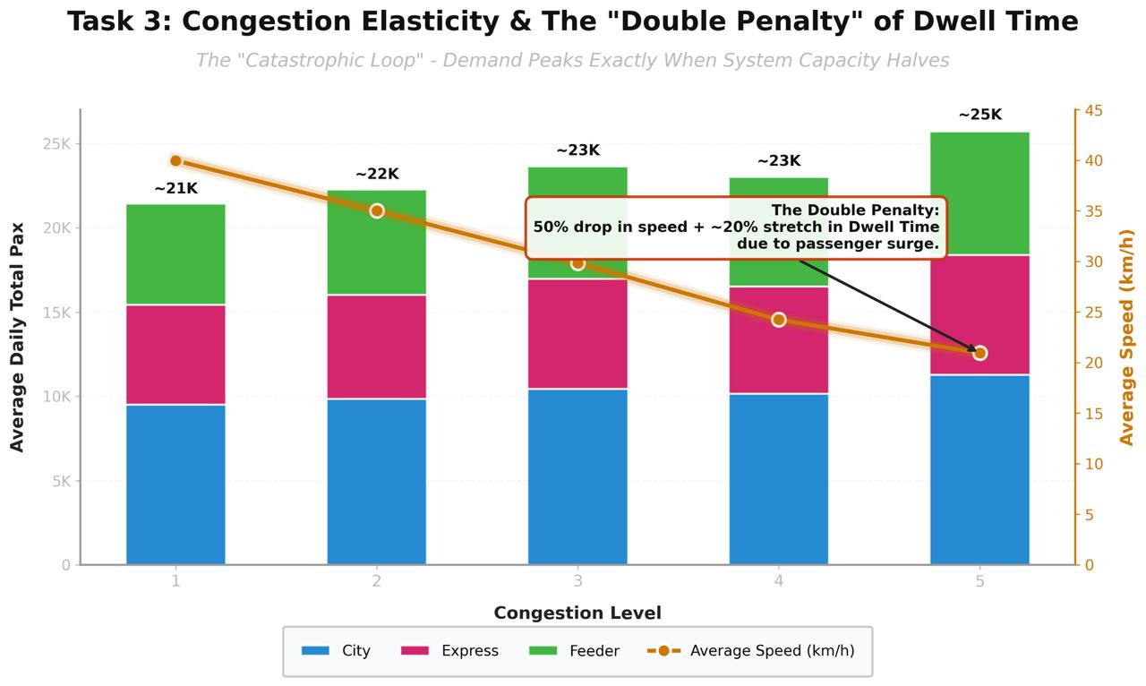
Figure 3: Congestion elasticity & the Double Penalty of Dwell Time
Task 4: H2 2025 Baseline Forecast & Structural Imbalance
(Covers Expectation: Baseline forecast & Corridor-level imbalance)
Identified Core Finding:
Imminent Overload Risk on City Corridors vs. Idle Capacity on Intercity Routes
Justification:
Looking at recent 2025 data to inform the H2 baseline forecast, there is a severe structural imbalance in route utilization:
- Overload Risk Corridors: City routes 101 and 103 are bearing massive volume, projecting the highest daily averages (>3,200 pax) going into the H2 2025 winter uplift.
- Underutilized Capacity: Intercity route 109 shows severe underutilization (1,834 pax), almost half the volume of core city routes, yet it runs on long 22km routes consuming significant dwell time.
Operational Explanation:
The network has evolved unevenly. High-frequency City routes connecting major residential hubs (Res_InternationalCity) to CBD nodes are operating near maximum capacity. Conversely, Intercity routes are burning fuel with empty seats. The baseline forecast for Q4 2025 indicates that without intervention, Routes 101 and 103 will breach safety and capacity thresholds.
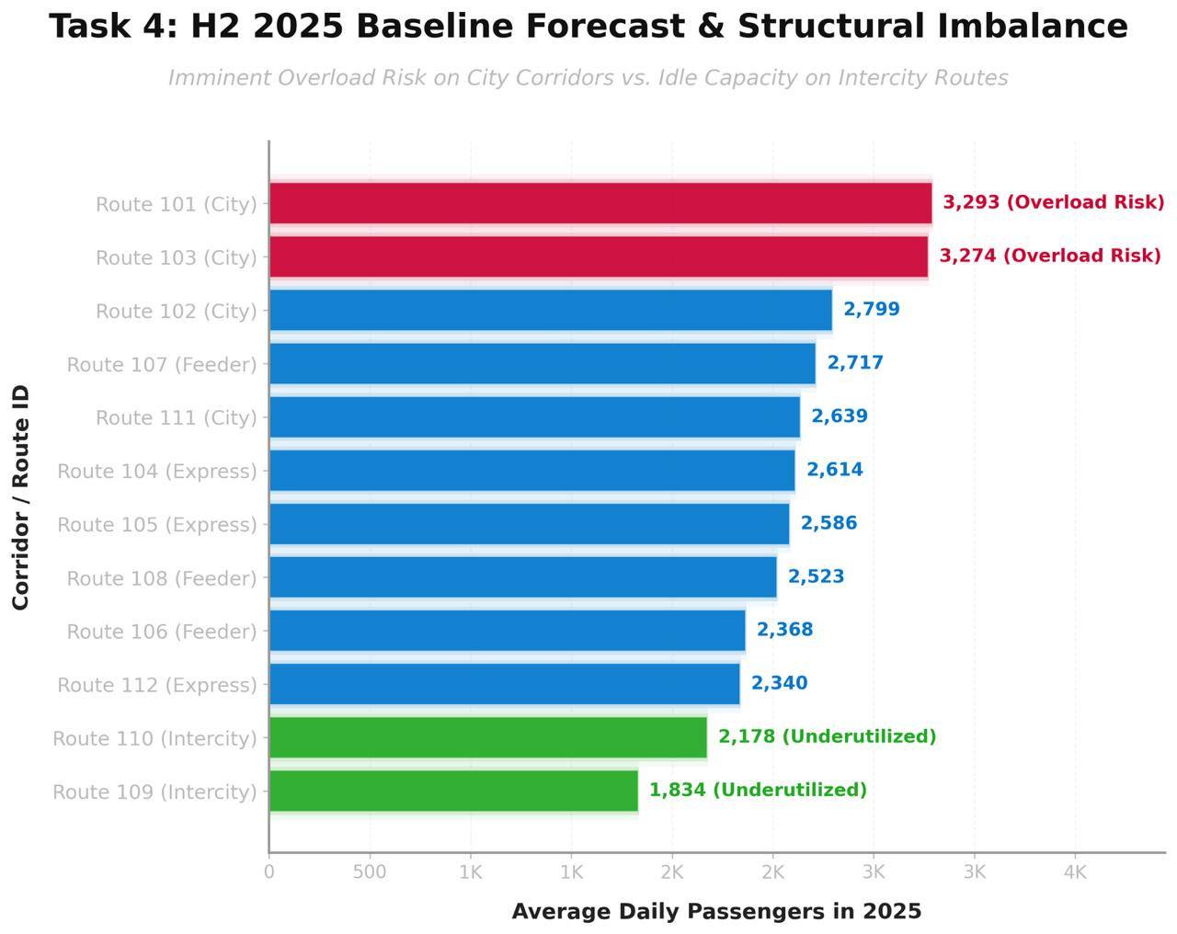
Figure 4: Baseline Forecast & Structural Imbalance
Task 5: Initial Fleet Allocation Strategy
(Covers Expectation: Initial allocation strategy)
Identified Core Finding:
Mandatory Shift to Dynamic Scheduling and Route Cannibalization
Justification:
Based on the diagnostics, we propose the following pre-emptive operational adjustments:
- Fleet Reallocation (Cannibalization): Immediately shift 10-15% of fleet allocation from the underperforming Intercity block (Routes 109, 110) to compress headways on the overloaded City block (Routes 101, 103).
- Dynamic Weekend Roster: Automate a Saturday/Sunday fleet swap. Slash CBD and Industrial weekend dispatches by 25% and inject those vehicles into the Coastal_Marina corridor.
- Congestion Trigger Protocol: At Level 4/5 congestion, prioritize dispatching to Feeder Routes (to protect Metro_Link access) and allow long Express/City routes to run with degraded headways.
Operational Explanation:
Without procuring new buses, we can artificially increase capacity on high-stress corridors by reallocating low-yield assets. Dynamic weekend scheduling eliminates dead mileage. Furthermore, prioritizing feeder routes during gridlock acts as a pressure relief valve, pushing surface passengers onto the Metro system when road speed collapses.
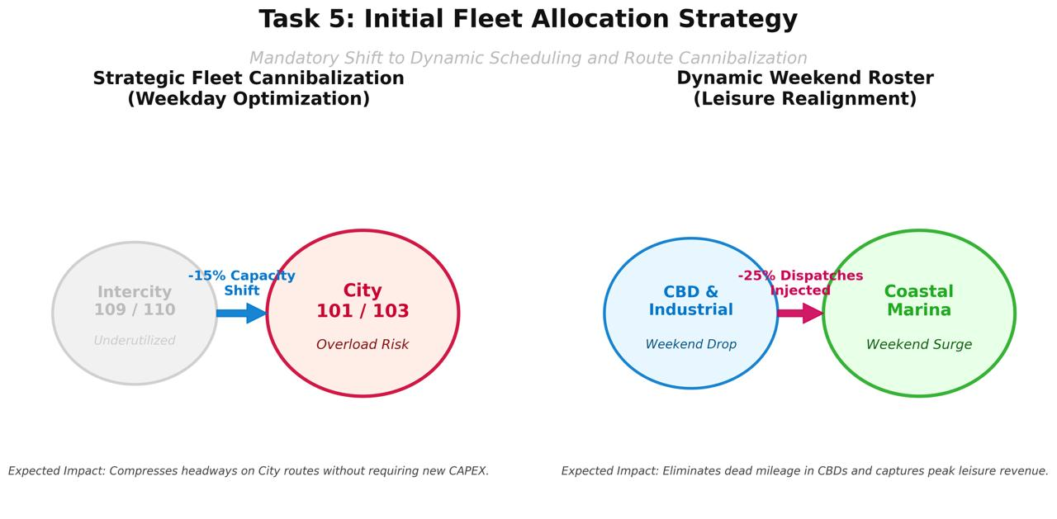
Figure 5: Initial Fleet Allocation Strategy

