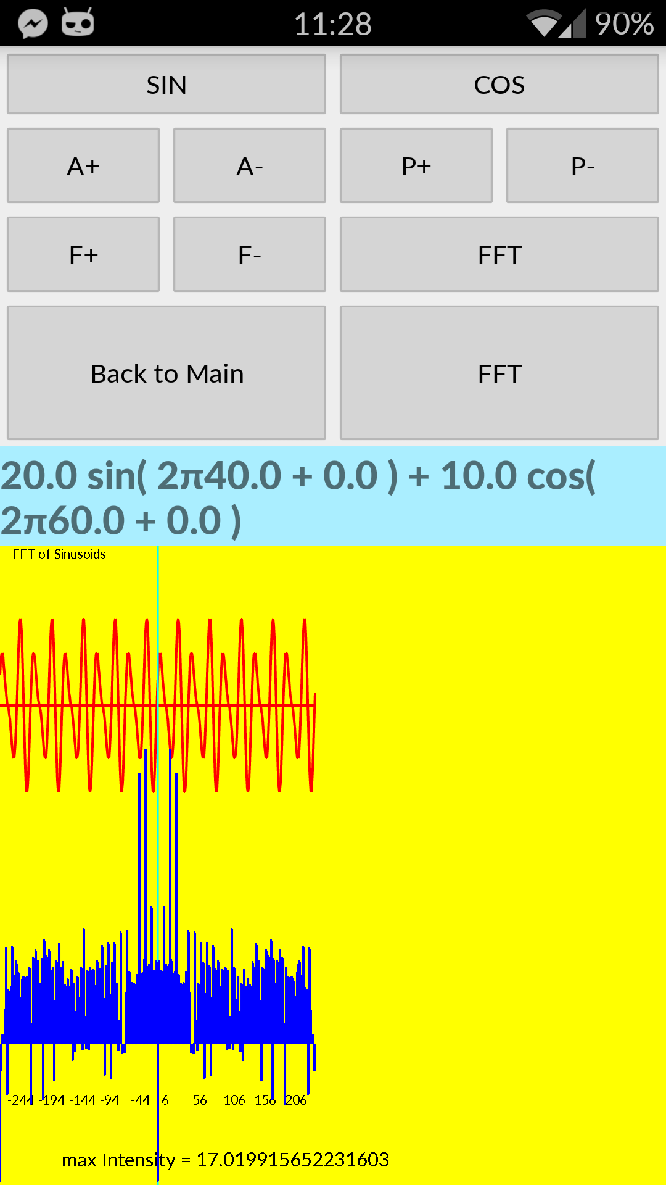

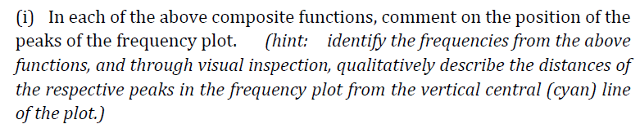

|  |  |  |  |  |  |
| --- | --- | --- | --- | --- | --- |
|  | Sin F | Cos A | Sin P | Cos P | Peak Position |
| a | 40 | 10 | 0 | 0 | Compared to the original function, only the **second highest (and second furthest) peak moves further away** from the central line, due to increment of cos frequency, which has the lower amplitude. |
| b | **80** | 10 | 0 | 0 | Compared to function a, only the **highest (and closest) peak moves further away** from the central line, due to increment of sin frequency, which has the higher amplitude. |
| ~~c~~ | ~~80~~ | ~~10~~ | ~~0~~ | ~~0~~ | ~~This function is the same as b.~~ |
| d | 80 | 10 | **10** | **9** | Compared to function b, the two **highest lengths’ peaks remain in the same position**, even though phases increased. |
| e | 80 | **30** | 10 | 9 | The **highest peak is no longer closest to the central line.** Now it is the second closest, as the amplitude of cos > amplitude of sin and frequency of cos > frequency of sin. |



If the amplitude of sin or cos is increased, its corresponding frequency peak will increase in height.



Changing the phase has no effect on the positions of the peaks.

# Screenshot of spectrogram activity

