PROCUREMENT RAG
Architecture, Data Pipelines, and LangGraph Retrieval Workflow
Purpose | Describe the retrieval-augmented generation (RAG) design for the procurement assistant.
Scope | Local document ingestion, MongoDB Atlas Vector Search, Google Gemini, and LangGraph tool routing.
Status | Implementation architecture based on the current project pipeline.

Architecture at a glance Procurement files are transformed into embedded chunks in MongoDB Atlas. A Gemini model uses LangGraph to decide whether a question requires retrieval, then uses matching document context to draft a grounded response.

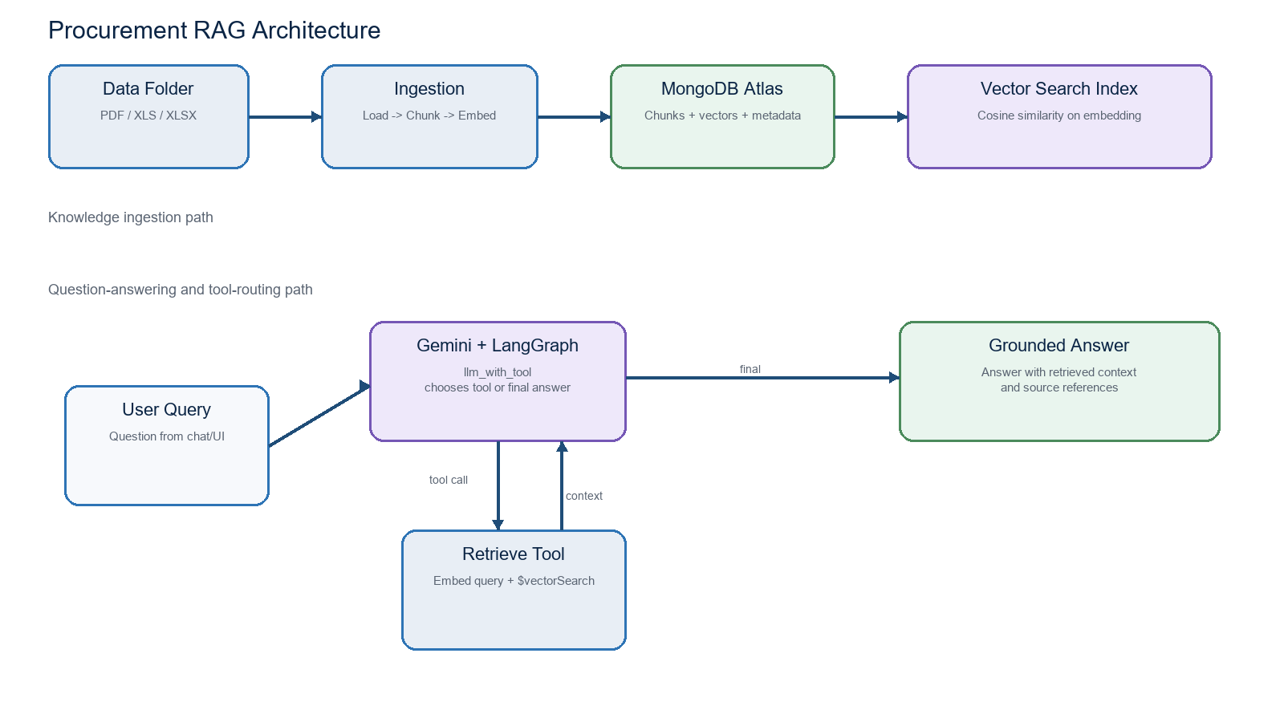
Figure 1. End-to-end procurement RAG architecture.

1. Executive Summary
The project implements a retrieval-augmented generation workflow for procurement information. The system indexes PDF and Excel sources from the local data directory, stores semantically searchable chunks in MongoDB Atlas, and supplies the most relevant evidence to a Google Gemini model. LangGraph controls the reasoning loop so the model can decide when it needs document context and can revisit the retrieval tool before finalizing an answer.
- Knowledge base: PDF, XLS, and XLSX procurement documents placed under the project data directory.
- Semantic layer: Hugging Face embeddings stored beside chunk text and source metadata in MongoDB Atlas.
- Answer layer: Gemini produces the response after optionally calling the MongoDB retrieval tool through LangGraph.

2. Architecture Components
Component | Role | Key Implementation
Data directory | Holds raw procurement source files. | Recursive discovery of PDF, XLS, and XLSX files.
LangChain loaders | Extract text and document units. | PyPDFLoader for PDFs; UnstructuredExcelLoader for Excel.
Chunking | Breaks long text into retrieval-sized passages. | RecursiveCharacterTextSplitter with configurable size and overlap.
Embedding model | Maps chunks and questions into the same vector space. | Hugging Face sentence-transformers/all-MiniLM-L6-v2 by default.
MongoDB Atlas | Stores chunks, metadata, and embedding vectors. | Documents collection with an Atlas Vector Search index on embedding.
Google Gemini | Chooses tool usage and writes the final response. | ChatGoogleGenerativeAI initialized with GOOGLE_API_KEY.
LangGraph | Controls the model/tool loop. | MessagesState graph with llm_with_tool and tools nodes.

3. Data Ingestion Pipeline
The ingestion pipeline prepares source material for semantic retrieval. It is implemented in code/ingest.py and uses settings from code/config.py.
- Discover files: recursively scan the configured data directory for supported PDF and Excel extensions.
- Load content: use LangChain document loaders to extract pages from PDFs and sheets/content from Excel files.
- Attach metadata: preserve source path, file name, file type, and a deterministic chunk number.
- Chunk text: split documents into overlapping text passages so answers retain neighboring context.
- Embed chunks: create normalized vectors through the configured Hugging Face embedding model.
- Upsert records: write text, metadata, and the vector to MongoDB using a SHA-256 derived identifier.
- Ensure vector index: create the Atlas Vector Search index if it does not already exist, using cosine similarity.
Why idempotent upserts matter A chunk ID is derived from the source, chunk number, and chunk content. Re-running ingestion updates the same stored chunk instead of blindly producing duplicate records.

4. MongoDB Atlas Vector Store
Each stored record represents one chunk of source text. MongoDB Atlas keeps both the evidence and its vector representation together.
Field | Purpose | Example
_id | Stable SHA-256 identity for upsert behavior. | Hash of source + chunk number + content
text | Original evidence provided back to the model. | A contract clause or payment-term passage
embedding | Dense vector used by Atlas Vector Search. | Normalized Hugging Face embedding
metadata | Traceability and filtering context. | source, file_name, file_type, chunk_number

The Atlas index targets the embedding field. Its dimension is determined dynamically from the configured embedding model, avoiding a hard-coded vector length.

5. Query and Retrieval Pipeline
The retrieval function in code/retrieve.py converts the user question into an embedding and uses MongoDB's $vectorSearch aggregation stage to select semantically relevant chunks.
- Receive a natural-language procurement question.
- Create a query vector with the same Hugging Face model used during ingestion.
- Run $vectorSearch against the embedding field using the configured Atlas index.
- Return the top matching chunk text, source metadata, and vector similarity score.
- Format those matches as readable context for the language model tool call.
Embedding compatibility The question and document chunks must use the same embedding model. Otherwise, their vector coordinates are not comparable and semantic retrieval quality degrades.

6. LangGraph Decision and Tool Loop
The graph in code/procurement_graph.py mirrors the requested tool-calling design. It contains two operational nodes: llm_with_tool and tools.
Graph element | Action | Next route
START | Receives the user message. | llm_with_tool
llm_with_tool | Gemini evaluates the question and either emits a tool call or writes a direct answer. | tools when a tool call exists; END otherwise
tools | ToolNode runs retrieve_procurement_context, which calls MongoDB retrieval and returns context as a ToolMessage. | llm_with_tool
END | Returns Gemini's final answer. | Workflow complete

The conditional edge uses tools_condition. This preserves the loop shown in the reference: Gemini can call retrieval, inspect the returned context, and decide whether another tool invocation is necessary before ending.

7. Grounded Answer Generation
Gemini is initialized in code/google_llm.py with a low temperature to encourage consistent, evidence-focused procurement answers. The system instruction guides the model to:
- Use the retrieval tool for document-specific procurement questions such as vendor terms, pricing, contracts, purchase orders, and policies.
- Use retrieved context for document-specific claims rather than inventing information.
- State when the available context is insufficient.
- Cite available source file names in the answer.
- Answer simple conversational questions without retrieval when no document evidence is needed.

8. Configuration and Operations
Setting | Purpose
MONGODB_URI | MongoDB Atlas connection string.
MONGODB_DATABASE / MONGODB_COLLECTION | Destination database and collection for chunk records.
MONGODB_VECTOR_INDEX | Atlas Vector Search index name, defaulting to vector_index.
EMBEDDING_MODEL | Hugging Face model used by both ingestion and retrieval.
CHUNK_SIZE / CHUNK_OVERLAP | Controls passage size and retained boundary context.
GOOGLE_API_KEY | Credential used to call the Google Gemini API.
GOOGLE_MODEL | Gemini model name, defaulting to gemini-2.5-flash.

Operational sequence Run ingestion after adding or changing source files. Wait for the Atlas search index to become READY, then run the LangGraph question workflow. Keep API keys and MongoDB credentials in environment variables, not source files.

9. Suggested Next Enhancements
- Add metadata filters to limit retrieval by vendor, document type, date, or department.
- Add a LangGraph checkpointer for conversation memory and durable execution. *
- Add response citations that include page or sheet-level locations when loader metadata provides them. *
- Add evaluation datasets to measure retrieval relevance, groundedness, and answer quality.
- Add additional tools, such as procurement-policy lookup or supplier master-data access, while retaining the same tool loop.

10. Project File Map
File | Responsibility
code/config.py | Reads environment-backed settings shared by pipelines.
code/ingest.py | Loads files, chunks content, creates embeddings, writes to Atlas, and ensures the vector index.
code/retrieve.py | Embeds a question and retrieves relevant MongoDB Atlas chunks.
code/google_llm.py | Creates the Google Gemini chat model client.
code/procurement_graph.py | Builds and invokes the LangGraph model/tool decision loop.
.env.example | Lists required and optional configuration variables.

