ZAF – Procurement Chat Assistant
  - Architecture and AI engineering portfolio
Implementation review | 20 September 2026

Project overview
ZAF brings supplier-document search and procurement database lookup into a single conversational interface. Users can ask about contract terms, purchase orders, and invoices without switching between files and SQL tools. A LangGraph agent selects the appropriate data tool, receives the returned evidence, and produces a natural-language response.
The project combines two retrieval patterns. Document questions use retrieval-augmented generation over MongoDB Atlas vectors. Purchase-order and invoice questions use generated SQL against existing MySQL tables. A LiteLLM gateway assigns model groups to general conversation, RAG, and code generation, while Streamlit provides a chat interface with session history.

Implemented capabilities and procurement value
Capability | Practical application
Supplier Contract tool | Locate relevant payment terms, contract clauses, vendor conditions, and policy passages.
Purchase Order tool | Look up order details using the configured purchase-order table schema.
Invoice tool | Retrieve invoice information from a separately configured table allowlist.
Conversation state | Continue a supplier discussion within the same running session.
Model gateway and tracing | Separate model selection from tools; inspect calls with LangSmith when tracing is enabled.

What the engineering demonstrates
The implementation connects unstructured documents and structured records through tool calling, rather than forcing both into one storage model. Its reusable ask(question, thread_id) function supports a UI and a CLI. Chunk provenance, schema-aware SQL prompts, explicit graph transitions, and provider-independent response parsing make the flow inspectable.
ZAF is a development-stage assistant. It does not create purchase orders, approve invoices, or execute procurement transactions. Business benefits are intended use cases; the repository contains no measured accuracy, latency, cost savings, or production outcomes.

System architecture
The system runs as a Python application with external LLM APIs, MongoDB Atlas, and MySQL. The gateway is an in-process LiteLLM Router, not a separately deployed proxy. The diagram separates ingestion from the live conversation and expands the three procurement tools.
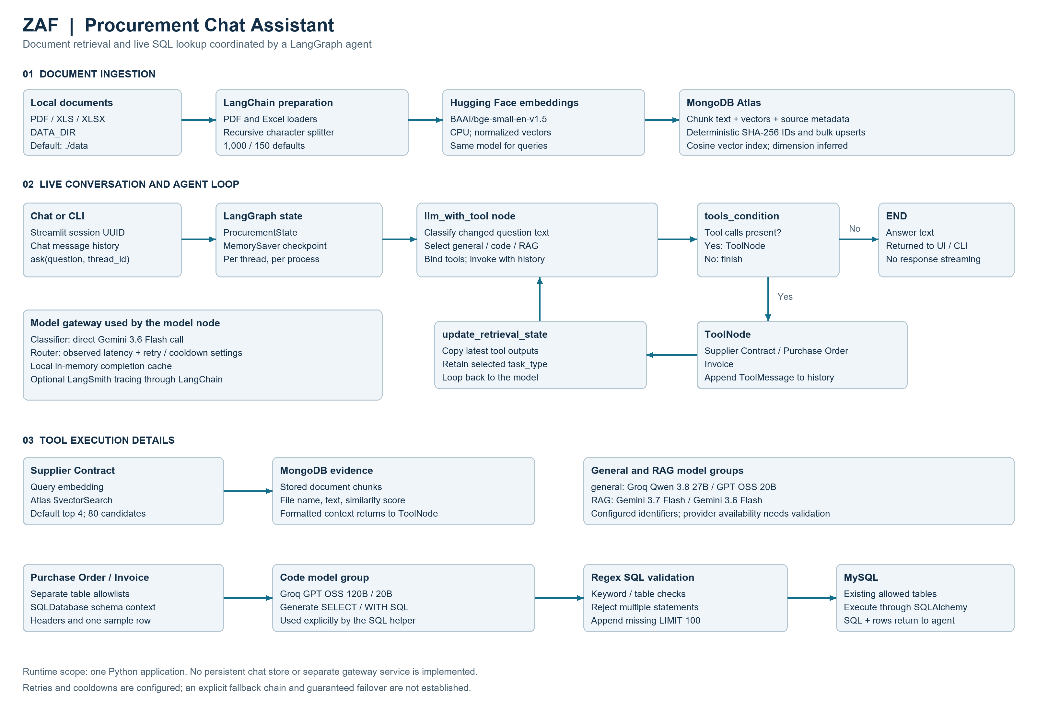
Figure 1 Actual application components and data flow

How the layers connect
Ingestion writes text, normalized embeddings, and source metadata into Atlas. Supplier Contract search reads those records. MySQL lookups remain live queries over existing tables; the ingestion pipeline does not copy relational data into the vector store.
The model node receives the system prompt and checkpointed message history. It can finish directly or issue a tool call. ToolNode adds tool output as messages; update_retrieval_state stores retrieval details before control returns to the model. The selected model group persists through this loop, but the underlying deployment can vary on each router invocation.
Thread memory, completion caching, and tracing serve different purposes: MemorySaver retains dialogue state, LiteLLM caches matching model requests, and LangSmith exports execution traces when enabled. Neither memory nor cache is durable across process restarts.

Document ingestion and retrieval

Preparing supplier documents
scr_code/ingest.py recursively discovers PDF, XLS, and XLSX files below DATA_DIR. It uses PyPDFLoader for PDFs and UnstructuredExcelLoader for spreadsheets. Each loaded document retains its resolved source path, file name, and file type before splitting.
RecursiveCharacterTextSplitter creates overlapping text chunks using CHUNK_SIZE and CHUNK_OVERLAP, defaulting to 1,000 and 150 characters. Chunk numbering is assigned across the full split result. This is character-based chunking; Hugging Face is used for embeddings, not as the splitter.
HuggingFaceEmbeddings runs the configured embedding model on CPU with normalized output. The default is BAAI/bge-small-en-v1.5. All chunk vectors are generated and sent to MongoDB with an unordered bulk upsert. IDs are SHA-256 hashes of source path, global chunk number, and text.
Stored field | Purpose
_id | Deterministic identifier for unchanged source path, chunk number, and text.
text | The chunk supplied as answer evidence.
embedding | Normalized numerical representation used for semantic similarity.
metadata | Source information and chunk number retained for provenance.

Building and querying the vector index
The ingestion entry point infers vector dimensions by embedding a short probe. If the configured index name is absent, it creates an Atlas vectorSearch index over the embedding field with cosine similarity. It does not wait for the index to become queryable or validate an already existing index definition.
scr_code/retrieve.py embeds the search query with the same model and sends a $vectorSearch aggregation to Atlas. The Supplier Contract tool defaults to four matches and uses numCandidates equal to limit multiplied by 20. Projection returns text, metadata, and vectorSearchScore. format_context() assembles file names, scores, and text into readable evidence sections.

RAG in this project
Retrieval-augmented generation is implemented by giving retrieved passages to the answer model through tool messages. The system prompt tells the model to use tools for source-specific facts and to state when evidence is insufficient. Source references are available in context, but the application does not enforce citations or verify the final answer against the sources.
The pipeline has no explicit OCR, reranking, metadata filtering, or similarity cutoff. Unchanged repeat ingestion is stable; edited or removed documents can leave stale chunks because there is no deletion reconciliation. Large corpora also require batching beyond the current all-in-memory processing.

Agent workflow and structured retrieval

From question to answer
Streamlit generates a UUID in session state and maintains visible user and assistant messages. It passes each question and the same thread ID to ask(). That function validates nonempty inputs, obtains the shared compiled graph, and invokes it with configurable.thread_id. The CLI calls the same function once per process.
Inside llm_with_tool, the latest human question is compared with current_question. Changed text triggers the Gemini classifier; identical text reuses task_type. The classifier sees only that question. The answer model sees the system prompt and the full message history, including prior tool results.
All three tools are bound to the selected model group. tools_condition ends the graph when no tool call is emitted. Otherwise ToolNode executes the call, then update_retrieval_state captures the latest outputs. The loop continues until the model returns its answer, subject to LangGraph runtime limits.
State field | Role
messages | Inherited MessagesState history with the message reducer.
current_question / task_type | Latest question text and retained general, code, or RAG selection.
retrieved_context | Most recent matching tool message content.
tool_context | Latest tool content keyed by tool name.
retrieval_count | Count of matching tool messages in current history, not only the latest turn.

Purchase Order and Invoice tools
Both tools call run_mysql_lookup() with their own table allowlist. SQLDatabase reflects the approved tables and includes headers/schema plus one sample row from each table. A dedicated prompt asks the code model group for one MySQL SELECT or WITH statement, using only that context and LIMIT 100 unless a smaller limit is requested.
A regex validator strips code fences, rejects common write keywords, comments, and multiple statements, checks detected FROM/JOIN table names, and appends LIMIT 100 if absent. SQLDatabase executes the accepted query through SQLAlchemy and returns SQL plus result text to the agent. The helper always uses get_routed_llm("code"), regardless of the agent’s selected route.
These checks constrain typical outputs but do not prove SQL safety. Complex syntax and CTE references can be misclassified; an existing larger numeric limit is not reduced. A read-only MySQL role remains essential. The tools convert lookup exceptions into tool-visible error text, and the UI displays technical exception details if ask() fails.

LLM gateway and core AI concepts

Configured model groups
scr_code/llm_gateway.py uses ChatLiteLLM for classification and ChatLiteLLMRouter for task-model calls. The following identifiers are configured in the current source. Provider availability, quotas, and tool-calling compatibility must be checked for the deployment account.
Purpose | Configured identifier
Classifier | gemini/gemini-3.6-flash
general | groq/qwen/qwen3.8-27b  groq/openai/gpt-oss-20b
code | groq/openai/gpt-oss-120b  groq/openai/gpt-oss-20b
RAG | gemini/gemini-3.7-flash  gemini/gemini-3.6-flash

Classification and prompt engineering
The classifier prompt asks for one of three labels. General covers conversation and non-database explanations, code covers programming and SQL construction, and RAG covers procurement records and documents. Invalid labels or classifier invocation errors default to RAG. No fine-tuning or model training is implemented.
Three prompt roles are separated: the classifier selects purpose, the agent system prompt defines tool use and evidence handling, and the SQL prompt supplies database context and output constraints. This separation makes intent routing and data access easier to inspect, while preserving a single agent graph.

Caching and latency routing
A shared Router is initialized on first use with routing_strategy="latency-based-routing" and cache_responses=True. Calls pass caching=True; Cache(type="local") stores completions in process memory. Matching requests can reuse responses, while latency routing uses observed deployment timings. It does not establish that the first deployment listed is preferred or always fastest.
The direct classifier call can precede Router initialization, so the first classifier request has no guaranteed application-initialized cache. Completion caching is separate from conversation memory and database execution.

Retry behavior and response handling
The Router sets num_retries=1, allowed_fails=1, and max_fallbacks=1. Multiple deployments share a task group, but no explicit fallbacks mapping or ordering policy is supplied. These settings express retry/cooldown intent; they do not establish guaranteed switching for every error. The GPT OSS 20B model_info ID is reused across code and general groups, another item to validate under failure testing.
get_response_text() normalizes string or list content across providers. LangChain-compatible wrappers retain the graph’s message and tool interfaces when model providers change.

Technology stack and engineering structure
Layer | Actual implementation
UI and runtime | Python; Streamlit chat messages, chat input, session state; CLI entry points.
AI orchestration | LangChain messages/tools, LangGraph StateGraph and MemorySaver.
Model access | LiteLLM 1.100.1; langchain-litellm 0.7.0; Groq and Gemini APIs.
Document processing | LangChain Community loaders, PyPDF, Unstructured, recursive text splitter.
Semantic retrieval | Hugging Face embeddings, Sentence Transformers, PyMongo, Atlas Vector Search.
Relational retrieval | MySQL through LangChain SQLDatabase, SQLAlchemy, and PyMySQL.
Configuration and observability | python-dotenv, Settings dataclass, LangSmith; pyproject.toml and uv.lock.

Important modules
Path | Responsibility
app.py / main.py | Streamlit session presentation and one-question CLI wrapper.
scr_code/config.py | Database, embedding, chunking, data-path, and tracing settings.
scr_code/ingest.py / retrieve.py | Document preparation, vector storage, index creation, and semantic search.
scr_code/llm_gateway.py | Classifier, deployment list, local cache, Router, text normalization.
scr_code/mysql_lookup.py | Schema context, code-model invocation, SQL validation, and execution.
scr_code/procurement_graph.py | Shared graph, state schema, three tools, checkpointing, and ask().

Design choices visible in the implementation
Data ingestion is separate from question answering, so source preparation can run independently. Domain tools use separate table allowlists, while a common SQL helper avoids duplicating prompt and validation logic. The graph and router are reused within a process; the embedding object and MongoDB client are recreated for each retrieval call.
The package is named scr_code. Existing sample inputs are under data_source, while config.py defaults to data. test.ipynb is an experimentation notebook, not an automated regression suite. ChromaDB and standalone provider adapters appear in dependencies but are not the active storage or model-call paths. There is no google_llm.py in the current analyzed package.
The dependency manifest requires Python >=3.12; .python-version selects 3.14. The inspected environment runs Python 3.14.6. The lockfile is the reproducible dependency source; requirements.txt contains duplicates and does not include Streamlit. No database migrations, deployment service, or authentication layer is defined in the application code.

Setup validation and future development

Running the project
From the project root, install with uv sync --locked, configure a private .env, run uv run --frozen python -m scr_code.ingest, then launch uv run --frozen streamlit run app.py. The companion README provides the complete placeholder configuration, command examples, and service prerequisites.
Set GOOGLE_API_KEY and GROQ_API_KEY for model access. Settings requires MONGODB_URI and LANGSMITH_API_KEY even with tracing disabled. LANGSMITH_TRACING defaults to false; enable it explicitly to export traces. Configure the MySQL URI and both table allowlists for relational tools, and set DATA_DIR=./data_source to match the existing folder.
The legacy .env.example lacks Groq and LangSmith variables. GOOGLE_MODEL does not control gateway routes. Atlas needs network access and index permissions; MySQL tables must already exist. The ingestion script creates an absent vector index but does not wait for it to become queryable.

Verification scope
All nine application Python files passed syntax parsing. Local --help checks succeeded for ingestion, retrieval, the graph CLI, and main.py; Streamlit reported version 1.61.1. The source, dependency declarations, lockfile, notebook structure, and example configuration keys were reviewed. Live LLM requests, database connectivity, ingestion results, clean installation, and performance were not certified by these checks.

Limitations and realistic next steps
Current boundary | Next improvement
In-memory checkpoint and cache; unbounded history | Add durable checkpoints, context trimming, and shared caching where needed. Separate CLI processes cannot share MemorySaver history.
Implicit retry/cooldown policy and hard-coded model IDs | Add explicit fallback policies, unique deployment IDs, capability checks, and fault-injection tests.
Regex SQL checks and unconstrained existing LIMIT | Use parser-based validation, read-only DB roles, hard row limits, and query timeouts.
No OCR, retrieval filters, reranking, or quality evaluation | Add preprocessing, supplier metadata filters, and retrieval/answer evaluation with non-confidential fixtures.
All-in-memory ingestion; stale chunks after source changes | Batch processing, reconcile deletions, reuse embeddings, and check index readiness.
No access-control layer or automated data redaction | Add authentication and source-level authorization; redact samples, trace data, and user-visible errors.

Document excerpts, sample rows, query results, and conversation history may be sent to model providers; enabled tracing also exports execution data. The next production milestone should establish authorized data access and measured answer quality before making deployment or business-impact claims.

