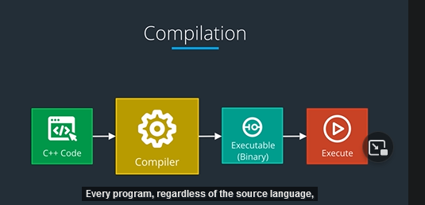

Need compile to execute

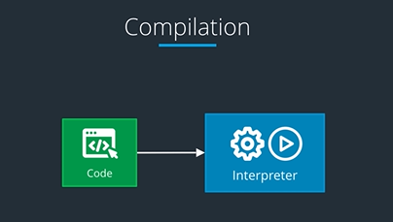

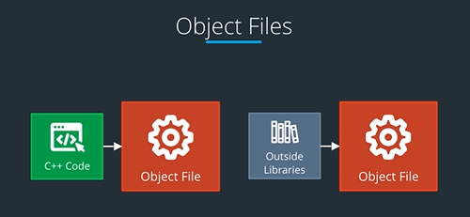

.cpp file inside the object file

Object file include machine code too

Sometimes object files are api and needed to link to execute and work

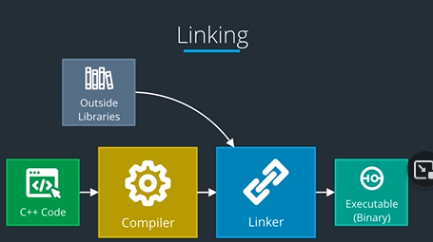

we picked the open source GNU Compiler Collection, more commonly called G++ or GCC. gcc is a command line tool.

There are many tools available to help you compile, ranging from barebones tools, such as g++ on Unix, to complex build systems that are integrated into IDEs like Visual Studio and Eclipse.

There is a high-level build tool called **CMake** that is fairly popular and cross-platform. CMake in and of itself, however, does not compile code. CMake results in compilation configurations. It depends on a lower-level build tool called **Make** to manage compiling from source. And then Make depends on a compiler to do the actual compiling.

./terminal

G++ help

Help

Pwd (print working dir

Chdir (cd) (change dir

Dir ( print all file and folder

Ls (list directory

• To compile the program: g++ filename.cpp -o executableName

• To execute the program: ./executableName

g++ filename.cpp -o nameOfExecutableCode.sth

./nameOfExecutableCode.sth [to run