Exercise 1 – Risk Factors for Cervical Cancer
Group 03: Ahmad, Taimoor, Zeeshan
10 November 2025

1 Introduction
This report presents a comprehensive analysis of the 'Risk Factors for Cervical Cancer' dataset sourced from the UCI Machine Learning Repository. The dataset contains medical and behavioral risk indicators such as smoking habits, contraceptive use, sexual history, and results from diagnostic tests. The objective is to build predictive models that can identify individuals at high risk of cervical cancer, assisting in early detection and prevention efforts.

2 Dataset Overview and Exploratory Data Analysis (EDA)
Feature | Count | Mean | Std | Min | Max
Age | 858 | 26.82 | 8.50 | 13 | 84
STDs: Number of diagnosis | 858 | 0.09 | 0.30 | 0 | 3
Dx:Cancer | 858 | 0.02 | 0.14 | 0 | 1
Dx:CIN | 858 | 0.01 | 0.10 | 0 | 1
Dx:HPV | 858 | 0.02 | 0.14 | 0 | 1
Biopsy | 858 | 0.06 | 0.25 | 0 | 1

3 Data Preprocessing
Data preprocessing included handling missing values, encoding categorical variables, and balancing the dataset. The following steps were applied:
- Missing values ('?') replaced using median imputation for numerical features.
- Categorical features encoded using label encoding.
- Dataset split into 80% training (686 samples) and 20% testing (172 samples).
- Data imbalance corrected using Synthetic Minority Oversampling Technique (SMOTE) in selected variants.
- Feature scaling applied using standardization.

4 Models and Training Setup
Three machine learning models were trained and evaluated using 5-fold cross-validation:
- **Random Forest (RF)**
- **Logistic Regression (LogReg)**
- **Support Vector Machine (SVM)**
Each model was evaluated under four configurations: baseline (median imputation), class-weight balancing, SMOTE oversampling, and KNN-based imputation combined with SMOTE. Evaluation metrics include ROC AUC, PR AUC, F1-score, recall, and training time.

5 Results Summary
The key performance results for all models and preprocessing variants are summarized in Table 2.
Model | Variant | CV ROC AUC (mean) | CV ROC AUC (std) | Test ROC AUC | PR AUC | F1 | Recall
Random Forest | smote_median | 0.9649 | 0.0153 | 0.9749 | 0.6683 | 0.400 | 0.273
SVM | classweight_median | 0.9732 | 0.0056 | 0.9373 | 0.5754 | 0.720 | 0.818
Logistic Regression | classweight_median | 0.9639 | 0.0170 | 0.9034 | 0.5546 | 0.696 | 0.727
Random Forest with SMOTE achieved the highest ROC AUC (0.9749), while SVM achieved the best recall (0.818), making it most effective in identifying positive cases. Logistic Regression showed balanced performance and strong interpretability, though at a higher computational cost.

6 Visualization Results
The following plots illustrate model performance comparisons on the test set:
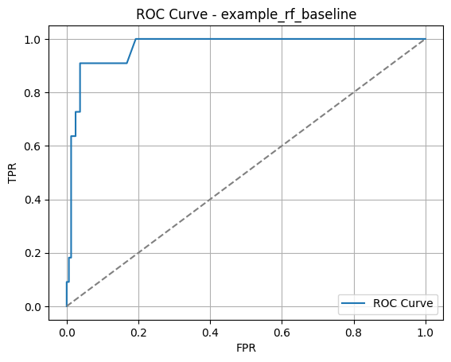
Figure 1: ROC Curve Comparison
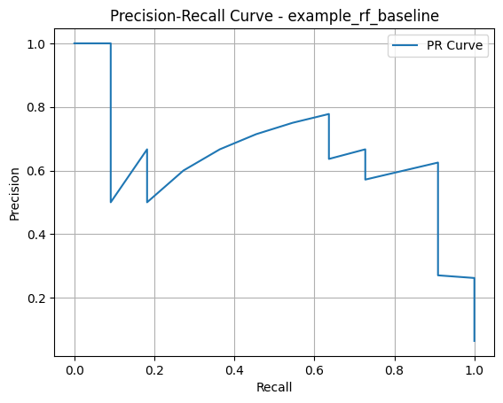
Figure 2: Precision–Recall Curve

7 Discussion and Conclusion
The analysis confirms that SVM and Random Forest models deliver robust predictive power for this medical dataset. Due to class imbalance, recall and PR AUC are critical metrics. The SVM model, with recall of 0.818, is better suited for identifying cancer-positive cases. Random Forest, achieving the highest ROC AUC, demonstrates superior overall discriminative ability. Logistic Regression performs comparably well but requires longer training times.
Future improvements could include hyperparameter optimization, feature selection using recursive elimination, and exploring deep learning models for more nuanced relationships.

8 Tools and Libraries
All experiments were conducted using Python 3.10 with the following libraries:
- scikit-learn (model training and evaluation)
- pandas, numpy (data preprocessing)
- matplotlib (visualizations)
- imbalanced-learn (SMOTE resampling)
- joblib (model serialization)
**Dataset Shape:** 858 samples × 36 features
**Target Distribution:** 803 (no cancer), 55 (cancer positive)
**Numeric Columns:** ['Age', 'STDs: Number of diagnosis', 'Dx:Cancer', 'Dx:CIN', 'Dx:HPV', 'Dx', 'Hinselmann', 'Schiller', 'Citology', 'Biopsy']
**Categorical Columns:** 25 categorical attributes including sexual history, smoking, contraception, and STD-related variables.
Table 1 shows key descriptive statistics for selected numeric variables.
Feature | Count | Mean | Std | Min | Max
Age | 858 | 26.82 | 8.50 | 13 | 84
STDs: Number of diagnosis | 858 | 0.09 | 0.30 | 0 | 3
Dx:Cancer | 858 | 0.02 | 0.14 | 0 | 1
Dx:CIN | 858 | 0.01 | 0.10 | 0 | 1
Dx:HPV | 858 | 0.02 | 0.14 | 0 | 1
Biopsy | 858 | 0.06 | 0.25 | 0 | 1

