P1 - As part of this assignment, we need to list down all the entities, their attributes and the table structures for the scenario mentioned in the previous slide. You also need to write the SQL queries required to create these tables along with few sample entries. Ensure the tables follow 1NF, 2NF, 3NF and BCNF rules.

The actual Movie Database I want to build: But this DB will have duplicate values and is not normalized:

|  |  |  |  |  |  |  |  |
| --- | --- | --- | --- | --- | --- | --- | --- |
| movie_id | movie_title | genre | view_type | city | theater | date | show_time |
| 1 | Jawan | Action | 2D | HYD | Cinepolis Mall A | 12-11-2023 | 3:00 PM |
| 1 | Jawan | Action | 2D | HYD | Cinepolis Mall B | 13-11-2023 | 6:00 PM |
| 1 | Jawan | Action | 2D | HYD | Cinepolis Towli Chowki | 14-11-2023 | 10:00 PM |
| 1 | Jawan | Action | 2D | HYD | INOX | 15-11-2023 | 2:00 PM |
| 1 | Jawan | Action | 2D | BLR | PVR | 15-11-2023 | 4:00 PM |
| 1 | Jawan | Action | 3D | MUM | PVR | 15-11-2023 | 4:00 PM |
| 2 | OPPENHEIMER | Drama | 2D | MUM | IMAX | 12-11-2023 | 3:00 PM |
| 2 | OPPENHEIMER | Drama | 2D | HYD | Cinepolis | 12-11-2023 | 6:00 PM |
| 2 | OPPENHEIMER | Drama | 2D | HYD | INOX | 13-11-2023 | 10:00 PM |
| 2 | OPPENHEIMER | Drama | 2D | BLR | INOX | 13-11-2023 | 2:00 PM |
| 3 | EVIL DEAD | Horror | 2D | BLR | PVR | 14-11-2023 | 4:00 PM |
| 3 | EVIL DEAD | Horror | 3D | KOL | PVR | 15-11-2023 | 4:00 PM |

Normalize the Tables:

We need to follow some normalizing techniques to separate the information in 3 separate Tables.

1. Movie Table
2. Theater Table
3. Show Table

**Movie Table:**

|  |  |  |
| --- | --- | --- |
| movie_id | movie_title | genre |
| 1 | Jawan | Action |
| 2 | OPPENHEIMER | Drama |
| 3 | Evil Dead | Horror |
|  |  |  |

Queries:

CREATE TABLE movies(

movie_id varchar UNIQUE PRIMARY KEY,

movie_title VARCHAR(50) NOT NULL, genre VARCHAR(50) NOT NULL)

**SELECT * FROM movies**

**Theater Table:**

|  |  |  |
| --- | --- | --- |
| theater_id | theater_name | city |
| 1 | Cinepolis Mall A | HYD |
| 2 | Cinepolis Mall B | HYD |
| 3 | Cinepolis Towli Chowki | HYD |
| 4 | INOX | HYD |
| 5 | PVR | BLR |
| 6 | PVR | MUM |
| 7 | IMAX | MUM |
|  |  |  |
|  |  |  |

Queries:

CREATE TABLE theaters (

theather_id varchar UNIQUE PRIMARY KEY,

theather_name VARCHAR(50) NOT NULL,

city VARCHAR(50) NOT NULL );

SELECT * FROM theaters;

**Shows Table:**

|  |  |  |  |  |  |
| --- | --- | --- | --- | --- | --- |
| show_id | theater_id | movie_id | date | show_time | view_type |
| 1 | 1 | 1 | 12-11-2023 | 3:00 PM | 2D |
| 2 | 2 | 1 | 13-11-2023 | 6:00 PM | 2D |
| 3 | 3 | 1 | 14-11-2023 | 10:00 PM | 2D |
| 4 | 4 | 1 | 15-11-2023 | 2:00 PM | 2D |
| 5 | 5 | 1 | 15-11-2023 | 4:00 PM | 2D |
| 6 | 6 | 1 | 15-11-2023 | 4:00 PM | 2D |
| 7 | 7 | 1 | 15-11-2023 | 4:00 PM | 3D |
| 8 | 8 | 2 | 12-11-2023 | 3:00 PM | 2D |
| 9 | 9 | 2 | 13-11-2023 | 6:00 PM | 2D |
| 10 | 9 | 2 | 13-11-2023 | 10:00 PM | 2D |
| 11 | 10 | 3 | 14-11-2023 | 4:00 PM | 2D |

Queries:

CREATE TABLE shows (

show_id varchar UNIQUE PRIMARY KEY,

movie_id varchar REFERENCES movies(movie_id),

theatre_id varchar REFERENCES theaters(theather_id),

show_time VARCHAR(50) NOT NULL,

date DATE NOT NULL);

SELECT * FROM shows;

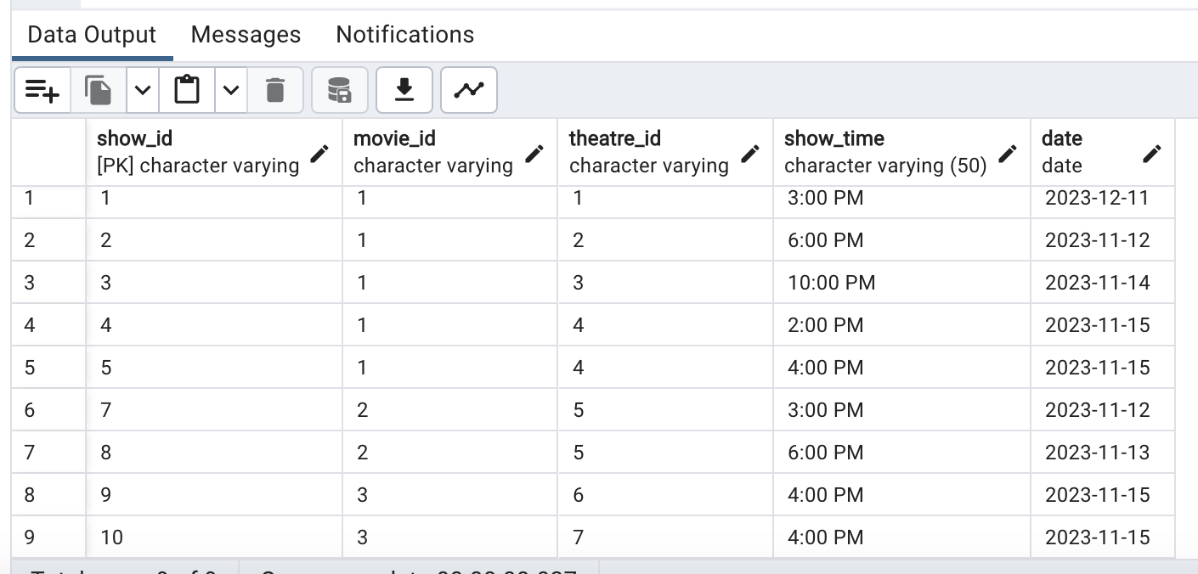

P2 - Write a query to list down all the shows on a given date at a given theatre along with their respective show timings.

Queries:

SELECT movies.movie_title, shows.show_time, theaters.theather_name

FROM shows

JOIN movies ON shows.movie_id = movies.movie_id

JOIN theaters ON shows.theatre_id = theaters.theather_id

WHERE shows.date = '2023-11-12' and theaters.theather_id = '2';

