ic2 design

Preliminary

Basics
ic2 is a 2D game viewed from above, with some 3D graphic effects. The environment is loosely based on an office.

Aim
- Each level has a task to complete.
- The game engages the player by providing puzzles, shoot-em-up action, and the achievement of progression through levels.
- Registered version should provide three hours of gameplay.

Elements
Player interacts with various elements.
- Office personnel. These are fairly dumb, and can be knocked out in various ways.
- Projectile weapons can be found which launch a variety of office objects.

Graphics
Graphical layout is much the same as the current ic2, with added features. Office furniture is pre-rendered in trueSpace using models found on the web. Player graphics are generated from rendering frames of crude models in trueSpace. The frames are stored as textures and drawn directly to the screen.

Audio
If the demo hits the target of 100k downloads, each MB in the demo adds £100 to server costs. Therefore the audio budget is limited to 4MB. The game proper can go up to 50MB before it causes problems. Current audio choice (SDL_mixer) can play OGGs and uncompressed WAVs.

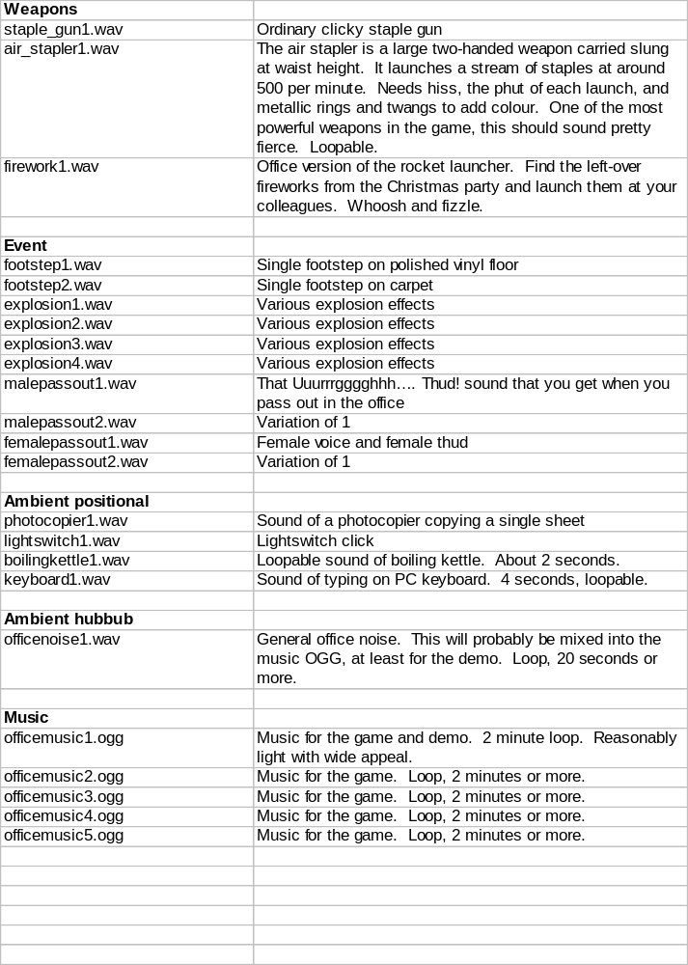

Appendix 1: Notes
- It would be nice to run around the office blowing everything away with a rocket launcher, before lobbing a nuclear warhead at the coffee machine and legging it. However this doesn’t address the target market fully. Game needs to be a bit nicer.

