Control

Problem
The user must control movement, including the orientation of the player, in 4D.

Degrees of freedom
In 2D, there are 3 degrees of freedom that determine the position and orientation of a player; two of position (x, y) and one of rotation (angle in the xy plane). In 3D, there are 6; three of position (x, y, z) and three of rotation (angle in the xy, xz and yz planes). In 4d, there are 10; four of position (x, y, z, w) and six of rotation (angle in the xy, xz, xw, yz, yw and zw planes).

However not all of these degree of freedom need to be controlled independently. It is possible to achieve any combination of position and orientation using a subset of potential movement. In general a player needs to:

- Move from place to place, at least my moving in the direction they are facing.
- Aim or turn to face other objects.
- Move to avoid incoming objects, i.e. in a direction other than the one they are facing.

Control is to some extent determined by the projection used on the display.

Proposals

Axial and radial projection
Radial projection maps one dimension to depth (i.e. ‘into’ the screen) and the other three equally spaced in the plane of the screen, 120° apart. Axial projection is similar, but the three ‘plane of screen’ dimension have a depth component to make the angle between all axis equal. They stick ‘out’ of the screen a to some extent, so unit vectors along each axis would form the corners of a regular tetrahedron.

Aiming
In a first person game, eye coordinates place the player at the origin, in this case looking along the w axis. To aim directly at an object, the player must change orientation so that, in eye coordinates, the object lies on the w axis.

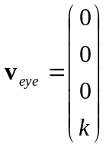 Equation 1
Our radial projective transform from eye to screen coordinates is
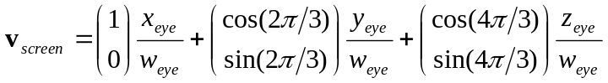
Equation 2
So when we are aiming at the object, it appears at (0,0) which we chose to be the centre of the screen. Unlike 3D, the converse is not true. If an object is at the centre of the screen we are not necessarily aiming at it. In projecting to 2D

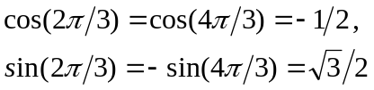 Equation 3
so
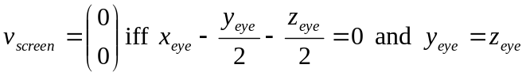 Equation 4
implying
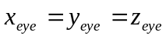 Equation 5
So any object where x, y and z are equal will appear at the centre of the screen, but the player won’t necessarily be facing towards it, and a shot fired along the w axis won’t necessarily hit it.

Mouse control
In this proposal, the three plane-of-screen axis are mapped similarly onto the mouse mat, so that x is left to right, y is bottom right to top left, and z top right to bottom left. The three axes of movement are 120° apart. Using 0° to represent movement from left to right and measuring angle anticlockwise, mouse movement affects player orientation as follows.

Angle of movement | Geometric effect | Result
0° | Positive rotation in xw plane
60° | Negative rotation in zw plane
120° | Positive rotation in yw plane
180° | Negative rotation in xw plane
240° | Positive rotation in zw plane
300° | Negative rotation in yw plane

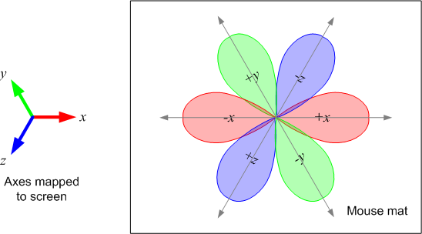
Figure 1: Mapping of mouse movement to rotation

For consistency with 3D games, the screen image should move in the direction opposite to the mouse motion. The rules are

- When the mouse is moved, points on the screen move in the opposite direction to the way the mouse pointer would move on the screen, and in proportion to the amount of movement
- In any sector, the motion will be achieved using the two axes that border that sector.

Two methods will be presented. The first works by generating a rotation about one plane, e.g. xz, and then the other, e.g. zw, the second by calculating the plane in which the rotation must occur.

Method 1
From Equation 2 we have
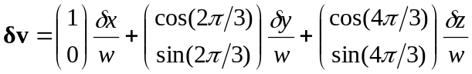
Equation 6
Let the mouse movement be represented by the 2D vector m in screen coordinates and a scaling factor be contained by k.
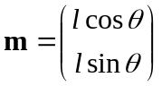
Equation 7
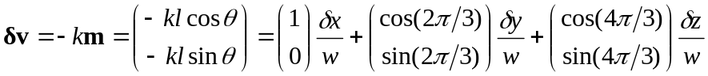
Equation 8
In sectors 0 and 3, δv is composed of δx and δz. Therefore
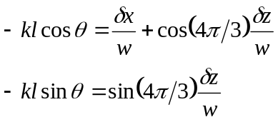
Equation 9
Solving yields
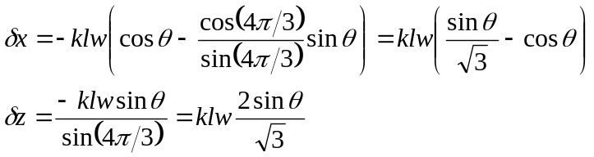
Equation 10
A rotation in xw moves point in the x direction thus
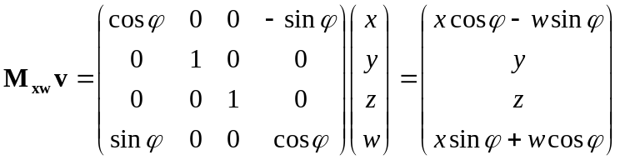
Equation 11
A similar result occurs for the zw plane. In the small angle approximation we take
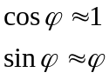
Equation 12
This yields a simple expression for δx that we can plug into Equation 10
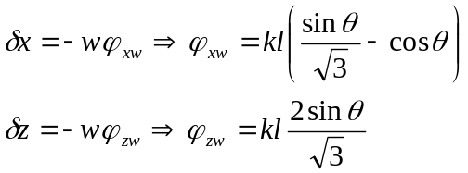
Equation 13
Therefore we can produce rotations that provide the correct δv by using the rotation matrices for the xw and zw planes using the angles calculated. However this derivation contains a number of approximations that require the angle of rotation to be small, namely
- w does not change appreciably, i.e. the rotation is not so large that objects of interest become noticeably closer
- The small angle approximation (Equation 12) is adequate
- The effect of applying one rotation after the other is not large. The zw rotation affects z as if the xw rotation had not been applied. This effect can be mitigated

A similar procedure provides the equations for the other sectors. For sectors 1 and 4

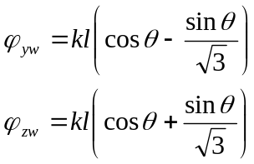
Equation 14
For sectors 2 and 5
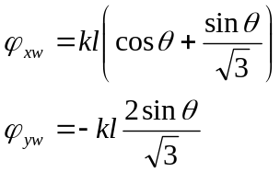
Equation 15

Method 2
This method determines the rotation plane required to support the mouse motion, and the rotation angle.

In sector 0, θ varies from 0° to 60°, with 0° corresponding to rotation only in the xw plane, and 60° to rotation only in the zw plane. As θ moves from 0° to 60°, the rotation plane rotates also, and can be defined by the following

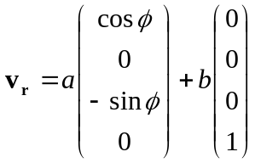
Equation 16
First we solve for φ, as the relationship between θ and φ is not linear. Using Equation 6, we assert that the rotation plane, projected into the screen, must be parallel to the direction of mouse movement.

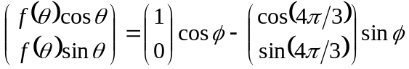
Equation 17
f(θ) is introduced because the magnitude of the vectors need not be equal. We solve be eliminating f(θ).

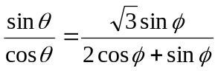
Equation 18
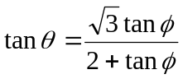
Equation 19
or equivalently

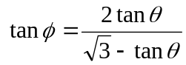
Equation 20
We can achieve a rotation in this plane by rotating in the xz plane (keeping y and w fixed) such that the rotation plane moves to the xw plane. We then rotation in xw, and then apply the inverse of the first rotation. The sequence of matrices applying these rotations is

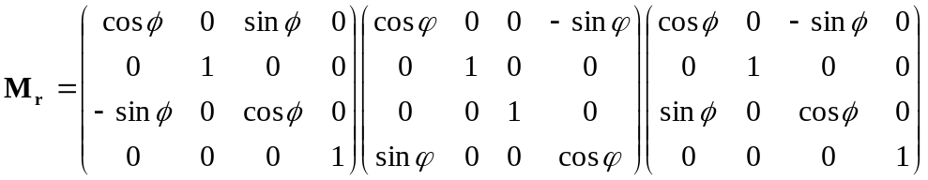
Equation 21
Multiplying out yields
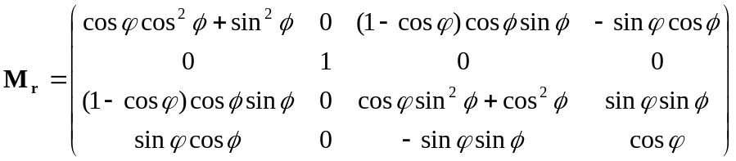
Equation 22
This gives us the appropriate rotation to move v in the right direction. Now we must calculate ϕ, the angle of rotation. Once again we make the small angle approximation for cosϕ and sinϕ from Equation 12
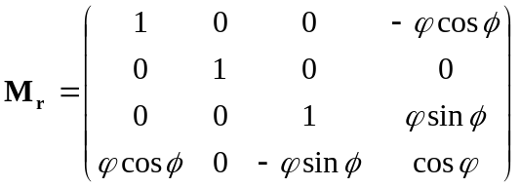
Equation 23
From this we calculate δx and δz
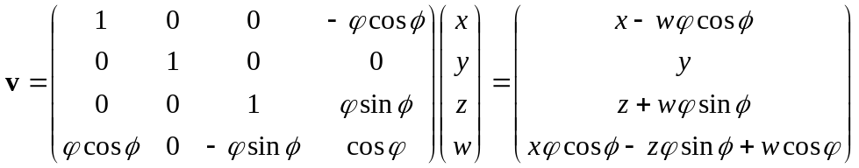
Equation 24
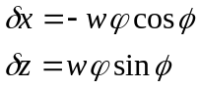
Equation 25
Returning to Equation 8
Equation 26
we have
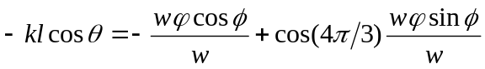
Equation 27
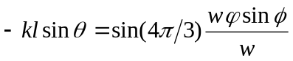
Equation 28
Either equation can be solved for ϕ.

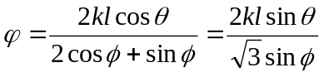
Equation 29
The equivalence of the two terms is a restatement of Equation 19.

