Rotation in four spatial dimensions
http://www.mushware.com/
DRAFT: This document has not been reviewed and may contain errors.

Problem
Orientation and angular velocity must be handled in four dimensions.

Characteristics
For rotation in four dimensions:

- There is no ‘axis of rotation’ in the conventional sense. In 3D, a rotation has 1 or 3 real eigenvalues, corresponding to rotation around an axis or the identity/inversion. In 4D, a rotation has 0, 2 or 4 real eigenvalues. These correspond to a rotation that moves every point, a rotation that leaves points in a plane fixed, and the identity/inversion.

Rotation with a pointwise-fixed invariant plane (2 real eigenvalues)

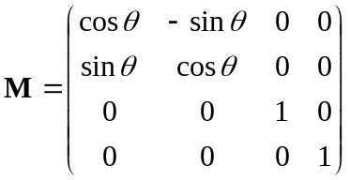 Equation 1
Matrix M represents a rotation in the xy plane by angle θ, keeping the z and w coordinates the same. The xy plane is invariant (because points in that plane stay in that plane), and the zw plane is pointwise invariant (because points in it do not move at all).

Rotation without a pointwise-fixed invariant plane (0 real eigenvalues)

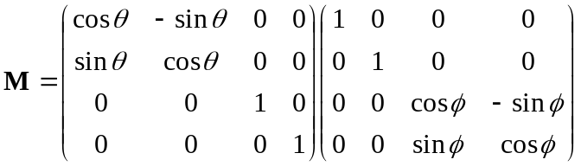 Equation 2
Matrix M represents a rotation in the zw plane by angle φ, keeping the x and y coordinates the same, followed by a rotation in the xy plane by angle θ as above. Generally this operation moves every point except the origin. If θ =φ or -φ, the rotation is isoclinic, and every point is moved through the same angle with respect to the origin.

Representations
Some possible representations for rotations are:

Type | Pros | Cons
Matrix | - Rapid calculation | - Need to be renormalised periodically due to calculation errors  - Difficult to interpolate between two orientations  - Cannot represent angular velocity >π
Quaternion pairs | - Easily converted to matrix form  - Easy to interpolate. | - Moderately difficult to calculate  - Cannot represent angular velocity >π
Quaternion pair + power | - Easily converted to matrix form  - Can represent angular velocity >π | - Difficult to calculate  - Difficult to interpolate
Angular velocity | - Potentially simple | - In 4D objects do not rotate about an axis. Two velocities and two orthogonal rotation planes are required
Euler angles | - Simple to generate a matrix representation | - Difficult to combine rotations  - Difficult to interpolate – gimbal lock

Quaternion representation and conversion
A unit quaternion is defined as
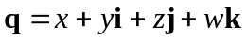 Equation 3
where
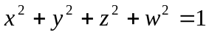 Equation 4
and Hamilton’s rules apply
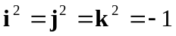 Equation 5
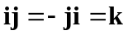 Equation 6
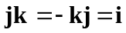 Equation 7
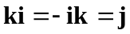 Equation 8

Converting from quaternion pair to matrix representation

From this definition, quaternion multiplication can be expanded and represented as a matrix.
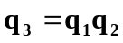 Equation 9
Expanding the multiplication yields:
Equation 10
Collecting terms:

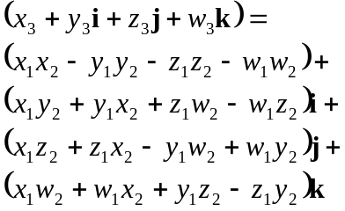
Equation 11
The equivalent matrix representation is:
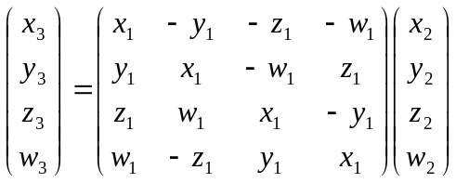
Equation 12
In three dimensions a unit quaternion can represents any rotation about the origin if points are transformed thus:
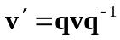 Equation 13
NB: Many published formulae for quaternion to matrix conversion result in a matrix that encapsulates the effect of both quaternion multiplications (which is shown below in Equation 19). The matrix above encapsulates just one.

For unit quaternions, the inverse is equivalent to the conjugate
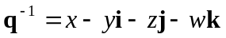 Equation 14
In four dimensions, a pair of unit quaternions can represent any rotation about the origin
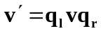 Equation 15
As shown in Equation 12, left multiplication by a quaternion can be represented by a 4×4 matrix:
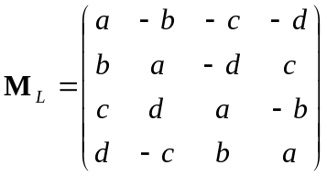 Equation 16
A similar procedure yields the matrix for right multiplication:
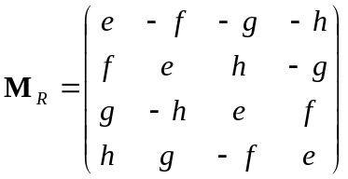 Equation 17
such that
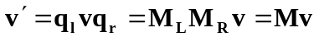 Equation 18

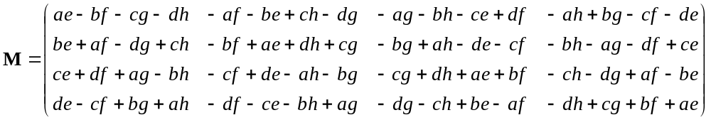
Equation 19
Matrix M can be used directly for rotation calculations.

There are two quaternion pair representations for each rotationError: Reference source not found, one obtained from the other by negating both quaternions. Negating all values a to h in Equation 19 leaves the matrix unchanged. This is relevant when interpolating between two orientations.

Converting from matrix to a quaternion pair representation
Determining quaternion values from a given matrix can be achieved as follows. For a rotation matrix M
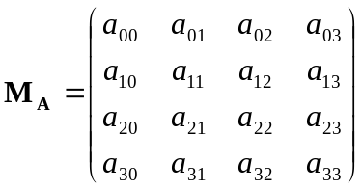 Equation 20
Let
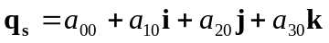 Equation 21
Let M_{S} be the matrix which implements premultiplication by q_{s}.
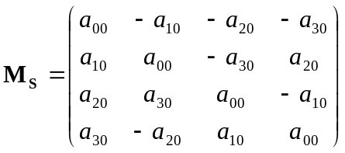 Equation 22
Since the inverse is the conjugate
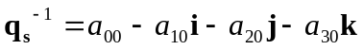 Equation 23
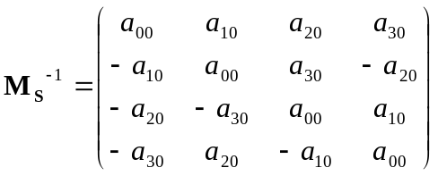 Equation 24
Calculate P such that
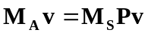 Equation 25
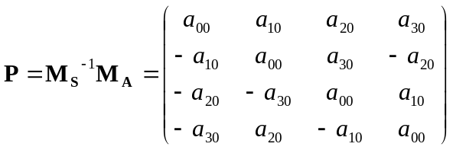 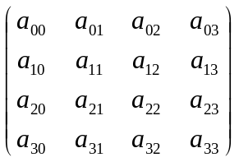 Equation 26
Therefore P has the form
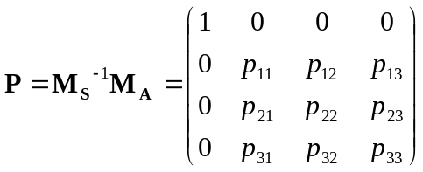 Equation 27
The top row is 1,0,0,0 because the rotation matrix is orthonormal and has the property
Equation 28
The zeros in the first column can be shown by inspection. We then construct a quaternion q_{p} that implements the 3D rotation P (by substitution into Equation 19, or as Salamin).
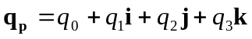 Equation 29
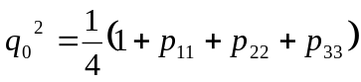 Equation 30
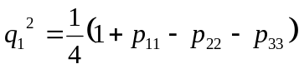 Equation 31
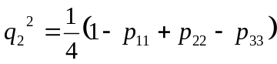 Equation 32
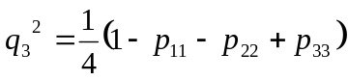 Equation 33
These equations determine the magnitude but not the sign of values within the quaternion. It is adequate to choose one root (usually the largest) with arbitrary sign and calculate the rest using the following.
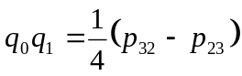 Equation 34
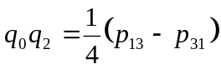 Equation 35
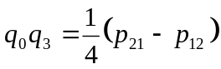 Equation 36
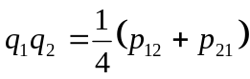 Equation 37
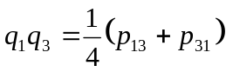 Equation 38
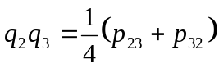 Equation 39
Returning to
Equation 25
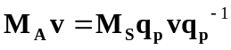 Equation 40
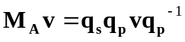 Equation 41
The quaternions performing the rotation are
Equation 42
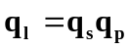 Equation 43
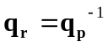 Equation 44

Summary
Quaternion values can be substituted into Equation 19 to generate the corresponding matrix. Below, the plane numbering is arbitrarily chosen. Trigonometric identities

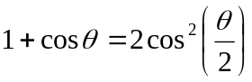
Equation 45
and
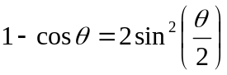
Equation 46
are used to simplify the results.

The choice of direction of rotation and plane numbering below is arbitrary, and in this case has been chosen such that, for a rotation of π/2, the first axis (appearing in the order xyzw) moves to the second. One alternative scheme is to ensure that a sequence of π/2 rotations such as xy → yz → zx will lead will leave the x axis pointing in the same direction (in this scheme here it would lie along –x). This can be achieved by negating the sine components in planes 2 and 3, and may be more consistent with group theory interpretations.

Rotation in plane 0: xy plane
A rotation through angle θ in the xy plane, where θ=π/2 takes x to y and y to –x.

Equation 47
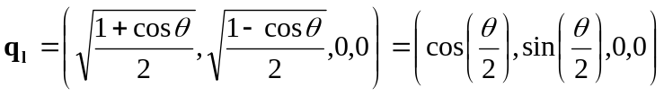
Equation 48
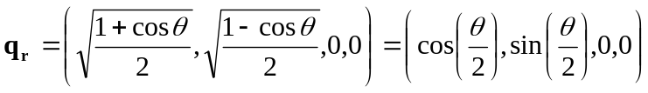
Equation 49

Rotation in plane 1: zw plane
A rotation through angle θ in the zw plane, where θ=π/2 takes z to w and w to –z.

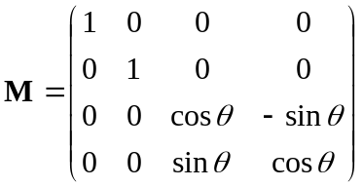
Equation 50
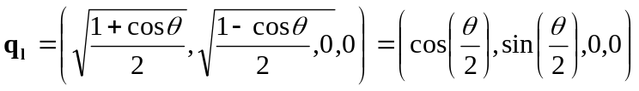
Equation 51
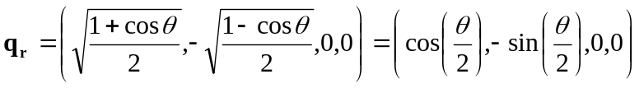
Equation 52

Rotation in plane 2: xz plane
A rotation through angle θ in the xz plane, where θ=π/2 takes x to z and z to –x.

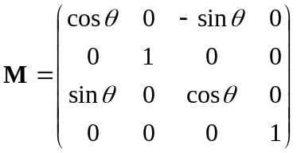
Equation 53
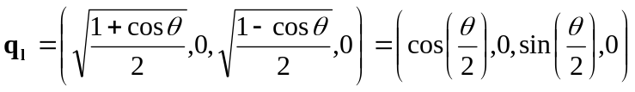
Equation 54
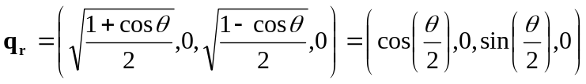
Equation 55

Rotation in plane 3: yw plane
A rotation through angle θ in the yw plane, where θ=π/2 takes y to w and w to –y. Note that the negated sine value is now in the left hand side quaternion.

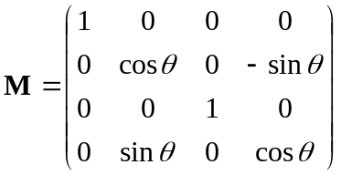
Equation 56
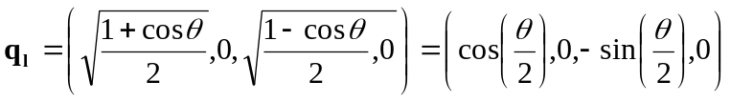
Equation 57
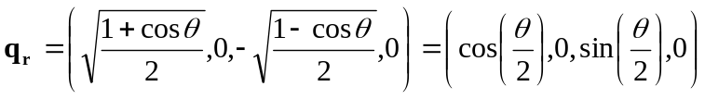
Equation 58

Rotation in plane 4: xw plane
A rotation through angle θ in the xw plane, where θ=π/2 takes x to w and w to –x.

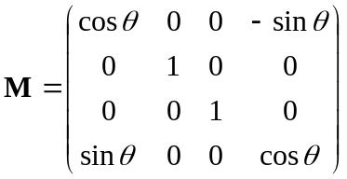
Equation 59
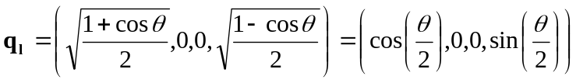
Equation 60
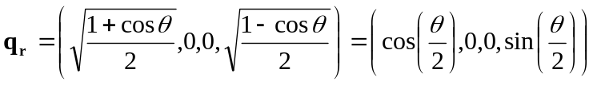
Equation 61

Rotation in plane 5: yz plane
A rotation through angle θ in the yz plane, where θ=π/2 takes y to z and z to –y.

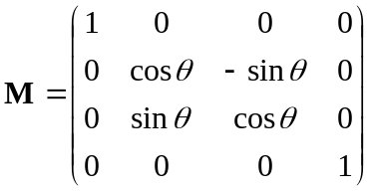
Equation 62
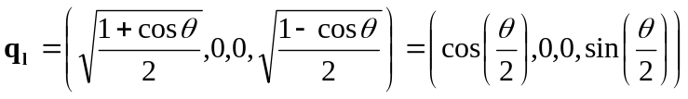
Equation 63
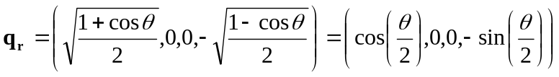
Equation 64

Combining rotations


Equation 65
The quaternion pair applying rotation A followed by rotation B is

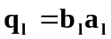
Equation 66
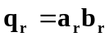
Equation 67

Interpolation

Quaternion representations of rotations can be interpolated using the slerp formula

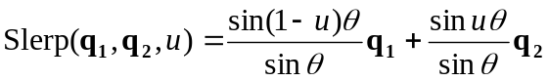
Equation 68
Where

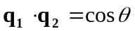
Equation 69
It is likely that this will extend to 4D rotations, using slerp on each quaternion independently, but no proof is presented here.

Version History
- 2004-12-01: Created with filename rotation1-2004-12-01
- 2005-02-28: Draft

Author: Andy Southgate. First published in the UK in 2005.
The author and his employer (Mushware Limited) waive all of their copyright rights vested in this particular version of this document, and any intellectual property rights arising from said document, to the furthest extent permitted. A written waiver can be obtained via http://www.mushware.com/.

A Matrix-Based Proof of the Quaternion Representation Theorem for Four-Dimensional Rotations Johan E. Mebius (2001) http://www.xs4all.nl/~plast/So4.htm
Quaternions and Orthogonal 4x4 Real Matrices Henry G. Baker (1996) ftp://ftp.netcom.com/pub/hb/hbaker/quaternion/orthogonal-4x4.txt
Application of Quaternions to Computation with Rotations Eugene Salamin (1979) http://www.ai.mit.edu/people/bkph/courses/Articles/stanfordaiwp79-salamin.pdf ftp://ftp.netcom.com/pub/hb/hbaker/quaternion/stanfordaiwp79-salamin.ps.gz
Animating Rotation with Quaternion Curves Ken Shoemake (1985) http://www-2.cs.cmu.edu/~kiranb/animation/p245-shoemake.pdf

