Core Temporal Design

Frame timing
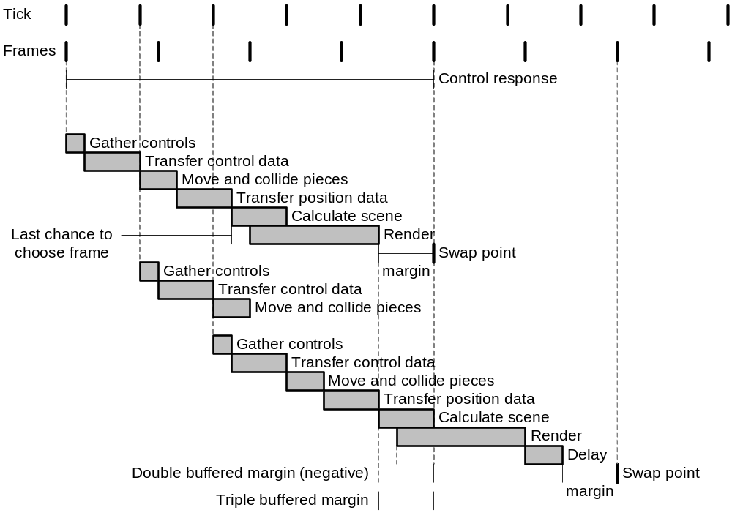
Figure 1: Frame operations and timing

Calculating the target frame
For smooth motion, the software must reliably predict which frame to render. It has the following information:

Known values
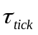 | Tick period
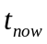 | Time now
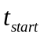 | Time at start of calculation
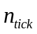 | Current tick number
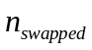 | Frame number which we last swapped to

Estimated values
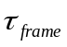 | Frame period
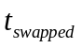 | Time that the last frame was swapped to the display
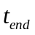 | Time at end of rendering

Configured values
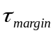 | Safety margin when calculating next frame

Calculated values
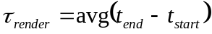 | Time taken to calculate and render a frame
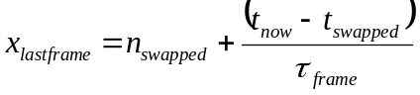 | The (non-integer) frame number for this exact moment
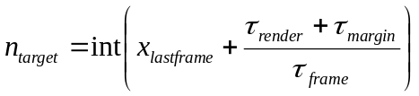 | Frame number we expect to be next when render completes
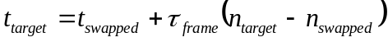 | Time when the newly rendered frame will be swapped in

Appendix 1: Notes
- How many threads do we need? Candidates are server thread, client thread and render thread.
- Need three diagrams for simple, local client/server and remote client/server.
- Frame timing is the same for simple, local and remote.
- Measurement points need to be marked.
- If threads are used, priorities need to be set so they do what we want, and behaviour needs to be predictable.
- For this project, we want to implement client/server assuming perfect and instant comms. Real multiplayer can be added later without having to redesign everything.
- Frame interpolation and prediction need position and velocity from the server.
- Timing points are:
  - Start of calculation
  - End of rendering
  - Swap point
- Margin can be adjusted dynamically, without interfering with the scheme.
- When double buffered, the swap point constrains when we can start the next render. Triple buffering removes this constraint.

