Projection

Problem
Objects in four-dimensional space must be mapped to a two-dimensional screen image.

Elements
For a first attempt, lets try to extend the concept of the human eye to 4-space. To simplify, I’ll treat the eye as a pinhole camera, with a small pinhole at the origin, and a projection screen on the left. Only rays that go through the origin are permitted to reach the screen.

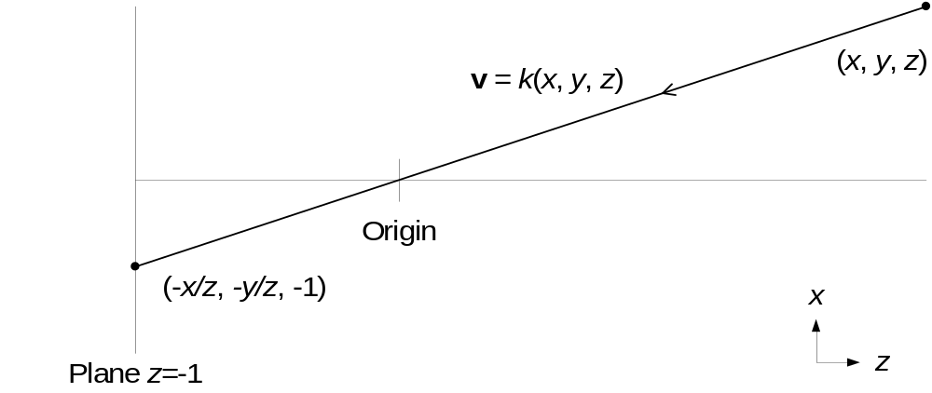
Figure 1: Pinhole camera with planar screen in 3-space
Figure 1 shows a conventional pinhole camera, with all points in z>0 projecting onto a plane at z=-1.

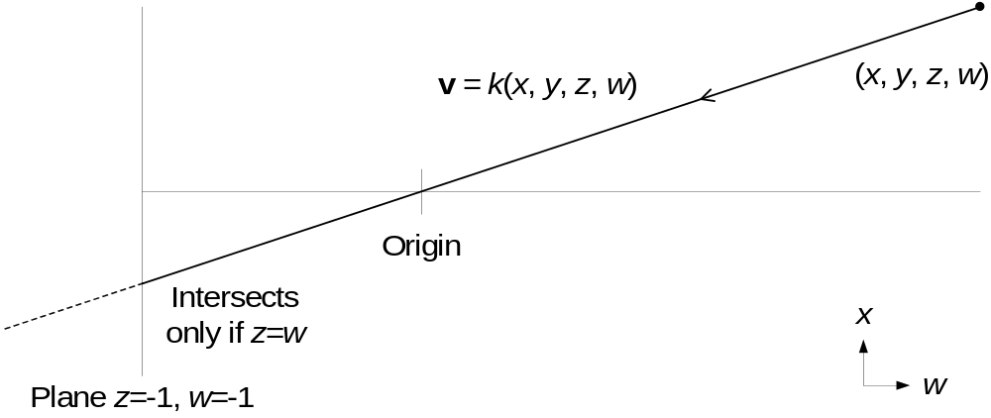
Figure 2: Pinhole camera with planar screen in 4-space
When extending the concept to 4-space in Figure 2, we hit a problem. A plane has two degrees of freedom and two constrained axes in 4-space, shown by the plane equation z=w=-1 above. The line equation v = k(x, y, z, w) will not satisfy the plane equation for any k unless z=w. So, almost none of the rays from points in z>0, w>0 hit the projection screen, and we don’t form a complete image of the scene. We only see parts of objects in the hyperplane z=w. This is a three-dimensional, zero-thickness slice of the scene.

This is not too much of a surprise, since a plane does not divide a 4-space into two parts, no more than a line divides a 3-space into two parts. The thing that does divide a 4-space into two parts is a hyperplane. A hyperplane has three degrees of freedom and one constrained axis.

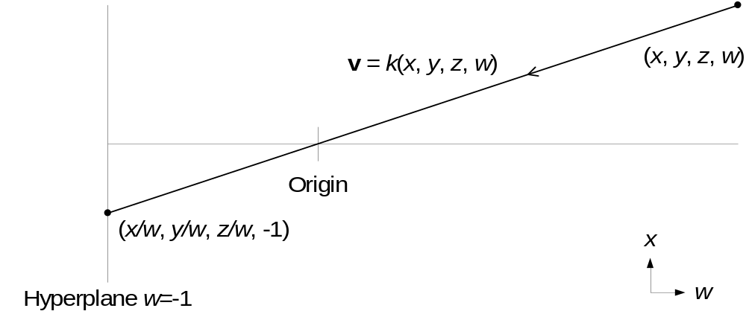
Figure 3: Pinhole camera with hyperplanar screen in 4-space
Using a hyperplane as a screen in Figure 3 generates equations similar to those for the 3-space camera in Figure 1. However i

