Projection and Rendering 1
DRAFT: This document has not been reviewed and may contain errors.

Introduction
This document describes methods for displaying a four dimensional space on a two or three0F0F dimensional display.

Problem
Objects in four dimensional space must be projected and rendered to a two or three dimensional screen image.

Analysis
There are many projections that map from four to three dimensions. Discarding one axis will do it, as will any 4×3 matrix where at least three of the columns are linearly independent. We need criteria to choose a particular transformation.

Desirable property | Description
Linear | Linear transformations are those that can be represented by a matrix and an offset vector1F1F. These are simple to handle mathematically.
Physically based (realistic) | There must be an optical model of the four dimensional space, from which the projection is derived.
Familiar | For ease of understanding the optical model should be similarly to that of the 3D real world. Light should travel in straight lines, reflect from surfaces, etc.
Dimensionally consistent observer | The observer in the 4D world should be a 4D creature. The author postulates2F2F that 3D entities in a 4D world are not real.
Retentive | The projection should retain information where possible. There are methods that lead to a rendered image of a 3D slice of a 4D world, but these discard a large part of the 4D world, which is undesirable.
Dimensional equivalence (homogenous space) | Each dimension should be equivalent to any other, i.e. there should be no ‘special’ direction or axis. There is one exception: the direction in which the viewer is looking is special, but if the viewer is looking along the x axis, the y, z and w axes should be treated equivalently by the projection. In practice this is difficult to achieve, as one dimension must be lost.
Table 1: Projection characteristics

For a first attempt, we to extend the concept of the human eye to 4-space. To simplify, I shall treat the eye as a pinhole camera, with a small pinhole at the origin, and a projection screen on the left. Only rays that go through the origin are permitted to reach the screen.

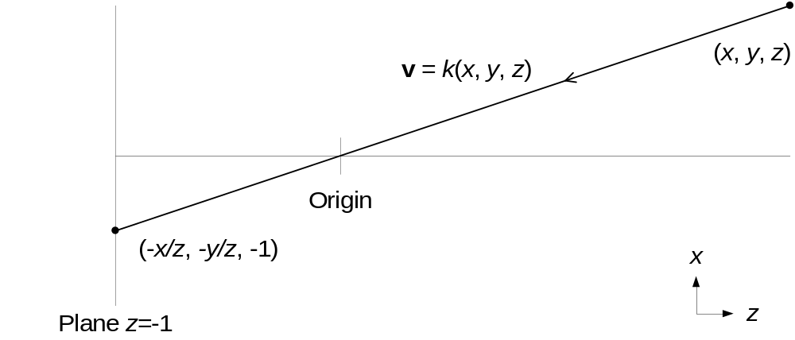
Figure 1: Pinhole camera with planar screen in 3-space
1H1HFigure 1 shows a conventional pinhole camera, with all points in z>0 projecting onto a plane at z=-1.

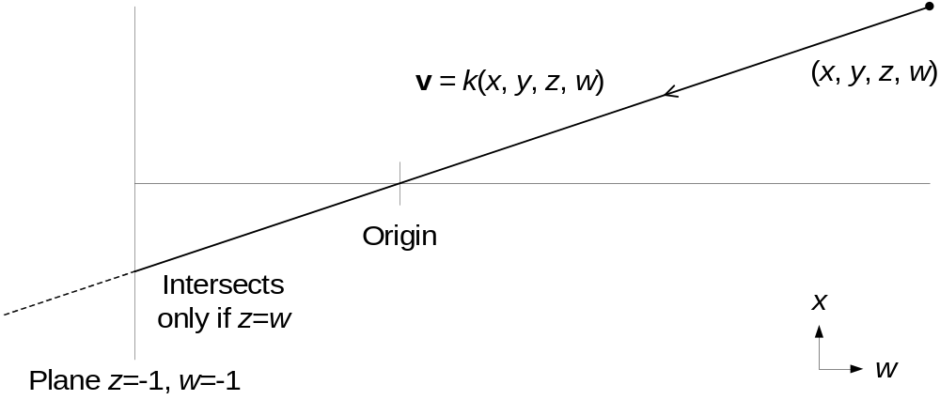
Figure 2: Pinhole camera with planar screen in 4-space
When extending the concept to 4-space in 2H2HFigure 2, we hit a problem. A plane has two degrees of freedom and two constrained axes in 4-space, shown by the plane equation z=w=-1 above. The line equation v = k(x, y, z, w) will not satisfy the plane equation for any k unless z=w. So, almost none of the rays from points in z>0, w>0 hit the projection screen, and we don’t form a complete image of the scene. We only see parts of objects in the hyperplane z=w. This is a three-dimensional, zero-thickness slice of the scene.

This is not surprising, since a plane does not divide a 4-space into two parts, no more than a line divides a 3-space into two parts. A hyperplane has three degrees of freedom and one constrained axis, and does divide a 4-space into two parts.

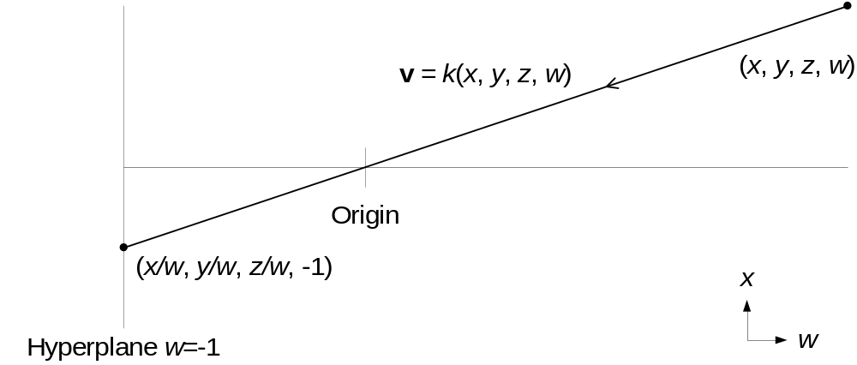
Figure 3: Pinhole camera with hyperplanar screen in 4-space
Using a hyperplane as a screen in 3H3HFigure 3 generates equations similar to those for the 3-space camera in 4H4HFigure 1. Each point in w>0 projects to a point on the hyperplane at w=-1.

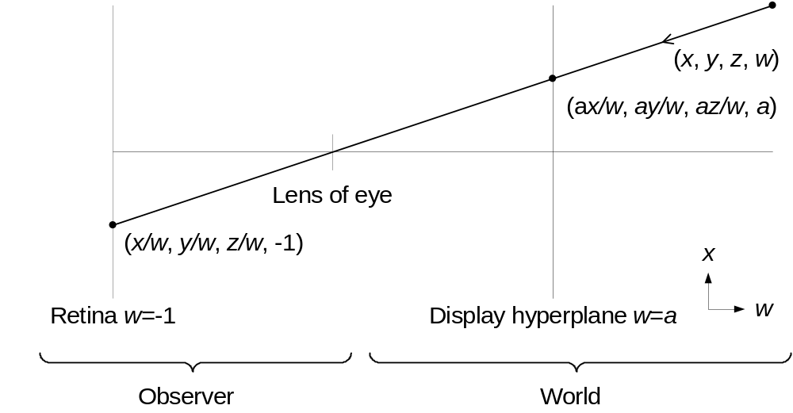
Figure 4: Observer and display in 4-space
Returning to the eye concept, this hyperplane is the retina of our four dimensional creature. 5H5HFigure 4 shows the division between the observer and the external world. The hyperplanar display at w=a mimics the view of the external world by projecting each point in w>0 into the display hyperplane. Both retina and display have extent in three dimensions and are thin in the other.

We can envisage a set of nerves leaving the retina in the direction perpendicular to it, each from a particular 3D position on the hyperplane (x, y, z). The signals from these nerves are processed by the brain to recreate an internal construct of the 4D space being viewed. Once the signals leave the retina, subsequent processing doesn’t necessarily require that the machinery exist in 4D space. A 3D brain similar to ours could theoretically do the same job for 4D space that ours does for 3D space, i.e. perform 4D spatial reasoning and navigation. However this facility is unlikely to arise without any stimulus or evolutionary advantage to be gained. In one sense, the task of the projection is to provide the best stimulus for a brain used to a 3D world to comprehend a 4D one.

Vertex projections
The vertex projection maps 4D vertices to 3D vertices. The projections presented here assume the pinhole camera and hyperplanar retina and display geometry shown in 6H6HFigure 4. This has implications for the projection:
- Only w is used in any perspective scaling and depth tests. We know whether one object is in front of another purely from their w coordinates3F3F.
- For a point at position v, any point kv in 4-space will map to the same point on the screen.
- The x, y and z coordinates in the hyperplanar retina map to x and y in the display screen, and w in 4-space maps to z in a 3 dimensional display.
- For a flat display or retina of finite size, there will be limits of the form –k < x < k or similar on coordinates within the hyperplane x, y and z. The exact form of the limits depends on the shape of the retina or display. Where the limit is exceeded, the associated point in 4D will not be visible4F4F.

Candidate vertex projections
It is convenient to draw 4D to 3D linear transformations as arrows representing the vector that each of the 4D axes map to. 7H7HFigure 5 shows the discard-z projection. The diagram on the left shows the axes as they appear on the display. On the right, the view has been tilted slightly to reveal the w axis.
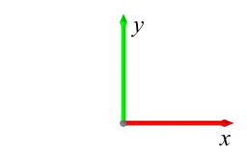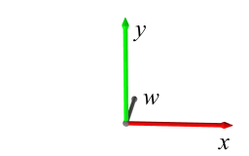
Figure 5: Discard-z projection
As the name suggests, this transformation simply discards the z coordinate. The transformation from eye to screen coordinates is:
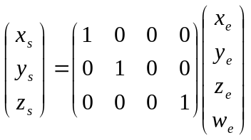
Equation 1: Discard-z transformation
8H8HEquation 1 does not include a perspective transformation; these will be discussed later on. In this simple form, the resultant axes in 3D appear as columns of the matrix. For a purely 2D display, z_{s} can be ignored.

9H9HFigure 6 shows the radial projection. Again the diagram of the right is tilted to reveal w. The other axes are coplanar.
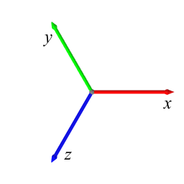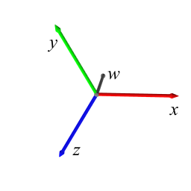
Figure 6: Radial projection
The radial projection attempts to treat all display plane axes (x, y and z) equivalently, by mapping them to the display 120° (2π/3 radians) apart.

First, we introduce scale factor k for the display plane coordinates5F5F.

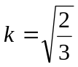
Equation 2: Scale factor k
The transformation from eye to screen coordinates is:
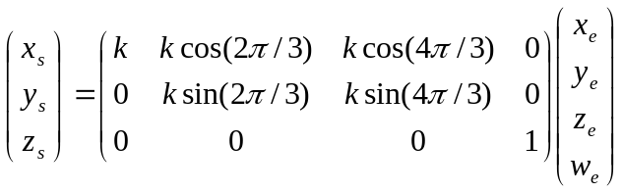
Equation 3: Radial transformation
It is important to note that this does not solve the dimensional equivalence problem. We are still discarding a dimension. Whereas discard-z simply discarded the z axis, the radial projection discards an axis in the direction (1,1,1,0). Addition of any proportion of (1,1,1,0) to any vector in eye coordinates will not change the projected vector in screen coordinates.

The radial projection differs only from the discard-z projection by a rotation in 4-space. This means that, instead of using the projection matrix in 10H10HEquation 3, we could apply a rotation to the eye coordinates first and then apply the discard-z projection from 11H11HEquation 1. This will prove useful later, as the discard-z projection is easier to interface with the OpenGL pipeline.

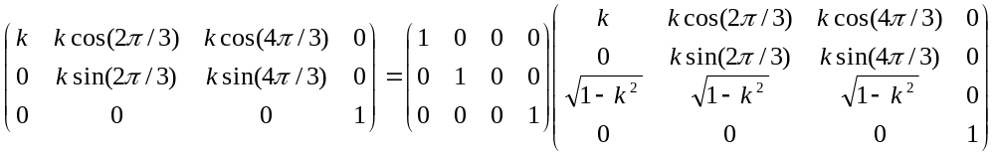
Equation 4: Conversion of discard-z to radial projection using a rotation
The matrix on the left of 12H12HEquation 4 is a rotation matrix6F6F. It allows us to interchange our projections using a rotation about the origin in eye coordinates in 4-space.

Using the 3D projection
Projection and rendering must be performed using hardware essentially optimised for 3D. Programmable vertex shaders have brought flexibility to the 3D pipeline, but in certain areas the pipeline is still fixed.

In OpenGL the projection matrix projects from eye coordinates to clip coordinates. Both include an additional coordinate to allow perspective projections, and both translations and rotations, to be contained in single matrices. Usually w is used to represent the additional coordinate, but since we have already used w for the fourth spatial dimension, h will be used. Clip coordinates map the extent of the display device to a cube with unit extent along each axis, i.e. -h≤x≤h, -h≤y≤h, -h≤z≤h. The projection transform also performs perspective shortening.

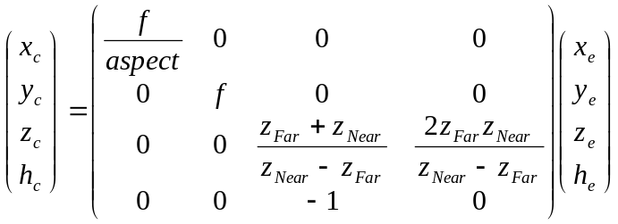
Equation 5: The projection matrix in 3D
f is related to the viewing angle and z_{Near} and z_{Far} specify the z position of the near and far clipping planes; the area within them is mapped between -h and h. The matrix scales the z axis appropriately for the depth buffer and copies z_{e} into h_{e} to perform the perspective transformation7F7F. Normalised device coordinates are then generated by dividing thus:

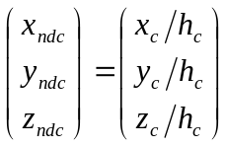
Equation 6: Perspective scaling in 3D
Putting these together for z_{ndc} yields:

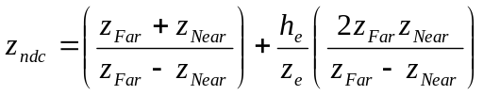
Equation 7: z value in normalised device coordinates in 3D
i.e. a scaled and offset value mapping the -z_{Near} and -z_{Far} planes to -1 and 1 respectively.

Points to note are:
- The projection matrix and perspective scaling invert z, such that 1/z is used for depth tests.
- Although we have support for four coordinates in eye space there are difficulties in using those directly as the coordinates in 4D space. The nature of h_{e} as the divisor of the z_{e} coordinates is important to transform z correctly for the depth buffer, clipping and perspective-correct texture mapping. The latter will most likely require the 1/z relationship of the 3D pipeline.

The 4D projection matrix
A 4D projection matrix can be constructed by combining the standard projection matrix with the vertex projections of 13H13HEquation 1 and 14H14HEquation 3.

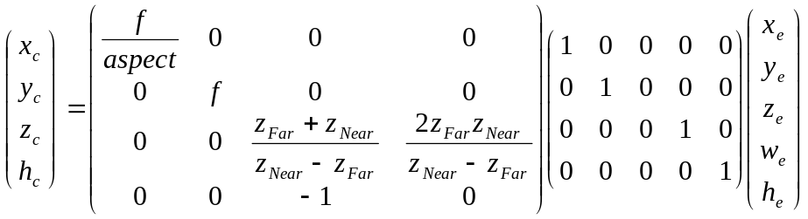
Equation 8: Projection in 4D
The new matrix introduced is a homogenous version of the discard-z matrix. We now have 5 eye coordinates, which has pros and cons. It is useful because a translation vector can be placed in the final column as per 3D OpenGL. The drawback is that hardware is not well optimised for 5 element vectors.

If programmable vertex shaders are available, the entire projection can be moved into the hardware.

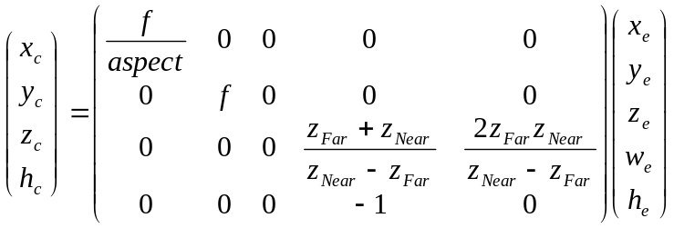
Equation 9: Projection in 4D for programmable vertex shaders
Although not used for projection, z_{e} will be required for lighting calculation, etc. To avoid 5 element vectors, it is desirable to use h_{e}=1 for all vertices. This will allow the reuse of the usual 4-value interfaces as h_{e} will not need to be passed. In the shader, calculation can be performed in the following stages:

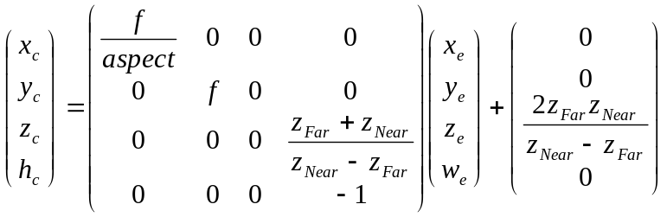
Equation 10: OpenGL shader projection calculation
This splitting of single matrices into a matrix and additive vector will be extended throughout the OpenGL pipeline in the following section. For now we note that a further trick can be played by setting z_{e} to the constant and modifying the matrix.

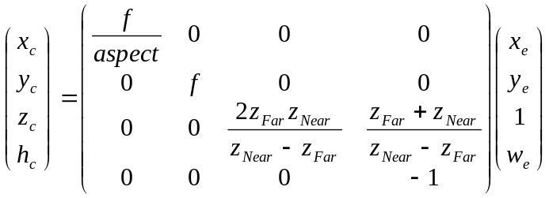
Equation 11: Modifying the projection matrix and input data to remove the additive vector

The vertex pipeline
The pipeline includes the model, view and projection transformation. For convenience we will separate the modelview matrix into its model and view elements. Each transformation will contained in a 4×4 rotation matrix and a 4 element additive vector.

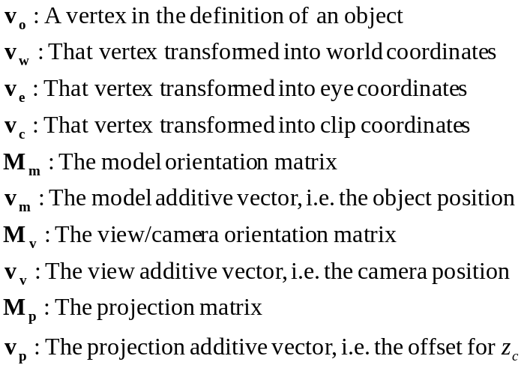
Equation 12: Notation
A vertex within an object undergoes the model, view and projection transformations shown below. A combined Modelview transformation is also shown.

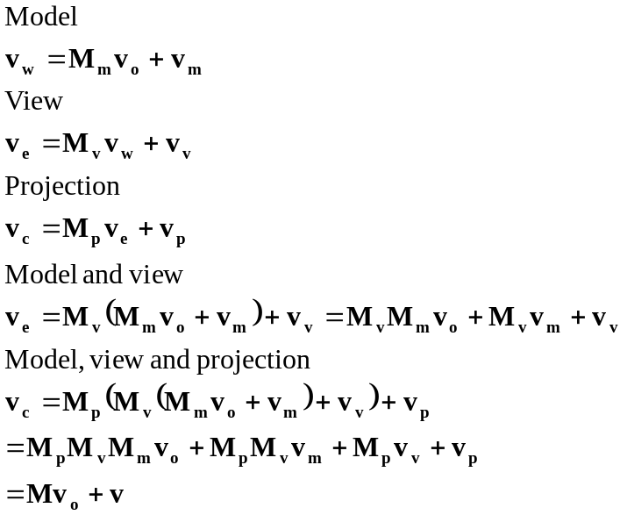
Equation 13: Vertex transformation pipeline
15H15HEquation 13 shows the effect of the model, view and projection matrices. If desirable, these can be combined into a single transformation using M and v as shown. However both M and v must be recalculated if any of the model, view or projection transformations change.

Optimisations
Given 16H16HEquation 13, how much of the OpenGL pipeline can be reused? On hardware with programmable vertex shaders, the entire transformation can be kept within the graphics card. Without them, only the projection matrix can easily be used. The modelview matrix could be used, but the additive vectors still need to be recalculated at each change of view, position or orientation, and this is similar in difficulty to calculating the vertex positions themselves.

Reuse of other aspects of the OpenGL 3D pipeline
Element | Description
Lighting | Without programmable vertex shaders only ambient lighting is reusable, as positions, distances and normals relate to 3D. With programmable vertex shaders, the position interface can be used (4D), but the normal interface cannot (3D). Another interface can be reused for normals, or at least the additional normal coordinate. An interface that supports the glDrawArrays method would be ideal, such as the texture coordinate interface.
Texture mapping | Texture mapping has a rich coordinate interface and presents no problems. However OpenGL 3D textures cannot be directly mapped to 3D faces of 4D objects. A 3D texture returns the value of a pixel at the given coordinates, whereas a 4D render with 3D textures requires the integral along a line drawn through the texture.
Normal vectors | Cannot be reused directly, as they are limited to 3 coordinates.
Clipping | Can be reused. An additional method is required for hidden axis clipping.
Table 2: Reuse of the OpenGL pipeline

Rendering

Hidden axis clipping and hinting
In the discard-z projection, the z coordinate is discarded and takes no further part in the rendering process. This presents a number of problems.

- No clipping is performed on the z axis. This means that everything, regardless of its z value, will be drawn. This is in contrast to the x and y coordinates, for which objects are clipped to the viewing frustrum.
- No distance shrinking occurs for the z axis. For x and y, distance shrinking occurs implicitly because the screen is further from the viewer as x and y increase. Although the effect is small for x and y, it can become large for z if z is not clipped. An object far away in z, say at (0,0,10000,1), would be drawn the same size as the same objects at (0,0,0,1). Its size will be a strong function of the view orientation. This would lead to a confusing display.
- There is no way for the viewer to know the position of an object in z from its position and size on the display. Additional hinting is required if the view is required to aim at the object. To allow accurate aiming, the hinting must convey the z coordinate quantitatively.

17H17HTable 3 lists several methods for hidden axis clipping. These can be combined if desired.

Solution | Description
Alpha clipping | In this solution, objects diminish in alpha as they move away from the view axis in z. Objects at distant z are transparent so are not seen. Since we are introducing transparency the renderer must solve the order-dependency problem.
Additional clipping hyperplanes | Objects are clipped against hyperplanes z=±k. This method treats the z axis similarly to x and y so is consistent. However clipped edges can be visible on the display as hard and unnatural lines truncating visible objects.
Pseudo-perspective | Pseudo-perspective shrinks objects as they move away from the view along the z axis. Scaling is applied so that the object is the correct size for its distance from the viewer. The object keeps its place in the depth sort order because, although scaled, it has not moved further away in w. The guiding principle is that rotating the view in the zw plane (or any plane) should not change the size of the object, as the distance to it has not changed.
Table 3: Hidden axis clipping
18H18HTable 4 suggests various methods for hidden axis hinting. Again these can be combined if desired. Ideally these are done on a per-vertex or per-pixel basis, not per-object.

Solution | Description
Ghost image hinting | Objects are rendered with one or more translucent copies at an offset in x and y from the main object. The degree and/or direction of the offset depends on the z value at that point
Blur hinting | Objects blur as they move away on the z axis. Although technically demanding, the concept of objects blurring as they move away in another dimension is appealing. A directional blur could be used to hint the sign of z.
Parameter hinting | Various rendering parameters can vary with z. Static qualities, like colour, texture, and illumination. Dynamic qualities, such as a periodic wobble, with its amplitude dependent on the z coordinate. Even size or orientation could be used. However some of these effects may reduce the realism of the scene.
Stereoscopic hinting | The z axis could affect the stereoscopic displacement of objects. Even vertical parallax could be introduced, if the eye could make sense of it.
Instrumented gunsight | If hinting is required only to aim at an object, the renderer could add a display to the gunsight (or elsewhere) telling the user where the object within it is on the z axis. Knowledge of the z axis should not be required to bring the target into the gunsight in the first place.
Texture blending | Using multiple textures and transparency, the resulting texture of an object can change with its position on the z axis.
Rolling or wobbling view | Either a continuous rotation or a wobbling of the view could be introduced in an attempt to make the z coordinate apparent. This may just confuse the viewer however.
Table 4: Hidden axis hinting

Alpha clipping
Alpha clipping ensures that objects at distant z are not drawn by making them transparent. Alpha is determined from the z and w coordinates of a vertex or pixel.
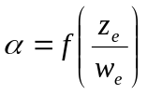
Equation 14: Alpha for alpha clipping
The smoothstep function is one candidate for generating smooth α values.
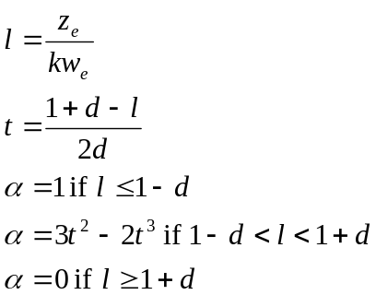
Equation 15: The smoothstep function for alpha
The value of k controls the position of the cutoff, and d controls its sharpness.
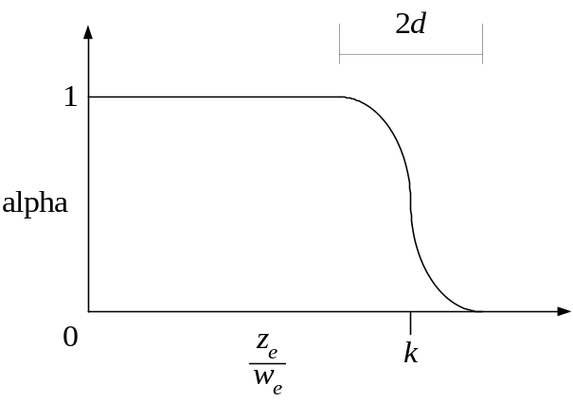
Figure 7: The smoothstep function for alpha
The value of alpha can change in a non-linear way as we move across polygons. If the mesh size (and hence the polygons) is large compared to the rate of change of alpha, artefacts will appear due to linear interpolation of the non-linear function across the polygon. In this case, either further mesh division, larger d or per-pixel alpha calculation in the fragment shader can be employed.

Pseudo-perspective
Pseudo-perspective can be achieved by replacing the perspective transform. From 19H19HFigure 3 we see that the perspective transform is:

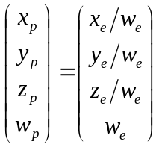
Equation 16: Perspective transform for a 4D pinhole camera
Pseudo-perspective is required because an axis has been discarded, so we must first specify which axis has been discarded. In 20H20HEquation 17 we use the discard-z projection. We use the principle that rotation of the view in zw should not change the size of the visible object.
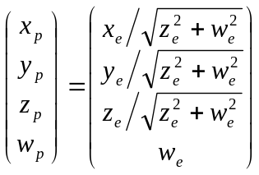
Equation 17: Pseudo-perspective transform
Although shown above, z_{p} need not be calculated as the subsequent discard-z transformation will discard it.
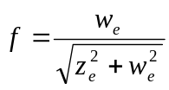
Equation 18: Pseudo-perspective correction factor
The correction factor in 21H21HEquation 18 may appear potentially large, but objects that stray too far from the view axis will be clipped. For an object at angle θ off-axis in the zw plane, f=cos θ. Points to note are:
- The pseudo-perspective transform is non-linear.
- The correction factor is small: 0.85<f<1 for a view half-angle of <30˚.
- Objects move towards the centre of the screen when f is applied, as well as shrinking.
- When an object is being aimed at, its position will be close to (0,0,0,k) and f will have little effect. Pseudo-perspective does not provide useful hidden axis hinting at the aiming point unless the aim is significantly off.
- The calculation presented is not rigorous; it is based on a guiding principle.

Hinting examples
22H22HFigure 8 and 23H23HFigure 9 show the result of some of the hinting techniques8F8F. A curved bar is rotated slightly about its central point by a small angle θ in zw so that at the top, z_{e}≈-θ, in the centre z_{e}=0 and at the bottom z_{e}≈θ.
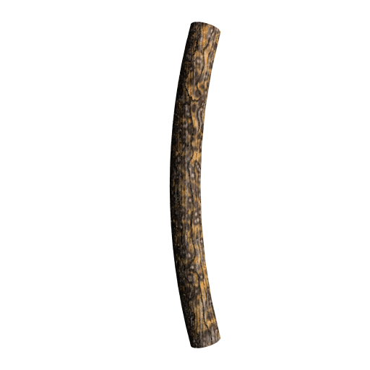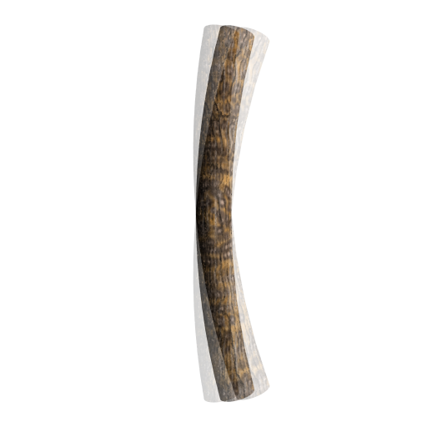
Figure 8: Unhinted (left) and ghost hinted images (right)
In the unhinted image the z displacement is not visible. In the ghost hinted image the ghost images move further from the main image as the z displacement increases.

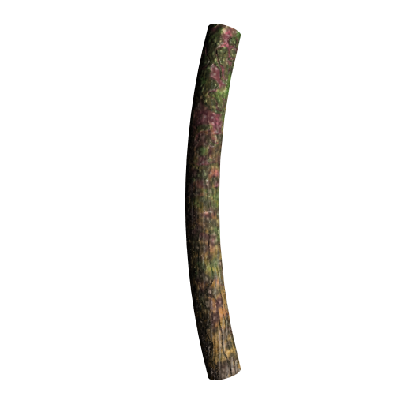
Figure 9: Blur hinted (left) and texture hinted images (right)
In the blur hinted image, the ends of the bar are blurred in proportion to their z displacement. With texture hinting, the surface texture changes with the z displacement.

More complex hinting is possible, including techniques which . For example, the blur could stream off to one side or the other, depending on the direction of the z displacement. Te pattern of ghost images could appear on different sides of the object for positive and negative z. The texture itself could be ghosted, so that another, transparent copy of the surface texture slides over the base texture as z changes.

Rendering
The above section has covered the pipeline for vertex projection. One major question remains. What should a 4D object look like? How do we render the faces of the object? Although this section begins from a ray tracing perspective, our eventual aim is to produce a polygonal renderer for 4D objects.

Faces of 4D objects
Consider one of the eight faces of the four dimensional hypercube or tesseract. We choose the face for which x=1 and y, z and w range from –1 to +1. This face has a single normal along the x axis (1,0,0,0). Light rays approaching from the region x>1 that impinge on the face undergo specular reflection, diffuse reflection and absorption. No rays impinge on the face from x<1, as those would be coming from inside of the object.

A light ray hits the face at a single point (1,y,z,w). The face has definite material properties at that point and reflects light in a predictable way. In the renderer, those characteristics could be represented as a combination of uniform and varying variables, and parametric and stored 3D textures.

However, we hit a problem. Because the projection to the screen necessarily discards one axis, each pixel on the screen will correspond to an entire line through the 3D texture. By considering a ray model we shall see why.

Ray models
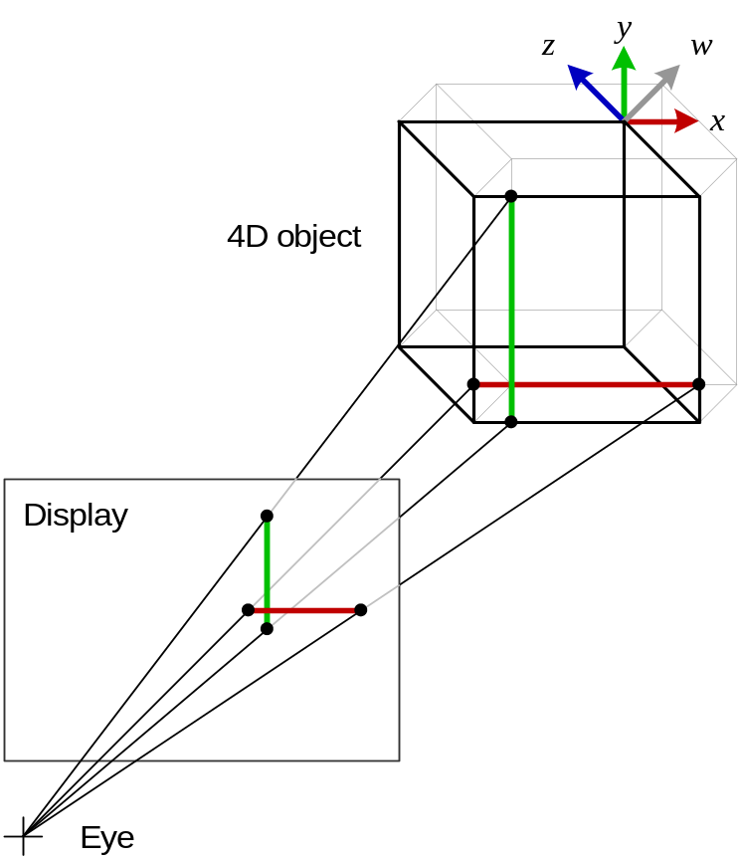
Figure 10: Ray projection of x and y using the discard-z transform
24H24HFigure 10 shows a ray projection from a 4D tesseract to a 2D display using the discard-z projection. A single face is highlighted using bold lines. Projected rays are shown as the x and y axes are traversed across the face. The tesseract has zero rotation, so its axes are the same as eye space. As we traverse the face in x and y, the projected ray traverses an area in x and y on the display. Each x and y value on the face corresponds to a unique x and y value on the display. This situation is similar to 3D ray projection.

Before continuing, it is important not to be lead into the 3D interpretation of this diagram. Although the face looks like a cube, it is flat and has zero hypervolume. It has zero thickness in the w direction. At any orientation, no part of the face can be in front of or behind any other part in a way that would hide one part from the viewer. The face is a boundary between the inside and outside of the object, and not an object itself. It is analogous to a square face of a cube in 3D, and not to the cube itself. Whereas a cube in 3D has 3D volume, this face has 3D surface hyper-area.
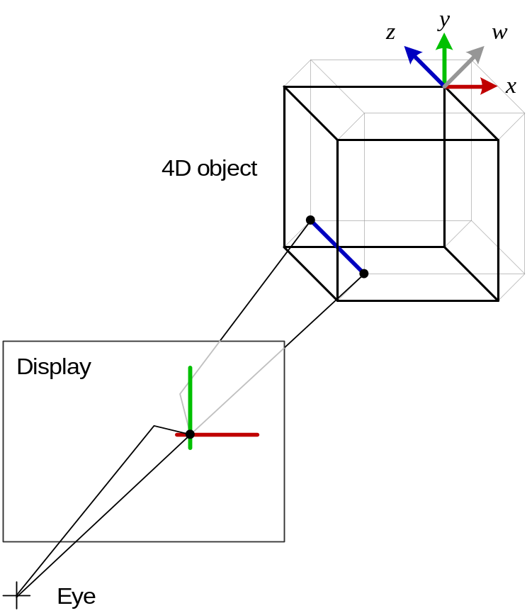
Figure 11: Ray projection of z using the discard-z transform
25H25HFigure 11 shows the effect of traversing in z across the face. Since z is discarded by the projection, traversing in z across the face has no effect on the position mapped to the display. Since no part of the z traversal is particularly special compared to any other, each part makes an equal contribution to the colour of that part of the display. Hence the contribution to the display will be the sum of colours present along the path in z across the face.

Now consider the z=1 face. As we traverse z we cross this face, and find it has zero thickness in z. How does this face reflects light? Light arriving from z>1 reflects from all points of the form (x,y,1,w) which are on the face. However none of this light goes back to the viewer at the origin, because the face is of zero thickness when viewed from that point. It is edge on, in the same way that the x=1 and y=1 faces are. The difference is that, whilst x=1 and y=1 map to zero-thickness lines on the display, z=1 covers the entire size of the tesseract on the display. A consequence is that, as the tesseract rotates and one face approaches the z=1 orientation, it will because very large and disappear! This is because its aspect of zero thickness is hidden as the z axis is discarded by the projection. The reason it has zero thickness as we traverse it in z is because it is not visible.
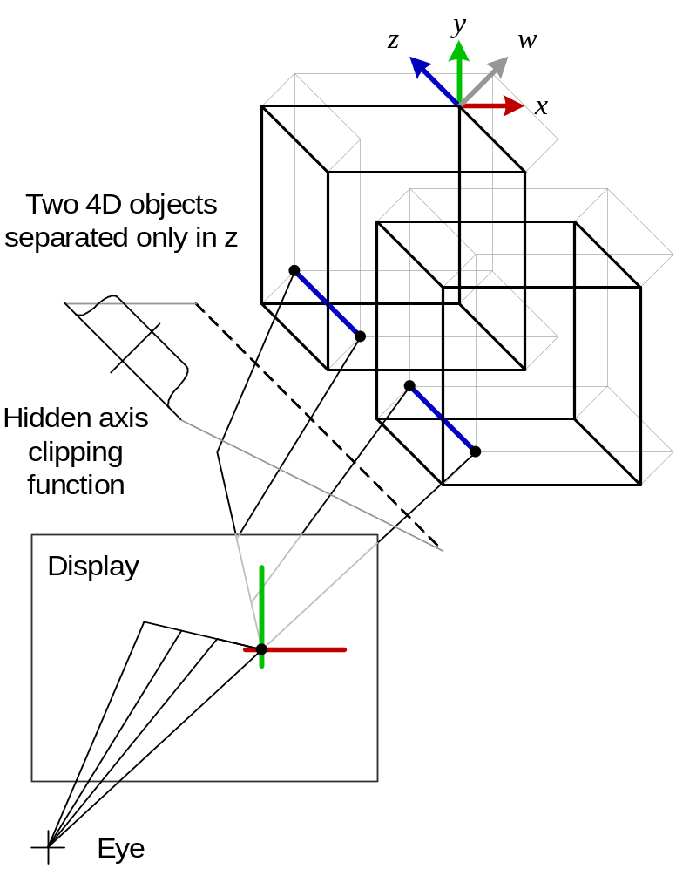
Figure 12: Projection of z from multiple objects
When multiple objects are introduced in 26H26HFigure 12, we find that the colour at a particular display point potentially depends on the contribution of all of the objects that project to that point. The hidden axis clipping (HAC) function limits the view in the z – a job done by the limits of display size for x and y. The function modulates the contribution of each part of the z traversal. Perspective, depth culling and transparency also modulate the contribution, in the same way that they do for the x and y axes.

Now we can attempt to form the proper path integral along the z axis. It has the following properties:
- The coordinates x/w and y/w determine where a coordinate in eye space will map to the display. Regions in eye space for which x/w and y/w match the
- In the w direction, pixel values are combined using depth testing and alpha values, as they are in 3D.

It is as if we render a line to the display for the z traversal just like we did for the x and y traversals, and then squash that line into a single pixel.

Points to note:
- The shape of the HAC function can be altered in order to render a slice or wedge of the scene. If the hack function becomes a narrow peak, we return to rendering a 3D slice of the 4D world.
- There are corollaries with the retina of our 4D creature. To map the 3D retina to our 2D retina, lines must be contracted into points. Since there is no criterion for selecting areas of the 3D retina (no part is ‘in front’ of another) the mean value is taken.

Implementation
We could render the scene much as described, by integrating the paths through the 3D textures relevant to a particular pixel, whilst applying the HAC function, and writing the result to the pixel. However that would be difficult, exhibit poor performance, and besides we would like to draw polygons rather use a ray tracing technique.

One possible solution has been hinted at already. We rotate about the origin in eye coordinates in yz so that the z axis maps to the y axis and the y axis is discarded. We then render a thin slice of the scene at a particular y value. This slice is the intersection of the slice hyperplane with the face hyperplane. Except for degenerate cases, this intersection will be a 2D plane. Therefore we can use conventional 2D polygons to render this intersection. When rendering 3D textures we use a single value from the texture, instead of the sum of a path, because the slice is thin.

The HAC function is applied by blending a texture over this rendered image, to diminish the top and bottom edges smoothly towards black. Each vertical column of pixels would then be summed and scaled to generate a value for the display pixel for the y value we initially chose and the x value of the pixel column. The drawback of this method is that it increases the computation requirement per frame by a factor of the display dimension, i.e. ≈1000. 27H27HFigure 13 shows the pipeline.

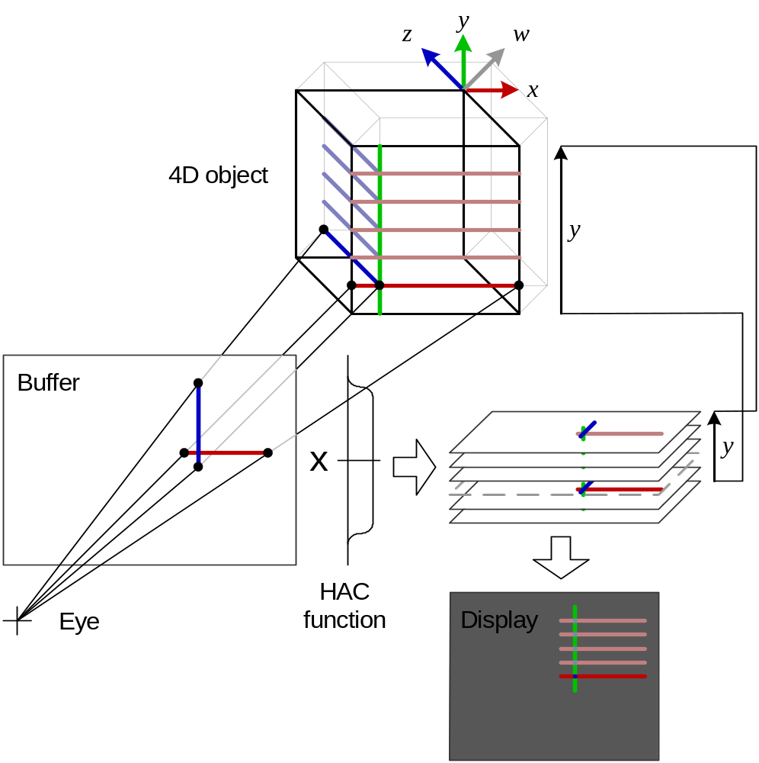

Figure 13: Rendering pipeline for y layered stack
What happens to the depth test and perspective effect of w in the above pipeline? The depth test is performed when rendering each to the buffer. Since depth depends only on w our rotation in yz has not changed the relationship of different primitives.

Let us consider how each face orientation is rendered in this scheme. The faces x=±1, y=±1 and z=±1 are edge on to the display so are not drawn, so we tilt them slightly to make them visible. A small rotation in xw, yw or zw respectively is suitable. For x=1, the face extends in y, z and w and it flat in x. The face is sliced in y and for each slice a rectangle is rendered into the buffer for that slice, 2 units high (the size of the face in z) and 2cosθ wide (where θ is the angle of our tilt). This rectangle is the generated as the intersection of the face with the hyperplane y=y_{s} which defines this particular slice. Other orientations of the face may produce a differently shaped section through the cube.

At each pixel in the rectangle, the fragment shader chooses a single value from its 3D texture, using the 3 texture coordinates that span the face, performs the depth test on w using the buffer, and writes it to the buffer if it passes. After rendering, the HAC function is applied, which smoothly darkens the top and bottom of the screen towards black. Vertical columns in the buffer are summed, and each sum is written to a pixel on the display. The x coordinate on the screen is the x coordinate of the column, and the y coordinate is the y coordinate of the slice. The process then proceeds onto the next slice. The figures below show the results.
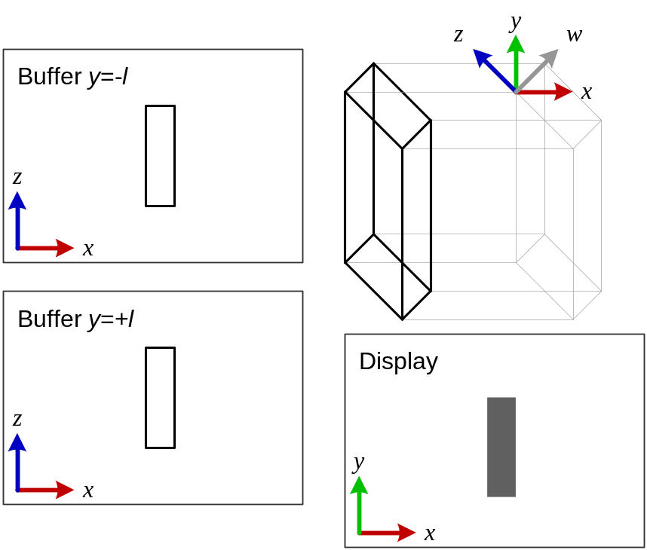
Figure 14: Result of rendering the x=-1 face to the display
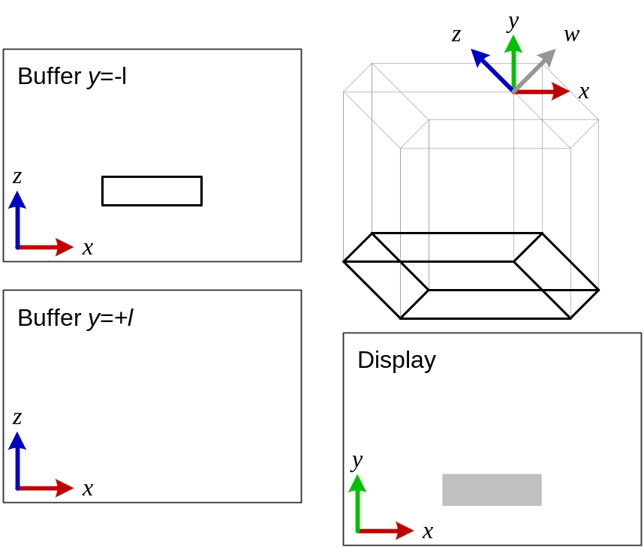
Figure 15: Result of rendering the y=-1 face to the display
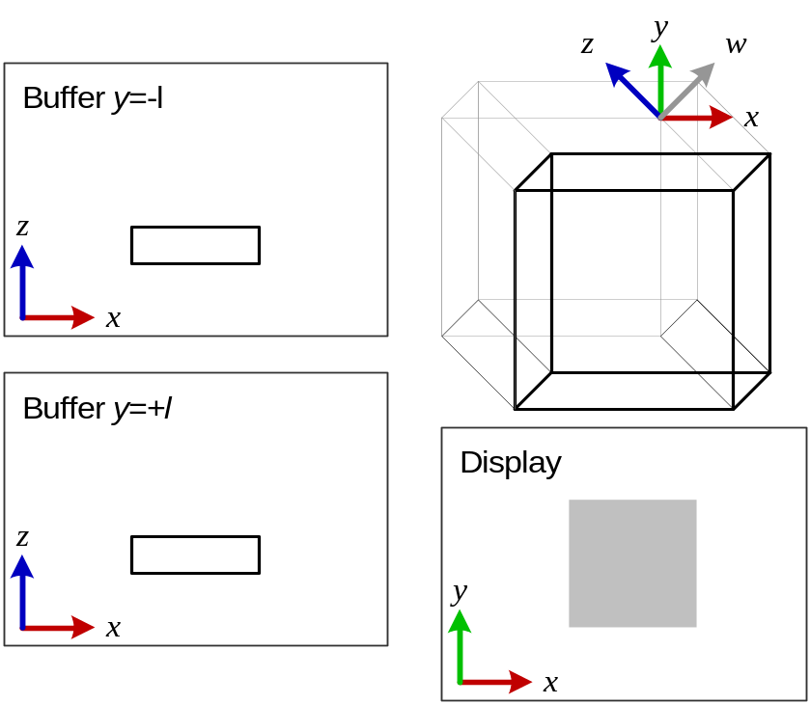
Figure 16: Result of rendering the z=-1 face to the display
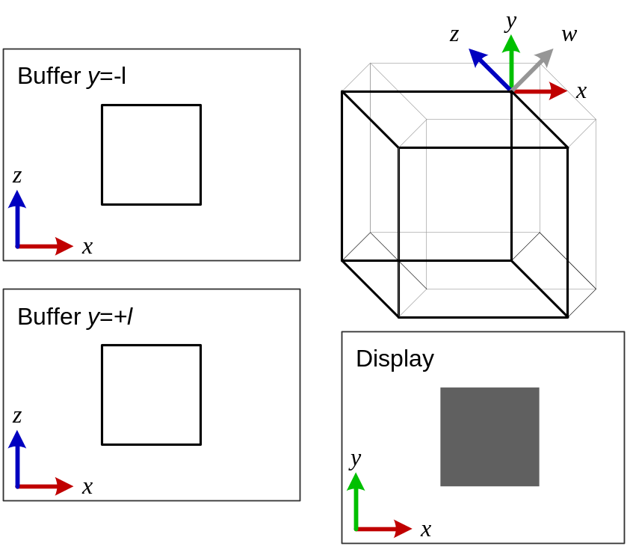
Figure 17: Result of rendering the w=-1 face to the display
It is equally possible to turn the situation round. Instead of rendering slices in xz, we render slices in xy, as shown in Figure 18.
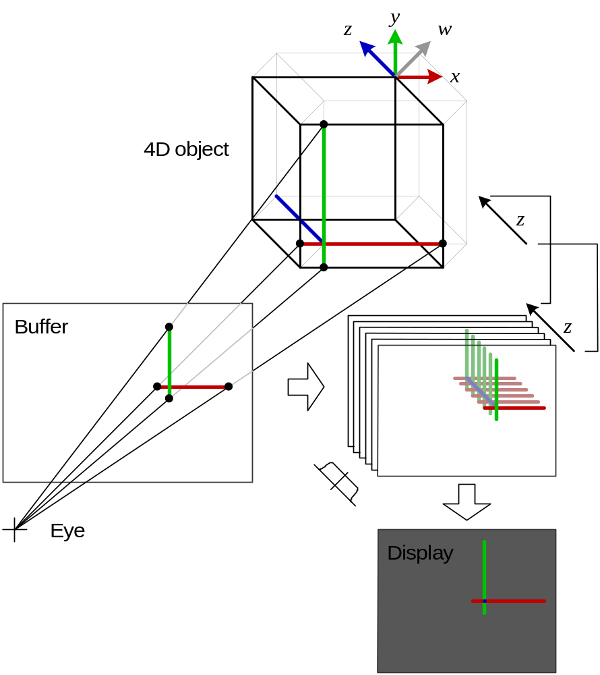
Figure 18: Rendering pipeline for z layered stack
28H28HFigure 18 shows a z layered stack, which is similar to the y layered stack of 29H29HFigure 13. There are pros and cons to each. The z layered stack can take advantage of full screen anti aliasing (FSAA) capabilities built into the hardware, as it is rendering a slice that maps directly to the display each time. The y layered stack cannot do this because hardware FSAA, designed for 3D, cannot anti-alias between slices in the vertical. The HAC function is now a single value applied to each buffer. Its drawback is that, for the final recombination, each destination on the display pixel requires one source pixel from each layer. It is undesirable to store every buffer until recombination. A high-bit-depth accumulation buffer is ideal. If such a buffer is absent or inefficient, buffers can be rendered and combined tree-wise so that only a few are required in memory at any one time.
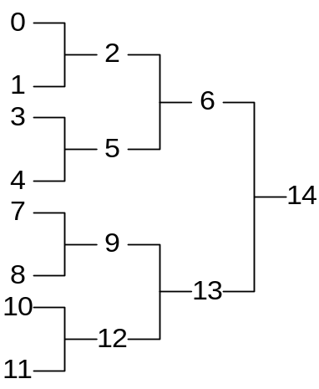
Figure 19: Order for rendering buffers for z layered stack
30H30HFigure 19 shows a possible rendering order. When two buffers on the left hand side of a junction are ready, the area combined into a buffer that is the average of the two, and the two original buffers are discarded. The maximum of buffers required at any one time is equal to the depth of the tree plus one - five in this case.

Optimising stack rendering
In the stack implementations above, performance can be improves by reducing resolution along any axis, including the hidden axis. In the y layered stack (Figure 13) we can reduce the z dimension to reduce resolution in z. In Figure 18 we can reduce the number of layers in the stack to achieve the same effect. For both of these optimisations, as we reduce resolution in z, the final image will progressively appear to be more a composite of slices than a smooth object.

For real-time rendering, further optimisation may be necessary. For this we turn to a different method: one that approximates the real image by rendering slices of each face directly as 2D polygons.

Face slicing
Face slicing approximates the output of the stack renderer by rendering polygons directly to the final display. Such a renderer could conceivably integrate paths through 3D textures to produce an accurate result, but this would be time consuming and place high demand on vertex and fragment shaders. Instead the face slicing technique renders a number of slices of the face as 2D polygons. Using variable transparency, these are combined to approximate the integral through the 3D face.

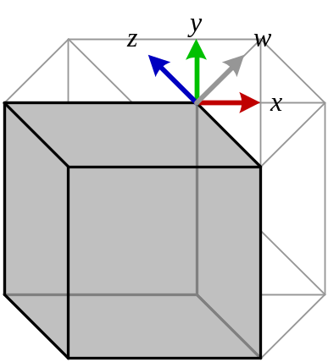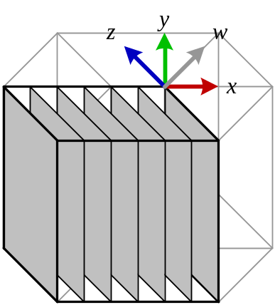
Figure 20: Slice rendering stages 1 and 2: Render solid, then slices along x axis
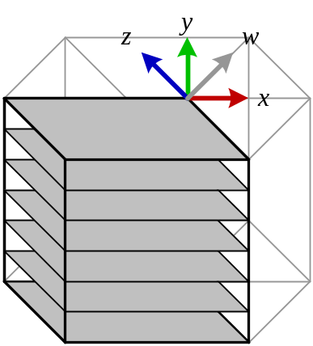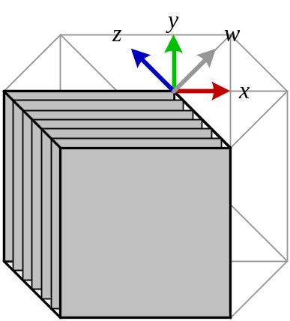
Figure 21: Slice rendering stages 3 and 4: Render slices along y and z axes
Figure 20 and Figure 21 shows the basic technique. Firstly the solid outline of the face drawn to write the depth values and initialise the alpha values in the frame buffer. Then, three sets of slices are rendered - one for each extent direction of the face - using the face texture(s), lighting and material. Each slice is translucent, so that previously drawn slices show through it. In this way, an approximation of the integrated paths through the 3D texture is built up.

Drawn as shown above using simple transparency, the face would have slightly jagged edges and a grid of visible slice edges. We can mitigate this to some extent by appropriate choice of blending algorithm. OpenGL provides a number of options for combining source and destination colour and alpha values. However these options are not limitless and, as we shall see, there is no ideal combination for our problem. Since this area of the pipeline cannot be programmed as part of a vertex or fragment shader, the following applies regardless of their availability.

Our aim is for the resultant display pixel to be the average value of the pixels written to it.

Version History
- 2005-04-27: Created with filename project-and-render1-2005-04-27
- 2005-05-04

Author: Andy Southgate. First published in the UK in 2005.
The author and his employer (Mushware Limited) irrevocably waive all of their copyright rights vested in this particular version of this document to the furthest extent permitted. The author and Mushware Limited also irrevocably waive any and all of their intellectual property rights arising from said document and its creation that would otherwise restrict the rights of any party to use, and/or distribute the use of, the techniques and methods described herein. A written waiver can be obtained via 0H0Hhttp://www.mushware.com/. Please cite as ‘Projection and Rendering 1, Andy Southgate, Mushware, 31H31H2005-05-04’.

A current example of a three dimensional display would be displays that present a different picture to each eye, using LCD shutters, parallax or colour filters, to add stereoscopic depth to a scene. Although pseudo-3D, the depth component of each pixel is significant.
The offset vector can be moved into the matrix in the usual way if homogenous coordinates are used.
In full, the postulate is that ‘Entities with an area of influence of zero (hyper)volume are not real’. It is an extension of the nature of the 3D real world, with ‘area of influence’ accounting for particles like the electron, with zero volume but an electric field extending over a volume.
This and the following refer to eye coordinates. The world is rotated and translated so that the camera is sited at the origin looking along the w axis before performing this test.
It’s possible to design a wraparound retina much like the human eye, where there is no such limit. The equivalent wraparound display could be, for example, a box in which the viewer sits, where each side is a projection displays.
k is used to ensure that a unit hypercube of hypervolume 1 in 4D maps to a unit cube of volume 1 in 3D. This is an element of the choice of the projection. In 2D mapping of the globe there is a similar choice as to whether to preserve area, angles, distances, etc.
Fundamentally, rotations preserve the distance between points and do not invert objects, i.e. turn them inside out or change their handedness. For a matrix, this implies that it is orthonormal and has determinant 1.
OpenGL Technical FAQ 12.050 explains the operation of the depth transformation (http://www.opengl.org/resources/faq/technical/).
For simplicity, a 3D bar is shown.
Despite what the diagram might suggest, a path through the face is the wrong concept.
In this calculation we use a zero thickness slice to approximate the thin slice of the view.
When the two hyperplanes are coplanar, the face is edge-on and not visible.
Which it does. A single face cannot fail a depth test against itself.
Again, the diagram can be misleading. No slice is in front of any other. Hidden axis clipping aside, each makes an equal contribution to the colour of the resultant display pixel.

