Laboratorul 8, Lucrarea A.
GitHub, pas cu pas

Realizat: Adam Marius SI-261

Repozitoriu exercitii-git:
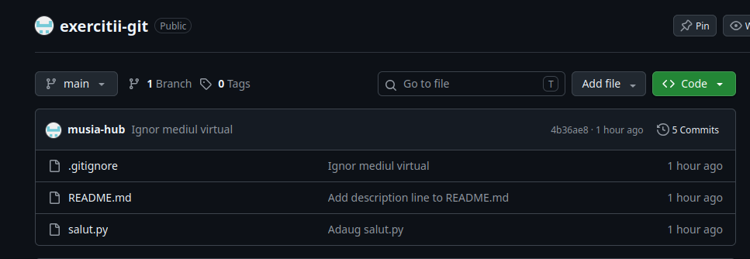

https://github.com/musia-hub/exercitii-git

Repozitoriu ex-2:
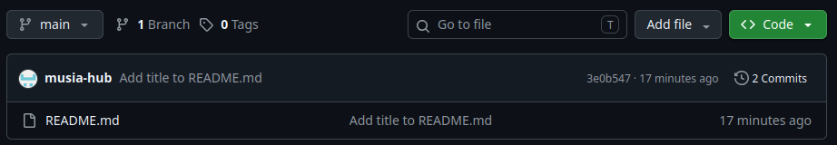

https://github.com/musia-hub/ex-2

