Compositional Processes as Graph
Semantic Modelling and Terminology in the Anton Webern Gesamtausgabe (AWG)
Dr. Stefan Münnich · Anton Webern Gesamtausgabe, University of Basel · stefan.muennich@unibas.ch · edition.anton-webern.ch
Comparative Perspectives on Genetic Criticism in Music · IMS Study Group · Rome, German Historical Institute, 16–18 November 2026
Question. How can a digital edition represent non-linear compositional processes – and keep philological claims as open as the evidence demands?
Answer: partly. concomitates, plain precedes and a certainty tag keep claims open. Elsewhere openness survives only as free text – readable, not queryable.
1 The AWG: three forms of edition, one graph in two layers
Form of edition | Presents | Edits
work edition · Werkedition | versions published or meant for print | TextVersion
text edition · Textedition | versions beyond a sketch, not printed | TextVersion
sketch edition · Skizzenedition | diplomatic transcriptions of sketches | Sketch

Generated layer  derived from the edition data | Curated layer  asserted by the editors
Draft ontology v0.1 · SPARQL in the app · Turtle export · no reasoning
2 Op. 25: the sketches cross the opus order
Op. 25 = M 317 (song I) · M 322 (song II) · M 321 (song III). The curated chain:
M 317 Sk4 | → | M 321 Sk1–9 | → | M 322 Sk1
Song III was sketched before song II. The generated layer shows three separate “islands”.
3 Terms from the material become classes
Term | In the documents | Class
sketch · Skizze | Sk1, Sk2, Sk2.1 | Sketch ⊂ Inscription
row table · Reihentabelle | Webern’s sheet of row forms | RowTable ⊂ Sketch
paratext · Paratext | title, dating, instruments | Paratext ⊂ Inscription
version · Textfassung | TF1, TF2 | TextVersion
edition complex · Editionskomplex | opus or M number | EditionComplex
uncertainty | “presumably” | tag certainty: uncertain
Not modelled yet: “study composition”, “ink draft”.
4 Two relations carry the genetic order
Relation | Meaning | cf. CIDOC CRM
precedes | A begun before B, overlap allowed | P176 “starts before the start of”
concomitates | A and B shape each other, no order | P174 “starts before the end of”
precedesScripture | evidence: the writing
precedesContent | evidence: the musical content
precedes is transitive; concomitates is symmetric, not transitive.
5 Standards serve as alignments, not as the model
A sketch’s genetic place rests on content and material traces together – which LRMoo separates (F2 Expression vs. F5 Item).
Standard | In the AWG model | Link
LRMoo | edition complex ≈ F1 · version, sketch ≈ F2 · document ≈ F5 | rdfs:seeAlso
CIDOC CRM | temporal reading: precedes ≈ P176 · concomitates ≈ P174 | rdfs:seeAlso
DC terms, SKOS, PROV, rdf:Statement | parts · concept schemes · attribution · statements | used directly
MEI | not integrated yet | –
6 The model could transfer; the pipeline cannot
Portable  - Inscription · Document · Folio · Placement  - precedes · concomitates | Tied to the AWG  - the generator reads the AWG’s own data  - Sk1 before Sk2 is read as precedes
7 Example: M 317, sketchbook 3, fol. 38v
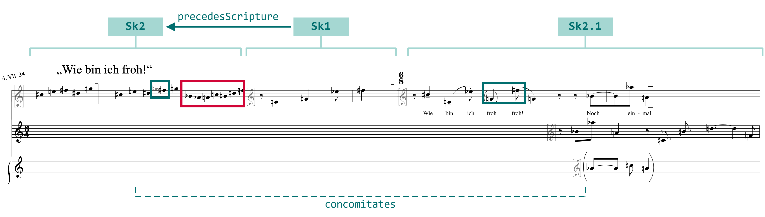

Sk1 precedesScripture Sk2  The end of Sk2 is squeezed (red): Sk1 was there first. | Sk2.1 concomitates Sk2  In both, g gives way to f♯ (green): neither comes first.
Source: AWG online edition, M 317 Sk2, Sk1, Sk2.1, superimposed (development version, 12 Nov 2026).
8 What the graph shows
→ Clusters  Sk2.1 and its variants: one work phase at a glance | → Paths  Sk1 → Sk4 → M 321: the work leaves the song | → Gaps  a “presumably” without a tag counts as certain
9 Where model and data disagree
Model lags data  - staves, measures as free text  - no writing instruments | Data lags model  - 29 Sk## placeholders  - datings without year
12 generator warnings – each gap is information.
10 Conclusion
- Layers show where editorial judgment becomes explicit.
- Warnings show where the data disagree.
- Model and data are written side by side: concomitant.
Next: named graphs for ink and pencil layers · persons · archives
For discussion. Whose genetic order does the graph show – Webern’s or ours?
How much of Webern’s compositional process survives translation into formal models?

