Compositional Processes as Graph
Semantic Modelling and Terminology in the Anton Webern Gesamtausgabe (AWG)
Dr. Stefan Münnich · Anton Webern Gesamtausgabe, University of Basel · stefan.muennich@unibas.ch · edition.anton-webern.ch
Comparative Perspectives on Genetic Criticism in Music · IMS Study Group · Rome, German Historical Institute, 16–18 November 2026
Question. How can a digital edition represent non-linear compositional processes – and keep philological claims as open as the evidence demands?
A possible answer (from the AWG case). Relations that do not force one sequence, uncertainty marked on the statement rather than in the relation, and generated and editorially asserted knowledge kept apart. They help in part: what a model has no form for stays in prose – readable, but not queryable.
1 The AWG: three forms of edition, one graph in two layers
Form of edition | Presents | Edits
work edition · Werkedition | versions published or meant for print | TextVersion
text edition · Textedition | versions beyond a sketch, not printed | TextVersion
sketch edition · Skizzenedition | diplomatic transcriptions of sketches | Sketch

Generated layer  derived from the edition data | Curated layer  asserted by the editors
Draft ontology v0.1 · SPARQL in the app · Turtle export · no reasoning
2 Op. 25: the sketches cross the opus order
Op. 25 = M 317 (song I) · M 322 (song II) · M 321 (song III). The curated chain:
M 317 Sk4 | → | M 321 Sk1–9 | → | M 322 Sk1
Song III was sketched before song II. The generated layer shows three separate “islands”.
3 Terms from the material become classes
Term | In the documents | Class
sketch · Skizze | Sk1, Sk2, Sk2.1 | Sketch ⊂ Inscription
row table · Reihentabelle | Webern’s sheet of row forms | RowTable ⊂ Sketch
paratext · Paratext | title, dating, instrumentation | Paratext ⊂ Inscription
version · Textfassung | TF1, TF2 | TextVersion
edition complex · Editionskomplex | all edition-relevant material of a composition, by opus or M number | EditionComplex
uncertainty | “presumably” | tag certainty: uncertain
Not modelled yet: “study composition”, “ink draft”.
4 Two relations link inscriptions: a sequence, or mutual influence
Relation | Meaning | cf. CIDOC CRM
precedes | A begun before B, overlap allowed | P176 “starts before the start of”
concomitates | A and B shape each other; which came first cannot be decided | P174 “starts before the end of” (the overlap, not the influence)
precedesScripture | evidence: the writing
precedesContent | evidence: the musical content
precedes is transitive; concomitates is symmetric, not transitive.
5 For now, the model is domain-specific, with links to standards
Relating sketches draws on content and page together – which LRMoo separates (F2 Expression vs. F5 Item).
Standard | In the AWG model | Link
LRMoo | edition complex ≈ F1 · version, sketch ≈ F2 · document ≈ F5 | rdfs:seeAlso
CIDOC CRM | temporal reading: precedes ≈ P176 · concomitates ≈ P174 | rdfs:seeAlso
DC terms, SKOS, PROV, rdf:Statement | single terms: parts · concept schemes · attribution · statements | used directly
MEI | not integrated yet | –
6 The model could transfer; the pipeline cannot
Portable  - Inscription · Document · Folio · Placement  - precedes · concomitates | Tied to the AWG  - the generator reads the AWG’s own data and M numbers  - Sk1 before Sk2 is read as precedes, without evidence type
Transfer to other repertoires is plausible but untested.
7 Example: M 317, sketchbook 3, fol. 38v
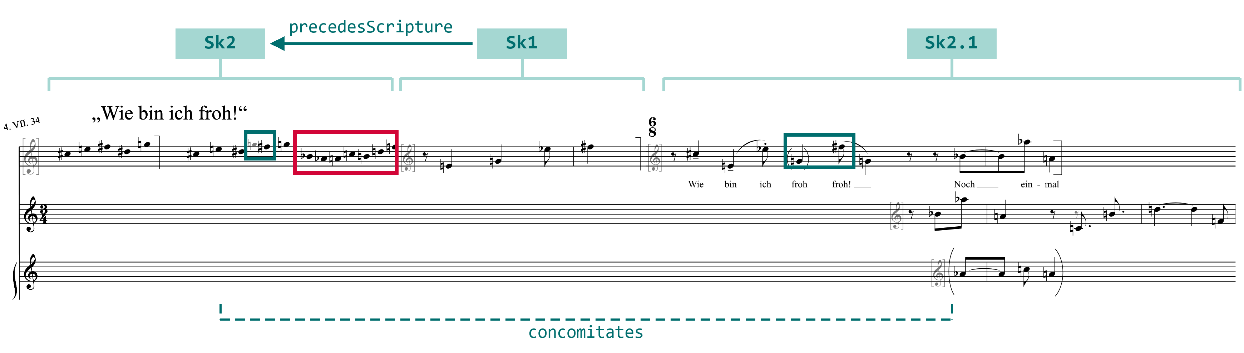

Sk1 precedesScripture Sk2  The end of Sk2 is squeezed (red): Sk1 already took the space – an order inferred from the writing. | Sk2.1 concomitates Sk2  In both, g gives way to f♯ (green): which came first cannot be decided.
Source: AWG online edition, M 317 Sk2, Sk1, Sk2.1, superimposed (development version, 12 Nov 2026).
8 What the graph shows
→ Clusters  Sk2.1 and its variants: one work phase at a glance | → Paths  Sk1 → Sk4 → M 321: the work leaves the song | → Gaps  a “presumably” without a tag counts as certain
9 Where model and data diverge, each gap is information
Model lags data  - staves, measures in their own notation, stored as strings  - no writing instruments yet | Data lags model  - sketchbook 3 as two excerpts · 29 Sk## placeholders  - datings without year
Some gaps are ours to close; others belong to the evidence. The generator reports them: 12 warning rules.
10 Conclusion
- Layers show where editorial judgment becomes explicit.
- Warnings show where the data are open or disagree.
- Model and data are written side by side: concomitant.
Next: named graphs for ink and pencil layers · persons · archives
For discussion. Whose process does the graph show – Webern’s or ours?
How much of (Webern’s) compositional processes survives translation into formal models?

