1
Open run.bat
Change R:\vimeodownloader to the actual path of your vimeodownloader
Write a runnable shell on macOS, the content should be very similar to my bat, just ask ai if any problem

2.
Open application.yml
datasource:
name: sqlite3
driver-class-name: org.sqlite.JDBC
url: jdbc:sqlite:C:\Users\xxx\AppData\Roaming\Mozilla\Firefox\Profiles\bo237zk2.default-1630147081943\cookies.sqlite
username:
password:

change above to your actual path of cookies.sqlite

3.
Run your mac shell, if no errors, it should look like this
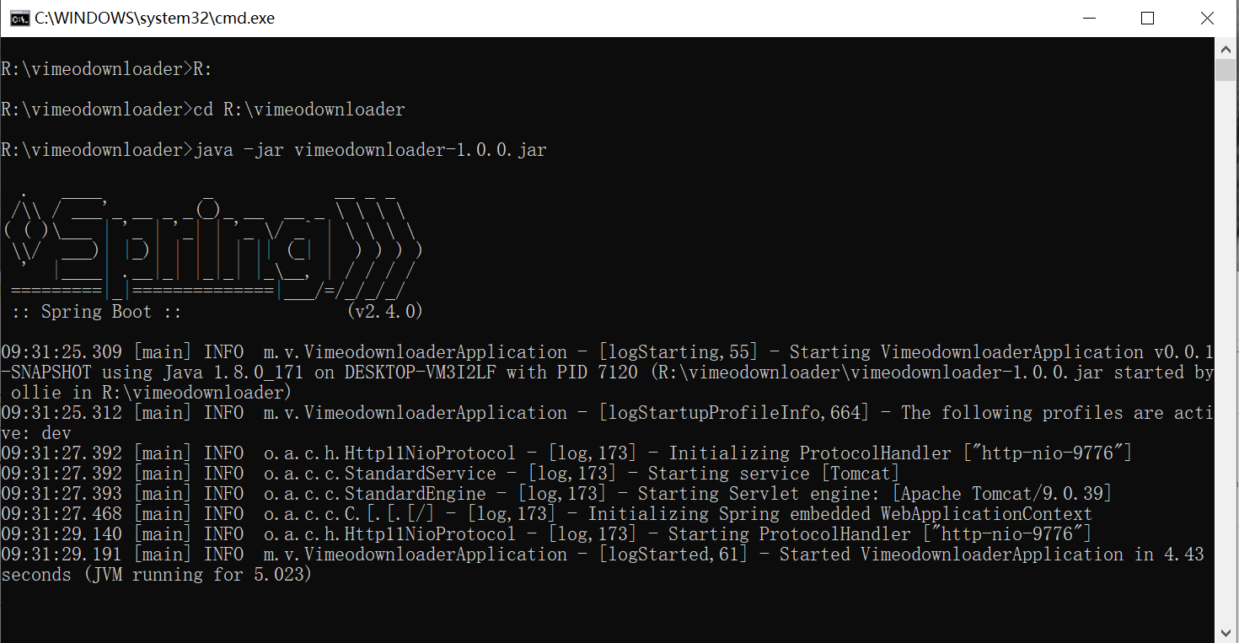

4
Open your firefox brower, make sure vimeo is logged in (signed in), otherwise there won’t be originals returned form vimeo server.

5
Use a brower to send various requests, see readme.txt
If you have installed Postman, use it, it’ll be more convenient
You can just import “Sent.postman_collection.json”, I have set this up already, you use this to make requests, will be much easier
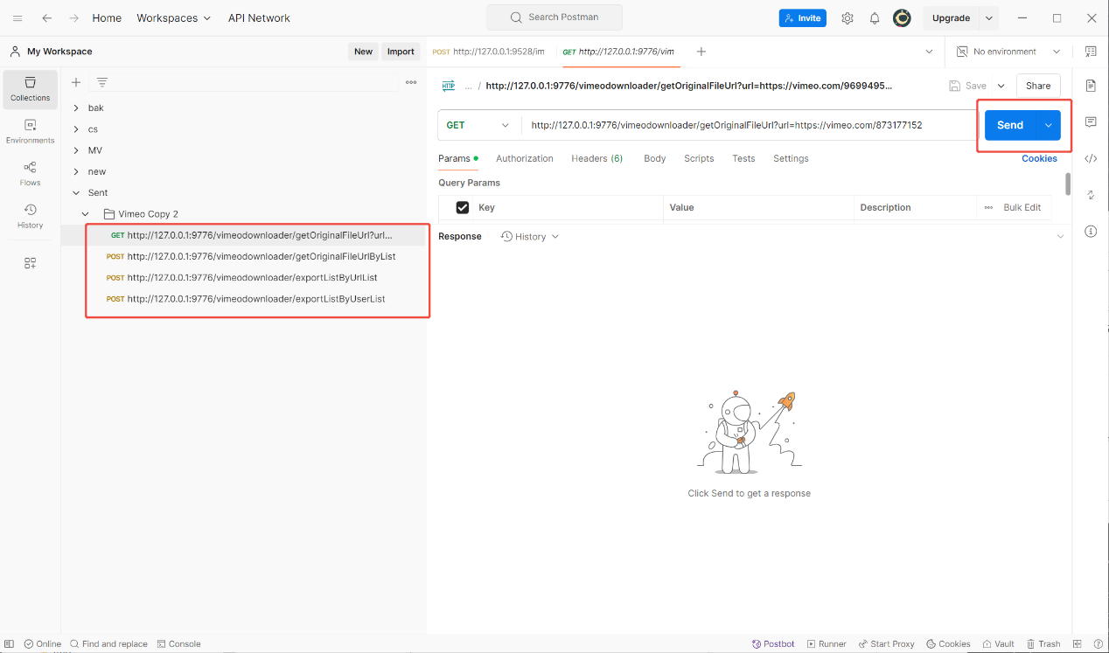

There are 4 postman links I already set to use
For getOriginalFileUrl and getOriginalFileUrlByList, just press “Send” button
For exportListByUrlList and exportListByUserList, you’ll have to press “send and download” button, and you will get an Excel file with multiple spreadsheets each includes the parsing results of one vimeo account
