**Toiletries Unlimited Ltd.**

**The Best Damn Toiletry Case**



Index:

Parts List……………………………………………………………………………………………………………pg. 3

Assembly Instructions……………………………………………………………………………………….pg. 4

Operating Instructions………………………………………………………………………………………pg. 5

Maintenance…………………………………………………………………………………………………….pg. 5

Warranty…………………………………………………………………………………………………………..pg. 5

Customer Support Information…………………………………………………………………………pg. 5

Parts List:

1. Bottom/Stand: 8”x8.5”x1”



1. Top Compartment: 8”x8.5”x1.25”



1. Connecting Pin: 8”x.025” dia.



Assembly Instructions:

1. Product comes preassembled prior to purchase with the top compartment attaching to the bottom/stand by one connecting pin.
2. Should any of the parts become disassembled follow these instructions:
3. Push the top and bottom together.

ii. Push the pin into the hinge.

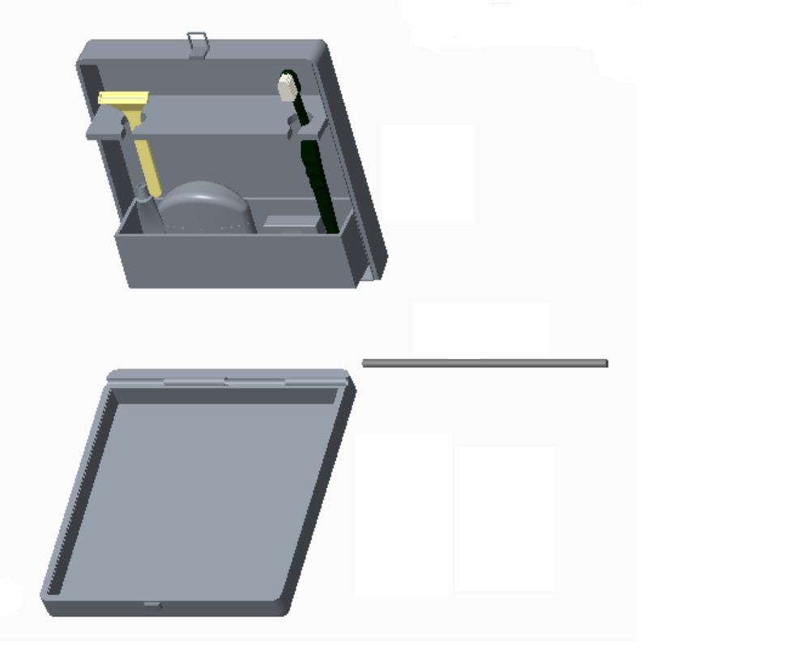

i

ii

i

Operating Instructions:

This product is designed for the ease of use and comfort of knowing your essential toiletries are safely stowed away. Having specific compartments for your toothbrush, shaving razor, deodorant, and floss ensures that each item stays where you placed it until time for use. Once placed into their respective holders this travel companion neatly folds closed into a small, easy to store box. Upon arrival to your destination it can be opened and the bottom used as a base to keep your toiletries off the counter and in a clean space.

Maintenance:

Due to the strong, durable design of this travel companion maintenance is kept to a minimum. After use it can be quickly rinsed and wiped out to clear out any liquid, or debris, that may have accumulated during your trip. Warm water and a mild soap should be all that is necessary to maintain a clean, portable travel companion.

Warranty:

This travel companion was designed with durability, reliability, and ease of transport in mind. We also understand malfunctions can happen. Should you experience a defect that hinders the performance of your travel companion the company will send replacement parts for up to 6 months from purchase. Should the malfunction occur when using the product outside of it’s designed purpose then the company holds no liability. For any warranty issues please refer to our customer service.

Customer Service and Contact Information:

Any questions, or concerns, can be sent through the following channels;

**Customer Support number**: 1-800-667-7325

Cody McCray- [cmccray4@uncc.edu](mailto:cmccray4@uncc.edu)

Alexander Caviness- [acavines@uncc.edu](mailto:acavines@uncc.edu)

Austin Teeter- [ateeter1@uncc.edu](mailto:ateeter1@uncc.edu)

Alexander Harward- [aharwar5@uncc.edu](mailto:aharwar5@uncc.edu)