Министерство науки и образования РФ
Федеральное государственное автономное образовательное
учреждение высшего профессионального образования
«Санкт-Петербургский государственный электротехнический
университет «ЛЭТИ» им. В. И. Ульянова (Ленина)»
(СПбГЭТУ «ЛЭТИ»)

Факультет компьютерных технологий и информатики

Кафедра вычислительной техники

Отчёт по лабораторной работе № 5
на тему: “Аутентификация и авторизация
пользователей web-приложения”
по дисциплине
“Web-программирование”

Выполнил студент гр.9308: | Яловега Н.В.
Проверил: | Павловский М.Г.

Санкт-Петербург, 2021 г.

Оглавление
Введение 3
Настройка базовой аутентификации 4
Настройка SSL-протокола 6
Вывод 7
Приложение 1. (tomcat-users.xml) 8
Приложение 2. (server.xml) 10
Приложение 3. (web.xml) 14

Введение
Целью работы является знакомство со способами реализации аутентификации и
авторизации пользователей Web-приложения.

Настройка базовой аутентификации
Для начала необходимо добавить роли и пользователей в файл сервера Tomcat tomcat-users.xml. Далее требуется изменить web.xml проекта. Допустимыми ролями установим только «admin» и «user».

Попробуем авторизироваться за пользователя kivyfreakt группы user:
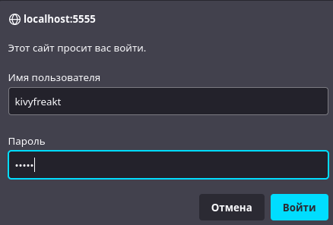
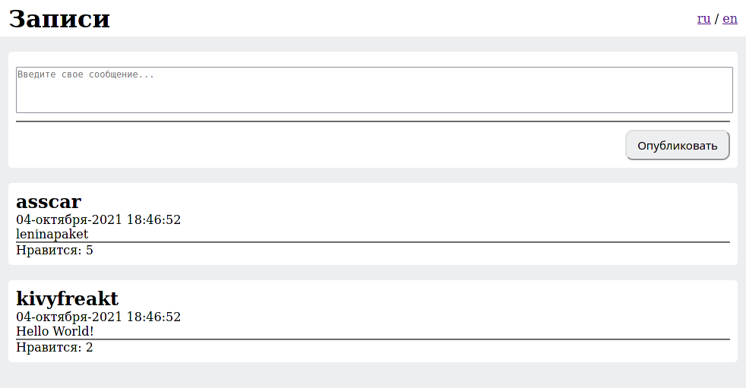
Теперь авторизуемся за пользователя admin c одноименным паролем. Без перезапуска сервера для повторной авторизации потребуется сбросить cookie-файлы браузера, зайти через другой браузер или зайти в режиме инкогнито.
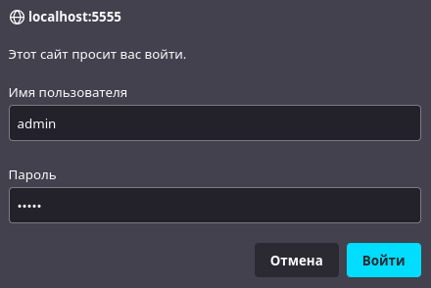
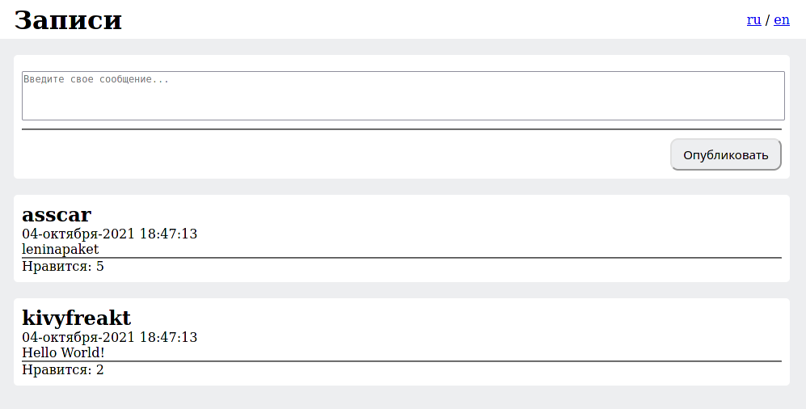
Важно заметить, что мы поставили авторизацию с корневой ссылки “/”, поэтому напрямую перейти по URL мы также не сможем без авторизации.

Настройка SSL-протокола
Сначала сгенерируем хранилище ключей и сам ключ в папке conf в корневой директории сервера Apache Tomcat и отредактируем server.xml для добавления SSL ключа.

Теперь проверим работу защищённого протокола, перейдя по ссылке https://localhost:8443/social

Подтверждаем переход, авторизуемся как пользователь admin:
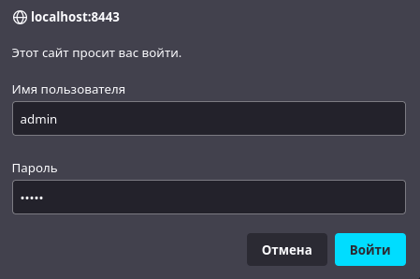
Успешно переходим на главную страницу:
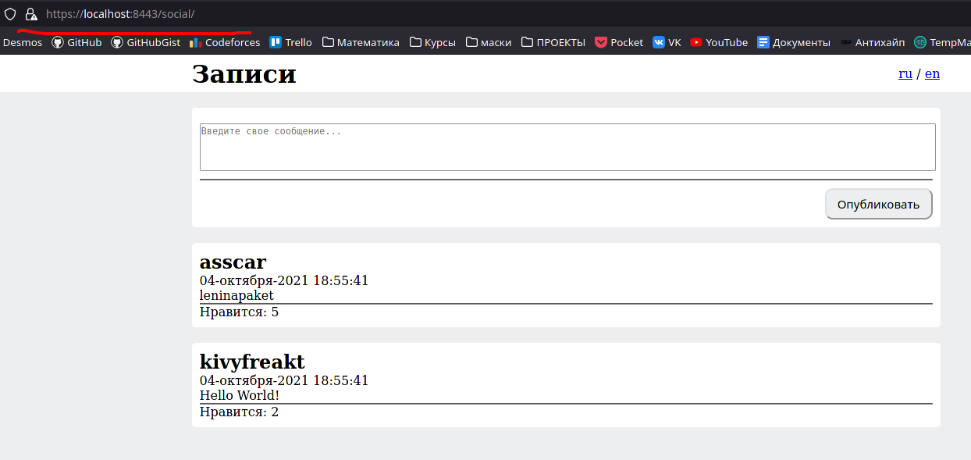

Вывод
В ходе выполнения лабораторной работы была изучены технологии аутентификации: базовая, а также при помощи протокола SSL. Было создано хранилище ключей, а также разобран способ защиты содержимого сервера при помощи ролей и прав доступа.

Приложение 1. (tomcat-users.xml)
<?xml version="1.0" encoding="UTF-8"?>
<!--
Licensed to the Apache Software Foundation (ASF) under one or more
contributor license agreements. See the NOTICE file distributed with
this work for additional information regarding copyright ownership.
The ASF licenses this file to You under the Apache License, Version 2.0
(the "License"); you may not use this file except in compliance with
the License. You may obtain a copy of the License at

http://www.apache.org/licenses/LICENSE-2.0

Unless required by applicable law or agreed to in writing, software
distributed under the License is distributed on an "AS IS" BASIS,
WITHOUT WARRANTIES OR CONDITIONS OF ANY KIND, either express or implied.
See the License for the specific language governing permissions and
limitations under the License.
--><tomcat-users version="1.0" xmlns="http://tomcat.apache.org/xml" xmlns:xsi="http://www.w3.org/2001/XMLSchema-instance" xsi:schemaLocation="http://tomcat.apache.org/xml tomcat-users.xsd">
<!--
By default, no user is included in the "manager-gui" role required
to operate the "/manager/html" web application. If you wish to use this app,
you must define such a user - the username and password are arbitrary.

Built-in Tomcat manager roles:
- manager-gui - allows access to the HTML GUI and the status pages
- manager-script - allows access to the HTTP API and the status pages
- manager-jmx - allows access to the JMX proxy and the status pages
- manager-status - allows access to the status pages only

The users below are wrapped in a comment and are therefore ignored. If you
wish to configure one or more of these users for use with the manager web
application, do not forget to remove the <!.. ..> that surrounds them. You
will also need to set the passwords to something appropriate.
-->
<!--
<user username="admin" password="<must-be-changed>" roles="manager-gui"/>
<user username="robot" password="<must-be-changed>" roles="manager-script"/>
-->
<!--
The sample user and role entries below are intended for use with the
examples web application. They are wrapped in a comment and thus are ignored
when reading this file. If you wish to configure these users for use with the
examples web application, do not forget to remove the <!.. ..> that surrounds
them. You will also need to set the passwords to something appropriate.
-->

<role rolename="admin"/>
<role rolename="user"/>
<user username="admin" password="admin" roles="admin"/>
<user username="kivyfreakt" password="12345" roles="user"/>
<user username="user" password="123" roles="user"/>

</tomcat-users>

Приложение 2. (server.xml)
<?xml version="1.0" encoding="UTF-8"?>
<!--
Licensed to the Apache Software Foundation (ASF) under one or more
contributor license agreements. See the NOTICE file distributed with
this work for additional information regarding copyright ownership.
The ASF licenses this file to You under the Apache License, Version 2.0
(the "License"); you may not use this file except in compliance with
the License. You may obtain a copy of the License at

http://www.apache.org/licenses/LICENSE-2.0

Unless required by applicable law or agreed to in writing, software
distributed under the License is distributed on an "AS IS" BASIS,
WITHOUT WARRANTIES OR CONDITIONS OF ANY KIND, either express or implied.
See the License for the specific language governing permissions and
limitations under the License.
--><!-- Note: A "Server" is not itself a "Container", so you may not
define subcomponents such as "Valves" at this level.
Documentation at /docs/config/server.html
--><Server port="8005" shutdown="SHUTDOWN">
<Listener className="org.apache.catalina.startup.VersionLoggerListener"/>
<!-- Security listener. Documentation at /docs/config/listeners.html
<Listener className="org.apache.catalina.security.SecurityListener" />
-->
<!-- APR library loader. Documentation at /docs/apr.html -->
<Listener SSLEngine="on" className="org.apache.catalina.core.AprLifecycleListener"/>
<!-- Prevent memory leaks due to use of particular java/javax APIs-->
<Listener className="org.apache.catalina.core.JreMemoryLeakPreventionListener"/>
<Listener className="org.apache.catalina.mbeans.GlobalResourcesLifecycleListener"/>
<Listener className="org.apache.catalina.core.ThreadLocalLeakPreventionListener"/>

<!-- Global JNDI resources
Documentation at /docs/jndi-resources-howto.html
-->
<GlobalNamingResources>
<!-- Editable user database that can also be used by
UserDatabaseRealm to authenticate users
-->
<Resource auth="Container" description="User database that can be updated and saved" factory="org.apache.catalina.users.MemoryUserDatabaseFactory" name="UserDatabase" pathname="conf/tomcat-users.xml" type="org.apache.catalina.UserDatabase"/>
</GlobalNamingResources>

<!-- A "Service" is a collection of one or more "Connectors" that share
a single "Container" Note: A "Service" is not itself a "Container",
so you may not define subcomponents such as "Valves" at this level.
Documentation at /docs/config/service.html
-->
<Service name="Catalina">

<!--The connectors can use a shared executor, you can define one or more named thread pools-->
<!--
<Executor name="tomcatThreadPool" namePrefix="catalina-exec-"
maxThreads="150" minSpareThreads="4"/>
-->

<!-- A "Connector" represents an endpoint by which requests are received
and responses are returned. Documentation at :
HTTP Connector: /docs/config/http.html
AJP Connector: /docs/config/ajp.html
Define a non-SSL/TLS HTTP/1.1 Connector on port 8080
-->
<Connector connectionTimeout="20000" port="5555" protocol="HTTP/1.1" redirectPort="8443" useBodyEncodingForURI="true"/>
<!-- A "Connector" using the shared thread pool-->
<!--
<Connector executor="tomcatThreadPool"
port="8080" protocol="HTTP/1.1"
connectionTimeout="20000"
redirectPort="8443" />
-->
<!-- Define an SSL/TLS HTTP/1.1 Connector on port 8443 with HTTP/2
This connector uses the NIO implementation. The default
SSLImplementation will depend on the presence of the APR/native
library and the useOpenSSL attribute of the
AprLifecycleListener.
Either JSSE or OpenSSL style configuration may be used regardless of
the SSLImplementation selected. JSSE style configuration is used below.
-->
<Connector
protocol="org.apache.coyote.http11.Http11NioProtocol"
port="8443"
maxThreads="150"
SSLEnabled="true"
useBodyEncodingForURI="true">
<SSLHostConfig>
<Certificate
certificateKeystoreFile="$conf/lab5"
certificateKeystorePassword="123456"
type="RSA"
/>
</SSLHostConfig>
</Connector>

<!-- Define an AJP 1.3 Connector on port 8009 -->
<!--
<Connector protocol="AJP/1.3"
address="::1"
port="8009"
redirectPort="8443" />
-->

<!-- An Engine represents the entry point (within Catalina) that processes
every request. The Engine implementation for Tomcat stand alone
analyzes the HTTP headers included with the request, and passes them
on to the appropriate Host (virtual host).
Documentation at /docs/config/engine.html -->

<!-- You should set jvmRoute to support load-balancing via AJP ie :
<Engine name="Catalina" defaultHost="localhost" jvmRoute="jvm1">
-->
<Engine defaultHost="localhost" name="Catalina">

<!--For clustering, please take a look at documentation at:
/docs/cluster-howto.html (simple how to)
/docs/config/cluster.html (reference documentation) -->
<!--
<Cluster className="org.apache.catalina.ha.tcp.SimpleTcpCluster"/>
-->

<!-- Use the LockOutRealm to prevent attempts to guess user passwords
via a brute-force attack -->
<Realm className="org.apache.catalina.realm.LockOutRealm">
<!-- This Realm uses the UserDatabase configured in the global JNDI
resources under the key "UserDatabase". Any edits
that are performed against this UserDatabase are immediately
available for use by the Realm. -->
<Realm className="org.apache.catalina.realm.UserDatabaseRealm" resourceName="UserDatabase"/>
</Realm>

<Host appBase="webapps" autoDeploy="true" name="localhost" unpackWARs="true">

<!-- SingleSignOn valve, share authentication between web applications
Documentation at: /docs/config/valve.html -->
<!--
<Valve className="org.apache.catalina.authenticator.SingleSignOn" />
-->

<!-- Access log processes all example.
Documentation at: /docs/config/valve.html
Note: The pattern used is equivalent to using pattern="common" -->
<Valve className="org.apache.catalina.valves.AccessLogValve" directory="logs" pattern="%h %l %u %t &quot;%r&quot; %s %b" prefix="localhost_access_log" suffix=".txt"/>

<Context docBase="/home/kivyfreakt/temp/tomcat10/wtpwebapps/social" path="/social" reloadable="true" source="org.eclipse.jst.jee.server:social"/></Host>
</Engine>
</Service>
</Server>

Приложение 3. (web.xml)
<?xml version="1.0" encoding="UTF-8"?>
<web-app xmlns:xsi="http://www.w3.org/2001/XMLSchema-instance" xmlns="http://java.sun.com/xml/ns/j2ee" xmlns:web="http://xmlns.jcp.org/xml/ns/javaee" xsi:schemaLocation="http://xmlns.jcp.org/xml/ns/javaee http://java.sun.com/xml/ns/javaee/web-app_2_5.xsd http://java.sun.com/xml/ns/j2ee http://java.sun.com/xml/ns/j2ee/web-app_2_4.xsd" id="WebApp_ID" version="2.4">
<display-name>social</display-name>

<welcome-file-list>
<welcome-file>Main.jsp</welcome-file>
</welcome-file-list>

<servlet>
<servlet-name>Main</servlet-name>
<jsp-file>/Main.jsp</jsp-file>
</servlet>
<servlet-mapping>
<servlet-name>Main</servlet-name>
<url-pattern>/main</url-pattern>
</servlet-mapping>
<servlet>
<servlet-name>Post</servlet-name>
<jsp-file>/Post.jsp</jsp-file>
</servlet>
<servlet-mapping>
<servlet-name>Post</servlet-name>
<url-pattern>/post</url-pattern>
</servlet-mapping>

<security-role>
<role-name>admin</role-name>
</security-role>

<security-role>
<role-name>user</role-name>
</security-role>

<security-constraint>
<web-resource-collection>
<web-resource-name>/</web-resource-name>
<url-pattern>/</url-pattern>
<http-method>GET</http-method>
<http-method>POST</http-method>
</web-resource-collection>
<auth-constraint>
<role-name>admin</role-name>
<role-name>user</role-name>
</auth-constraint>
</security-constraint>

<login-config>
<auth-method>BASIC</auth-method>
<realm-name>Write Post List</realm-name>
</login-config>

</web-app>

