
TEEGALA KRISHNA REDDY ENGINEERING COLLEGE
(Affiliated to SBTET)
Medbowli, Meerpet, Saroor Nagar, Hyderabad, Telangana-500097

A
INDUSTRIAL TRAINING REPORT ON
EVIDENTPAY - PAYMENT VERIFICATION SYSTEM

DIPLOMA IN
DEPARTMENT OF COMPUTER SCIENCE AND ENGINEERING

SUBMITTED BY

S.NO Name of the student Roll no

- S.BHUVANA KRUTHI 24248-CS-018

Under the esteemed guidance of Mr.S.VAMSI KRISHNA
(ML ENGINEER)
DEPARTMENT OF COMPUTER SCIENCE AND ENGINEERING
Medbowli, Meerpet, Saroor Nagar, Hyderabad, Telangana-500097

TEEGALA KRISHNA REDDY ENGINEERING COLLEGE
( Affiliated to SBTET)
Medbowli, Meerpet, Saroor Nagar, Hyderabad, Telangana-500097



CERTIFICATE

This is to certify the dissertation entitled "EVIDENTPAY – PAYMENT VERIFICTION SYSTEM " is a bonafide work done by S.BHUVANA KRUTHI with the roll no. (24248-CS-018) under the esteemed guidance of Mr.S. VAMSI KRISHNA(ML ENGINEER), in partial fulfillment of the academic requirements for the award of the Diploma in DEPARTMENT OF COMPUTER SCIENCE AND ENGINEERING, submitted to the Department of computer science and Engineering, TEEGALA KRISHNA REDDY ENGINEERING COLLEGE, Hyderabad, during the academic year 2026-2027.

TRAINING GUIDE HEAD OF THE DEPARTMENT
Mr.VAMSI KRISHNA(ML ENGINEER ) Mrs.C.BINDU PRIYA

INTERNAL EXAMINER EXTERNAL EXAMINER

PRINCIPAL
Dr. P. VENKATRAM REDDY

TEEGALA KRISHNA REDDY ENGINEERING COLLEGE
(Affiliated to SBTET)
Medbowli, Meerpet. Saroor Nagar, Hyderabad, Telangana-500097

DECLARATION

The work presented in this dissertation entitled "EVIDENTPAY - PAYMENT VERIFICATION SYSTEM " is original and has been carried out under the supervision of Mr.S.VAMSI KRISHNA(ML ENGINEER)

Also, I declare that the matter embodied in this industrial training report has not been submitted in any full or any part there for the award of any degree of any other institution.

INDUSTRIAL TRAINING ASSOCIATE

S.NO Name of the student Roll no

1. S.BHUVANA KRUTHI 24248-CS-018

TEEGALA KRISHNA REDDY ENGINEERING COLLEGE
(Affiliated to SBTET)
Medbowli, Meerpet, Saroor Nagar, Hyderabad, Telangana-500097

ACKNOWLEDGEMENT

I am highly indebted to Principal Dr. P. VENKAT RAM REDDY, for giving me the permission to carry out this industrial training.

I would like to thank Mrs. C.BINDU PRIYA, head of the Department of computer science and Engineering for being moral support throughout the period of my study in TKREC.

I am grateful to Mr.S.VAMSI KRISHNA (ML ENGINEER) , for his valuable suggestion and guidance given by her during the execution of this industrial training.

With great pleasure I want to take this opportunity to express my heartfelt gratitude to all the people who helped in making this industrial training a grand success.

I would like to thank the teaching and Non-teaching staff of Department of computer science and Engineering for sharing their knowledge with me.

INDUSTRIAL TRAINING ASSOCIATE

S.NO Name of the Student Roll No

- S.BHUVANA KRUTHI 24248-CS-018

ABSTRACT

EvidentPay is a payment screenshot verification and transaction reconciliation system developed to simplify the process of checking online payment claims. During college events, workshops, and seminars, organizers often receive payment screenshots from participants through WhatsApp. Manually verifying each screenshot with bank transaction records can be time-consuming and may lead to errors.
EvidentPay uses Optical Character Recognition (OCR) to extract important details such as transaction ID, payment amount, date, and time from uploaded payment screenshots. The extracted information is compared with transaction records provided by the organizer in CSV format. Based on this comparison, the system identifies matching transactions, amount mismatches, duplicate claims, and unverified payments.
The system also provides explanations for verification results and allows organizers to review uncertain cases manually. It is designed to reduce manual effort, improve the efficiency of payment checking, and maintain a clear verification history.
The project is developed using Python, FastAPI, Tesseract OCR, image processing, SQLite, HTML, and CSS. EvidentPay acts as a decision-support system, never an accusation, helping organizers make more informed payment-verification decisions.

LIST OF TABLES

Table 1.1: Organization of the report
Table 2.1: Comparison of the existing and proposed systems
Table 3.1: Functional requirements
Table 3.2: Non-functional requirements
Table 3.3: Hardware requirements
Table 3.4: Software requirements
Table 3.5: Use case descriptions
Table 4.1: Structure of the Verification table
Table 4.2: Structure of the Evidence table
Table 4.3: Module design
Table 5.1: Python libraries and their purpose
Table 6.1: Pages of the user interface
Table 6.2: Fields compared by the matching module
Table 6.3: Mismatch conditions and their handling
Table 6.4: Verification outcomes and recommended handling
Table 6.5: Important components and their functions
Table 7.1: Example of a verification
Table 8.1: Unit test plan
Table 8.2: Integration test plan
Table 8.3: Test cases and expected results
Table 8.4: Actual results of the test cases
Table A.1: Source files of the project

LIST OF FIGURES

Figure 4.1: Architecture diagram of EvidentPay
Figure 4.2: Level 0 DFD (context diagram)
Figure 4.3: Level 1 DFD of EvidentPay
Figure 4.4: Flowchart of the verification process
Figure 4.5: Use case diagram
Figure 4.6: Class diagram of the main components
Figure 4.7: Entity relationship diagram
Figure 8.1: Home page of EvidentPay
Figure 8.2: Verification page with upload options
Figure 8.3: Result page showing Matched status
Figure 8.4: Result page showing Not Matched or Needs Review
Figure 8.5: WhatsApp reply suggestion
Figure 8.6: Verification history page
Figure A.1: Additional screenshot 1
Figure A.2: Additional screenshot 2

LIST OF ABBREVIATIONS

Abbreviation | Full form
AI | Artificial Intelligence
API | Application Programming Interface
ASGI | Asynchronous Server Gateway Interface
CSS | Cascading Style Sheets
CSV | Comma-Separated Values
DFD | Data Flow Diagram
ER | Entity Relationship
HTML | HyperText Markup Language
ID | Identifier
IDE | Integrated Development Environment
LAN | Local Area Network
OCR | Optical Character Recognition
RAM | Random Access Memory
SQL | Structured Query Language
UI | User Interface
UML | Unified Modeling Language
UPI | Unified Payments Interface
XLSX | Microsoft Excel Open XML Spreadsheet

TABLE OF CONTENTS

Chapter 1 – Introduction 1
1.1 Introduction to the Project 1
1.2 Background 1
1.3 Problem Statement 2
1.4 Objectives 2
1.5 Scope of the Project 3
1.6 Motivation 3
1.7 Organization of the Report 4
Chapter 2 – Literature Survey 5
2.1 Introduction 5
2.2 Existing Systems 5
2.3 Related Technologies 5
2.4 Research / Literature Review 6
2.5 Limitations of Existing Systems 6
2.6 Proposed System 7
Chapter 3 – System Analysis and Requirements 8
3.1 Functional Requirements 8
3.2 Non-Functional Requirements 9
3.3 Hardware Requirements 9
3.4 Software Requirements 10
3.5 Feasibility Study 10
3.6 Use Case Analysis 11
Chapter 4 – System Design 12
4.1 System Architecture 12
4.2 Architecture Diagram 13
4.3 Data Flow Diagram (DFD) 14
4.4 Flowchart 16
4.5 UML Diagrams 17
4.6 Database Design 18
4.7 Module Design 20
Chapter 5 – Technologies Used 21
5.1 Programming Languages 21
5.2 Frameworks 21
5.3 Python Libraries and Packages 21
5.4 Frontend Technologies 22
5.5 Database Technologies 22
5.6 Development Tools 22
5.7 Hardware Components 22
Chapter 6 – System Implementation 23
6.1 Project Folder Structure 23
6.2 Backend Implementation 23
6.3 Frontend Implementation 23
6.4 Database Implementation 24
6.5 Statement Processing and Transaction Matching Module 24
6.6 Mismatch Detection Module 25
6.7 AI Agent Implementation 25
6.8 Risk Assessment and Result Handling Module 26
6.9 Explanation of Important Functions, Methods and Classes 27
Chapter 7 – Working Procedure 28
7.1 Installation Procedure 28
7.2 Configuration 28
7.3 Step-by-Step Execution 28
7.4 Flow of Execution 29
7.5 LAN Configuration and Connectivity 29
7.6 User Interaction 29
7.7 Output Generation 30
Chapter 8 – Testing and Results 31
8.1 Testing Methodology 31
8.2 Unit Testing 31
8.3 Integration Testing 32
8.4 System Testing 32
8.5 Test Cases and Expected Results 33
8.6 Actual Results 34
8.7 Output Screenshots 34
8.8 Result Analysis 36
Chapter 9 – Advantages and Applications 37
9.1 Advantages 37
9.2 Applications 37
9.3 Limitations 37
9.4 Future Enhancements 38
Chapter 10 – Conclusion 39
10.1 Conclusion 39
10.2 Project Outcome 39
10.3 Future Scope 39
References / Bibliography 40
Appendix A – Complete Source Code 41
Appendix B – Installation Commands 42
Appendix C – Configuration Files 43
Appendix D – Additional Screenshots 44
Appendix E – User Manual 45

CHAPTER 1
INTRODUCTION

1.1 Introduction to the Project
Digital payments have become a common part of everyday life. People use UPI applications, mobile banking and other online payment services to transfer money. After making a payment, the sender may share a screenshot with the receiver as confirmation of the transaction.
However, receiving a payment screenshot does not always confirm that the money has actually reached the receiver’s bank account. The screenshot may contain incomplete information, incorrect transaction details or information that does not match the actual bank statement. Checking every payment manually can take time, especially for shop owners, small businesses and individuals who receive multiple payments every day.
EvidentPay is an AI-based payment screenshot verification system developed to simplify this process. It allows users to upload a payment screenshot along with a bank statement containing transaction records. The system extracts important payment information from the screenshot using Optical Character Recognition (OCR) and compares it with the available transaction records.
The system uses separate processing modules and AI agents to coordinate verification, evaluate matching information and explain the final result. It also provides suitable WhatsApp reply suggestions based on the verification outcome. EvidentPay is designed as a decision-support system. It helps users understand the available transaction evidence rather than automatically declaring a payment fraudulent.

1.2 Background
Online payment services have changed the way people pay and receive money. Small shops, online sellers, freelancers and service providers now receive many payments through UPI and mobile banking applications. In many everyday situations, the payer shares a screenshot of the payment as quick proof that the transaction has been completed.
A screenshot is only an image. It shows what was displayed on the payer’s device at a particular moment, but it does not by itself show that the amount was credited to the receiver’s account. Screenshots may be cropped, unclear or incomplete, and the details shown in them can differ from the entries in the receiver’s bank records.
The usual way of checking a payment is to open the banking application or to download the bank statement and compare the details by hand. At the same time, technologies such as OCR, image processing and data-processing libraries have become easily available. These technologies make it possible to read the text in a screenshot and to compare it with structured statement data automatically. EvidentPay brings these technologies together in one web application and organizes the work through separate modules and agents.

1.3 Problem Statement
Digital payment screenshots are frequently used as proof of successful transactions. However, a screenshot by itself cannot establish whether the transaction was successfully completed or whether the money was received. Users generally depend on manual verification by opening their banking applications or checking downloaded bank statements. This process becomes difficult when there are many transactions or when the screenshot contains unclear or incomplete information.
Some important problems include:
- Difficulty in manually checking multiple payment transactions.
- Possibility of overlooking transaction details.
- Difficulty in matching transaction IDs, amounts and dates.
- Incomplete or unclear information in screenshots.
- Time required to compare screenshots with bank statements.
- Difficulty in understanding why a transaction does not match.
- Difficulty in preparing suitable responses when payment information is uncertain.
Therefore, a system is required to automatically extract payment information, compare it with available transaction records and provide an understandable verification result. EvidentPay addresses these problems by combining OCR, image processing, data processing, transaction matching and AI-agent-based decision support.

1.4 Objectives
The main objective of EvidentPay is to develop a system that simplifies payment screenshot verification by comparing extracted payment information with available bank transaction records. The specific objectives are:
- To develop a user-friendly web application for payment screenshot verification.
- To allow users to upload payment screenshots in supported image formats.
- To extract important transaction details using OCR technology.
- To process bank statements provided in CSV and Excel formats.
- To compare transaction IDs, amounts, dates and other available details.
- To identify matching, mismatching and incomplete transaction information.
- To coordinate the verification process using separate AI-agent modules.
- To generate understandable explanations for verification results.
- To generate polite WhatsApp reply suggestions.
- To store previous verification records using an SQL database.
- To reduce manual effort and improve the consistency of payment verification.

1.5 Scope of the Project
The scope of EvidentPay covers the following activities:
- Accepting a payment screenshot and a bank statement (CSV or Excel) from the user.
- Preparing the screenshot and extracting transaction details with OCR.
- Reading and organizing the transaction records in the supplied statement.
- Comparing the transaction ID, amount, date and other available details.
- Producing one of three outcomes: Matched, Not Matched or Needs Review.
- Explaining the result in simple language and suggesting a WhatsApp reply.
- Storing the verification details in an SQLite database and showing the history.
The project does not cover the following:
- It does not connect directly to any bank account or banking service.
- It does not send messages to WhatsApp automatically; the user reviews and sends the reply.
- It does not declare a person or a screenshot fraudulent.
- It does not replace official bank confirmation.

1.6 Motivation
Shop owners, online sellers, freelancers and other people who receive digital payments every day often have to check payment screenshots one by one. This takes time, and small details such as a wrong amount or a missing transaction ID are easy to overlook. When a payment cannot be confirmed, the receiver also has to decide how to reply politely to the sender.
The motivation for EvidentPay is to reduce this routine effort and to make the checking process consistent. The project is also motivated by the need for a tool that explains its result. A bare status such as “matched” or “not matched” is of limited use, so EvidentPay shows the evidence behind the status and explains it in plain language. The system is intentionally built as a decision-support tool so that users stay in control of the final decision.

1.7 Organization of the Report
The remaining chapters of this report are organized as shown in the table below.
Table 1.1: Organization of the report
Chapter | Title | Description
1 | Introduction | Introduces the project, background, problem, objectives, scope and motivation.
2 | Literature Survey | Reviews existing systems, related technologies and the proposed system.
3 | System Analysis and Requirements | Lists functional, non-functional, hardware and software requirements, feasibility and use cases.
4 | System Design | Presents the architecture, data flow diagrams, flowchart, UML diagrams, database and module design.
5 | Technologies Used | Describes the languages, frameworks, libraries, tools and hardware used.
6 | System Implementation | Explains how the backend, frontend, database and verification modules are implemented.
7 | Working Procedure | Explains installation, configuration, execution steps and output generation.
8 | Testing and Results | Describes the testing methods, test cases, results and analysis.
9 | Advantages and Applications | Lists advantages, applications, limitations and future enhancements.
10 | Conclusion | Summarizes the conclusion, project outcome and future scope.

CHAPTER 2
LITERATURE SURVEY

2.1 Introduction
A literature survey studies the existing methods, tools and technologies that are related to the problem being solved. This chapter looks at how payment screenshots are verified at present, the technologies that can help in automating the work, and the limitations that EvidentPay tries to overcome.

2.2 Existing Systems
In the existing system, payment verification is generally performed manually. When a person receives a payment screenshot, they may open their banking application or download their bank statement to check whether the transaction appears in the records. The user then compares the screenshot information with the available transaction details. This approach is useful but becomes time-consuming when several transactions need to be checked.
The commonly followed methods are:
- Checking the banking or payment application: the receiver opens the application and searches for the transaction.
- Checking the downloaded bank statement: the receiver reads the statement and looks for a record with the same amount and reference number.
- Reading general-purpose OCR output: some tools only convert the image into text. They do not compare the text with any transaction record.

2.3 Related Technologies
Optical Character Recognition (OCR). OCR is the technology used to recognize and extract text from images. Tesseract is a widely used open-source OCR engine and can be used from Python through the Pytesseract library.
Image processing. Operations such as resizing, grayscale conversion and contrast improvement make the text in an image easier to read for the OCR engine. The Pillow library provides these operations in Python.
Data processing. Bank statements are structured data in CSV or Excel files. Pandas is used to read and organize such data, and OpenPyXL is used to read Excel workbooks.
Web frameworks. FastAPI is a Python framework for building the backend of web applications. HTML and CSS are used for the user interface.
Relational databases. SQLite is a lightweight relational database that stores data in a single file and needs no separate server.
Agent-based design. An AI agent is a software component that performs a specific task based on the information it receives and the rules or logic it follows. Dividing a process among agents with separate responsibilities makes the system easier to understand and maintain.

2.4 Research / Literature Review
The ideas used in EvidentPay are drawn from well-established areas of study. The main observations from these areas are summarized below.
Text recognition from images. Work on OCR shows that recognition quality depends strongly on the quality of the input image. Text that is small, blurred or of low contrast is recognized less reliably. For this reason, EvidentPay prepares the screenshot before text extraction, and it treats the OCR output as information that may contain errors.
Image preprocessing. Studies and tool documentation on OCR commonly recommend preprocessing steps such as scaling, conversion to grayscale and contrast adjustment to improve readability. These steps are implemented in EvidentPay with Pillow.
Information extraction from text. Fields such as an amount, a date or a reference number follow recognizable patterns. After OCR, these fields can be identified from the recognized text and converted into a standard form before comparison.
Reconciliation of records. Comparing records from two sources, such as a receipt and a ledger, is known as reconciliation in accounting. It is done by matching key fields such as reference number, amount and date. EvidentPay applies the same idea to a screenshot and a bank statement.
Explainable decision support. Systems that support human decisions are more useful when they show the evidence behind a result. EvidentPay therefore reports the matching evidence and a plain-language explanation along with the verification status.

2.5 Limitations of Existing Systems
- Manual comparison requires time and attention.
- Important transaction details may be missed.
- Checking several transactions individually is difficult.
- Users may find it difficult to identify the reason for a mismatch.
- There is no single process for extracting and comparing screenshot information.
- Maintaining previous verification details separately can be inconvenient.

2.6 Proposed System
EvidentPay provides an automated approach to payment screenshot verification. The user uploads a payment screenshot and the corresponding bank statement, and the system processes both inputs separately. The image processing module prepares the screenshot, the OCR module extracts the transaction ID, amount, date and payment status, and the statement processing module reads the records from the CSV or Excel file.
The transaction matching module compares the extracted information with the statement records. The verification agent evaluates the matching results and the explanation agent prepares a simple explanation. The system then displays the result, suggests a WhatsApp reply and stores the details in the database. EvidentPay does not consider a screenshot as final proof of payment; the result depends on the transaction information available in the supplied statement.
Table 2.1: Comparison of the existing and proposed systems
Aspect | Existing system | EvidentPay
Extraction of details | Read manually from the image | Extracted automatically using OCR
Comparison | Done by the user by eye | Done by the matching module
Input formats | Banking application or statement | Screenshot with CSV or Excel statement
Explanation of result | Not provided | Provided by the Explanation Agent
Reply to sender | Written manually | Suggested automatically
Record keeping | Separate and informal | Stored in the SQLite database
Effort and time | High for many payments | Reduced

CHAPTER 3
SYSTEM ANALYSIS AND REQUIREMENTS

3.1 Functional Requirements
Functional requirements describe what the system must do.
Table 3.1: Functional requirements
ID | Requirement
FR1 | The system shall allow the user to upload a payment screenshot.
FR2 | The system shall check that the uploaded file has a supported image format.
FR3 | The system shall allow the user to upload a bank statement in CSV or Excel format.
FR4 | The system shall prepare the screenshot using image processing before OCR.
FR5 | The system shall extract the transaction ID, amount, date and status from the screenshot.
FR6 | The system shall read and organize the transaction records in the statement.
FR7 | The system shall compare the transaction ID, amount and date with the statement records.
FR8 | The system shall produce the status Matched, Not Matched or Needs Review.
FR9 | The system shall display the comparison evidence and an explanation of the result.
FR10 | The system shall generate a polite WhatsApp reply suggestion.
FR11 | The system shall store each verification in the database.
FR12 | The system shall display the history of previous verifications.

3.2 Non-Functional Requirements
Table 3.2: Non-functional requirements
Requirement | Description
Usability | The interface should be simple so that users without technical knowledge can use it.
Reliability | The system should handle missing, unclear or wrongly formatted data without failing.
Accuracy | Matching should be based on the available evidence and should not assume missing information.
Security | Uploaded files should be validated, handled carefully and accessible only to authorized users.
Maintainability | The modular design should make it easy to modify or extend individual modules.
Portability | The application should run on common operating systems with Python installed.
Performance | A typical screenshot and statement should be processed within a reasonable time.
Explainability | Every result should be accompanied by evidence and a simple explanation.

3.3 Hardware Requirements
Table 3.3: Hardware requirements
Component | Minimum | Recommended
Processor | Intel Core i3 or equivalent | Intel Core i5 or equivalent
RAM | 4 GB | 8 GB
Storage | 1 GB free space | 2 GB or more free space
Display | 1366 x 768 resolution | 1920 x 1080 resolution
Input devices | Keyboard and mouse | Keyboard and mouse
Network | Required only for installing packages | Wi-Fi or LAN for access from other devices

3.4 Software Requirements
Table 3.4: Software requirements
Software | Details
Operating system | Windows 10 or 11, Linux or macOS
Programming language | Python 3
Web framework | FastAPI
OCR engine | Tesseract OCR with Pytesseract
Libraries | Pillow, Pandas, OpenPyXL
Database | SQLite
Frontend | HTML and CSS
Browser | Google Chrome, Microsoft Edge or Mozilla Firefox
Editor | Visual Studio Code or any Python IDE

3.5 Feasibility Study
Technical feasibility. All components of EvidentPay are available as free and open-source software and have good documentation. Python, FastAPI, Tesseract, Pillow, Pandas, OpenPyXL and SQLite work together without difficulty on ordinary computers. The project is therefore technically feasible.
Economic feasibility. No paid software, license or special hardware is needed. The system can be developed and run on a normal personal computer, so the cost is very low.
Operational feasibility. The web interface is simple and requires only uploading two files. Users such as shop owners and freelancers can use it with little training, and it reduces the effort of manual checking.
Legal and data feasibility. The system works only on the files supplied by the user and does not access bank accounts. Sensitive financial information is kept to a minimum.

3.6 Use Case Analysis
The main actor of EvidentPay is the User, who may be a shop owner, online seller, freelancer, service provider or an individual. The use cases are listed in the table below, and the use case diagram is given in Chapter 4.
Table 3.5: Use case descriptions
ID | Use case | Description
UC1 | Upload screenshot | The user selects and uploads the payment screenshot.
UC2 | Upload bank statement | The user uploads the CSV or Excel bank statement.
UC3 | Verify payment | The system extracts details and compares them with the statement (includes OCR and matching).
UC4 | View result and explanation | The user views the status, evidence and explanation.
UC5 | Generate WhatsApp reply | The user generates a suitable reply based on the result.
UC6 | View verification history | The user views previous verification records.

CHAPTER 4
SYSTEM DESIGN

4.1 System Architecture
The system architecture explains how the different modules of EvidentPay communicate and work together. The application is divided into input, processing, verification, AI agent and output layers.
Input Layer. Receives the payment screenshot and the bank statement in CSV or Excel format from the user.
Processing Layer. Prepares and extracts information from both inputs. Image processing prepares the screenshot, OCR extracts the readable transaction information and statement processing reads the bank transaction records.
Verification Layer. Compares the extracted information with the bank statement. Transaction matching checks the important fields, and evidence processing organizes the information that supports the result.
AI Agent Layer. The Coordinator Agent manages the workflow, the Payment Verification Agent evaluates the transaction evidence and the Explanation Agent prepares an understandable result.
Output Layer. Presents the verification status, the matching and mismatching details, the explanation, the WhatsApp reply suggestion and the verification history.

4.2 Architecture Diagram
The architecture of EvidentPay is shown in the figure below.
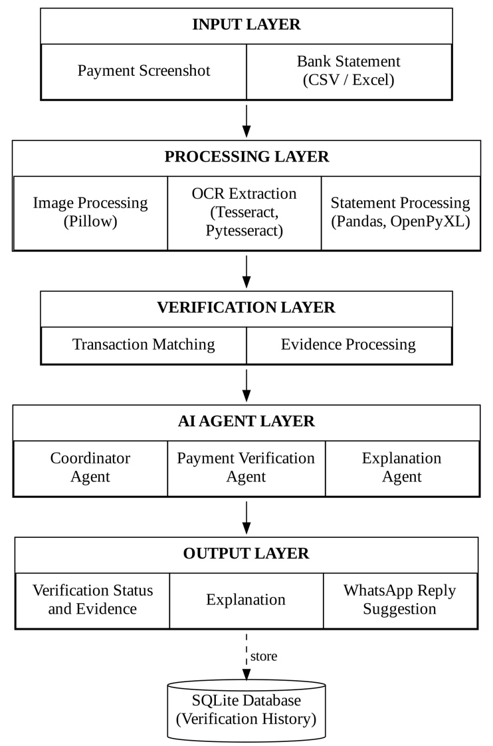
Figure 4.1: Architecture diagram of EvidentPay

4.3 Data Flow Diagram (DFD)
The Level 0 data flow diagram shows EvidentPay as a single process that exchanges data with the user and the verification history store.
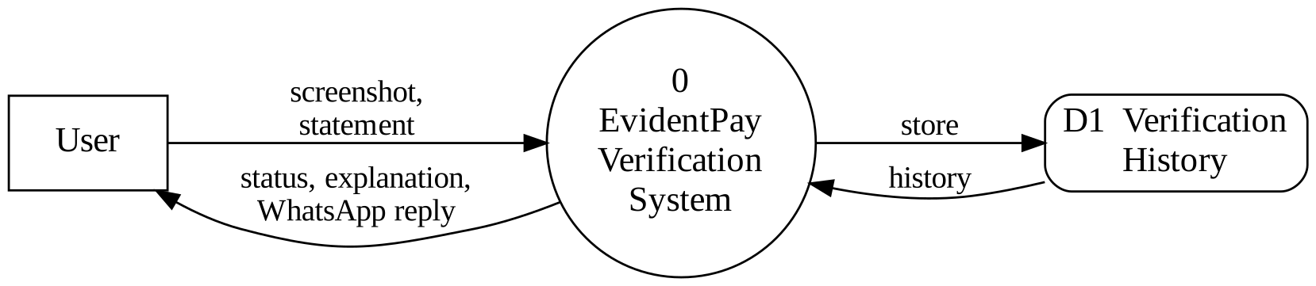
Figure 4.2: Level 0 DFD (context diagram)
The Level 1 data flow diagram breaks the system into its main processes: image processing, OCR extraction, statement processing, transaction matching, verification with explanation, and reply generation with history storage.
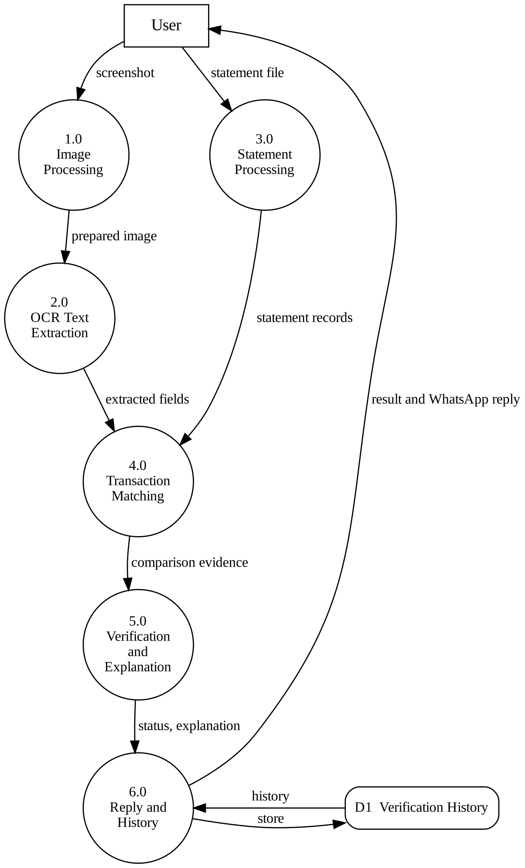
Figure 4.3: Level 1 DFD of EvidentPay

4.4 Flowchart
The flowchart below shows the sequence of operations from the upload of files to the display of the result.
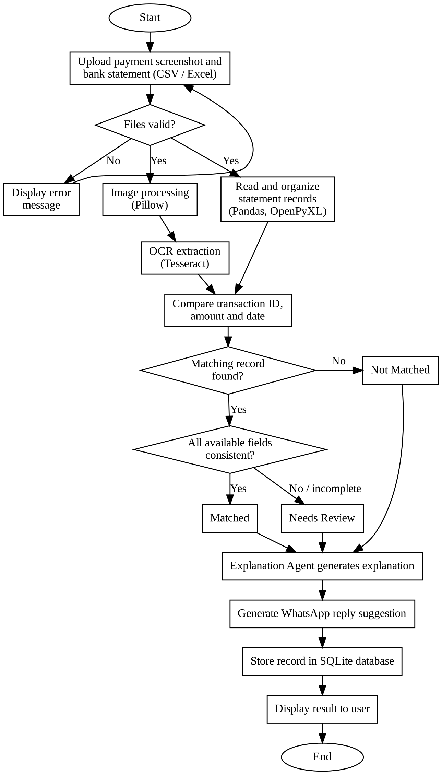
Figure 4.4: Flowchart of the verification process

4.5 UML Diagrams
The use case diagram shows the interaction between the user and the system. Verify payment includes the extraction of text and the matching of transactions.
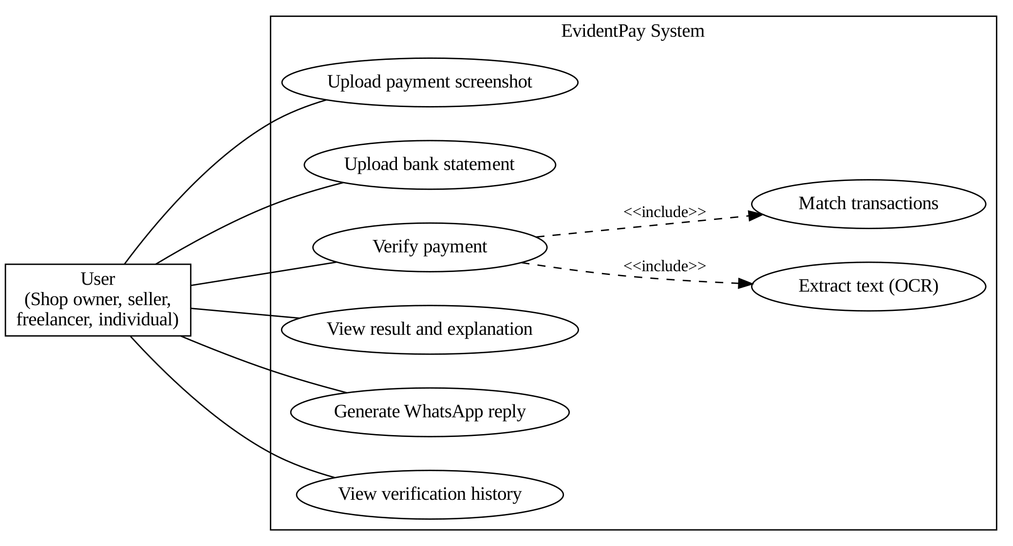
Figure 4.5: Use case diagram
The class diagram shows the main components of the system and their responsibilities. It is a conceptual diagram that shows how the work is divided among the components.
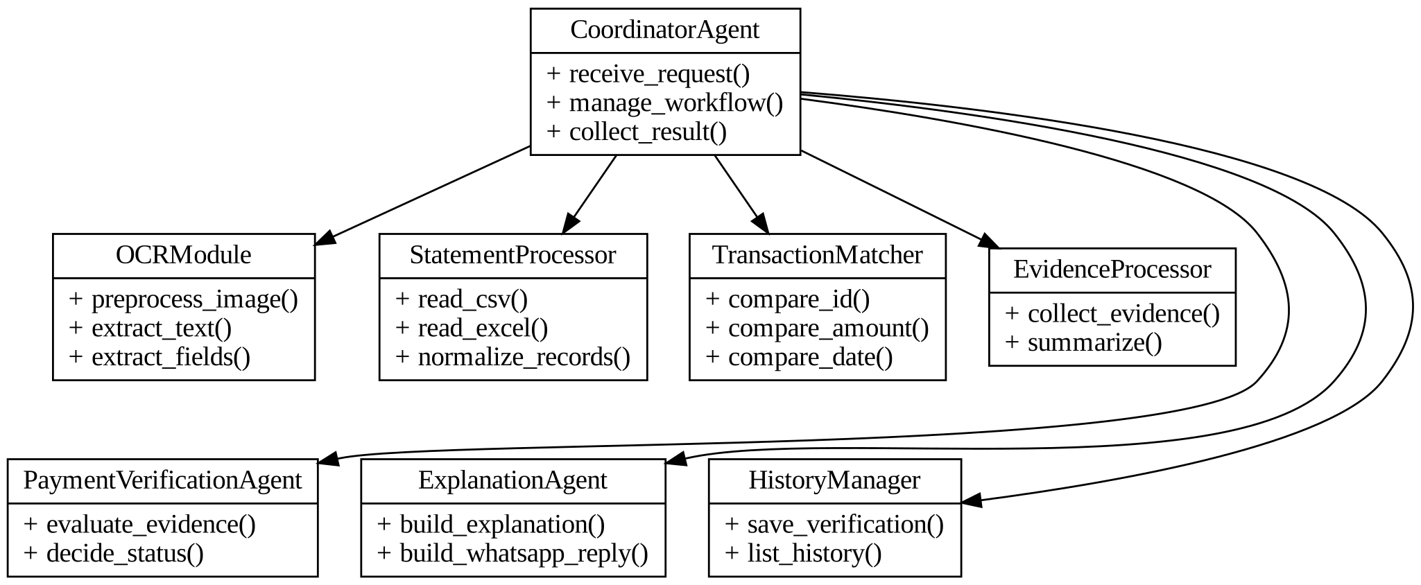
Figure 4.6: Class diagram of the main components

4.6 Database Design
EvidentPay uses SQLite to store the verification history. The database has two tables. The Verification table stores the main details of each verification, and the Evidence table stores the field-wise comparison that supports the decision. The Verification ID connects the two tables.
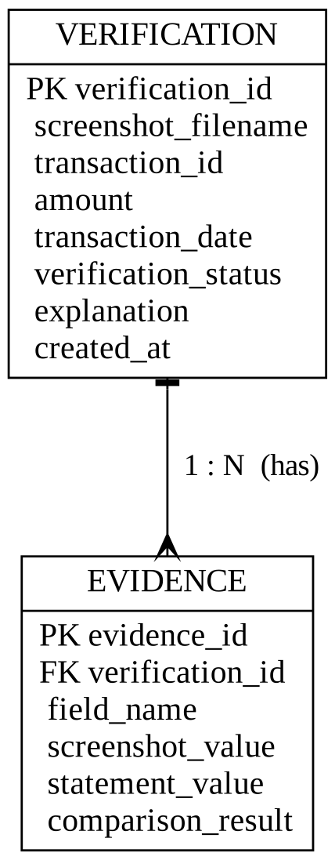
Figure 4.7: Entity relationship diagram
Table 4.1: Structure of the Verification table
Field | Description
verification_id | Primary key that identifies each verification
screenshot_filename | Name of the uploaded screenshot
transaction_id | Transaction ID extracted from the screenshot
amount | Transaction amount extracted from the screenshot
transaction_date | Transaction date extracted from the screenshot
verification_status | Matched, Not Matched or Needs Review
explanation | Plain-language explanation of the result
created_at | Date and time of the verification

Table 4.2: Structure of the Evidence table
Field | Description
evidence_id | Primary key of the evidence record
verification_id | Foreign key referring to the Verification table
field_name | Field compared, such as transaction ID, amount or date
screenshot_value | Value extracted from the screenshot
statement_value | Value found in the bank statement
comparison_result | Result of the comparison for that field

4.7 Module Design
EvidentPay is divided into modules, each with a clear responsibility. The input, processing and output of each module are summarized below.
Table 4.3: Module design
Module | Input | Processing | Output
Screenshot Upload | Image file | Checks the file format | Accepted image
Image Processing | Accepted image | Resizes, converts to grayscale, improves contrast | Prepared image
OCR Extraction | Prepared image | Recognizes text and identifies fields | Transaction details
Statement Processing | CSV or Excel file | Reads and organizes records | Statement records
Transaction Matching | Details and records | Compares ID, amount and date | Comparison result
Evidence Processing | Comparison result | Organizes supporting evidence | Evidence list
Payment Verification Agent | Evidence | Decides the status | Matched / Not Matched / Needs Review
Explanation Agent | Status, evidence | Prepares simple explanation | Explanation text
Coordinator Agent | User request | Manages the workflow | Final response
WhatsApp Reply | Status | Selects a suitable message | Reply suggestion
Verification History | Final result | Stores and retrieves records | History list

CHAPTER 5
TECHNOLOGIES USED

5.1 Programming Languages
Python is the main programming language used to develop EvidentPay. It is used for backend development, image processing, OCR integration, statement processing, transaction matching, database operations and agent coordination. Python was chosen because it is easy to read, has a large collection of libraries and works on all common operating systems.

5.2 Frameworks
FastAPI is a Python web framework used to develop the backend of the application. It handles user requests, screenshot uploads, statement uploads and communication between the frontend and the backend. It also connects the different processing modules and returns the verification results to the web interface. An ASGI server such as Uvicorn is used to run the FastAPI application.

5.3 Python Libraries and Packages
The Python libraries used in the project are listed in the table below.
Table 5.1: Python libraries and their purpose
Library | Purpose in EvidentPay
Pytesseract | Python interface to the Tesseract OCR engine; used to extract text directly through Python code
Pillow | Opens, resizes, converts and improves screenshot images before OCR
Pandas | Reads CSV files, organizes transaction records, handles missing values and prepares data for comparison
OpenPyXL | Reads Excel (XLSX) bank statements
sqlite3 | Python module used to work with the SQLite database
Uvicorn | Server used to run the FastAPI application
python-multipart | Supports file uploads in FastAPI

Tesseract itself is an OCR engine installed on the system. It recognizes text from images and is used to extract payment information from the uploaded screenshots.

5.4 Frontend Technologies
HTML is used to create the structure of the web application. It provides elements such as upload sections, input fields, buttons, result areas and the verification history page.
CSS is used to design the appearance of the application. It controls page layouts, colours, spacing, fonts, buttons and other interface elements.

5.5 Database Technologies
SQLite is a lightweight relational database management system used to store the verification history and related transaction information. It does not require a separate database server, stores the data in a single file and is therefore suitable for a small application such as EvidentPay.

5.6 Development Tools
- Visual Studio Code or another Python IDE for writing and running the code.
- pip, the Python package manager, for installing the libraries.
- A Python virtual environment to keep the project packages separate.
- A web browser for testing the user interface.
- Git for version control, where required.

5.7 Hardware Components
EvidentPay runs on an ordinary personal computer or laptop with the specifications given in Chapter 3. A smartphone can be used to capture or receive the payment screenshots, which are then uploaded through the browser. No special sensors or devices are required.

CHAPTER 6
SYSTEM IMPLEMENTATION

6.1 Project Folder Structure
The project is arranged in folders so that the backend modules, frontend pages and stored data are kept separate. The folder structure is shown below.
evidentpay/
main.py (FastAPI application and routes)
agents/ (Coordinator, Verification and Explanation agents)
modules/ (image processing, OCR, statement processing, matching)
database/ (SQLite database file and database functions)
templates/ (HTML pages)
static/ (CSS files)
uploads/ (temporary uploaded files)
requirements.txt (list of Python packages)

6.2 Backend Implementation
The backend is developed with FastAPI. It exposes routes for opening the home page, receiving the screenshot and statement for verification, displaying the result and showing the verification history. When the user submits the two files, the backend validates the file types, saves them temporarily and hands the request to the Coordinator Agent.
The backend does not perform the verification itself. It acts as the connection between the web interface and the processing modules, and it returns the final result to the browser. This keeps the web layer separate from the verification logic.

6.3 Frontend Implementation
The frontend consists of simple HTML pages styled with CSS. The pages are listed below.
Table 6.1: Pages of the user interface
Page | Purpose
Home Page | Introduces EvidentPay and gives access to the verification process
Verification Page | Allows the user to upload a payment screenshot and a bank statement
Result Page | Displays the status, transaction details, comparison evidence and explanation
WhatsApp Reply Section | Shows a suitable reply that the user can copy and use
History Page | Displays previously completed verifications

6.4 Database Implementation
The SQLite database is created with the Verification and Evidence tables described in Chapter 4. After every verification, the main details are inserted into the Verification table and the field-wise comparison results are inserted into the Evidence table with the same Verification ID. The history page reads these tables to show the earlier results. Only the information required for the history is stored, so that sensitive financial data is kept to a minimum.

6.5 Statement Processing and Transaction Matching Module
The statement processing module reads the CSV file using Pandas and the Excel file using OpenPyXL. It brings the records into a consistent format, handles missing or wrongly formatted values where possible, and keeps the fields needed for comparison, such as the transaction ID or reference number, date, description and credit amount.
The transaction matching module then compares the details extracted from the screenshot with these records. Not every bank statement contains the same fields, so the module compares the fields that are available instead of assuming that every field is present.
Table 6.2: Fields compared by the matching module
Field | What is checked
Transaction ID | Whether the reference number in the screenshot matches a reference in the statement
Amount | Whether the payment amount matches the corresponding credit entry
Date | Whether the transaction date is consistent with the statement record
Description | Available descriptions or reference text that support the comparison

For example, if the screenshot shows the amount ₹1,500 and the transaction ID TXN12345, and the statement has a credit of ₹1,500 with the ID TXN12345, then the amount and the transaction ID match. If the amount matches but the transaction ID is missing, the transaction is not treated as fully verified and is marked for additional checking.

6.6 Mismatch Detection Module
The evidence processing module records the outcome of each comparison so that mismatches and missing information are clearly identified. The kinds of mismatch handled by the system are shown below.
Table 6.3: Mismatch conditions and their handling
Condition | Handling
Transaction ID differs | Reported as a transaction ID mismatch in the evidence
Amount differs | Reported as an amount mismatch; the explanation states that the screenshot and statement amounts do not match
Date differs | Reported as a date inconsistency and marked for review
No matching record in the statement | Explained as no matching record found in the supplied statement
Field missing or unreadable | Result marked as Needs Review; the missing field is stated

6.7 AI Agent Implementation
EvidentPay uses a modular agent-based approach. Each agent has a defined responsibility instead of placing the whole verification process inside one large function.
Coordinator Agent. Receives the verification request, controls the sequence of operations, ensures that the screenshot and statement are processed before verification, passes the result to the Explanation Agent and collects the final response.
Payment Verification Agent. Receives the extracted screenshot information, the statement details and the comparison evidence, and determines the verification outcome by following the verification rules.
Explanation Agent. Converts the outcome into simple language. For example, it explains that the details are consistent with the statement record, that the transaction ID was missing, that the amounts differ, or that no matching record was found.
The decisions are based on the available transaction evidence. The system does not make unsupported assumptions about whether a person is trustworthy.

6.8 Risk Assessment and Result Handling Module
Because a screenshot cannot be treated as final proof, the system classifies every result into one of three outcomes and suggests how it should be handled. A not-matched result does not automatically mean that the screenshot is fake. There may be reasons such as statement delays, missing records or OCR errors.
Table 6.4: Verification outcomes and recommended handling
Outcome | Meaning | Recommended handling
Matched | Important details are consistent with a record in the supplied statement | Treat the payment as supported by the statement; confirm in the bank if required
Not Matched | The statement has no transaction matching the available details | Check the transaction status and request an updated confirmation
Needs Review | Information is incomplete, unclear or inconsistent | Review manually and check the missing details

The module also supports the generation of a WhatsApp reply based on the outcome. For example: “Thank you for sharing the payment screenshot. We could not find a matching transaction in the available bank statement. Could you please check the transaction status and share an updated confirmation?” The message is only a suggestion. The user can review and edit it before sending, and EvidentPay does not send messages automatically.

6.9 Explanation of Important Functions, Methods and Classes
The important components of the implementation and their functions are summarized below.
Table 6.5: Important components and their functions
Component | Function
Upload handler | Receives the files, checks the formats and passes them to the processing modules
Image preparation function | Reads the image with Pillow and applies resizing, grayscale conversion and contrast improvement
Text extraction function | Runs Tesseract through Pytesseract and returns the recognized text
Field identification function | Finds the transaction ID, amount, date and status in the recognized text
Statement reader | Reads CSV and Excel files and organizes the records
Matching function | Compares the screenshot fields with the statement records
Evidence builder | Records the result of each comparison
Coordinator Agent | Controls the order of operations and collects the result
Payment Verification Agent | Decides the verification status
Explanation Agent | Writes the explanation and the WhatsApp reply
History functions | Save verification records and read them for the history page

CHAPTER 7
WORKING PROCEDURE

7.1 Installation Procedure
The steps for installing EvidentPay on a computer are as follows.
- Install Python 3 from the official website.
- Install the Tesseract OCR engine on the computer.
- Copy the project folder to the computer.
- Create and activate a virtual environment.
- Install the required Python packages using the commands given below.
python -m venv venv
venv\Scripts\activate
pip install fastapi uvicorn python-multipart pillow pytesseract pandas openpyxl

7.2 Configuration
After installation, the following settings are checked:
- The path of the Tesseract OCR executable is set so that Pytesseract can find it.
- The folder used for temporary uploads exists.
- The SQLite database file is created automatically or is available in the database folder.
- The supported image formats and statement formats (CSV and XLSX) are enabled.

7.3 Step-by-Step Execution
The application is started with the following command and opened in a browser.
uvicorn main:app --reload
The overall working procedure then proceeds as follows.
- The user opens the EvidentPay web application in a browser.
- The user selects and uploads the payment screenshot.
- The user uploads the bank statement in CSV or Excel format.
- The screenshot is prepared for OCR using image processing.
- Tesseract OCR extracts the readable transaction information.
- The statement processing module reads and organizes the transaction records.
- The matching module compares the screenshot details with the statement records.
- The Payment Verification Agent evaluates the results and identifies the status.
- The Explanation Agent prepares a simple explanation.
- The application displays the status, matching details and explanation.
- The user can generate a polite WhatsApp reply based on the result.
- The verification information is stored in SQLite for later viewing.

7.4 Flow of Execution
When the user submits the two files, the backend passes the request to the Coordinator Agent. The Coordinator Agent first calls the image processing and OCR modules for the screenshot and the statement processing module for the statement. The results are given to the matching module, which compares the fields and produces the evidence. The Payment Verification Agent then decides the status, and the Explanation Agent prepares the explanation and the reply suggestion. Finally, the Coordinator Agent collects the response, the history module stores the record and the result is displayed. The complete flow is shown in the flowchart in Chapter 4.

7.5 LAN Configuration and Connectivity
By default, the application runs on the local computer and is opened in the browser of the same computer. It can also be used from other devices on the same local network (LAN or Wi-Fi) when required. For this, the server is started so that it listens on all network interfaces, and other devices open the address of the host computer in their browsers.
uvicorn main:app --host 0.0.0.0 --port 8000

Access from another device on the same network:
http://<IP address of the host computer>:8000
The host computer and the other device must be connected to the same network, and the firewall must allow the chosen port. Since the application handles financial information, it should be used only on trusted networks.

7.6 User Interaction
The user interacts with EvidentPay through the browser. The user selects the screenshot and the statement using the upload buttons and starts the verification. After the result appears, the user reads the status and explanation, may generate and edit a WhatsApp reply, and can open the history page to see earlier verifications. No technical knowledge is needed.

7.7 Output Generation
The output consists of the verification status, the transaction details, the matching and mismatching details, the explanation, the WhatsApp reply suggestion and the stored history record. As an example, consider a screenshot showing ₹2,000. The OCR module extracts the transaction ID UPI789456, the amount ₹2,000 and the date 05-11-2026, and the statement contains a transaction with the same details.
Table 7.1: Example of a verification
Field | Screenshot | Bank statement | Result
Transaction ID | UPI789456 | UPI789456 | Match
Amount | ₹2,000 | ₹2,000 | Match
Date | 05-11-2026 | 05-11-2026 | Match

The Payment Verification Agent returns the status Matched, and the Explanation Agent states that the important transaction details are consistent with the supplied statement. If the transaction ID or amount were different, the mismatch would be identified and explained, and if important information were unavailable, the result would be marked Needs Review.

CHAPTER 8
TESTING AND RESULTS

8.1 Testing Methodology
Testing was planned to check that every module works correctly by itself and that the modules work correctly together. The following levels of testing were used: unit testing of individual modules, integration testing of connected modules and system testing of the complete application. Each test case has a defined input and an expected result, and the actual result is compared with the expected result.

8.2 Unit Testing
Each module was tested separately.
Table 8.1: Unit test plan
Module | Test | Expected result
Upload | Upload an unsupported file type | File is rejected with an error message
Image processing | Process a normal screenshot | A prepared image is produced
OCR extraction | Extract text from a clear screenshot | Amount, ID and date are identified
Statement processing | Read CSV and XLSX files | Records are read into a consistent format
Transaction matching | Compare identical details | All fields are reported as matching
Database | Save and read a record | The record is stored and retrieved correctly

8.3 Integration Testing
Integration testing checked the connections between modules.
Table 8.2: Integration test plan
Modules tested | Expected result
Image processing and OCR | The prepared image is passed to OCR and text is extracted
OCR and matching | Extracted fields are received by the matching module
Statement processing and matching | Statement records are available for comparison
Matching and agents | Evidence is used to decide the status and explanation
Agents and database | The final result is stored and shown in the history

8.4 System Testing
System testing was carried out on the complete application through the browser. The user uploads a screenshot and a statement, the result is displayed with its evidence and explanation, the WhatsApp reply is generated and the record appears in the history page. Both CSV and Excel statements, matching and non-matching cases, and incomplete or unclear screenshots were included in this testing.

8.5 Test Cases and Expected Results
Table 8.3: Test cases and expected results
ID | Test scenario | Expected result
TC1 | Clear screenshot; statement contains matching record | Status Matched; all fields shown as matching
TC2 | Statement does not contain the transaction | Status Not Matched; no matching record explained
TC3 | Amount in screenshot differs from statement | Amount mismatch reported
TC4 | Transaction ID missing; amount matches | Status Needs Review
TC5 | Date differs from statement record | Date inconsistency reported and marked for review
TC6 | Blurred or low-quality screenshot | Status Needs Review; unclear information stated
TC7 | Unsupported file type uploaded | Error message; no processing
TC8 | Bank statement in Excel format | Records read correctly
TC9 | CSV with missing values | Processed without failure
TC10 | Generate WhatsApp reply | Suitable message for the status
TC11 | Open history page | Previous records displayed
TC12 | Submit without a statement | User is asked to upload the statement

8.6 Actual Results
The test cases were executed on the application and the observed results were recorded in the table below.
Table 8.4: Actual results of the test cases
ID | Expected result | Actual result | Status
TC1 | Matched
TC2 | Not Matched
TC3 | Amount mismatch reported
TC4 | Needs Review
TC5 | Date inconsistency reported
TC6 | Needs Review
TC7 | Error message
TC8 | Excel read correctly
TC9 | No failure
TC10 | Suitable reply
TC11 | History displayed
TC12 | Prompt for statement

8.7 Output Screenshots
The screenshots of the application are given below.
[Insert screenshot of the Home Page]
Figure 8.1: Home page of EvidentPay
[Insert screenshot of the Verification Page]
Figure 8.2: Verification page with upload options
[Insert screenshot of the Result Page – Matched]
Figure 8.3: Result page showing Matched status
[Insert screenshot of the Result Page – Not Matched / Needs Review]
Figure 8.4: Result page showing Not Matched or Needs Review
[Insert screenshot of the WhatsApp Reply Section]
Figure 8.5: WhatsApp reply suggestion
[Insert screenshot of the History Page]
Figure 8.6: Verification history page

8.8 Result Analysis
The results show that EvidentPay compares the extracted screenshot details with the supplied statement and reports the outcome together with its evidence. Cases in which the details agree produce the Matched status, cases with no matching record produce Not Matched, and cases with missing or unclear information produce Needs Review instead of a wrong conclusion.
The accuracy of the result depends mainly on three factors: the quality and readability of the screenshot, the correctness of the OCR output, and the completeness of the bank statement. Clear screenshots give better extraction, while blurred screenshots or unusual layouts may cause recognition errors. Statement formats also differ between banks. For these reasons the system reports uncertain cases for review and works as a decision-support tool, not as a final authority.

CHAPTER 9
ADVANTAGES AND APPLICATIONS

9.1 Advantages
- Reduces the effort required for manual transaction checking.
- Automatically extracts text from payment screenshots.
- Supports CSV and Excel bank statement files.
- Compares important transaction information.
- Identifies matching and mismatching fields.
- Provides explanations instead of displaying only a status.
- Uses separate modules for different responsibilities.
- Maintains verification history.
- Generates polite WhatsApp reply suggestions.
- Provides a simple and user-friendly web interface.

9.2 Applications
EvidentPay can be useful in situations where people frequently receive digital payments.
- Small businesses: shop owners can compare customer payment screenshots with their transaction records.
- Online sellers: sellers can check whether payment details match before processing an order.
- Freelancers: freelancers can organize and check payment information received from clients.
- Service providers: people providing services can compare payment details with their statements.
- Individuals: individuals can understand whether a shared screenshot matches their transaction records.

9.3 Limitations
- OCR accuracy depends on screenshot quality and text readability.
- Incorrect OCR extraction may affect transaction matching.
- Verification depends on the accuracy and completeness of the supplied bank statement.
- Different banks may use different statement formats.
- A missing transaction record does not necessarily mean that a payment was not made.
- The application does not directly access or verify transactions with banks.
- A matching screenshot and statement record do not independently prove that the screenshot itself is genuine.
Therefore, the application supports verification decisions but does not replace official bank confirmation.

9.4 Future Enhancements
- Improved OCR: use advanced OCR techniques for low-quality and differently formatted screenshots.
- Additional statement formats: support more bank statement formats and description patterns.
- Advanced image analysis: add image consistency checks that give supporting evidence, not definitive proof of manipulation.
- Multilingual support: support payment screenshots containing multiple languages.
- Authorized banking integration: explore secure integration with authorized banking services where official access is available.
- Improved matching: handle differences in date formats, transaction descriptions and reference numbers more flexibly.
- Enhanced history: add better search and filtering of previous records.

CHAPTER 10
CONCLUSION

10.1 Conclusion
EvidentPay is an AI-based payment screenshot verification system developed to simplify the process of checking digital payment information. The project combines image processing, Optical Character Recognition, statement processing, transaction matching and agent-based workflow coordination to compare payment screenshots with available bank transaction records.
The Coordinator Agent manages the verification workflow, the Payment Verification Agent evaluates the available transaction evidence and the Explanation Agent provides an understandable explanation of the result. The system also provides WhatsApp reply suggestions and maintains previous verification records using an SQLite database.

10.2 Project Outcome
The outcome of the project is a working web application that:
- accepts a payment screenshot and a CSV or Excel bank statement;
- extracts transaction details from the screenshot using OCR;
- compares them with the statement records and reports Matched, Not Matched or Needs Review;
- explains the result in simple language with supporting evidence;
- suggests a polite WhatsApp reply; and
- stores the verification history in an SQLite database.
The main purpose of the project is to provide a clear, organized and evidence-based decision-support system for digital payment verification. It does not automatically accuse anyone of fraud or replace official banking confirmation.

10.3 Future Scope
EvidentPay can be extended in many ways. Better OCR, support for more bank statement formats, multilingual screenshots, flexible matching and secure integration with authorized banking services can improve its accuracy and usefulness. Additional image consistency checks can provide more supporting evidence, and richer search features can make the verification history easier to use.

REFERENCES
- Python Official Documentation – https://docs.python.org/3/
- FastAPI Documentation – https://fastapi.tiangolo.com/
- Tesseract OCR Documentation – https://tesseract-ocr.github.io/
- Pytesseract Documentation – https://github.com/madmaze/pytesseract
- Pillow Documentation – https://pillow.readthedocs.io/
- Pandas Documentation – https://pandas.pydata.org/docs/
- OpenPyXL Documentation – https://openpyxl.readthedocs.io/
- SQLite Documentation – https://www.sqlite.org/docs.html

APPENDIX A
COMPLETE SOURCE CODE
The complete source code of EvidentPay is given in this appendix. The table lists the files of the project and their purpose.
Table A.1: Source files of the project
File | Purpose
main.py | FastAPI application and routes
agents | Coordinator, Payment Verification and Explanation agents
modules | Image processing, OCR, statement processing and matching
database | SQLite database creation and access functions
templates | HTML pages of the user interface
static | CSS files

[Paste the complete source code of each file here, with the file name above each listing]

APPENDIX B
INSTALLATION COMMANDS
The commands used to set up and run EvidentPay are given below.
python -m venv venv
venv\Scripts\activate
pip install fastapi uvicorn python-multipart pillow pytesseract pandas openpyxl
uvicorn main:app --reload
Tesseract OCR must also be installed on the computer before running the application.

APPENDIX C
CONFIGURATION FILES
The list of required Python packages (requirements.txt) is given below.
fastapi
uvicorn
python-multipart
pillow
pytesseract
pandas
openpyxl
Other settings: the Tesseract executable path, the upload folder and the SQLite database file name are set in the application code as described in Chapter 7.

APPENDIX D
ADDITIONAL SCREENSHOTS
[Insert additional screenshot]
Figure A.1: Additional screenshot 1
[Insert additional screenshot]
Figure A.2: Additional screenshot 2

APPENDIX E
USER MANUAL
- Open the EvidentPay web application in the browser.
- Click the upload button and select the payment screenshot (image file).
- Upload the bank statement in CSV or Excel format.
- Start the verification and wait for the result.
- Read the status (Matched, Not Matched or Needs Review), the evidence and the explanation.
- If needed, generate the WhatsApp reply, review and edit it, and send it yourself.
- Open the History page to view earlier verifications.
Note: the result depends on the supplied bank statement. Please confirm important payments with official bank records.

