AN INDUSTRIAL TRAINING REPORT ON

MACHINE LEARNING
Project:

EVIDENTPAY
UPI Payment Verification and Screenshot Tampering Analysis System
Training undertaken at

Central Institute of Tool Design (CITD), Balanagar
Submitted to
State Board of Technical Education and Training, Telangana, Hyderabad
In partial fulfilment of the requirements for the award of the

DIPLOMA IN

CLOUD COMPUTING AND BIG DATA
Academic Year 2026-2027
Submitted by
MUSINI GOMATHI
PIN: 24054-CCB-004

DEPARTMENT OF CLOUD COMPUTING AND BIG DATA
GOVERNMENT INSTITUTE OF ELECTRONICS
Affiliated to S.B.T.E.T., Telangana East Marredpally, Secunderabad - 500026

Government Institute of Electronics
Affiliated to SBTET, Telangana
East Marredpally, Secunderabad - 500026
CERTIFICATE

This is to certify that MUSINI GOMATHI (PIN 24054-CCB-004), a student of the Department of Cloud Computing and Big Data at Government Institute of Electronics, carried out the industrial training project entitled “EvidentPay - UPI Payment Verification and Screenshot Tampering Analysis System” under the guidance of S VAMSI at the Central Institute of Tool Design (CITD), Balanagar.
This report is submitted in partial fulfilment of the requirements for the award of the Diploma in Cloud Computing and Big Data during the academic year 2026-2027.

Internal Examiner External Examiner

Head of Department Principal

ACKNOWLEDGEMENT

I thank Sri M. V. Satish Kumar, Principal of Government Institute of Electronics, for the opportunity to undertake industrial training as part of my diploma.

I am grateful to Sri S. P. Venkat Reddy, Head of the Department of Cloud Computing and Big Data, and to the faculty members for their encouragement throughout the training.

I extend my sincere thanks to my industry guide, S VAMSI, and to the training staff at the Central Institute of Tool Design (CITD), Balanagar. The opportunity to connect machine learning concepts with the design, implementation and testing of EvidentPay helped me relate classroom learning to a practical application.

I also thank my classmates, friends and family for their valuable support and encouragement during the training and project development.

MUSINI GOMATHI
24054-CCB-004

DECLARATION OF THE CANDIDATE

I, MUSINI GOMATHI (PIN 24054-CCB-004), declare that this report records my industrial training at the Central Institute of Tool Design (CITD), Balanagar, under the guidance of S VAMSI. It describes the machine learning topics studied during training and my account of the project “EvidentPay - UPI Payment Verification and Screenshot Tampering Analysis System”.
I submit this report to the Department of Cloud Computing and Big Data at Government Institute of Electronics in partial fulfilment of the requirements for the award of the diploma during the academic year 2026-2027.
To the best of my knowledge, this report has not previously been submitted by me for the award of another diploma or degree. Technical sources consulted are acknowledged in the report.

Place: Secunderabad
Date:

Signature of the candidate
MUSINI GOMATHI
PIN: 24054-CCB-004

CONTENTS

S.NO TOPIC PAGE
- Introduction to Machine Learning 1
- Types of Machine Learning 1
- Machine Learning Workflow 2
- Data Preprocessing 3
- Feature Engineering 4
- Regression Algorithms 4
- Classification Algorithms 5
- Clustering Algorithms 7
- Dimensionality Reduction 8
- Model Training and Testing 8
- Model Evaluation Metrics 9
- Overfitting and Underfitting 10
- Bias-Variance Tradeoff 11
- Cross-Validation 11
- Ensemble Learning 11
- Model Deployment Using FastAPI 12
P1 Project Overview and Objective 14
P2 Architecture and Strategy 15
P3 Step-by-Step Implementation and Workflow Guide 20
P4 Problems Faced and Troubleshooting 30
P5 System Design 33
P6 Testing and Validation 34
P7 Expected Output 37
P8 Advantages 38
P9 Future Scope 39
P10 Conclusion 40

5

MACHINE LEARNING

Introduction to Machine Learning

What is Machine Learning?
Machine Learning (ML) is a branch of Artificial Intelligence (AI) that enables computers to learn patterns from data and make predictions or decisions without being explicitly programmed for every task.
Instead of writing fixed rules, we provide data to an ML algorithm, which learns relationships and uses them to make predictions on new data.
Example:
    - Providing historical house prices to a model.
    - The model learns how different factors affect house prices.
    - It predicts the price of a new house based on its features.

Applications of Machine Learning
    - Email spam detection.
    - Fraud detection.
    - Recommendation systems.
    - Image and speech recognition.
    - Medical data analysis.
    - Weather forecasting.
    - Customer behaviour prediction.

Important Terminology

Term | Meaning
Dataset | Collection of data used for learning
Features | Input variables used for prediction
Target | Output variable to be predicted
Sample | A single data record
Model | A mathematical system trained using data
Algorithm | Method used to learn patterns
Training | Process of teaching a model using data
Prediction | Output generated by a trained model

Types of Machine Learning
Machine Learning is mainly divided into three categories.
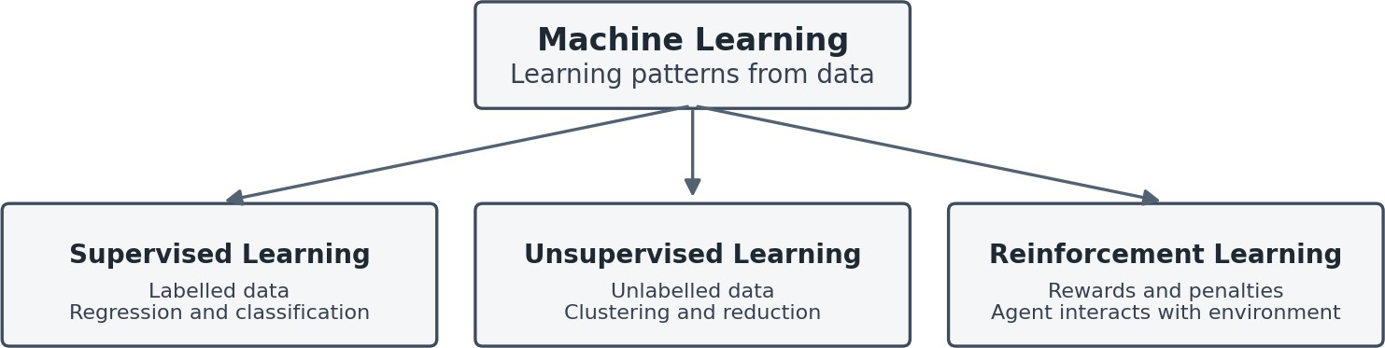

Figure: Three main types of Machine Learning.

Supervised Learning
Supervised Learning is a type of ML in which the model is trained using labelled data. Each training record contains input features and the correct output (target).
Example: Predicting whether a passenger survived the Titanic disaster using passenger information. Types:
    - Regression
    - Classification

Unsupervised Learning
Unsupervised Learning uses unlabelled data. The model identifies hidden patterns, relationships and groups without predefined output labels.
Example: Grouping customers based on their purchasing behaviour. Types:
    - Clustering
    - Dimensionality Reduction

Reinforcement Learning
Reinforcement Learning is a type of ML in which an agent learns through interaction with an environment. The agent receives rewards for good actions and penalties for incorrect actions.
Example: Training a computer to play a game by rewarding successful moves.

Machine Learning Workflow
The Machine Learning workflow describes the sequence of steps involved in developing an ML model.

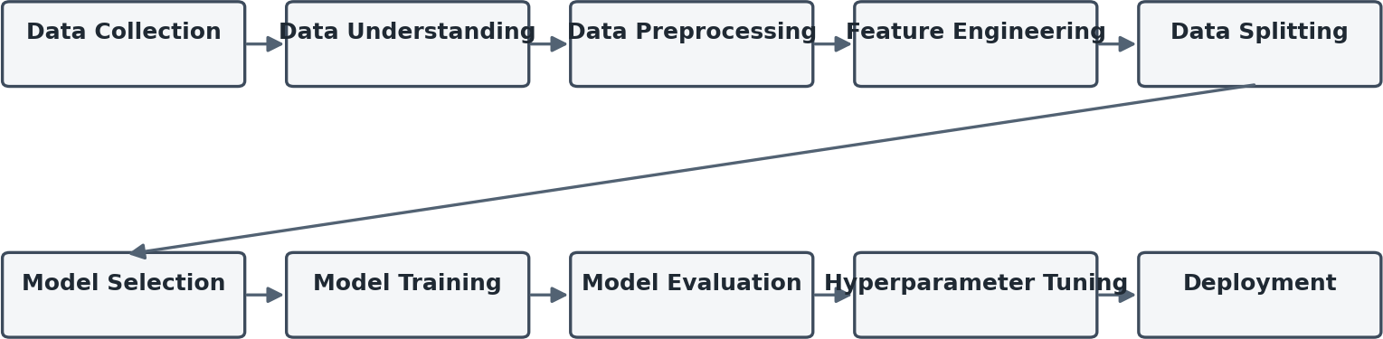

Figure: Typical Machine Learning workflow.
- Data Collection: Collecting data from sources such as CSV files, databases and datasets.
- Data Understanding: Examining the dataset, its features, data types and target variable.
- Data Preprocessing: Cleaning data and handling missing or inconsistent values.
- Feature Engineering: Selecting, transforming and creating useful features.
- Data Splitting: Dividing data into training and testing sets.
- Model Selection: Choosing a suitable ML algorithm.
- Model Training: Training the algorithm using training data.
- Model Evaluation: Measuring model performance using evaluation metrics.
- Hyperparameter Tuning: Improving performance by adjusting model settings.

- Deployment: Making the trained model available for real-world predictions.

Data Preprocessing
Data Preprocessing is the process of cleaning and transforming raw data into a suitable format before training an ML model.
Real-world datasets may contain missing values, duplicate records, incorrect data types and inconsistent information.

Handling Missing Values
Missing values occur when certain records do not contain information for particular features. Common methods:
    - Removing rows containing missing values.
    - Removing columns with excessive missing values.
    - Replacing missing numerical values using mean or median.
    - Replacing missing categorical values using mode.

Handling Duplicate Values
Duplicate records are repeated entries in a dataset.
They can affect model performance by giving repeated observations unnecessary importance. Duplicates can be identified and removed using Pandas.

Encoding Categorical Data
ML algorithms generally require numerical input. Therefore, categorical values must be converted into numerical representations.
Label Encoding: Assigns a numerical value to each category. Example:
Category | Encoded Value
Low | 0
Medium | 1
High | 2
One-Hot Encoding: Creates separate binary columns for each category. Example:
Colour | Red | Blue | Green
Red | 1 | 0 | 0
Blue | 0 | 1 | 0
Green | 0 | 0 | 1

Feature Scaling
Feature Scaling brings numerical features into a comparable range.
It is particularly important for distance-based and gradient-based algorithms. Standardization:
Transforms data to have a mean of approximately 0 and standard deviation of 1.
z = (x − μ) / σ
Where:

    - (x) = Original value
    - (μ) = Mean
    - (σ) = Standard deviation Normalization (Min-Max Scaling):
Transforms values into a specified range, commonly 0 to 1.
x' = (x − x_min) / (x_max − x_min)

Data Augmentation
Data Augmentation is the process of generating modified versions of existing training data to increase dataset diversity.
It is commonly used in image-related ML tasks. Examples include:
    - Image rotation.
    - Flipping.
    - Cropping.
    - Brightness adjustment.

Feature Engineering
Feature Engineering is the process of selecting, modifying or creating input variables to improve model performance.

Feature Selection
Selecting the most relevant features from a dataset while removing unnecessary or irrelevant features.

Feature Extraction
Transforming existing data into a new set of meaningful features.

Feature Importance
Feature Importance measures how much each input feature contributes to a model's predictions.
For example, in a Titanic survival prediction model, passenger class, age and gender may contribute differently to the prediction.

Parameters and Hyperparameters
Parameters: Values learned automatically by the model during training. Example: Coefficients in Linear Regression.
Hyperparameters: Settings selected before or during model training to control its behaviour. Examples:
    - K in KNN.
    - Alpha in Ridge and Lasso Regression.
    - Number of trees in Random Forest.

Regression Algorithms
Regression is a supervised learning technique used to predict continuous numerical values. Examples include predicting house prices, salary and temperature.

Linear Regression
Linear Regression models the relationship between an independent variable and a continuous dependent variable using a straight line.
Formula:

y = mx+c
Where:
    - (y) = Predicted output.
    - (x) = Input feature.
    - (m) = Slope.
    - (c) = Intercept.
The model attempts to find the best-fitting line by minimizing prediction errors.

Ridge Regression
Ridge Regression is a regularized version of Linear Regression that adds an L2 penalty to the loss function. It reduces the impact of large coefficients and helps prevent overfitting.
Loss = MSE + αΣ(j=1 to n) βⱼ²
Here, alpha controls the strength of regularization.

Lasso Regression
Lasso Regression uses L1 regularization to reduce the magnitude of coefficients.
It can shrink some coefficients to exactly zero, which helps perform feature selection.
Loss = MSE + αΣ(j=1 to n) |βⱼ|
Difference between Ridge and Lasso:

Ridge | Lasso
Uses L2 regularization | Uses L1 regularization
Reduces coefficient values | Can make coefficients zero
Usually retains all features | Can eliminate less useful features

Classification Algorithms
Classification is a supervised learning technique used to predict discrete categories or class labels. Examples:
- Spam or not spam.
- Fraudulent or legitimate.
- Survived or not survived.

Logistic Regression
Logistic Regression is a classification algorithm used to predict the probability of an observation belonging to a particular class.
It uses the Sigmoid function to convert output values into probabilities between 0 and 1.
σ(z)=1 / (1 + e^(−z))
A threshold, commonly 0.5, is used to assign the predicted class.

K-Nearest Neighbors (KNN)
KNN is a supervised learning algorithm that predicts the class of a new data point based on the classes of its nearest neighbours.
It uses distance measurements to identify nearby data points. Euclidean Distance:
d=√Σ(i=1 to n)(xᵢ − yᵢ)²

The value of K determines the number of neighbours considered.

Support Vector Machine (SVM)
SVM is a supervised learning algorithm that finds an optimal decision boundary called a hyperplane to separate different classes.
It attempts to maximize the margin between the closest data points of different classes. Important concepts:
    - Hyperplane.
    - Support Vectors.
    - Margin.
    - Kernel Function.

Decision Tree
A Decision Tree is a tree-based algorithm that makes predictions by splitting data into smaller groups based on feature conditions.
It consists of:
    - Root Node: Starting point of the tree.
    - Decision Nodes: Nodes containing feature-based conditions.
    - Branches: Outcomes of decisions.
    - Leaf Nodes: Final predictions. Splitting Methods:
Entropy: Measures the impurity or uncertainty in a dataset.
Entropy(S)=-Σ pᵢ log₂(pᵢ)
Information Gain: Measures the reduction in entropy after splitting the dataset.
IG=Entropy(Parent)-WeightedEntropy(Children)
Gini Impurity: Measures the probability of incorrectly classifying a randomly selected observation.
Gini=1-Σ pᵢ²
We also studied ID3 and CART decision-tree approaches.

Random Forest
Random Forest is an ensemble learning algorithm that combines multiple Decision Trees to produce a more reliable prediction.
It uses:
    - Bootstrap Sampling.
    - Random Feature Selection.
    - Multiple Decision Trees.
    - Majority Voting for classification.
Each tree produces a prediction, and the final class is selected through majority voting.

Gradient Boosting
Gradient Boosting is an ensemble learning algorithm that builds models sequentially. Each new model attempts to correct the errors made by the previous models.
Important hyperparameters:
    - Number of estimators.
    - Learning rate.
    - Maximum depth.

AdaBoost
AdaBoost (Adaptive Boosting) combines multiple weak learners to create a stronger predictive model.
It increases the importance of incorrectly classified observations so that subsequent learners focus more on those mistakes.

XGBoost
XGBoost (Extreme Gradient Boosting) is an optimized gradient boosting algorithm designed for efficient and accurate predictions.
It includes regularization techniques to control model complexity and reduce overfitting.

Clustering Algorithms
Clustering is an unsupervised learning technique used to group similar data points based on their characteristics.
Unlike classification, clustering does not require predefined class labels.

K-Means Clustering
K-Means is a clustering algorithm that divides a dataset into K groups based on similarity. Working Process:
- Select the number of clusters (K).
- Initialize K cluster centroids.
- Calculate the distance between data points and centroids.
- Assign each data point to its nearest centroid.
- Recalculate the centroids.
- Repeat until the clusters stop changing significantly. Important Concept: Centroid represents the centre of a cluster.
Applications: Customer segmentation, image compression and grouping similar data.

Hierarchical Clustering
Hierarchical Clustering is an unsupervised learning algorithm that creates a hierarchy of clusters. It is commonly represented using a tree-like diagram called a Dendrogram.
Two approaches:
    - Agglomerative: Starts with individual data points and repeatedly merges similar clusters.
    - Divisive: Starts with one large cluster and repeatedly divides it into smaller clusters.

DBSCAN
DBSCAN stands for Density-Based Spatial Clustering of Applications with Noise.
It groups data points based on their density and identifies points that do not belong to any cluster as noise or outliers.
Important parameters:
    - Epsilon (ε): Maximum distance between neighbouring points.
    - MinPts: Minimum number of points required to form a dense region. Types of points:
    - Core Points.
    - Border Points.
    - Noise Points.
Unlike K-Means, DBSCAN does not require specifying the number of clusters beforehand.

Dimensionality Reduction
Dimensionality Reduction is the process of reducing the number of features in a dataset while retaining as much useful information as possible.
It helps reduce computational complexity, remove redundant information and simplify data visualization.

Principal Component Analysis (PCA)
PCA is a dimensionality reduction technique that transforms original features into a smaller set of new variables called Principal Components.
These components capture the maximum possible variance in the data. Working Process:
- Standardize the dataset.
- Calculate the covariance matrix.
- Find eigenvalues and eigenvectors.
- Sort components based on their eigenvalues.
- Select the required principal components.
- Transform the original dataset into the reduced feature space. Important terms:
  - Variance: Measures how much data values differ from their mean.
  - Covariance: Measures how two variables change together.
  - Eigenvalues: Represent the amount of variance captured by principal components.
  - Eigenvectors: Represent the directions of principal components.

Factor Analysis
Factor Analysis is a statistical dimensionality reduction technique used to identify hidden variables called latent factors that explain relationships among observed variables.
It assumes that several observed features may be influenced by a smaller number of underlying factors. Example: Different questions in a survey may measure underlying factors such as satisfaction or motivation. PCA vs Factor Analysis
PCA | Factor Analysis
Focuses on explaining total variance | Focuses on explaining shared variance
Creates principal components | Identifies latent factors
Mainly used for dimensionality reduction | Mainly used to identify underlying relationships

Model Training and Testing
Model Training and Testing are important stages in developing an ML model.

Training Dataset
The training dataset is used to teach the model by allowing it to learn patterns and relationships between input features and target values.

Testing Dataset
The testing dataset is used to evaluate the trained model using data that it has not seen during training.

Train-Test Split
Train-Test Split divides a dataset into separate training and testing portions. A commonly used ratio is:

    - 80% Training Data.
    - 20% Testing Data. Python implementation:
from sklearn.model_selection import train_test_split X_train, X_test, y_train, y_test = train_test_split(
X, y,
test_size=0.2, random_state=42
)
Where:
    - X represents input features.
    - y represents target values.
    - test_size determines the testing proportion.
    - random_state ensures reproducibility.

Model Evaluation Metrics
Model Evaluation Metrics are used to measure how accurately and effectively an ML model performs. Different metrics are used for classification and regression problems.

Confusion Matrix
A Confusion Matrix is a table used to evaluate classification models by comparing actual and predicted class labels.
It contains four important values:

Term | Meaning
True Positive (TP) | Correctly predicted positive
True Negative (TN) | Correctly predicted negative
False Positive (FP) | Incorrectly predicted positive
False Negative (FN) | Incorrectly predicted negative

Classification Metrics
Accuracy: Measures the proportion of correctly predicted observations.
Accuracy=(TP + TN) / (TP + TN + FP + FN)
Precision: Measures how many predicted positive observations are actually positive.
Precision=TP / (TP + FP)
Recall: Measures how many actual positive observations are correctly identified.
Recall=TP / (TP + FN)
F1-Score: Harmonic mean of Precision and Recall.
F1=2 × (Precision × Recall) / (Precision + Recall)

Regression Metrics
Mean Absolute Error (MAE): Calculates the average absolute difference between actual and predicted values.
MAE=1 / nΣ|yᵢ − ŷᵢ|
Mean Squared Error (MSE): Calculates the average squared difference between actual and predicted values.
MSE=1 / nΣ(yᵢ − ŷᵢ)²
Root Mean Squared Error (RMSE): Square root of MSE.

RMSE=√MSE

Overfitting and Underfitting

Overfitting
Overfitting occurs when a model learns the training data too closely, including noise and unnecessary patterns.
As a result, the model performs very well on training data but poorly on unseen testing data. Causes:
    - Excessively complex models.
    - Insufficient training data.
    - Too many unnecessary features.
    - Excessive training.
Solutions:
    - Regularization.
    - Cross-validation.
    - Feature selection.
    - Increasing training data.
    - Reducing model complexity.

Underfitting
Underfitting occurs when a model is too simple to learn the important patterns in the dataset. It performs poorly on both training and testing data.
Causes:
    - An overly simple model.
    - Insufficient training.
    - Poor feature selection.
    - Excessive regularization. Solutions:
    - Use a more suitable model.
    - Add relevant features.
    - Reduce excessive regularization.
    - Improve training.

Difference Between Overfitting and Underfitting

Overfitting | Underfitting
Learns training data too closely | Fails to learn important patterns
High training performance | Poor training performance
Poor generalization | Poor generalization
Model is often too complex | Model is often too simple

Bias-Variance Tradeoff
Bias and Variance are two important sources of prediction errors in Machine Learning.

Bias
Bias refers to the error caused by overly simple assumptions made by a model. High bias can lead to underfitting.

Variance
Variance refers to how much a model's predictions change when trained on different datasets. High variance can lead to overfitting.

Bias-Variance Tradeoff
The Bias-Variance Tradeoff refers to balancing bias and variance to achieve good performance on unseen data.
    - High Bias + Low Variance = Underfitting.
    - Low Bias + High Variance = Overfitting.
    - Balanced Bias and Variance = Better Generalization.

Cross-Validation
Cross-Validation is a model evaluation technique used to estimate how well a model performs on different subsets of data.
It helps reduce dependence on a single train-test split.

K-Fold Cross-Validation
The dataset is divided into K equal or nearly equal folds.
The model is trained K times, using K-1 folds for training and the remaining fold for validation. The process repeats until every fold has been used for validation.

Stratified K-Fold
Stratified K-Fold maintains approximately the same class distribution in every fold. It is useful for classification datasets, especially when class distributions are uneven.

Leave-One-Out Cross-Validation (LOOCV)
LOOCV is a cross-validation method in which one observation is used for validation while all remaining observations are used for training.
This process repeats for every observation in the dataset.

Holdout vs Cross-Validation

Holdout | Cross-Validation
Uses one data split | Uses multiple data splits
Faster | More computationally expensive
Evaluation depends on the split | Provides a more comprehensive evaluation

Ensemble Learning
Ensemble Learning is a technique that combines multiple individual models to improve prediction performance.
Instead of depending on one model, it combines predictions from multiple learners.

Bagging
Bagging stands for Bootstrap Aggregating.
It trains multiple models independently using different bootstrap samples of the original dataset. Their predictions are combined using:
    - Majority Voting for classification.
    - Averaging for regression.

Random Forest is an example of a bagging-based ensemble algorithm.

Boosting
Boosting trains models sequentially, where each new model focuses on correcting errors made by previous models.
Examples:
    - AdaBoost.
    - Gradient Boosting.
    - XGBoost.

Bagging vs Boosting

Bagging | Boosting
Models are trained independently | Models are trained sequentially
Uses bootstrap sampling | Focuses on previous model errors
Mainly helps reduce variance | Helps reduce bias and improve predictive performance

Model Deployment Using FastAPI
Model Deployment is the process of making a trained Machine Learning model available for real-world applications.
Instead of running predictions only inside a Python notebook, deployment allows other applications to send input data and receive predictions.

Saving a Trained Model
After training, a model can be saved as a file using Python's Pickle library. Common files:
    - model.pkl – Stores the trained ML model.
    - scaler.pkl – Stores the fitted feature scaler.
Saving the model avoids retraining it every time a prediction is requested.

Introduction to FastAPI
FastAPI is a Python web framework used to build APIs.
It acts as an interface between a frontend application and a trained ML model. Its responsibilities include:
    - Accepting input data.
    - Validating input.
    - Loading the trained model.
    - Processing the input.
    - Generating predictions.
    - Returning prediction results.

Prediction API Workflow
- A user enters input data through a frontend application.
- The frontend sends the data to the FastAPI backend.
- FastAPI receives and validates the input.
- The saved scaler transforms the input if required.
- The trained model generates a prediction.
- FastAPI returns the result to the frontend.

Important FastAPI Concepts

Concept | Purpose
API | Allows different applications to communicate
Endpoint | URL through which an API operation is accessed
GET | Retrieves information
POST | Sends information to the server
Pydantic | Validates input data
Uvicorn | Runs the FastAPI application
Swagger UI | Provides interactive API documentation

Deployment Workflow
We followed an end-to-end deployment workflow:
- Train the model using Python.
- Save the model and scaler.
- Develop a FastAPI application.
- Create a prediction endpoint.
- Test predictions using Swagger UI.
- Upload the project to GitHub.
- Deploy the application using Render.
- Test the deployed application through its public URL.

Important Deployment Considerations
    - requirements.txt contains the required Python packages.
    - Correct file paths must be maintained.
    - Environment variables are used for configuration.
    - Python and library versions must be compatible.
    - The application must listen on the deployment platform's assigned port.
    - The deployed application must correctly load its saved model files.

PROJECT OVERVIEW AND OBJECTIVE
Project Title: EvidentPay - UPI Payment Verification and Screenshot Tampering Analysis System

Project Overview
EvidentPay is a web-based UPI payment verification and screenshot tampering detection system developed to simplify the process of verifying digital payments made during college events, workshops, technical fests, seminars, and other registrations.
Nowadays, many events collect registration fees through UPI applications such as Google Pay, PhonePe, and Paytm. Participants usually share payment confirmation screenshots through WhatsApp as proof of payment. However, manually checking every screenshot and comparing it with bank transactions becomes difficult when the number of participants increases.
Another major problem is that payment screenshots can be edited using image-editing applications. A participant may modify the payment amount, transaction reference number, date, or other visible details and submit the altered image as genuine payment proof.
EvidentPay addresses these problems through two major verification processes:
- Payment Verification: Extracts payment details from uploaded screenshots and compares them with transactions in an imported bank statement.
- Screenshot Tampering Detection: Analyses uploaded payment screenshots using image-processing techniques to identify possible signs of image manipulation.
The system provides a centralized interface where event organizers can upload payment screenshots, import bank statements, analyse images, and view verification results.
Instead of depending entirely on manual verification, EvidentPay automates several steps and helps organizers identify matching transactions, duplicate claims, discrepancies, and potentially altered screenshots.

Problem Statement
Traditional UPI payment verification methods have several limitations:
    - Organizers need to manually open and inspect individual payment screenshots.
    - Comparing screenshots with bank statements is time-consuming.
    - Edited screenshots may contain incorrect payment amounts or transaction details.
    - The same payment screenshot may be submitted multiple times.
    - Some transactions may be missing from the imported bank statement.
    - Manual verification becomes difficult when hundreds of participants register for an event.
    - Visual inspection alone cannot reliably identify image manipulation.
Therefore, a system is required that can automate payment-detail extraction, transaction reconciliation, and screenshot analysis.

Objectives
The main objectives of EvidentPay are:
- To automate the extraction of payment information from UPI screenshots.
- To reduce manual work involved in payment verification.
- To verify payments by comparing extracted details with bank statement transactions.
- To identify duplicate payment claims.
- To detect discrepancies in transaction amount, UTR, date, and sender information.
- To analyse screenshots for possible signs of image manipulation.
- To support screenshot analysis even when a bank statement is unavailable.
- To provide a simple web interface for event organizers.
- To generate clear verification results that help organizers make informed decisions.

Scope of the Project
EvidentPay is mainly designed for:
    - College technical fests.
    - Workshops and seminars.
    - Student registration systems.
    - Conference registrations.
    - College club events.
    - Other small and medium-sized events that collect UPI payments.
The current system supports payment screenshot uploads and bank statement imports. It also provides a separate screenshot analysis workflow that examines image characteristics without requiring a bank transaction reference.

ARCHITECTURE AND STRATEGY

System Architecture
EvidentPay follows a client-server architecture.
The frontend handles user interaction, while the backend processes uploaded files, extracts payment information, performs reconciliation, and analyses screenshots.
The application consists of the following major layers:

Presentation Layer
The presentation layer is developed using React. It provides the user interface through which organizers create events, upload screenshots, import bank statements, and view results.

Application Layer
The application layer is developed using FastAPI. It handles incoming requests, manages processing workflows, connects the frontend with backend services, and returns results.

Processing Layer
This layer performs the major operations of the system:
  - OCR-based payment detail extraction.
  - Bank statement parsing.
  - Payment reconciliation.
  - Image processing and tampering analysis.
  - Duplicate detection.

Database Layer
SQLite is used to store event information, extracted payment details, and related verification records. SQLAlchemy is used for database operations.

File Processing Layer
The system processes uploaded screenshots and bank statement files using image-processing and document-processing libraries.

Technologies Used

Technology | Purpose
React 19 | Frontend development
Python | Backend processing
FastAPI | Backend API development
Uvicorn | Running the FastAPI application
SQLite | Database storage
SQLAlchemy | Database management
Tesseract OCR | Extracting text from screenshots
Pytesseract | Connecting Python with Tesseract
OpenCV | Image processing and analysis
Pillow | Image loading and manipulation

Technology | Purpose
NumPy | Numerical image operations
ImageHash | Perceptual image hashing
scikit-image | SSIM-based image comparison
pdfplumber | Extracting transaction information from text-based PDFs
Pandas | Processing CSV bank statements

Implementation Strategy
The project follows a modular implementation strategy. Each major operation is handled by a separate service or processing component.
The system is divided into two independent verification modes.

Mode 1: Bank Statement-Based Payment Verification
This mode verifies whether the payment details extracted from a screenshot correspond to an actual credit transaction in the imported bank statement.
The process involves:
- Uploading payment screenshots.
- Extracting payment details using OCR.
- Importing the bank statement.
- Extracting transaction details from the statement.
- Comparing payment information with bank transactions.
- Identifying matches, duplicates, and discrepancies.
- Displaying the verification results.

Mode 2: Screenshot-Only Tampering Analysis
This mode analyses a screenshot independently of bank statement data. It uses image-processing techniques to examine:
  - Image similarity.
  - Perceptual hash differences.
  - Error Level Analysis (ELA).
  - Noise patterns.
  - Edge characteristics.
  - Image metadata.
  - OCR text and visible information.
This mode is important because not every organizer has access to a bank statement or transaction records. It provides image-analysis indicators even when no reference screenshot or bank transaction is available.
Important distinction: Screenshot-only analysis identifies possible editing indicators. It does not guarantee that an image is genuine or manipulated.

Overall Architecture Diagram
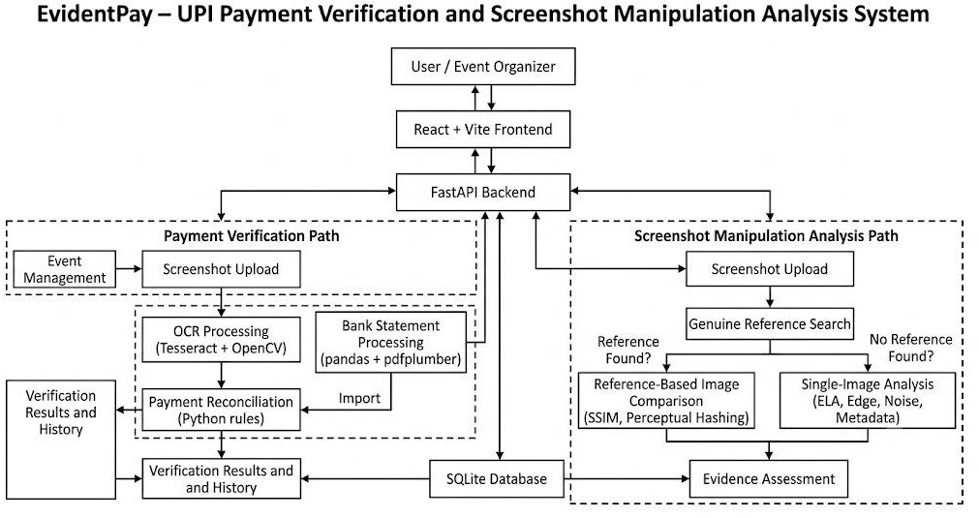
Figure 1: EvidentPay system architecture

APPLICATION SCREENSHOTS
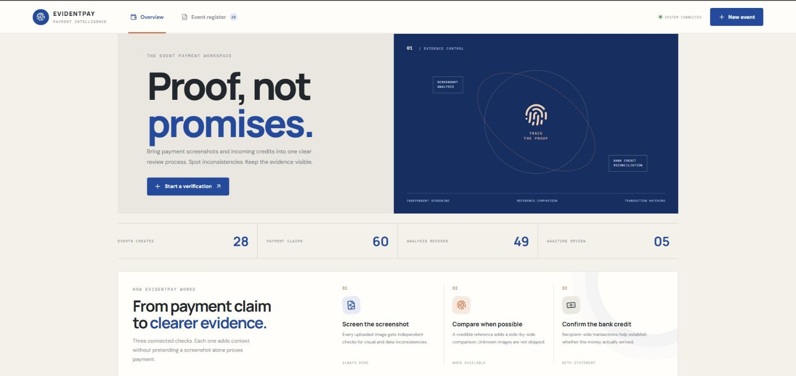
Figure 2: EvidentPay application homepage
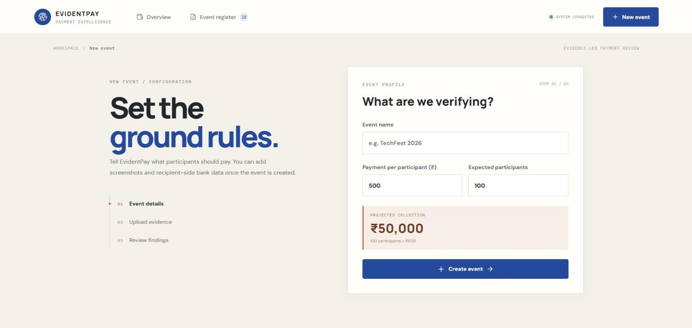
Figure 3: Event creation and configuration screen

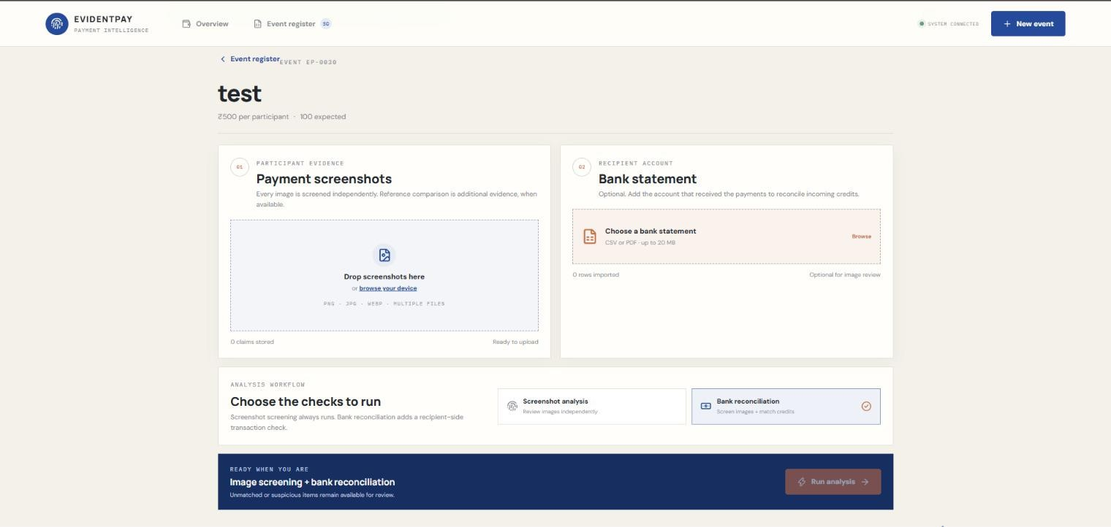
Figure 4: Screenshot and bank statement upload workflow
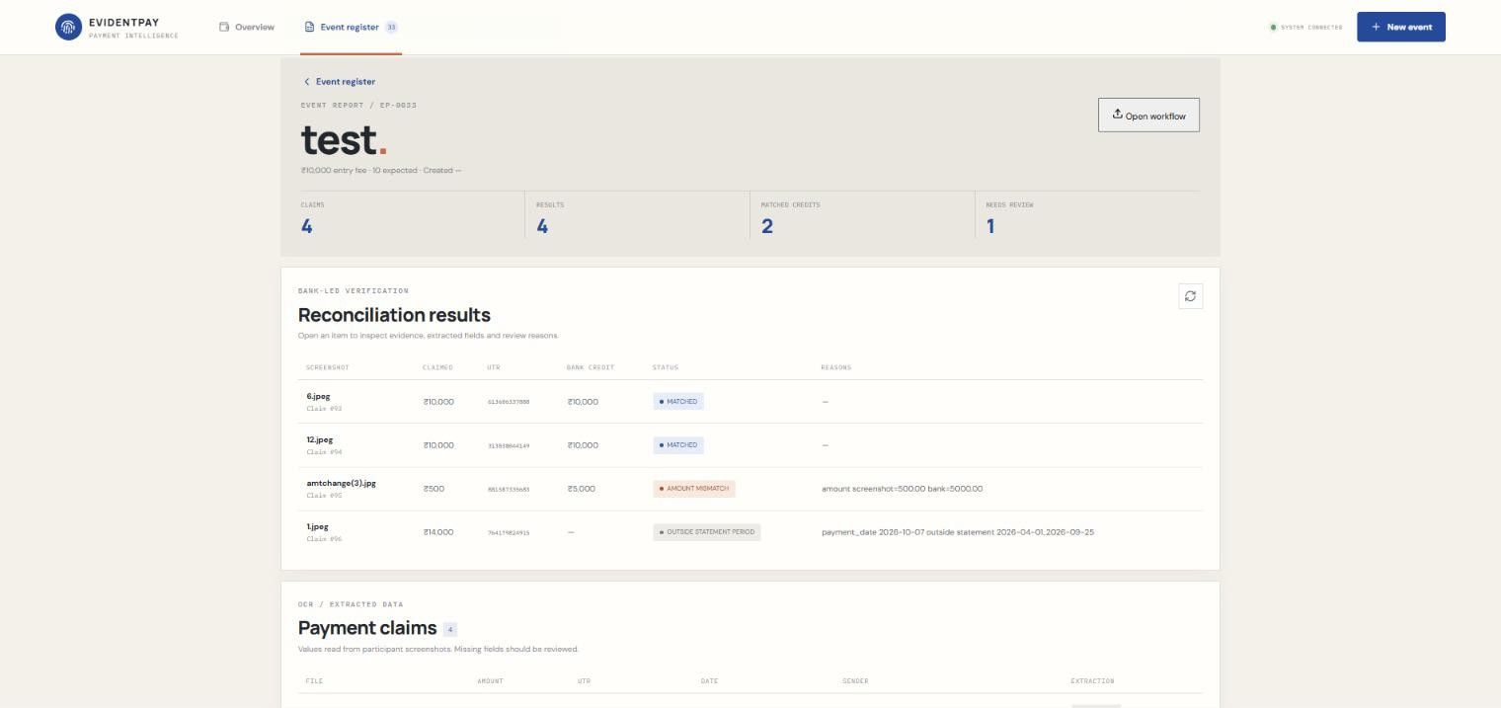
Figure 5: Payment reconciliation results

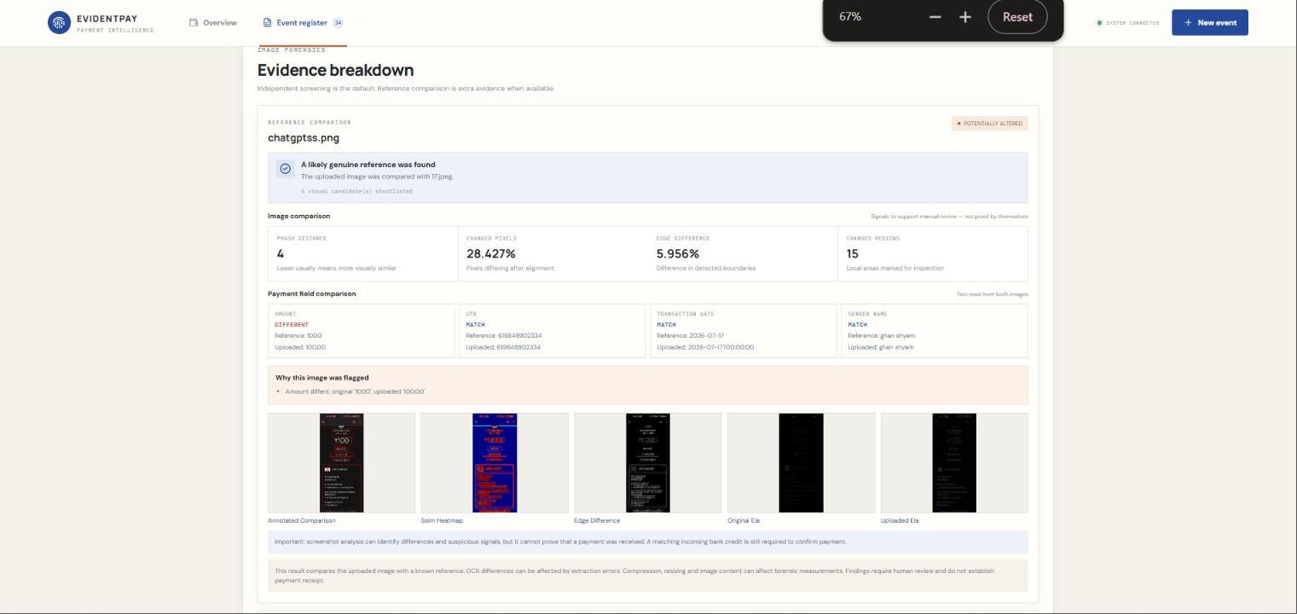
Figure 6: Evidence breakdown and reference-based image comparison
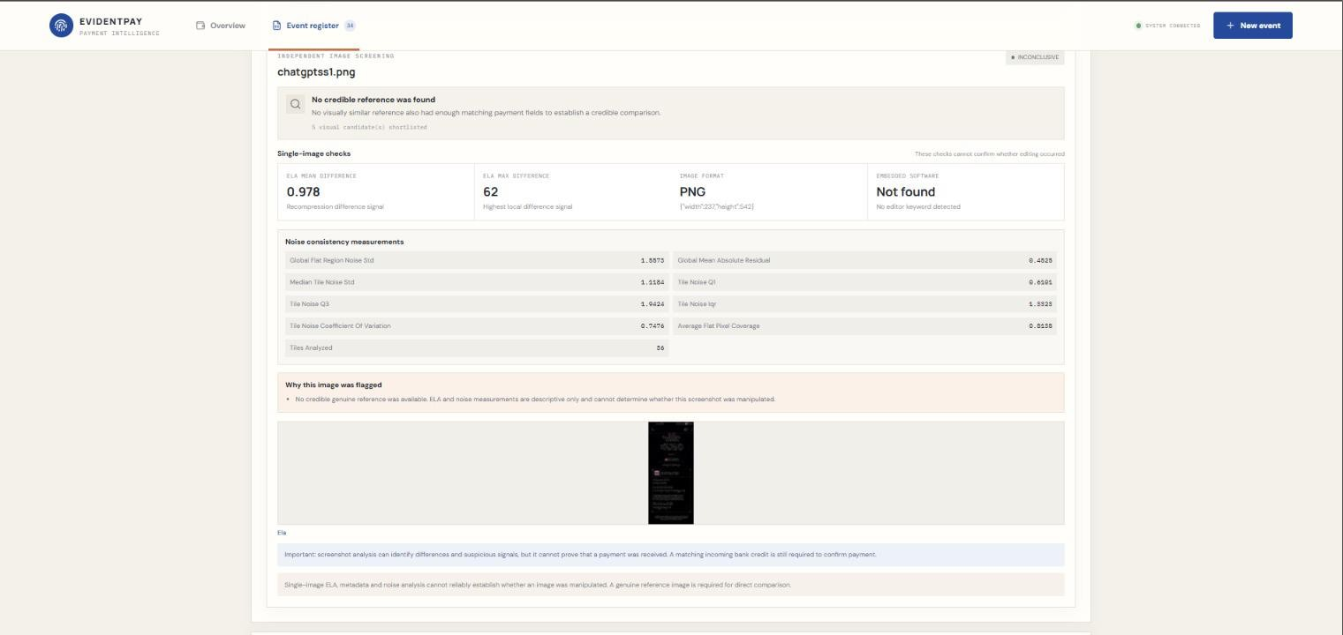
Figure 7: Reference-free screenshot analysis

STEP-BY-STEP IMPLEMENTATION AND WORKFLOW GUIDE
The implementation of EvidentPay was carried out in multiple stages. Each stage focuses on developing and integrating a particular functionality of the application.

Step 1 – Project Setup
The initial step involved creating the project structure and setting up the development environment. The project was divided into two major parts:
    - Frontend – React application.
    - Backend – Python application using FastAPI.
The backend was organized into separate modules for API routes, OCR processing, statement parsing, reconciliation, and image analysis.
This modular structure makes the application easier to maintain, test, and extend.
Frontend implementation – React
React is used to build the interactive frontend, including event management, screenshot uploads, bank statement imports, reconciliation results and screenshot analysis. React uses reusable components and state-driven rendering to update interface elements when application data changes. This helps organize and maintain the different sections of EvidentPay. A separate literal React code snippet was not included in the supplied code material.

Step 2 – Event Creation
The organizer first creates an event by providing the required information. The event setup includes:
    - Event name.
    - Registration fee.
    - Estimated number of participants. For example:
Field | Sample value
Event name | Technical Fest 2026
Registration fee | ₹500
Estimated participants | 100
These details establish the basic configuration for payment verification.
The registration fee is used as a reference when evaluating extracted payment amounts.
Code Snippet 1: Event Creation Request and Endpoint (upload.py)
This code defines the information required to create an event and validates the event name, ticket price and expected participant count.
class EventCreateRequest(BaseModel):
event_name: str = Field(min_length=1, max_length=150) event_price: float = Field(gt=0) expected_participant_count: int = Field(gt=0)

@router.post("")
def create_new_event(payload: EventCreateRequest):

if not payload.event_name.strip(): raise HTTPException(
status_code=400,
detail="Event name cannot be empty"
)

event = create_event( event_name=payload.event_name.strip(), event_price=payload.event_price,
expected_participant_count=payload.expected_participant_count
)

return {
"event_id": event.event_id, "event_name": event.event_name, "event_price": str(event.event_price),
"expected_participant_count": event.expected_participant_count
}
}

Step 3 – Uploading Payment Screenshots
After creating an event, the organizer uploads the payment screenshots received from participants.
The system accepts multiple screenshots so that organizers do not need to process each image individually. The uploaded screenshots are passed to the backend for processing.
The images are stored and processed separately, and their extracted information is associated with the corresponding event.
Code Snippet 2: Payment Screenshot Upload (upload.py)
This endpoint accepts multiple payment screenshots, checks their file formats, saves them with unique filenames and sends them for OCR extraction.
@router.post("/{event_id}/screenshots") def upload_screenshots(
event_id: int,
files: list[UploadFile] = File(...)
):

event = get_event(event_id) if not event:
raise HTTPException(status_code=404, detail="Event not found")

SCREENSHOT_DIR.mkdir(parents=True, exist_ok=True) results = []

for file in files: saved_path = None try:
extension = Path(file.filename or "").suffix.lower()

if extension not in ALLOWED_IMAGE_EXTENSIONS: results.append({
"filename": file.filename, "status": "failed",
"error": "Unsupported image format"
})
continue

unique_filename = f"{uuid4().hex}{extension}" saved_path = SCREENSHOT_DIR / unique_filename

with open(saved_path, "wb") as destination: shutil.copyfileobj(file.file, destination)

if saved_path.stat().st_size == 0:
raise ValueError("Empty image file")

if saved_path.stat().st_size > MAX_IMAGE_SIZE:
raise ValueError("Image exceeds the 10 MB limit")

ocr_data = extract_payment(str(saved_path))

Step 4 – OCR-Based Information Extraction
OCR stands for Optical Character Recognition.
It is a technology used to extract readable text from images.
EvidentPay uses Tesseract OCR through the Pytesseract library to identify the information displayed in UPI payment screenshots.
The OCR service attempts to extract:
    - Payment amount.
    - UTR / transaction reference number.
    - Transaction date.
    - Sender name.
    - Other relevant payment text.
For example, consider a payment screenshot containing:

Extracted field | Example
Amount | ₹500
UTR | 123456789012
Date | 02-06-2026
Sender | Rahul
The extracted details are converted into structured data for further processing. Image preprocessing and OCR configuration are used to improve text recognition.
The OCR results are not treated as automatically verified payments. They are only the information read from the uploaded image.

Code Snippet 3: Amount Extraction Using OCR (ocr_service.py)
This function extracts the payment amount from a screenshot. It processes the amount region at multiple image scales and uses majority voting to improve OCR reliability.
def extract_amount(img):
"""Extract amount using multiple image scales and majority voting.""" digits, flags = amount_digits_image(img)

if digits is None: return {
"amount": None, "amount_text": None, "flags": flags,
}

votes = {}

for height in DIGIT_HEIGHTS:
ratio = height / digits.shape[0]

resized = cv2.resize( digits,
None, fx=ratio, fy=ratio,
interpolation=cv2.INTER_AREA,
)

resized = cv2.copyMakeBorder( resized,
20, 20, 20, 20, cv2.BORDER_CONSTANT,
value=255,
)

extracted = pytesseract.image_to_string( resized,
config="--psm 7 -c tessedit_char_whitelist=0123456789,",
).strip()

if AMOUNT_RE.match(extracted):
votes[extracted] = votes.get(extracted, 0) + 1

if not votes:
return {
"amount": None, "amount_text": None,
"flags": flags + ["no_valid_amount_reading"],
}

amount_text = max(votes, key=votes.get)

if votes[amount_text] < len(DIGIT_HEIGHTS):
flags = flags + [f"amount_scale_disagreement {votes}"]

return {
"amount": amount_to_int(amount_text), "amount_text": amount_text,
"flags": flags,
}

Code Snippet 4: Extracting Payment Details (ocr_service.py)
This function extracts important payment information from OCR text, including UTR, transaction date, sender name, contact name, payment application and payment status. It also identifies missing or invalid information.
def extract_payment(path): try:
img = load_image(path) except Exception:
return {
"amount": None, "amount_text": None, "utr": None,

"date": None, "transaction_date": None, "transaction_time": None, "sender_name": None, "contact_name": None, "payment_app": None, "status": None, "raw_text": "", "confidence": 0.0,
"flags": ["unreadable_image"], "needs_review": True,
}

amount_data = extract_amount(img) text_data = extract_text_fields(img)

flags = amount_data["flags"] + text_data["flags"]

if text_data["utr"] and not is_valid_utr(text_data["utr"]): flags.append("invalid_utr")

return {
"amount": amount_data["amount"], "amount_text": amount_data["amount_text"], "utr": text_data["utr"],
"date": text_data["date"],
"transaction_date": text_data["transaction_date"], "transaction_time": text_data["transaction_time"], "sender_name": text_data["sender_name"], "contact_name": text_data["contact_name"], "payment_app": text_data["payment_app"], "status": text_data["status"],
"raw_text": text_data["raw_text"], "confidence": text_data["confidence"], "flags": flags,
"needs_review": bool(flags),
}

Step 5 – Bank Statement Import
After screenshot processing, the organizer imports the bank statement. The system supports:
    - CSV bank statements.
    - Text-based PDF bank statements.
Pandas is used for CSV processing, while pdfplumber is used to extract transaction information from supported text-based PDFs.
The system attempts to identify:
    - Transaction date.
    - Transaction description.
    - UTR / transaction reference.
    - Credit amount.
    - Debit amount.
    - Balance, when available.
The extracted transactions are converted into a structured format.

Why is the bank statement important?
A screenshot only displays the payment information claimed by the participant. A bank statement provides recipient-side transaction information that can be used to corroborate the payment.
The system therefore compares the screenshot information against actual imported credit transactions rather than relying only on the screenshot.

Code Snippet 5: Bank Statement Processing (statement_service.py)
This function reads bank statement CSV files and converts their rows into a common transaction format for reconciliation. The _normalize_rows() function identifies transaction date, UTR, description, credit and debit columns and converts them into a consistent structure.
def load_statement_csv(path):
with open(path, "r", encoding="utf-8-sig", newline="") as file: rows = list(csv.reader(file))

return _normalize_rows(rows)

Step 6 – Payment Reconciliation
Payment reconciliation is the main verification process of EvidentPay.
It compares the information extracted from screenshots with the transactions available in the imported bank statement.
The reconciliation process considers the following parameters:

UTR Verification
The transaction reference number extracted from the screenshot is compared with the reference number in the bank statement.

Amount Verification
The amount displayed in the screenshot is compared with the corresponding credit amount.

Date Verification
The transaction dates are compared. The implemented matching logic allows a tolerance of one day to account for date differences.

Sender Name Verification
The sender name extracted from the screenshot is compared with the sender information available in the bank transaction description, where available.

Credit/Debit Verification
The system checks whether the corresponding transaction is a credit rather than an outgoing debit.

Duplicate Detection
The system identifies when multiple uploaded screenshots claim the same transaction reference. The reconciliation service uses these checks to determine the appropriate result.
Code Snippet 6: Payment Reconciliation (matching_service.py)
The following deterministic Python checks compare the extracted payment information with the matching bank transaction. The first block handles an unreadable or mismatched amount.
if payment_amount is None: return _result(
payment, NEEDS_REVIEW,
["Payment amount could not be read"], utr_matched=True, amount_matched=None, date_matched=None,
bank=bank
)

if payment_amount != bank_amount: return _result(
payment, AMOUNT_MISMATCH,
["Payment amount does not match bank credit"], utr_matched=True,
amount_matched=False, date_matched=None, bank=bank
)

Code Snippet 6 (continued): Sender Name Verification
The sender name is normalized and compared with the sender information available in the bank transaction description. A mismatch is returned for review.
if screenshot_sender and bank_sender: sender_matched = (
_normalize_name(screenshot_sender)
== _normalize_name(bank_sender)
)

if not sender_matched: return _result(
payment, SENDER_NAME_MISMATCH,
["Sender name does not match bank description"], utr_matched=True,
amount_matched=True, date_matched=True, bank=bank, sender_matched=False
)

Code Snippet 7: Duplicate Payment Detection (duplicate_service.py)
This function identifies multiple screenshot claims containing the same UTR. The first claim is retained, and subsequent claims are recorded as duplicates of the first claim.
def find_duplicate_claims(payments): first_by_utr = {}
duplicates = {}

for p in payments: utr = p.get("utr")

if not utr:
continue

if utr not in first_by_utr: first_by_utr[utr] = p["id"]
else:
duplicates[p["id"]] = first_by_utr[utr]

return duplicates

Reconciliation results

Status | Meaning
MATCHED | Payment details successfully match a bank credit transaction.
DUPLICATE | The same transaction has been claimed more than once.
AMOUNT_MISMATCH | Screenshot amount differs from the corresponding bank  transaction.
UTR_MISMATCH | Transaction reference information does not match.
SENDER_NAME_MISMATCH | Sender information differs from the available bank description.
NEEDS_REVIEW | Information is incomplete, uncertain, or requires manual checking.
OUTSIDE_STATEMENT_PERIOD | The relevant transaction date falls outside the imported statement  period.
UNMATCHED | No suitable matching transaction could be established.
The exact result depends on the available information and reconciliation rules.

Step 7 – Screenshot Tampering Analysis
In addition to payment verification, EvidentPay includes a separate image-analysis module.
This module examines the characteristics of uploaded screenshots to identify possible editing or manipulation. The system uses multiple image-processing methods.

Perceptual Hashing (pHash)
Perceptual hashing converts an image into a compact representation that captures its overall visual characteristics. The generated hash can be compared with another image to estimate visual similarity.

It is useful for:
  - Identifying duplicate or visually similar images.
  - Comparing screenshots with known original images.
  - Finding major visual differences.

Structural Similarity Index (SSIM)
SSIM is used to compare the structural similarity between two images.
It evaluates differences in luminance, contrast, and structural information. The similarity score generally ranges from 0 to 1.
  - A score closer to 1 indicates higher structural similarity.
  - A lower score indicates greater structural differences.
SSIM is particularly useful when comparing an original screenshot with a suspected edited version.
However, SSIM is a comparison technique, not an independent proof of manipulation. It requires a reference image for meaningful reference-based comparison.
Code Snippet 9: Reference-Based Image Comparison (forensic_service.py)
This code compares an original screenshot with a modified screenshot using the Structural Similarity Index (SSIM). It identifies visually different regions and generates a difference map. This comparison requires both the original and modified images and is separate from screenshot-only analysis.
score, diff = structural_similarity( original_gray,
modified_gray, full=True, data_range=255
)

diff = (1 - diff) * 255 diff = diff.astype("uint8")

threshold = cv2.threshold( diff,
30,
255, cv2.THRESH_BINARY
)[1]
kernel = np.ones((3, 3), np.uint8) threshold = cv2.morphologyEx(
threshold, cv2.MORPH_OPEN,
kernel
)

threshold = cv2.dilate( threshold,
kernel, iterations=1
)

Error Level Analysis (ELA)
Error Level Analysis is an image-analysis technique used to examine differences in JPEG compression levels. When an image is resaved, different regions may show different compression characteristics.
ELA highlights these variations and can help identify suspicious areas.
It is important to note that compression differences can also occur naturally. Therefore, ELA results must be interpreted carefully.

Noise Analysis
Noise analysis examines the distribution and characteristics of pixel-level variations. Edited regions may sometimes have noise patterns that differ from the surrounding image.

This method helps identify unusual image characteristics.

Edge Detection
Edge detection identifies boundaries and transitions between image regions. It can help examine:
  - Text boundaries.
  - Image regions.
  - Unusual transitions.
  - Differences in sharpness around modified areas. OpenCV is used for image processing and edge analysis.

Metadata Analysis
Image metadata provides information about the file, such as its format, dimensions, and available technical properties.
Metadata can sometimes provide clues about how an image was created or modified.
However, many messaging applications, including WhatsApp, remove or modify metadata during image sharing and compression.
Therefore, the absence of editing metadata does not establish that a screenshot is genuine.

OCR Comparison
OCR comparison examines text extracted from the image and checks for differences in readable content when a suitable reference is available.
It can help identify changes in important payment information, such as:
  - Amount.
  - Transaction reference.
  - Date.
  - Sender information.
  - Step 8 – Reference-Based and Reference-Free Analysis EvidentPay supports two different situations in screenshot analysis. Reference-based analysis
When an original screenshot is available, the uploaded image can be compared against it using methods such as
pHash and SSIM.
Additional image-analysis indicators can help identify suspicious differences.

Reference-free analysis
When an original screenshot is unavailable, the system analyses the uploaded image using its own image characteristics.
It examines ELA, noise, edges, metadata, and other available indicators.
This is useful because organizers should not need to find an original screenshot for every submitted payment image.
However, without a reference image, the system cannot reliably establish exactly which pixels were changed or prove that the image was edited.
The output is therefore descriptive and indicates whether there are possible signs of alteration.
Code Snippet 8: Screenshot-Only Integrity Analysis (evidence_service.py)
This function analyses a screenshot without requiring an original reference image or bank statement. It examines image metadata, Error Level Analysis (ELA) and noise consistency, then produces an assessment based on the available indicators.
def analyze_single_screenshot(image_path, output_dir): image_path = Path(image_path)
output_dir = Path(output_dir)

if not image_path.is_file():
raise FileNotFoundError(f"Screenshot not found: {image_path}")

output_dir.mkdir(parents=True, exist_ok=True)

metadata = analyze_image_metadata(image_path) ela = create_ela_image(
image_path,
output_dir / f"{image_path.stem}_ela.png"
)

noise = None noise_error = None

try:
noise = analyze_noise_consistency(image_path) except Exception as error:
noise_error = str(error)

detected_editors = metadata.get("detected_editor_keywords", []) indicators = []

if detected_editors: indicators.append(
"Known image-editing software was identified in metadata: "
+ ", ".join(detected_editors)
)

if not metadata.get("software"): indicators.append(
"No software information was found in image metadata."
)

if noise_error: indicators.append(
f"Noise analysis could not be completed: {noise_error}"
)

if detected_editors:
assessment = "POTENTIALLY_ALTERED" else:
assessment = "NO_CLEAR_EDITING_INDICATORS"

Step 9 – Displaying Results
After processing, the system returns the results to the frontend. The organizer can view:
    - Uploaded screenshots.
    - Extracted payment details.
    - Payment verification status.
    - Bank transaction matching information.
    - Duplicate claims.
    - Detected discrepancies.
    - Screenshot analysis indicators.
Separating payment reconciliation results from screenshot tampering analysis prevents one type of result from being incorrectly interpreted as the other.

PROBLEMS FACED AND TROUBLESHOOTING
During the development of EvidentPay, several technical and practical challenges were encountered. The following are the major problems and the approaches used to address them.

OCR Recognition Errors

Problem:
Initially, OCR did not consistently recognize payment details from screenshots.

Some images contained unclear text, compressed content, different layouts, or variations in font and alignment. This resulted in incorrect or missing amounts, dates, and UTR numbers.

Solution:
    - Used Tesseract OCR with Pytesseract.
    - Tested different OCR page segmentation configurations.
    - Used image preprocessing to improve text visibility.
    - Adjusted OCR processing for payment screenshot layouts.
    - Improved the extraction and validation of important fields.
The OCR configuration using Page Segmentation Mode 4 (PSM 4) produced an average OCR accuracy of approximately 81.74% in an earlier test involving 35 Google Pay screenshots.

Duplicate Payment Screenshots

Problem:
A participant could submit the same payment screenshot multiple times.
Without duplicate checking, the same transaction could be counted as multiple payments.

Solution:
The reconciliation service checks transaction references and identifies repeated payment claims.
The first valid claim is considered during reconciliation, while subsequent claims using the same transaction reference are flagged as duplicates.

Matching Transactions with Different Dates

Problem:
The date displayed in a payment screenshot may differ slightly from the date recorded in a bank statement. This can happen due to transaction processing or differences in date representation.

Solution:
A date tolerance of one day was implemented in the reconciliation logic.
This allows the system to handle small date differences without immediately rejecting a potentially valid transaction.

Bank Statement Parsing Errors

Problem:
Some PDF bank statements could not be processed successfully. Possible reasons included:
    - Scanned or image-based PDF documents.
    - Password-protected files.
    - Different bank statement layouts.
    - Transaction tables that could not be identified.
    - Variations in column headings and formatting.

Solution:
The system uses pdfplumber to extract transaction information from supported text-based PDFs. CSV import is also supported as an alternative.
However, PDF parsing is dependent on the structure and readability of the uploaded statement. Image-only PDFs and unsupported layouts may still require OCR or bank-specific parsing support.

Out-of-Statement Transactions

Problem:
Some payment screenshots contained transactions that were not covered by the imported bank statement period. Initially, these transactions were reported as unmatched or outside the available statement data.
This made it difficult to distinguish between a missing payment and a transaction that simply fell outside the imported date range.

Solution:
The reconciliation process considers the date range covered by the imported statement.
Transactions outside that period are identified separately using the OUTSIDE_STATEMENT_PERIOD status.
This prevents the system from incorrectly treating every transaction missing from the statement as a fraudulent payment.

Detecting Edited Screenshots

Problem:
One of the major challenges was identifying manipulated screenshots.
A screenshot may contain edited payment amounts, UTR numbers, or dates while still appearing visually similar to an original image.
Simple image comparison methods cannot always identify small modifications.

Solution:
Multiple image-analysis techniques were integrated:
- Perceptual hashing.
- SSIM.
- Error Level Analysis.
- Noise analysis.
- Edge detection.
- Metadata examination.
- OCR text comparison.
Using multiple indicators provides more information than relying on a single image-processing technique.

WhatsApp Image Compression

Problem:
Many payment screenshots are shared through WhatsApp.
WhatsApp may compress images and remove metadata, making it difficult to identify the original file characteristics. This also affects image similarity and compression-based analysis.

Solution:
The system uses several image-analysis indicators instead of depending entirely on metadata or JPEG compression information.
The limitations of compressed images are considered when interpreting results.

Reference Image Availability

Problem:
Reference-based methods such as SSIM require an original image for comparison.
In real-world situations, an organizer may only receive the submitted screenshot without having access to its original version.

Solution:
A separate reference-free screenshot analysis workflow was introduced.
It analyses the uploaded image independently and produces descriptive results based on available indicators.
This makes screenshot analysis possible without requiring a reference image, although the certainty of the result is limited.

Integration of Multiple Modules

Problem:
The application contains several independent modules, including OCR, statement parsing, reconciliation, and image processing.
Integrating these components into one application while maintaining consistent data flow was challenging.

Solution:
The backend was organized into separate services with FastAPI handling communication between the frontend and processing modules.
This modular structure allows individual components to be tested and improved without rewriting the entire application.

SYSTEM DESIGN
System design describes how the internal components of EvidentPay interact with each other to perform payment verification and screenshot analysis.

Input Design
The system accepts two major categories of input.

Input | Description
Event details | Event name, registration fee, estimated participants
Payment screenshots | Images submitted by participants
Bank statement | CSV or supported text-based PDF
Reference image | Optional original image for reference-based comparison

Processing Design
The system processes uploaded information through separate modules.

OCR Module
Extracts payment information from screenshots.

Statement Parser Module
Reads bank statement files and converts transaction information into structured records.

Reconciliation Module
Compares screenshot details with bank transaction information.
Duplicate Detection Module Identifies repeated transaction claims. Image Analysis Module
Analyses screenshot characteristics using image-processing techniques.

Result Generation Module
Organizes processing results and sends them to the frontend.

Database Design
SQLite is used as the database for the application.
It provides a lightweight storage solution suitable for the current project.
SQLAlchemy is used to interact with the database through Python objects and database operations. The database logically manages information related to:
    - Events.
    - Uploaded payment records.
    - Extracted payment information.
    - Verification results.
    - Transaction references.
    - Associated analysis information.
The uploaded image files and imported statements are also handled by the application's file-processing workflow.

API Design
FastAPI provides communication between the frontend and backend.
It allows the React application to send requests to the backend for processing.

Major API operations include:
    - Event creation.
    - Screenshot upload.
    - Payment information extraction.
    - Bank statement import.
    - Payment reconciliation.
    - Screenshot analysis.
    - Retrieval of verification results.
FastAPI also provides interactive API documentation through its Swagger interface.

Data Flow Design
The data flow can be represented as:
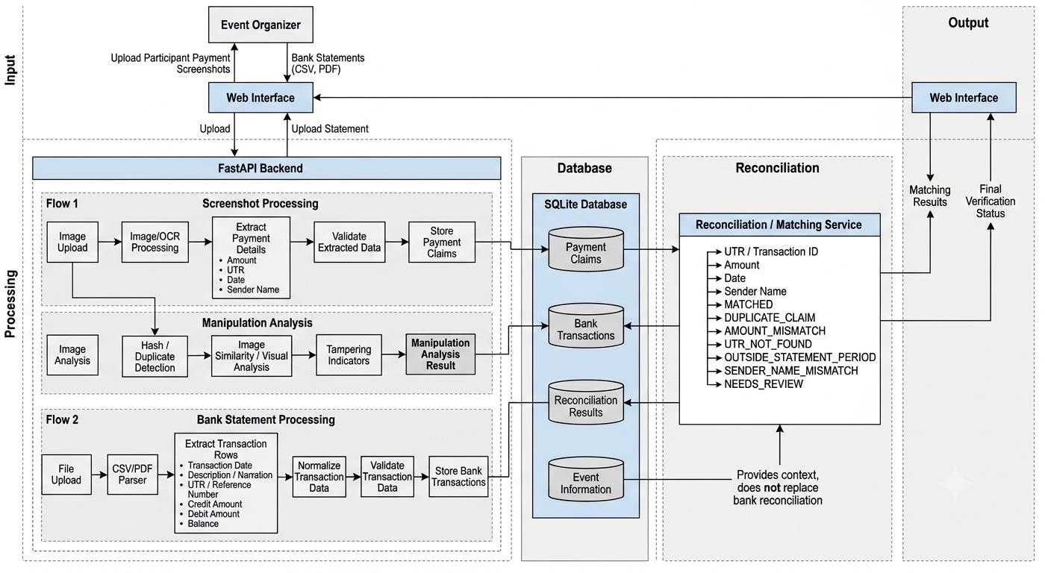
Figure 8: EvidentPay data flow design

Security and Data Handling
Since the application processes payment-related information, appropriate data-handling practices are important. The system should:
    - Validate uploaded file types.
    - Handle unreadable files safely.
    - Avoid accepting invalid transaction information as verified.
    - Keep payment records associated with their respective events.
    - Prevent duplicate payment claims from being counted multiple times.
    - Restrict access to sensitive uploaded information in a production deployment.
The current application is a project-level implementation and should not be considered a certified banking or fraud-detection platform.

TESTING AND VALIDATION
Testing is performed to ensure that the individual modules and the complete application work correctly under different conditions.

EvidentPay was tested using actual payment screenshots, edited screenshots, bank statement data, and different input conditions.
The testing process focused on OCR accuracy, payment reconciliation, duplicate identification, image analysis, and frontend-backend integration.

Unit Testing
Unit testing was performed on individual backend components to verify that each module produces the expected results.
The major components tested include:
    - OCR extraction.
    - Bank statement parsing.
    - UTR comparison.
    - Amount comparison.
    - Date comparison.
    - Sender name comparison.
    - Duplicate detection.
    - Image processing.
    - Screenshot analysis.
The reconciliation module was tested against 25 test cases, and all 25 tests passed.
These tests covered duplicate transactions, amount and UTR mismatches, date tolerance, missing OCR values, debit rejection, and transactions outside the statement period.

OCR Testing
OCR testing was conducted using labelled payment screenshots.
The objective was to measure whether the system could correctly extract important transaction details. The following results were obtained in a later test involving 38 screenshots:
Field | Correctly extracted | Accuracy
UTR | 38/38 | 100%
Amount | 37/38 | 97.37%
Date | 28/38 | 73.68%
Accuracy is calculated against the labelled test data, not against all possible UPI screenshot formats.
The results indicate that UTR extraction was highly accurate in the tested dataset. Date extraction was comparatively more challenging due to differences in screenshot layouts and date formats.

Payment Reconciliation Testing
The payment reconciliation module was tested using a collection of 38 payment screenshots and an associated bank statement.
The test results were:

Result | Count
Total screenshots | 38
Matched payments | 35
Duplicate claims | 1
Outside statement period | 2
The duplicate case involved two screenshots claiming the same UTR.
The two outside-period cases contained transaction dates that were not covered by the imported statement period.
These results demonstrate that the system can identify valid matches, repeated claims, and transactions that fall outside the available statement data.

Tampered Screenshot Testing
A separate test dataset containing 10 edited payment screenshots was used to evaluate the screenshot analysis workflow.
The screenshots were modified versions of genuine payment screenshots. The modifications included changes to important payment details, such as:
    - Amount.
    - UTR.
    - Date.
    - Other visible payment information.
A corresponding set of original screenshots was maintained for reference-based comparison.
The purpose of this test was to evaluate whether the image-analysis methods could identify differences between genuine and edited screenshots.
The testing included:
    - pHash comparison.
    - SSIM comparison.
    - ELA analysis.
    - Noise analysis.
    - Edge analysis.
    - OCR text comparison.
The reference-based methods were evaluated using the original and modified screenshot pairs.
The reference-free analysis was also designed to examine images independently without requiring their original versions.
It is important to distinguish between identifying suspicious image characteristics and establishing confirmed manipulation. The current system does not provide a guaranteed classification of every fake or genuine screenshot.

Integration Testing
Integration testing was conducted to verify that different components work together correctly. The following workflows were tested:
- Screenshot upload and OCR extraction.
- Bank statement upload and transaction parsing.
- OCR output and reconciliation integration.
- Image upload and screenshot analysis.
- Backend processing and frontend result display.
An inverted-contrast image test was also used to verify that the complete OCR processing pipeline could handle a modified image input.

Frontend Testing
The frontend was tested to ensure that the user interface works correctly and communicates with the backend. The testing covered:
    - Event creation.
    - Screenshot uploading.
    - Bank statement importing.
    - Switching between verification modes.
    - Displaying processing results.
    - Handling unsuccessful file processing.
A production build of the React frontend was also completed successfully.

  - Overall Testing Summary Testing results

43
Automated tests passed

25/25
Reconciliation tests passed

38/38
UTR extraction in labelled test

35
Matched payments in real screenshot test
The 43 passing tests include the reconciliation test coverage; these numbers are not separate totals to be added together.
The testing results demonstrate that the main payment verification workflow and its individual processing components are functioning as expected within the tested conditions.

EXPECTED OUTPUT
The expected output of EvidentPay is a structured verification report that helps event organizers understand the status of submitted payments and identify suspicious screenshots.
The application produces two categories of results.

Payment Verification Output
When a screenshot is uploaded and a bank statement is available, the system extracts the payment information and compares it with the imported transaction records.

Example:
Screenshot | Amount | UTR | Verification result
SS001 | ₹500 | 123456789012 | MATCHED
SS002 | ₹500 | 123456789013 | DUPLICATE
SS003 | ₹400 | 123456789014 | AMOUNT_MISMATCH
SS004 | ₹500 | 123456789015 | NEEDS_REVIEW
SS005 | ₹500 | 123456789016 | OUTSIDE_STATEMENT_PE  RIOD
The above is an illustrative output, not an actual individual test record. The results help the organizer identify:
    - Successfully verified payments.
    - Repeated payment claims.
    - Incorrect transaction amounts.
    - Transaction reference discrepancies.
    - Incomplete or uncertain information.
    - Transactions outside the imported statement period.

Screenshot Analysis Output
When screenshot-only mode is selected, the system examines the image without requiring a bank statement. The analysis output includes available indicators from the image-processing methods.
Possible output categories include:

Result | Meaning
POTENTIALLY_ALTERED | The image contains indicators that may suggest editing or manipulation.
NO_CLEAR_EDITING_INDICATORS | The analysis did not identify sufficient evidence of suspicious editing.
INCONCLUSIVE | The available image information is insufficient for a reliable  assessment.
These results describe the findings of image analysis. They should not be interpreted as absolute proof of authenticity or fraud.

Final Application Output
The final application is expected to provide:
- Event information.
- Uploaded payment screenshots.
- Extracted payment details.
- Bank statement transaction information.
- Payment reconciliation status.
- Duplicate payment identification.
- Screenshot tampering analysis indicators.
- A centralized interface for reviewing the results.
The main purpose is to reduce manual verification effort and provide organizers with useful information for making payment-related decisions.

ADVANTAGES
EvidentPay offers several advantages over traditional manual payment verification methods.

Automated Payment Verification
The system automatically extracts payment details and compares them with imported bank transactions, reducing the need for manual checking.

Reduced Manual Work
Organizers can upload multiple screenshots instead of opening and verifying every image individually.

Duplicate Payment Identification
Repeated transaction claims can be identified, helping prevent the same payment from being counted more than once.

Discrepancy Detection
The system checks important payment information such as amount, UTR, date, and sender details.

Screenshot Tampering Analysis
Image-processing methods provide additional indicators that can help identify potentially manipulated payment screenshots.

Independent Screenshot Analysis
The screenshot-only mode can analyse an image without requiring a bank statement or original reference screenshot.

Multiple File Format Support
The system supports payment screenshot uploads and bank statement imports in CSV and supported text-based PDF formats.

Centralized Verification
All payment-related processing and results are available through a single web application.

Modular Architecture
The use of separate backend services makes the system easier to maintain, test, and extend.

Practical Application
The system addresses a real problem faced by colleges, event organizers, and institutions that collect payments through UPI.

FUTURE SCOPE
Although EvidentPay provides automated payment verification and screenshot analysis, several improvements can be introduced in future versions.

Advanced Image Tampering Detection
A machine learning or deep learning model can be trained to identify manipulated payment screenshots.
The model could learn patterns associated with edited text, inconsistent image regions, and altered payment information.
This could improve detection beyond manually designed image-analysis indicators.

Reference-Free Manipulation Detection
The current reference-free workflow examines image characteristics without an original screenshot.
Future development can focus on improving this capability through trained image-forensics models that identify manipulation patterns independently.
This would make the system more useful in real-world situations where original screenshots are unavailable.

Improved Bank Statement Compatibility
Future versions can support additional bank statement formats and layouts.
Bank-specific parsers can be introduced to improve transaction extraction from different PDF structures. OCR-based extraction can also be added for scanned bank statements.

Advanced OCR Integration
OCR can be improved to support different UPI application layouts, regional languages, low-quality images, and more complex screenshot formats.
Additional validation can improve the extraction of UTR numbers, dates, and amounts.

Direct Bank API Integration
In the future, authorized banking or payment gateway integrations could be introduced to retrieve transaction information directly.
This could reduce the need for organizers to manually import bank statements.
Such integration would require appropriate permissions, secure authentication, and support from the relevant financial institutions.

Improved AI-Based Analysis
AI models can be introduced to analyse multiple manipulation indicators and generate understandable explanations.
For example, the system could explain why a screenshot was flagged, such as unusual compression patterns or inconsistent image regions.
Any such explanation should remain linked to measurable evidence rather than relying only on an AI-generated judgment.

Multi-Event Management
The application can be expanded to support multiple events simultaneously.
Organizers could manage different registration fees, participants, payment records, and verification reports from one dashboard.

Cloud Deployment
The application can be deployed on a cloud platform to make it accessible to organizers from different locations.

Cloud storage and scalable backend infrastructure could support larger numbers of screenshots and transactions.

Automated Reports
Future versions can generate downloadable reports containing:
    - Total uploaded screenshots.
    - Total matched payments.
    - Duplicate claims.
    - Unmatched transactions.
    - Amount discrepancies.
    - Screenshot analysis results.
These reports would make event management and financial record-keeping easier.

Improved User and Access Management
Authentication and role-based access control can be introduced.
Different permissions can be assigned to administrators, event organizers, and verification staff to improve security and access management.

CONCLUSION
EvidentPay is a web-based UPI payment verification and screenshot tampering analysis system developed to address the challenges involved in manually verifying digital payments.
The project combines OCR technology, bank statement processing, transaction reconciliation, and image-processing techniques to automate important parts of the payment verification process.
The bank statement-based verification module extracts payment details from screenshots and compares them with imported bank transactions. It helps identify successful matches, duplicate claims, transaction discrepancies, and other cases requiring further review.
The separate screenshot analysis module examines image characteristics using techniques such as perceptual hashing, SSIM, Error Level Analysis, noise analysis, edge detection, and metadata examination. It provides additional indicators of possible screenshot manipulation, including when an original reference image is unavailable.
The project was tested using actual payment screenshots, edited screenshots, and different bank statement scenarios. The testing demonstrated the functionality of the major processing modules and the integration of the frontend and backend.
Overall, EvidentPay demonstrates how automation and image-processing technologies can be applied to a practical financial verification problem.
Although further improvements are required for advanced reference-free manipulation detection, broader bank compatibility, and production-level deployment, the project establishes a foundation for a more efficient and organized UPI payment verification system.

