Charge exchange dp→(pp)n reaction study at 1.75 A GeV/c by the STRELA spectrometer

S.N. Basilevª, Yu.P. Bushuevª, V.V. Glagolevª, S.A. Dolgiyª, D.A. Kirillovª,
N.V. Kostyaevaª,A.D. Kovalenkoª,A.N. Livanovª, P.K. Manyakovª,G.Martinská^{b},
J. Mušinský^{c}, N.M. Piskunovª, A.A. Povtoreikoª, P.A. Rukoyatkinª, R.A. Shindinª, I.M. Sitnikª, V.M. Slepnevª, I.V. Slepnevª, J. Urbán^{b}

ª Joint Institute for Nuclear Research, 141980 Dubna, Moscow region, Russia
^{b} University of P.J. Šafarik, Jesenna. 5, SK-04154 Košice, Slovak Republic
^{c} Institute of Experimental Physics, Watsonova 47, SK-04001 Košice, Slovak Republic

Abstract
The differential cross sections of the charge exchange reaction dp → (pp)n has been measured at 1.75 GeV/c per nucleon for small transferred momenta using the one arm magnetic spectrometer STRELA at the Nuclotron accelerator. The ratio of the differential cross section of the charge exchange reaction dp → (pp)n to that of the np → pn elementary process is discussed in order to estimate the spin-dependent part of the np → pn charge exchange amplitude on the basis of dp → (pp)n data. The np → pn amplitude turned out to be predominantly spin-dependent.

- Introduction

In the theory of nucleon-nucleon scattering extracting complex amplitudes of the scattering matrix is a matter of fundamental importance. For all amplitudes to be obtained, a complete experiment must be performed, i.e., an experiment with a set of observed quantities providing a full and exhaustive description of this process. Such an experiment comprises measurements with polarized both projectile and target what is large and laborious task.
Nevertheless under certain experimental conditions, there is a possibility to determine some amplitudes of the scattering matrix or a set of them. One of the chances is the charge exchange reaction on the deuteron dp → (pp)n with the use of unpolarized protons and unpolarized deuterons, which under certain conditions is determined only by the spin dependent amplitude of the elementary np → pn scattering. When studying the differential cross section of this reaction at small four-momentum transfer squared, it is possible to estimate the spin-dependent term of the np → pn scattering amplitude in the context of the impulse approximation. The effect can be understood qualitatively in the folowing way. Two nucleons, bound in the deuteron may be in ³S₁ and ³D₁ (T = 0) spatial and spin-symmetric states; their isospin is antisymmetric. In the charge exchange at 0⁰ w.r.t. laboratory frame (proton rest frame), the transition from ³S₁ or ³D₁ to a charge-symmetric ¹S₀ or ¹D₂ state of the two protons requires spin flip, in order to satisfy the Pauli principle and ensure an anti-symmetric total wave function. In this way, the spin-dependent part of the elementary charge exchange amplitude will be reflected through the probability of the charge exchange process on the deuteron.
The original idea to take use of the charge exchange reaction on the unpolarized deuteron to determine the spin-dependent part of the np → pn charge exchange was proposed by Pomeranchuk [1] and Chew [2]. Later this possibility was emphasized in a series of works partly [3-10]. The mathematical description was developed later by Dean [6, 7]. These formulas were obtained under certain assumptions, namely relying on the validity of the impulse and closure approximations. In the work by Lednicky and Lyuboshitz [11] it was shown that at relativistic energies these two assumptions are also justified.
In the general case the nucleon-nucleon (NN) amplitude in the centre of mass system can be presented as [12]

M = a + b (σ n)(σ_{i} n) + c[(σ n)+(σ_{i} n)] + e (σ m)(σ_{i} m) + f (σ l)(σ_{i} l), (1)

(Eur. Phys.J. A15, 471 (2002))

where the orthonormal basis

(Eur. Phys.J. A15, 471 (2002)) (2)

introduced in [13] is used. The vectors k and k‘ are the initial and final momenta, respectlively, σ and σ_{i} are the Pauli matrices corresponding to the fast particle and the struck nucleon from the deuteron, respectively.

The differential cross section of the elementary np →pn charge exchange can be represented as a sum of the spin-independent (superscript SI) and spin-dependent (superscript SD) parts:

(dσ/dt)_{np→pn}=(dσ/dt)^{SI}_{np→pn} +(dσ/dt)^{SD}_{np→pn}. (3)

The mathematical formalism developed in [6, 7, 10] allows to connect the differential cross sections of the deuteron charge exchange and the elementary np → pn reactions. In the impulse approximation the dp charge exchange differential cross section at small momentum transfer | t | is related to the NN-amplitudes via :

(dσ/dt)_{dp→(pp)n} = [1-S(t)] (dσ/dt)^{SI}_{np→pn}+ [1-1/3S(t)] (dσ/dt)^{SD}_{np→pn} , (4)

where S(t) denotes the deuteron form factor,
t is the 4-momentum transfer squared, t = (P_{d} - P₁- P₂)², P₁, P₂ are the final fast
protons four-momenta w.r.t. laboratory frame,

(dσ/dt)^{SI}_{np→pn} = | a |² + | c |² , (dσ/dt)^{SD}_{np→pn} = | b |² + | c |² + | e |² + | f |² , (5)

and the coefficients a, b, c, e and f refer to spin invariants of the elementary charge exchange amplitude eq. (1) [6,9].
In this paper we consider the case, when the scattering angle θ is very small, close to zero. Under such kinematical conditions one obtains

b = e and c = 0 (6)

and for the elementary cross sections simple expressions can be written,

(dσ/dt)^{SI}_{np→pn} = | a |² , (dσ/dt)^{SD}_{np→pn} = 2 | b |² + | f |² , (7)

where the amplitude a is spin – independent, and b and f are spin-dependent.

Equation (4) implies that at zero transfer | t | = 0 , i.e. at the neutron CMS scattering angle 180°, when S(t =0) =1, the differential cross section reduces to

(dσ/dt)_{dp→(pp)n} = 2/3(dσ/dt)^{SD}_{np→pn} . (8)

So, the charge exchange break-up reaction of the unpolarized deuteron on the unpolarized proton target at zero transfer (t=0) is completely determined by the
spin-dependent part of the elementary np → pn backward scattering in CMS, so the deuteron acts as a spin filter. It should be noted that this result also remains valid when the deuteron D- state is taken into account [11]. Thus, studying the dp → (pp)n process at small transferred momenta allows to estimate the spin-dependent part of the elementary np → pn reaction.
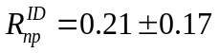 The first experiment of such type has been realized at the JINR synchrophasotron, irradiating the one-metre hydrogen bubble chamber with deuteron beams of 3.35 GeV/c momenta. The ratio of the elementary spin-independent to spin-dependent elastic np → pn charge exchange cross sections has been obtained [14]. This result testifies the prevailing contribution of the spin-dependent part to the the np → pn amplitude [12, 14].
The study of the charge exchange reaction using the chamber-based technique made it possible to propose a layout of an electronic experiment for studying the charge exchange reaction with a deuteron in the energy range above 1 GeV. For the observation of the proton pairs in a narrow cone coming from the dp → (pp)n reaction several variants of experimental setup, named STRELA, have been suggested and realized [15].
The aim of the present study is to extract information on the elementary np → pn charge exchange channel using the dp → (pp)n charge exchange reaction at 3.5 GeV/c deuteron momenta by the STRELA spectrometer [15]. The existing data on that reaction are still very scanty and concern mainly the dσ/dt distribution. During the past few years, interest in obtaining information on the cross section of the spin-dependent part of the np → pn scattering renewed. This is partly connected with the appearance of accelerated deuteron beams at the JINR LPHE Nuclotron with energies over 1 GeV. Before our investigations, no experiments with a fast deuteron beam have been carried out. In the region above 1 GeV the only results in a neutron beam of the Delta-Sigma group [16, 17, 18] are known, where the R_{dp}(0) = dσ/dt(nd)/ dσ/dt (np) ratios have been successfully measured. Seven data points at the energies T_{n} = 0.5-2.0 GeV have been obtained using liquid D₂ /H₂ and solid CD₂/ CH₂/C targets. The contribution of non-flip to flip ratio in the np → pn charge-exchange process have been estimated via R_{dp}(0) values. The experiment with monochromatic fast deuterons is more rational in respect to the analysis of experimental data: the two secondary protons, products of the charge exchange on deuteron dp → (pp)n, are fast moving in the forward direction at small angles, and so they are easily detectable.

2 Experimental facility STRELA

Based on the above mentioned ideas and experimental results, obtained using the 1m HBC [12,14] the experiment STRELA has been designed and constructed in the LHEP JINR Dubna with the aim to select and detect charge exchange events in deuteron proton collisions. The experiment demands registration of two protons with momenta approximately equal to the half of the primary deuteron beam momenta.
STRELA is a typical one-arm magnetic spectrometer composed of scintillator detectors (S1, S2) used to trigger the setup and blocks of drift chambers (DC1-DC4) used as coordinate detector and analyzing magnet (M). The recent version of the experimental setup is shown in Figure 1.

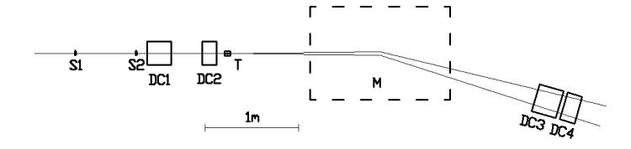

Figure 1: Layout of the experimental setup for determining the spin-dependent part of np → pn scattering: S1, S2 -scintillator counters, (DC1-DC4) drift chambers , M-analyzing magnet, T-target .

The sensitive areas of the drift chambers are the following: 125x125 mm² for DC1, DC2 and 250x250 mm² for DC3, DC4. The right-handed coordinate system has been used, where the z axis is in the beam direction and x and y axis lie in the plane of the chambers. Chambers DC1, DC3, DC4 are equiped with xy wires and DC2 only with x- wires. DC1 and DC3 are composed of 8 (4y, 4x) sensitive planes, DC4 is composed of 4 (2y, 2x) sensitive planes while the DC2 contains 4 (4x) sensitive planes. The analyzing magnet M of field intenzity B = 0.85T is used to separate deuterons and two protons, respectively. The drift length for all chambers is r_{max} = 21mm. The basic characteristics of the drift chambers have been established from irradiation of a polyethylene target with a deuteron beam of 3.5 GeV/c momentum. For each wire the minimal (t_{min}) and maximal (t_{max}) drift times have been determined. The average total drift time was found to be ~ 450 ns. In the track finding procedure the relation between the measured drift time and the minimal distance (or radius (r)) from the anode wire to the track plays an important role. To find the function, transforming the drift time (t) to radius, also referred to as r(t) relation, is the central task. This transformation function may depend on many parameters like: the electric field intensity, gas mixture, pressure, temperature and the chamber geometry. For determination of the transformation function two methods are applied: the linear or quick one, mainly used for the preliminary results and on-line monitoring, the second method, called cumulative or integral one suitable for off-line purposes, which gives the final results.The lateral resolution of the drift chambers which are 85 μm (χ²/ND = ….) and 102 μm (χ²/ND = ….) for large and small drift chambers, respectively is demonstrated on Fig.2. More technical details and the algorithm of the track reconstruction can be found in [15].

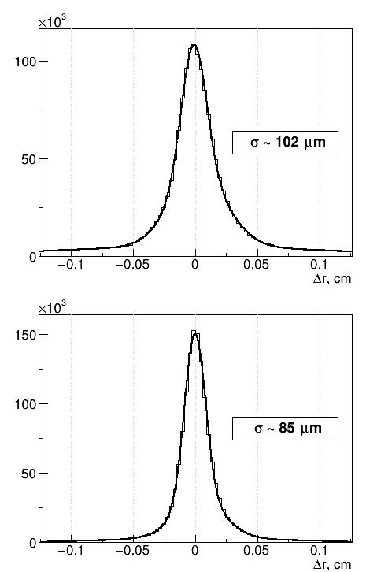

Figure 2: Lateral resolution of drift chambers: large (a), small (b) and Δr - track residuals in xz plane of drift chamber. Solid curve is a ??double?? Gaussian . Do obrazkov dať (a) pre 85 a (b) pre 102, obrázky dat vedľa seba.
Nepodarilo sa mi to, nakoľko sú urobené ako jeden.

The experimental setup was started by the two polystyrene based scintillation counters S₁ , S_{2.} The dimension of the scintillators in the counters are the following: S1 – 10 x 10 x 0,5 см³ , S2 – 7 x 7 x 0,5 см³. The light guides are made of plexiglass. For light read-out XP 2020 photomultipliers were used. The signals from the photomultipliers are connected to the shaper inputs. The use of these shapers allows to compensate the time spread of the signals caused by the leading edge of the amplitude of the photomultiplier signal. The time and amplitude information from the counters is digitized and recorded in each event for the subsequent monitoring of the counters and the entire trigger system functionality. The trigger system of the setup must ensure selection of events of the deuteron breakup reaction at zero angle (or close to zero) between the incoming deuteron and scattering protons. The acceptance of the experimental facility for the studied process of charge exchange reaction is close to100 %.
The dipole electromagnet 2SP-40, with transverse dimensions 100 x30 cm² , was used as an analyzing magnet. The magnet creates the required magnetic field in the range of 0.7-1.0 T at a distance of 150 cm along the path of the particles. The spreads in space of the non-interacting deuteron beam and that of the recorded protons from the examined reaction are bended to the blocks of large drift chambers for detection. The radius of the curvature of the stripping protons trajectory in the magnet is about 7 m at the value of the magnetic field 0.83 T.
The STRELA setup is irradiated with a deuteron beam of an incident momentum of 3.5 GeV/c. The detected events are supposed to contain either two protons with close momenta (equal to the half of the incident deuteron beam momenta), from the charge-exchange reaction of a deuteron with a proton dp → (pp)n or a single-proton from the charge retention deuteron breakup dp → (pn)p. The extracted beam intensity from the accelerator is not lower then ~ 10⁷ particles/s . Since the drift chambers are operable at intensities lower than ~ 10⁶ particles/s, a steel collimator with a rectangular aperture of 4x4 mm² and a length of 1.2 m has to be used to reduce the intensity. After applying the collimator the deuteron beam intensity of ~ 5.10⁵ particles/s or below is reached at the target.The deuteron flux (or number of triggers ) has been determined using S₁ , S₂ counters (monitored numbers – scalers) in coincidence. This is corrected for the efficiency of the drift chambers and admixture in the beam using a direct deuteron beam. The track of deuteron beam in drift chambers (DC1, DC2) before magnet and behind (DC3, DC4) are reconstructed using the track reconstruction algorithm [15]. The value of the correction is different from run to run and is in the interval (0.850, 0.890) .
Carbon and polyethylene targets have been used to extract the dp interaction. The final distributions of the dp interactions are obtained by subtracting CH2 and C distributions. The size of the targets have been determined by carbon nuclei equivalent. Carbon target was used to account for the background events. The shape of targets CH2 and C are cylindrical with diameters of 59.93 mm and 60.05 mm, respectively; the length of targets CH2 and C are 48 mm and 53.75 mm, respectively. The density of H nuclei per cm² for CH2 target is (4.7347 ± 0.0453).10²³/cm² . The background from other channels of the dp reaction and the influence of carbon nuclei have been estimated by the use of the GEANT3 simulation package for transporting the reaction products (taken from the corresponding events of the one metre bubble chamber at the momenta 3.3 GeV/c) through the experimental setup. More details about the chamber experiment can be found in [12, 14]. There is also shown that the dp → (pp)n reaction proceeding predominantly as a quasifree nucleon interaction and intermediate isobaric states does not influence the differential cross section at t=0.

3 Data analysis and experimental results

The experimental facility has been irradiated in the beam of deuterons with 3.5 GeV/c momenta. In the run of March 2014 one billion triggers were received. The first step in the analysis was to decode events. Calibration procedure and the track reconstruction in the drift chambers transformed the raw data into physical quantities. For the further processing and physical analysis three tracks in the XZ plane were selected: one before the target and two behind it. The topology of this events is shown in Fig. 1.

The distribution of the sum of the two charged particles momenta for both targets are obtained. The background from C and CH2 targets can be neglected.

(a)
(b)

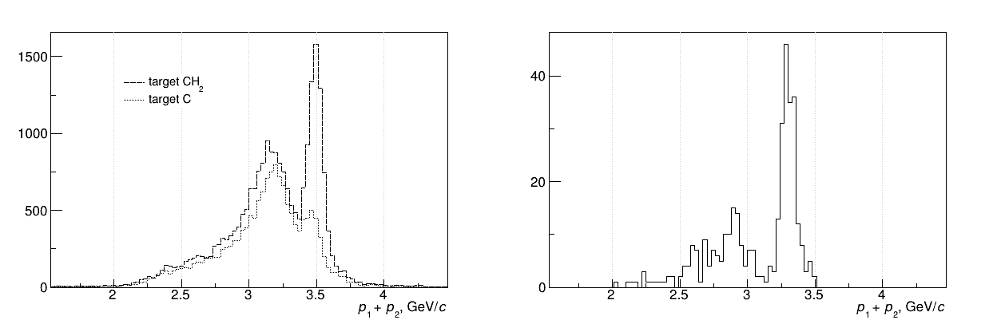

( c ) ( d )
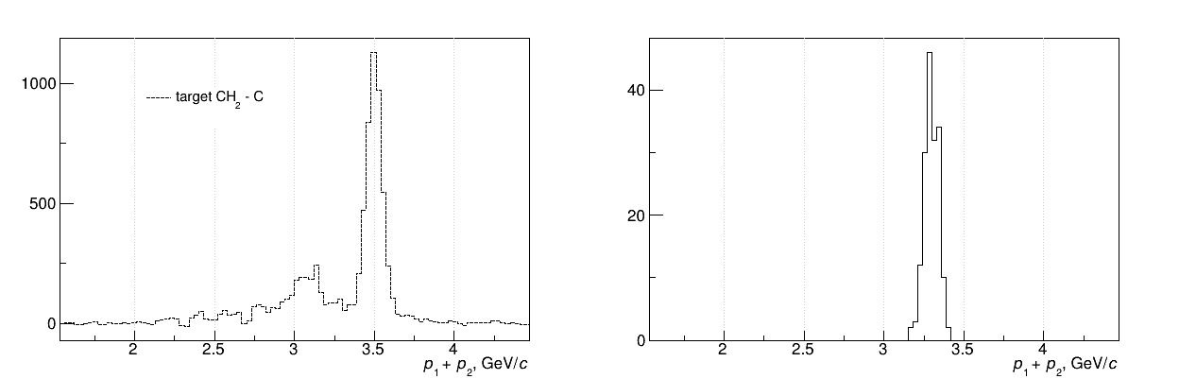

Figure 3: Distributions of the two proton momenta from dp reaction. Left side (a, c)- experimental results, right side (b, d) – simulation: a) targets CH2 dashed line, C dotted line; c) difference CH2-C; simulation included all channels dp- reaction (b) and only dp → ppn reaction (d).

The dependences of the sum of the two proton momenta from dp reaction are presented in Fig. 3 for CH2 and C targets (a) and their difference CH2-C (c). The results of simulation include all channels dp-reaction (Fig. 3b) and channel dp →ppn only (Fig. 3d). As one can see, the distribution has a characteristic peak near the incoming deuteron momentum kinematically associated with the pair of protons from the dp → ppn reaction (Fig.3c). The contribution from the background reactions, other than the studied dp → ppn reaction, which could also produce the two positively charged track in the forward direction, is negligible (Fig. 3d). Into the differential cross section dσ/dt only those events have been included, where the sum of the two charged particle momenta is in the interval 3.5 ± 0.2 GeV/c (Fig. 3c).
(a)
( a ) ( b )
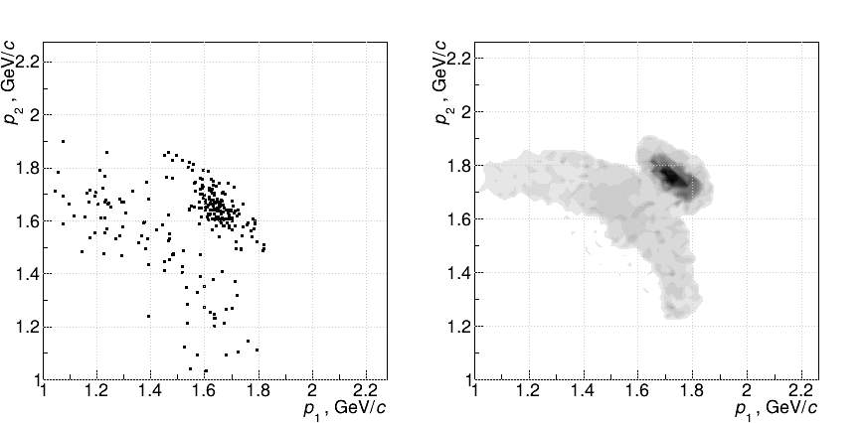

( c )
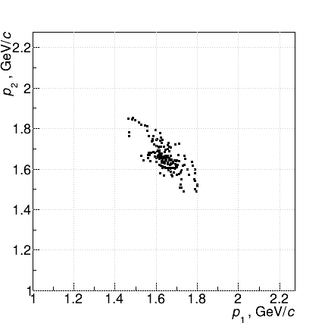

Figure 4: Two dimensional distribution of the measured momenta p₁ versus p₂ of the two charged particles from dp-reaction: simulation includes all channel dp-reaction (a) and only dp → ppn channel (c) and experimental distribution (b).

The plot of momenta p₁ versus p₂ of the two charged particles from dp-reaction is shown in Fig.4. From comparison Fig.4(a,c) with experimental results Fig. 4b, it can be seen that the background from other channels of the dp-reaction may be eliminated.

The measured differential distribution dN/dt of the dp → (pp)n reaction is displayed in Fig. 5.

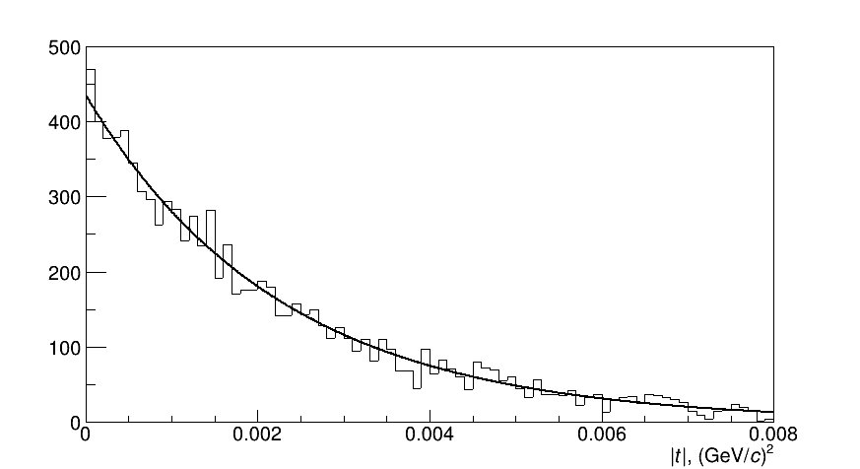

Fig.5. Differential distribution dN/dt of the dp → (pp)n reaction. Solid line – see details in the text.

The obtained differential distribution dN/dt of the dp → (pp)n of the reaction (Fig.5) are extrapolated to t=0 by the expression

dN/dt = (435.6±6.8)exp((440±9)*t) with χ²₌ 77.93/78. (9)

Extrapolation to t=0 gives:

dN/dt|_{t=0} = 435.6 ± 6.8 . (10)

This value corresponds to a value of the charge exchange differential cross section

dσ/dt|_{t=0} = 30.56 ± 0.48 mb/(GeV/c)² . (11)

The quoted error is statistical only. Systematic uncertainties which affect the overall normalization of the cross-sections have been estimated to be about 4.6 %. This uncertainty stems mainly from the deuteron flux determination. The uncertainty from the target thickness and the histogram bin width are comparably small.

The cross section was calculated using the relation
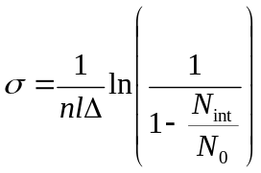
(12)

where l is the target length; n – the number of H nuclei /cm³ , N₀ – the number of beam triggers ; N_{int} – the number of interactions ; Δ - the histogram bin width. The number of triggers is corrected for the efficiency of streamer chambers.

The obtained charge exchange differential cross section on the deuteron at t=0 was compared with the available data from np → pn reaction at the same interpolated energy from published data. The closest energy data comes from measurements made at the SATURN accelerator [19,20]. Unlike to the other similar experiments, Bizard et al. [19] used quasi-monochromatic neutrons from accelerated deuteron stripping with a momentum spread of 5%. New data about np →pn scattering at the momenta of incident quasi monochromatic neutrons at 1.43, 2.3 and 5.20 GeV/c have been obtained in [21].
The values of dσ/dt|_{t=0} of np → pn reaction as a function of the incident momenta is shown in Fig. 6. The individual differential cross sections are transformed into dσ/dt versus t, from Bizard et al. [19] in the region of momenta (1.4 – 1.95) GeV/c and extrapolated at each momentum to t=0 by fitting the expression

dσ/dt = a exp (bt + ct²). (13)

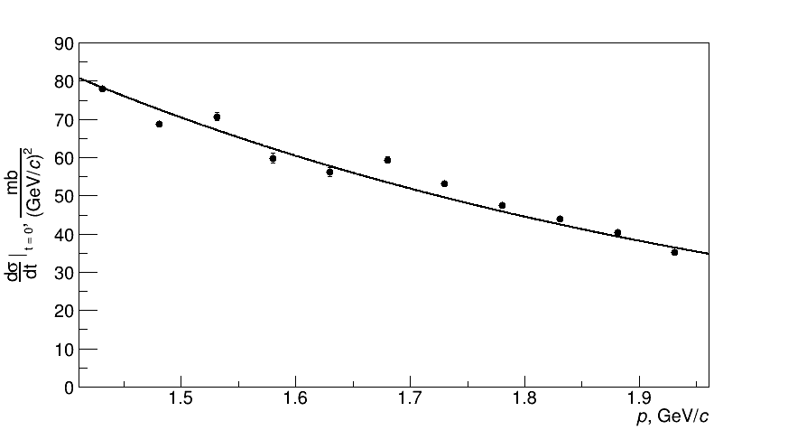

Figure 6: The dependence of the dσ/dt|_{t=0} for the np → pn reaction on the beam momentum.
The data points dσ/dt|_{t=0} are computed from a fit (13) to the np → pn experimental results [14]. The solid curve in the figure is a simple exponential fit to the data points.

To determine the dσ/dt|_{t=0} of the np → pn reaction at “our incident” proton momentum of 1.75 GeV/c/nucleon, an exponential fit is made to the results of Fig. 6, which gives the following value of dσ/dt|_{t=0} = 48.0 ± 0.2 mb/(GeV/c)². The systematical error due to fit procedure is 5%. The obtained value will be related to the estimated differential cross section of the quasi-elastic dp → (pp)n charge-exchange at t=0 from our experiment.
One can introduce the ratio of the differential cross sections at t=0 for the forward scattering (charge exchange) on the deuteron and proton

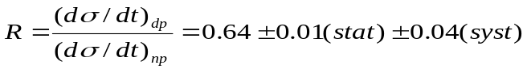
(14)

Under the assumption (8) stated above this, R can be related to

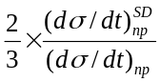

and accordingly the value of the spin-independent part of the elastic np → pn charge exchange cross section has been obtained as

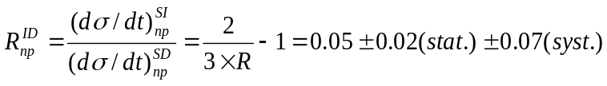. (15)

It should be emphasized that the obtained contribution, of course, depends on the elementary np → pn charge exchange cross section which is taken from another experiment and on the systematical errors of ~ 5% which is due to the fit procedure. Preliminary data on R_{dp} (0) have been published in [22, 23].

Conclusion

The spectrometric complex has been developed on the basis of the STRELA setup to study the charge-exchange reaction in unpolarized deuteron beam. The obtained ratio of the charge exchange differential cross sections at dp → (pp)n at | t | = 0 for dp → (pp)n and np → pn reactions R = 0.64 ± 0.01 (stat) ± 0.04 (syst) testifies the prevailing contribution of the spin-dependent part to the np → pn cross section scattering. Continuation of these researches at higher energies on STRELA setup is in progress.

Acknowledgment

This research was supported by the Ministry of Education, Science, Research and Sport of the Slovak Republic (VEGA Grant No.1/0113/18).

References

[1] I. Pomeranchuk, Sov. JETF 21, 1113 (1951).
[2] G.F.Chew,Phys.Rev. 84, 710 (1951).
[3] A.B. Migdal, J. Exp. Theor. Phys. (in Russian) 28, 3 (1955).
[4] I. Pomeranchuk, Dokl. Akad. Nauk (in Russian) LXXVIII, 249 (1951).
[5] L.I. Lapidus, J. Exp. Theor. Phys.(in Russian) 32,1437 (1957).
[6] N.W. Dean, Phys. Rev. D5, 1661 (1972).
[7] N.W. Dean, Phys. Rev. D5, 2832 (1972).
[8] B.S. Aladashvili et al., Nucl. Phys. B92, 189 (1975),
[9] B.S. Aladashvili et al., B86 461 (1975).
[10] D.V. Bugg, C. Wilkin, Nucl. Phys. A167, 575 (1987).
[11] R.Lednicky,V.L.Lyuboshitz, V.V.Lyuboshitz, Proc. XVI ISHEPP, Dubna 2004,
199.
[12] Glagolev, V.V. et al., Eur. Phys. J.A. 15, 471 (2002).
[13] M. Goldberger, K. Watson, Collision Theory (Wiley, New York, 1966).
[14] Glagolev, V.V. et al., Cent. Eur. J. Phys.6, 781 (2008).
[15] V.V. Glagolev et al., PTE, No4, 20 (2013).
[16] V.I. Sharov et al.: Eur. Phys. J.A 39, 267 (2009),
[17] V.I. Sharov et al., Yad. Phys. 72, 1051 (2009), [Phys. At. Nuclei 72, 1007(2009)].
[18] R.A. Shindin et al., Physics of Particle and Nuclei Letters 8, No.2, 90 (2011).
[19] G. Bizard et al., Nuclear Physics B85, 14 (1975).
[20] J. Bystricky, F. Lehar, Nucleon-Nucleon Scattering data, editors H. Behrens and G.
Ebel, Fachinformationszentrum Karlsruhe, 1978 Edition, N 11-1, p.521.
[21] Yu.A. Troyan et al., Physics of Particles and Nuclei Letters 11, No2, 101 (2014).
[22] S.N. Basilev et al., Proceedings of Science, XXII International Baldin Seminar on
High Energy Physics Problems, 15-20 September 2014, 147, pp.10;
[23] S.N. Basilev et al., XVI Advanced Research Workshop on High Energy Spin
Physics (DSPIN-15), September 8 – 12, 2015, Dubna, J.Phys. Conf. Series 678
(2016)No1, 012040.

Figure captions

Figure 1: Layout of the experimental setup for determining the spin-dependent part of np → pn scattering: S1, S2 -scintillator counters, (DC1-DC4) drift chambers , M-analayzing magnet, T-target .

Figure 2: Lateral resolution drift chambers: large (a), small (b) and Δr- track residuals in xz plane of drift chamber.Solid curve is a ?double? gaussian.

Figure 3: Distributions of the two proton momenta from dp reaction. Left side (a, c)- experimental results, right side (b, d) – simulation: a) targets CH2-dashed line, C- dotted line;
c) difference CH2-C; simulation included all channels dp- reaction (b) and only dp → ppn reaction (d).

Figure 4: Two dimensional distribution of the measured momenta p₁ versus p₂ of the two charged particles from dp-reaction: simulation includes all channel dp-reaction (a) and only dp → ppn channel (c) and experimental distribution (b).

Figure 5: Differential distribution dN/dt of the dp → (pp)n reaction.
Solid line – see details in the text..

Figure 6: Dependence of the dσ/dt|_{t=0} for the np → pn reaction on the beam momentum.
The data points dσ/dt|_{t=0} are computed from a fit (13) to the np → pn experimental results [15]. The solid curve is a simple exponential fit to the data points.

