MindCare: Detailed Project Deep-Dive & Presentation Guide
This guide provides a comprehensive breakdown of the MindCare Mental Health application, its architecture, features, and the technologies powering it.

1. Core Feature Set
MindCare is a holistic mental health platform designed for students. Here are the key modules:
- Empathetic AI (Tink): A sophisticated chat bot that provides emotional support and app-related information.
- Wellbeing Tracking: Includes Mood Check-ins (visualized via charts) and a Personal Journal (for deep reflection).
- Wellness Tools: Interactive tools like Breathing Exercises, Grounding Techniques, Daily Affirmations, and even a Meme Creator for stress relief.
- Content Hub: Access to mental health Blogs, Quotes, and curated Fitness/Yoga content for physical well-being.
- Professional Help: A directory of Therapists where users can view profiles and seek professional guidance.
- Safety & Crisis: Immediate access to Crisis Resources and emergency contacts.

2. Technical Architecture & Communication Flow
High-Level Architecture
The project follows a modern MERN-like (MongoDB, Express, React Native, Node) architecture with an AI Overlay.
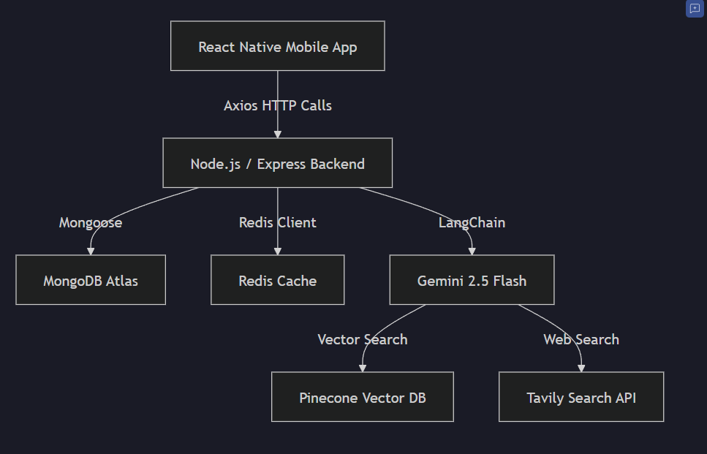
Communication Flow (How it's connected)
- Frontend to Backend: The mobile app uses Axios (configured in
apiClient.js) to send JSON requests to specific endpoints (e.g., POST /api/chat or GET /api/journals).
- Backend to Database: The server receives the request, validates the user (using JWT), and uses Mongoose models to interact with MongoDB.
- Backend to AI: For chat, the backend doesn't just send a message; it uses LangChain to orchestrate:
  - Retrieval: Pulling context from Pinecone (Vector DB).
  - Search: If needed, searching the web via Tavily.
  - Generation: Asking Gemini 2.5 Flash to create a response based on the message + context + search results.
- Data Persistence: All user settings, journals, and history are saved in MongoDB, ensuring they persist across sessions.

3. Deep-Dive: AI Integration (The "Brain")
The AI function (Tink) is not a simple chatbot; it's a RAG-based AI Agent (Retrieval-Augmented Generation).
- Gemini 2.5 Flash: The core LLM provides supportive and empathetic responses.
- LangChain: Acts as the orchestrator. It manages the "Chain of Thought" and decides whether to use a tool (like search) or reply from memory.
- Pinecone (Vector DB): Stores "Embeddings" of mental health knowledge. This allows Tink to have "Long-term memory" and specific knowledge about the MindCare app.
- Tavily Search: If a user asks a factual question Tink doesn't know (e.g., "What are recent studies on mindfulness?"), it uses Tavily to search the live internet.
- System Prompting: Tink is strictly instructed (via a System Template) to be non-judgmental and suggest professional help for crisis situations.

4. Database & Models
The data is linked using MongoDB, which uses flexible schemas. Key models include:
- User & Profile: Stores authentication data and user-specific concerns/settings.
- JournalEntry: Stores private thoughts with timestamps.
- MoodEntry: Stores emotional states (emojis/text) for charting progress.
- BlogPost: Content for the community feed.
- Therapist: Professional profiles for user browsing.

5. Key External Libraries & Their Roles
Frontend (Mobile)
- React Navigation: Manages the transitions between screens (Stack, Bottom Tabs).
- Redux: Acts as the "Global State Store" for user info and app data across all screens.
- Styled Components: Allows for clean, scoped CSS-in-JS styling.
- Lottie: Handles high-quality animations (e.g., in Breathing or Splash screens).
- React Native Chart Kit: Powers the mood tracking visualizations.
Backend (Server)
- Express: The framework that handles HTTP routing and middleware.
- Mongoose: The ODM (Object Data Modeling) library for MongoDB interaction.
- jsonwebtoken (JWT): Ensures secure login; the app sends a "token" with every request to prove who the user is.
- yt-search: Used to find relevant wellness/fitness videos for the content section.

6. How it's Integrated Together
- Integration: The api_route in
src/utils/route.js connects the mobile app "head" to the backend "body".
- Dynamic Content: Most screens (Home, Journals, Blogs) are not hardcoded; they fetch data dynamically from the backend as soon as the screen loads.
- Single Source of Truth: MongoDB is the source of truth. If you change your profile on one phone, it will update everywhere because it's linked to the central database.

