

AIRLINE RESERVATION SYSTEM

## IT’S ALL ABOUT SERVICES

AUTHOR :

**KHUSH PATEL (15012101031)**

**VARUN PAREKH (15012101021)**

*A PROJECT REPORT ON*

## AIRLINE RESERVATION SYSTEM

*SUBMITTED BY*

**Khush Patel (15012101031)**

*&*

**Varun Parekh (15012101021)**

*SUBMITTED TO*

**DEPARTMENT OF COMPUTER SCIENCE AND TECHNOLOGY**

**U. V. PATEL COLLEGE OF ENGINEERING INSTITUTE OF COMPTER TECHNOLOGY**



*GUIDANCE FROM*

**Prof. Sameer Mansuri**, **Prof. Prachi Pancholi &**

**Prof. Loganathan**

*Date : October 26, 2016 Place : Ahmedabad*

**1**

## TABLE OF CONTENT

**ABSTRACT 3**

**INTRODUCTION 4**

**DESCRIPTION 5**

**FEATURES 6**

**FUTURE PLANNING & SCOPE 7**

**ER DIAGRAMS 8**

**TABLE STRUCTURE 11**

**2**

ABSTRACT

Airline reservation System is a computerized system used to store and retrieve information and conduct transactions related to air travel. The project is aimed at exposing the relevance and importance of Airline Reservation Systems. It is projected towards enhancing the relationship between customers and airline agencies through the use of ARSs, and thereby making it convenient for the customers to book the flights as when they require such that they can utilize this software to make reservations.

# 3

INTRODUCTION

An airline reservation system (ARS) is part of the so-called [passenger](https://en.wikipedia.org/wiki/Passenger_service_system) [service systems](https://en.wikipedia.org/wiki/Passenger_service_system) (PSS), which are applications supporting the direct contact with the passenger.

ARS eventually evolved into the [computer reservations system](https://en.wikipedia.org/wiki/Computer_reservations_system) (CRS). A computer reservation system is used for the reservations of a particular airline and interfaces with a [global distribution system](https://en.wikipedia.org/wiki/Global_distribution_system) (GDS) which supports travel agencies and other distribution channels in making reservations for most major airlines in a single system.

Today all persons are busy with their schedule and no one have time to make a trip for holidays with their family. And this Airline Reservation Process is very difficult to understand in General meaning. But we are providing a Solution for that Problem.

This system provides a facility to easy access towards a customers and a real time users. They can easily connected through it and just 3 steps. There is no requirement for any type of Agent. We are giving a all this facility in one project “Airline Reservation System”.

# 4

DESCRIPTION

This software has two parts. First is user part and the administrator part. User part is used as a front end and administrator is the back end. Administrator is used by airline authority. It will allow the customers to access database and allow new customers to sign up for online access.

The system allows the airline passenger to search for flights that are available between the two travel cities, namely the “Departure city” and “Arrival city” for a particular departure and arrival dates. The system displays all the flight’s details such as flight no, name, price and duration of journey etc.

After search the system display list of available flights and allows customer to choose a particular flight. Then the system checks for the availability of seats on the flight. If the seats are available then the system allows the passenger to book a seat. Otherwise it asks the user to choose another flight.

To book a flight the system asks the customer to enter his details such as name, address, city, state, and credit card number and contact number. Then it checks the validity of card and book the flight and update the airline database and user database. The system also allows the customer to cancel his/her reservation, if any problem occurs.

The main purpose of this software is to reduce the manual errors involved in the airline reservation process and make it convenient for the customers to book the flights as when they require such that they can utilize this software to make reservations, modify reservations or cancel a particular reservation.

# 5

FEATURES

* Free Account
* Selection among Large no of Airways
* Full detailed Flights
* Easy to Get Flights
* Easy to edit and view your Personal Information
* User Friendly
* Secure

# 6

FUTURE PLANNING AND SCOPE

We are trying to give a live reporting which is updated by Airline Companies so that customer gets a live Flights checking, Available seats, Pricing and also planning to provide seats as per theirs choice so that they can travel very comfortably their journey. We will trying to provide food facility and choice to customers so that they can feel like their home and more effective amenities. We are also trying to make more attention on Business class people and their requirements.

Our future planning is to take this project towards an AndroidApp and QR Code Scanning. So that a Customer can easily contact to the Airlines and they are getting quick Services from Airlines.

We also want in future to place in market so that customer can take more advantages and saves their important time. We are also finding and approaching to companies which are using this type of software.

# 7

ER DIAGRAMS

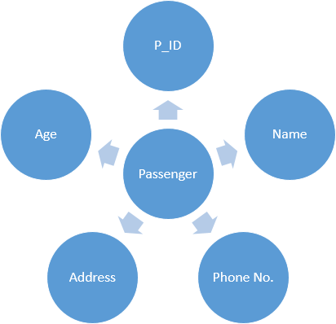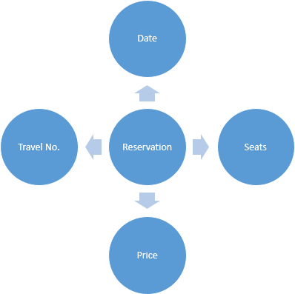

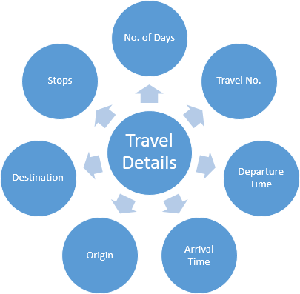

# 8

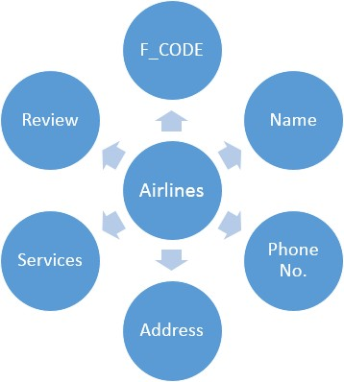

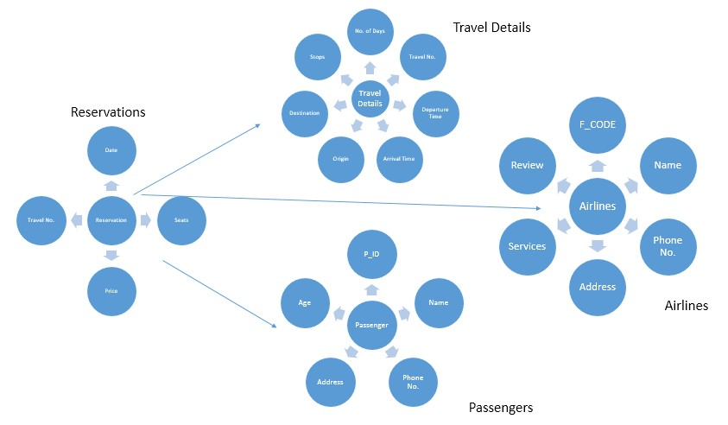**9**

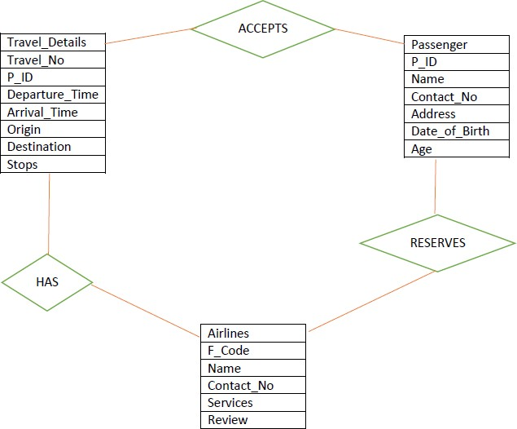

**10**

TABLE STRUCTURE

1. Table Name: Passenger_details

Description: To store the Passenger Personal Information Primary Key: Passenger_ID (P_ID)

|  |  |  |  |  |
| --- | --- | --- | --- | --- |
| **Sr. No.** | **Field Name** | **Data Type** | **Constraint** | **Description** |
| **1.** | P_ID | Varchar(10) | Primary Key | To store Unique ID of every  Passenger |
| **2.** | Name | Varchar(40) | Not null | To store Name of the  Passenger |
| **3.** | Address | Varchar(100) | Not null | To store Address of the  Passenger |
| **4.** | City | Varchar(20) | Not null | To store City |
| **5.** | State | Varchar(20) | Not null | To store  State |
| **6.** | Pincode | Numeric(6,0) | Not null | To store  Pincode |
| **7.** | Nationality | Varchar(20) | Not null | To store country Passenger  belongs to |
| **8.** | Contact_No | Numeric(10,0) | Not null,  must be 10 | To store  phone No. |
| **9.** | Email_Id | Varchar(30) | Not null, @ must be  present | To store Email |

# 11

|  |  |  |  |  |
| --- | --- | --- | --- | --- |
|  |  |  |  |  |
| **10.** | Date_Of_Birth | Date | Not null | To store  Birth date of Passenger |
| **11.** | Age | Numeric(3,0) | Not null | To store Age |
| **12.** | Gender | Char | Not null, M  or F | To store  Gender |

1. Table Name: Airlines_master

Description: To store Info of different private Airlines Primary Key: Name

# 12

|  |  |  |  |  |
| --- | --- | --- | --- | --- |
| **Sr No.** | **Field Name** | **Datatype** | **Constraint** | **Description** |
| **1.** | Name | Varchar(15) | Primary Key | To store  Name of the Airline |
| **2.** | Contact_No | Numeric(14,0) | Not null | To store contact no. of the  Airline |
| **3.** | Address | Varchar(50) | Not null | To store  Address |
| **4.** | Services | Varchar(50) | Not null | To store services provided by each  Airlines |
| **5.** | Class | Varchar(10) | Not null | To store classes of  Airlines |
| **6.** | Review | Varchar(30) | Not null | To store expert  review |

1. Table Name: Flight_details

Description: To store Schedule and Travel details of Airplanes Primary Key: F_CODE

|  |  |  |  |  |
| --- | --- | --- | --- | --- |
| **Sr No.** | **Field Name** | **Datatype** | **Constraint** | **Description** |
| **1.** | F_CODE | Varchar(10) | Primary Key | To store Unique ID of each  Plane |
| **2.** | Origin | Varchar(20) | Not null | To store Origin position of  Train |
| **3.** | Destination | Varchar(20) | Not null | To store  Destination of the Train |
| **4.** | Departure_Time | Date and Time | Not null | To store departure  Time |
| **5.** | Arrival_Time | Date and  Time | Not null | To store  Arrival Time |

1. Table Name: Flight_Reservation

Description: To store Info on Reservation Details Combining Passenger and Flights

Primary Key: R_CODE

Foreign Key: P_ID, F_CODE, Age

# 13

|  |  |  |  |  |
| --- | --- | --- | --- | --- |
| **Sr No.** | **Field Name** | **Datatype** | **Constraint** | **Description** |
| **1.** | R_CODE | Varchar(10) | Primary Key | To store Unique ID of each  Reservation |

|  |  |  |  |  |
| --- | --- | --- | --- | --- |
|  |  |  |  |  |
| **2.** | F_CODE | Varchar(6) | Not null,  reference | To store ID  of Flight |
| **3.** | P_ID | Varchar(10) | Not null, reference | To store ID  of Passenger |
| **4.** | Date | Date | Not null | To store date of  reservation |
| **5.** | Seats | Numeric(3) | Not null, less than total seats for corresponding  F_CODE | To store seats reserved |
| **6.** | Class | Varchar(10) | Not null | To store  Class of Passenger |
| **7.** | Age | Numeric(3) | Not null, reference | To store Age of  Passenger |
| **8.** | Price | Numeric(6,2) | Not null,  custom | To store  Price |

**14**