The George Washington University
School of Engineering and Applied Science
Department of Computer Science
CSci 243 – Data Mining – Spring 2007

Homework Assignment
Due Date: February 21, 2007

Instructor: A. Bellaachia

Problem 1: (25 points)

For each of the following data sets, explain whether or not data privacy is an important issue:
- Census data collected from 1900–1950. No
- IP addresses and visit times of Web users who visit your Website. Yes
- Images from Earth-orbiting satellites. No
- Names and addresses of people from the telephone book. No
- Names and email addresses collected from the Web. No

Problem 2: (25 points)
Discuss whether or not each of the following activities is a data mining task:
- Dividing the customers of a company according to their gender.
ANS: No. This is a simple database query.

- Dividing the customers of a company according to their profitability.

ANS: No. This is an accounting calculation, followed by the application of a threshold. However, predicting the profitability of a new customer would be data mining.

- Computing the total sales of a company.

ANS: No. Again, this is simple accounting.

- Sorting a student database based on student identification numbers.
ANS: No. Again, this is a simple database query.

- Predicting the outcomes of tossing a (fair) pair of dice.
ANS: No. Since the die is fair, this is a probability calculation. If the die were not fair, and we needed to estimate the probabilities of each outcome from the data, then this is more like the problems considered by data mining. However, in this specific case, solutions
to this problem were developed by mathematicians a long time ago, and thus, we wouldn’t consider it to be data mining.

- Predicting the future stock price of a company using historical records.
ANS: Yes. We would attempt to create a model that can predict the
continuous value of the stock price. This is an example of the area of data mining known as predictive modeling. We could use regression for this modeling, although researchers in many fields have developed a wide variety of techniques for predicting time series.

Problem 3: (25 points)
Do problem 3.3 on page 152.
Suppose that a data warehouse consists of the three dimensions time, doctor, and patient, and the two measures count and charge, where charge is the fee that a doctor charges a patient for a visit.
- Enumerate three classes of schemas that are popularly used for modeling data warehouses.
- Draw a schema diagram for the above data warehouse using one of the schema classes listed in (a).
- Starting with the base cuboid [day, doctor, patient], what specific OLAP operations should be performed in order to list the total fee collected by each doctor in 2004?
- To obtain the same list, write an SQL query assuming the data are stored in a relational database with the schema fee (day, month, year, doctor, hospital, patient, count, charge).

Solution:
- star schema: a fact table in the middle connected to a set of dimension tables
snowflake schema: a refinement of star schema where some dimensional hierarchy is normalized into a set of smaller dimension tables, forming a shape similar to snowflake.
Fact constellations: multiple fact tables share dimension tables, viewed as a collection of stars, therefore called galaxy schema or fact constellation.
- As figures below
- Starting with the base cuboid [day, doctor, patient], what specific OLAP operations should be performed in order to list the total fee collected by each doctor in 2004?
1. roll up from day to month to year
2. slice for year = “2004”
3. roll up on patient from individual patient to all
4. slice for patient = “all”
4. get the list of total fee collected by each doctor in 2004

Select doctor, Sum(charge)
From fee
Where year = 2004
Group by doctor
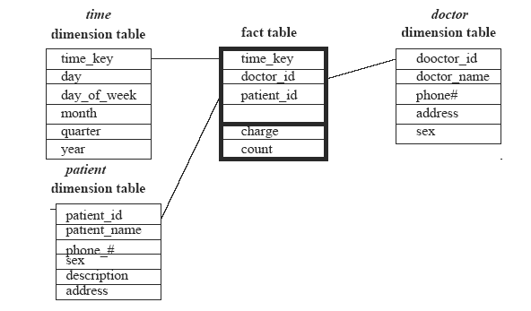

Problem 4: (25 points)
Do problem 3.4 on page 152
Suppose that a data warehouse for Big University consists of the following four dimensions: student, course, semester, and instructor, and two measures count and avg_grade. When at the lowest conceptual level (e.g., for a given student, course, semester, and instructor combination), the avg_grade measure stores the actual course grade of the student. At higher conceptual levels, avg_grade stores the average grade for the given combination.
- Draw a snowflake schema diagram for the data warehouse.
- Starting with the base cuboid [student, course, semester, instructor], what specific OLAP operations (e.g., roll-up from semester to year) should one perform in order to list the average grade of CS courses for each Big University student.
- If each dimension has five levels (including all), such as “student < major < status < university < all”, how many cuboids will this cube contain (including the base and apex cuboids)?

Solution:
(a)
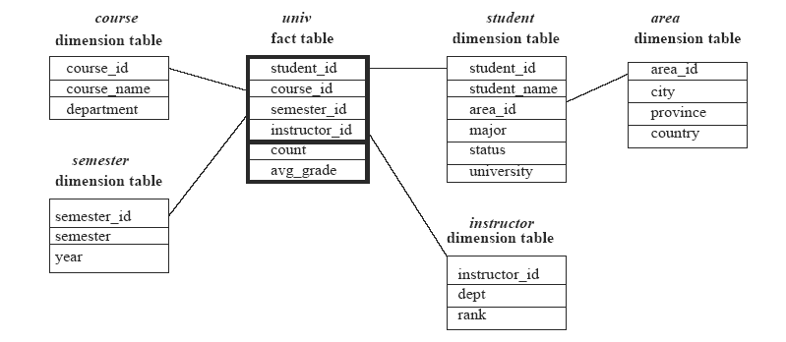
(b)
Starting with the base cuboid [student, course, semester, instructor]
1. roll-up on course from (course_key) to major
2. roll-up on student from (student_key) to university
3. Dice on course, student with department =”CS” and university=”Big University”
4. Drill-down on student from university to student name
(c) The cube will contain 5⁴=625 cuboids.

