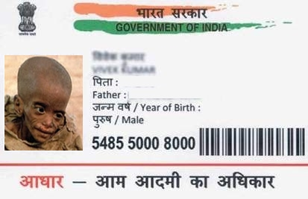

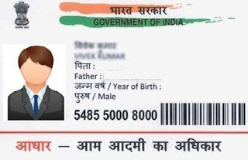

Radha

Father Name: Ram Kumar

DOB: 24/07/2007

Female

0014 6754 4532



[This Photo](https://free-newsalert.blogspot.com/2018/07/aadhar-card-banavo.html) by Unknown Author is licensed under [CC BY-NC-ND](https://creativecommons.org/licenses/by-nc-nd/3.0/)

