**National Institute Of Technology,Raipur**



**DEPARTMENT OF COMPUTER APPLICATIONS**

**A Term Project Report on**

**Web-Technology-Advance Java**

**TOPIC:-**

**E-COMMERCE WEBSITE**

**Submitted to: Submitted by:**

Dr.SHYAM SUNDAR MUSKAN AGRAWAL

ASSISTANT PROFESSOR MCA- 4th SEMESTER

NIT RAIPUR. ROLL NO: 20223057

**E-Commerce Website Introduction:-**

An eCommerce website is an information technology method in which traders, businesses/ marketers can sell various products and the customer can purchase on that website electronically by using the internet on the mobile and computer. It means an e-commerce website is an online shop. e means electronic. Commerce means business. Website means the group of HTML web pages and that is created to market/sell information/product/services.

From a bigger perspective, every website on the internet is the eCommerce Website. It can be the platform, it can be a marketplace, it can be a portal, it can be apps, it can be an entertainment website, shopping website, online courses website and online degree college.

In this e-Commerce website we will have two panels:-

1)Admin Panel

2)Users panel/customer panel

**This Website is built for following purposes:-**

* For buying product
* For Adding product
* Maintaining sale history
* Adding and managing products

**Admin Have Following Access:-**

* Add New Products
* Add New Category
* View Available Products
* View Current Users
* View Category
* Remove Products

**Users Have Following Access:-**

* Create New Account or Register
* Login
* View Available Products
* Buying products
* Select Product Quantity
* Add To cart
* Checkout Products

**Technologies used:-**

1. **Front-End Development:**

* Html
* Javascript
* Css
* Bootstrap

1. **Back-End Development**

* Java
* JDBC
* Servlet JSP
* Hibernate
* Maven Support

1. **Softwares used**

* Java 11
* Netbeans IDE 11.x
* Tomcat 8
* MySQL
* SqlYog

**This e-commerce website will have following categories:-**

1)CLOTHES

2)MOBILES

**OUTPUT IMAGES:-**

**This is Admin Page**

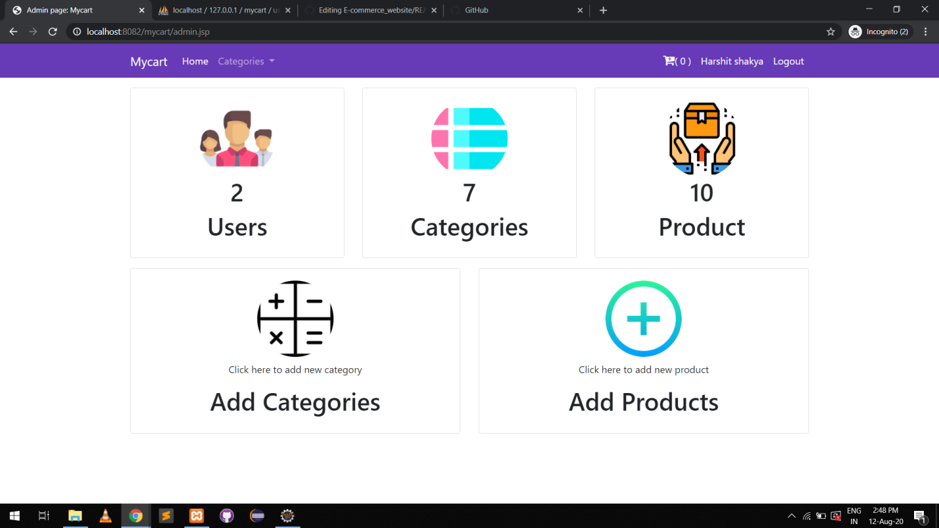

# This is Home Page

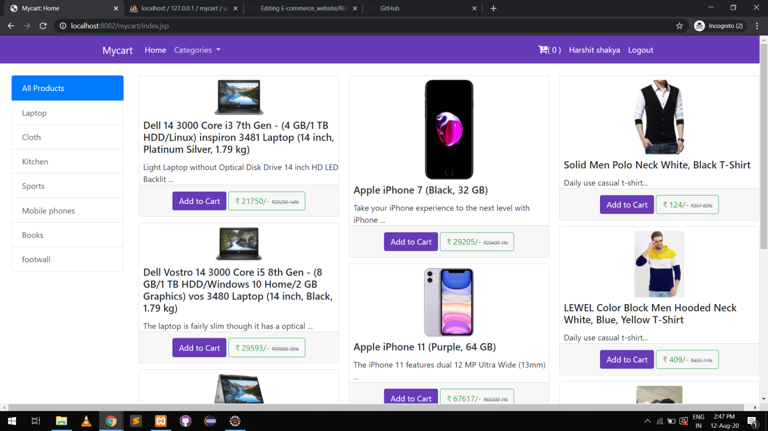

# This is Login Page

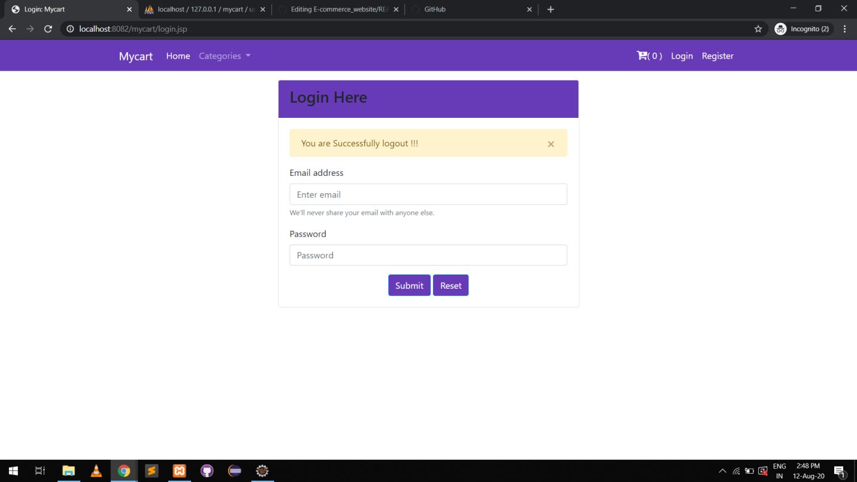

# This is Register Page

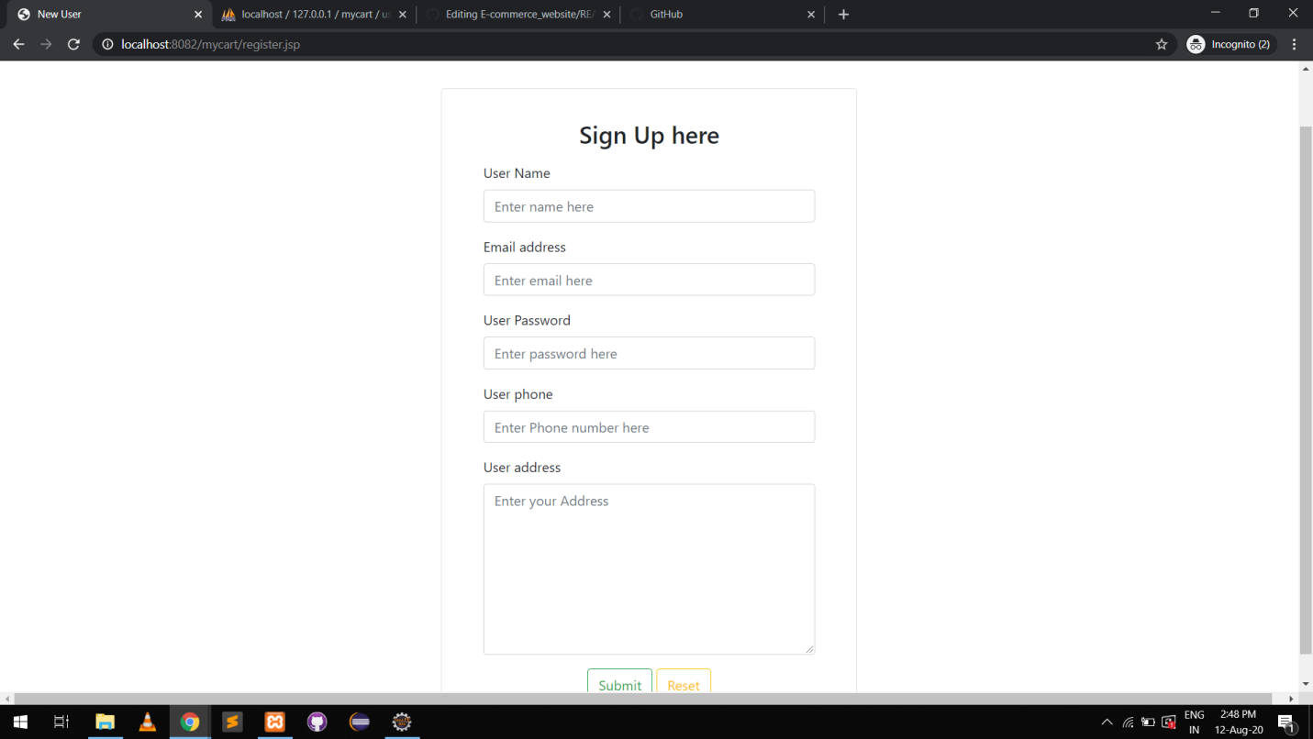

# This is Checkout Page

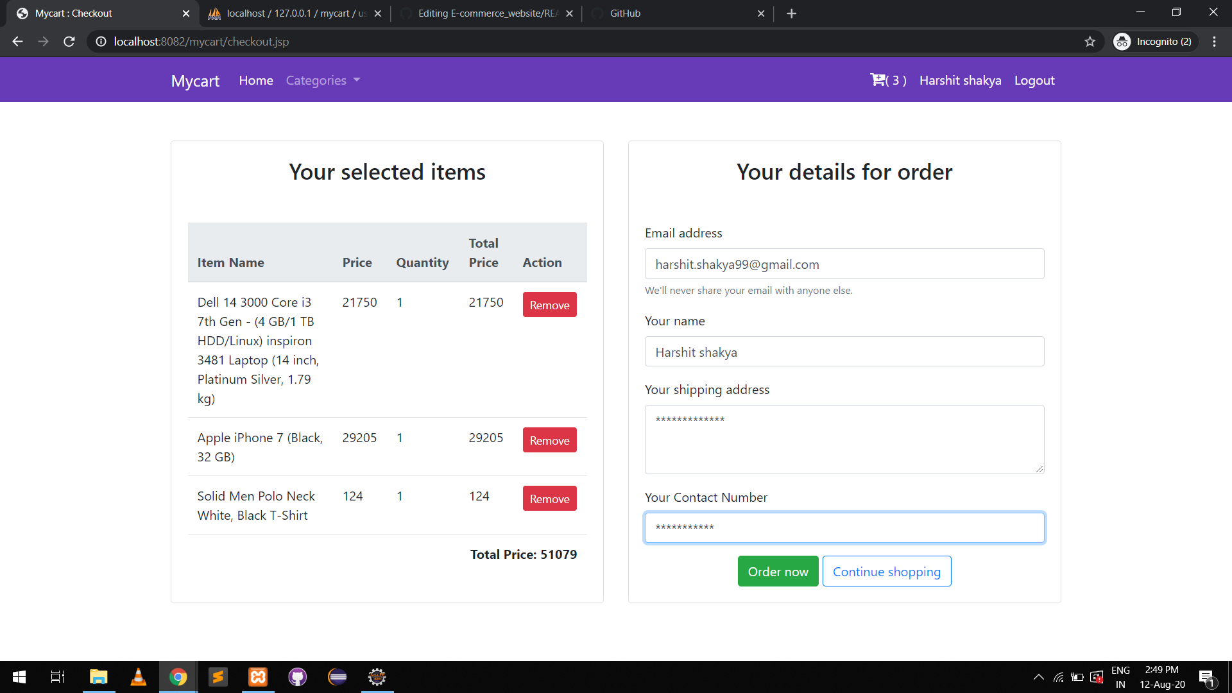

**CONCLUSION:-**

So this is an overall report of the paper giving a brief information about the technologies used for making the website,along with this we have also shown the list of categories of product.