Anil Kaushal
B.Tech-Mechanical Engineering DOB: 18/12/1998 S/o: Mr. Naresh Kaushal
Address: D-308 Phase 1 New Suresh Nagar Thatipur

Gwalior, M.P Pin-474011 Email Id: anilkaushal332@gmail.com , Mob: +91- 8516007682

Career Objectives
Looking for an organization which will help me to explore my talent, my skills and utilize them in the best possible way for the attainment of their goals.
Academic Credentials:
Examination | Year | Percentage | Institution | Board/University
B.Tech  (Mecahnical  Engineering) | 2021 | 6.92  (Upto 7th Sem) | Madhav Institute Of Technology & Science,Gwalior, M.P. | RGPV University Bhopal
Class XII | 2017 | 93.4% | School of Excellence No.1,Gwalior,M.P. | M.P. Board
Class X | 2015 | 85.15 % | School of Excellence No.1,Gwalior,M.P. | M.P. Board

Projects & Trainings:
 | ● | Minor Project- “Gyroscopic Stabilization of Unstable Vehicles”
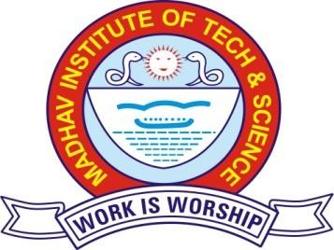
Description: As the vehicle tilts from vertical, a precession-inducing torque is applied to the gyroscope cage such that the resulting gyroscopic reaction moment will tend to right the vehicle. The key idea is that motion of the gyroscoperelative to the body is actively controlled in order to generate a stabilising moment. Duration: 2019-2020
Role: member
Team Size: 4
- Summer Training in “Advance Mechanical operations and processes” at Madhav Institute of Technology and Science, Gwalior (July, 2020).
- In-house Training in “Soft Skills” at Madhav Institute of Technology and Science, Gwalior (June, 2019).
- Summer Training in “Mechanical testing and measurement” at Madhav Institute of Technology and Science
(June, 2018).
Skills:
- Excellent in engineering drawing.
- SQL, Basics of C Language, AutoCAD.
- Swimming.
Rewards & Recognitions:
- Honored by C.M. in 10th & 12th class because of getting district merit list.
- Honored by divisional commissioner by participating in summer vacation fair.
- Honored by district collector on republic day by getting position in district merit list in 12th.
- Certified by colonel in attempting Combined Annual Training Camp.
Co-Curricular:
- Making AutoCAD drawing ● Playing musical instruments
- Technical work.
Extra-Curricular:
- Debate competition, Playing badminton, Football.
Interests & Hobbies:
- Craft work, Mechanical work, Reading books, Visit historical places, Playing chess, Making AutoCAD design.

