Azure Healthcare DevOps Pipeline
& Telemetry Infrastructure
Project Documentation Report
Production-Grade Infrastructure, Pipeline, and Observability Specification

1. Executive Summary & System Objectives
The Azure Healthcare DevOps Pipeline & Telemetry Infrastructure project establishes an automated, observable, and horizontally scalable foundation for a healthcare web application delivered as a set of independently deployable microservices. The infrastructure is engineered to mirror production-grade orchestration behavior within a local development context, using a Minikube-managed Kubernetes cluster as the execution environment and a GitHub Actions pipeline as the delivery mechanism between source control and running workloads.
The system is designed around four core engineering pillars, each addressed through a distinct architectural or operational mechanism rather than through ad-hoc configuration. These pillars anchor every subsequent design decision documented in this report.
Objective | Engineering Definition
Automation | Manual build, packaging, and deployment steps are eliminated through a GitHub Actions pipeline that governs the full lifecycle from commit to running container.
Scalability | Microservice decomposition of the healthcare platform allows individual components (patient records, appointments, authentication) to be scaled independently within the Kubernetes scheduler.
High Availability | Readiness and liveness probes, replica management, and controlled rolling updates are configured to minimize service disruption during redeployments or node-level failures.
Observability | A dedicated telemetry stack (Prometheus, Grafana, Alertmanager) is layered over the cluster to expose real-time resource, workload, and node-level health signals.

Collectively, these objectives position the infrastructure as a direct precursor to a managed cloud deployment: the same manifests, Helm charts, and pipeline logic that operate against Minikube are structured to be portable to Azure Kubernetes Service (AKS) with minimal reconfiguration, a pathway expanded upon in Section 6.

2. Infrastructure & Architecture Specifications

2.1 Orchestration Layer
The target orchestration layer consists of a Minikube-provisioned single-node Kubernetes cluster, instantiated with Docker Desktop configured as the underlying driver engine. This arrangement allows the full Kubernetes API surface — Deployments, Services, ConfigMaps, Secrets, and Horizontal Pod Autoscalers — to be exercised locally without dependency on a remote cloud control plane, while preserving manifest-level compatibility with a future AKS target.

2.2 Namespace Mapping Structure
Workload isolation is enforced through namespace segregation, separating patient-facing application logic from the operational tooling responsible for monitoring that logic. This separation limits the blast radius of a misconfiguration in either layer and simplifies role-based access control boundaries.
Namespace | Primary Role | Hosted Components
healthcare-app | Core application workloads | Patient Records Service, Appointment Service, Authentication / Gateway Service, associated ConfigMaps and Secrets
monitoring | Operational telemetry and alerting | Prometheus Server, Kube-State-Metrics, Node Exporter, Grafana, Alertmanager (deployed collectively via the kube-prometheus-stack Helm chart)
kube-system | Cluster-internal control plane | Minikube-managed system pods (DNS, proxy, scheduler components) — excluded from application-layer scope but referenced during diagnostics

2.3 Component Interaction Matrix
The following matrix traces the path of a single change from developer commit to running cluster state, identifying the responsible component and the downstream effect triggered at each stage.
Stage | Actor / Component | Action | Downstream Effect
1 | Developer Workstation | Source code is committed and pushed to the GitHub repository. | A workflow-dispatch or push event is registered against the configured branch trigger.
2 | GitHub Actions Runner | The CI workflow checks out source, resolves dependencies, and executes the Docker build. | A versioned container image is produced and staged for publication.
3 | Docker Hub Registry | The tagged image is authenticated and pushed to the designated repository namespace. | The image becomes pullable by any cluster node referencing the updated tag.
4 | Kubernetes Manifests | Deployment manifests are updated to reference the new image tag and applied via kubectl. | The cluster scheduler is instructed to reconcile actual state with the declared desired state.
5 | Minikube Cluster Runtime | A rolling update is executed across the affected Deployment's ReplicaSets. | Updated pods reach Ready state while the Prometheus/Grafana stack continues emitting live health telemetry.

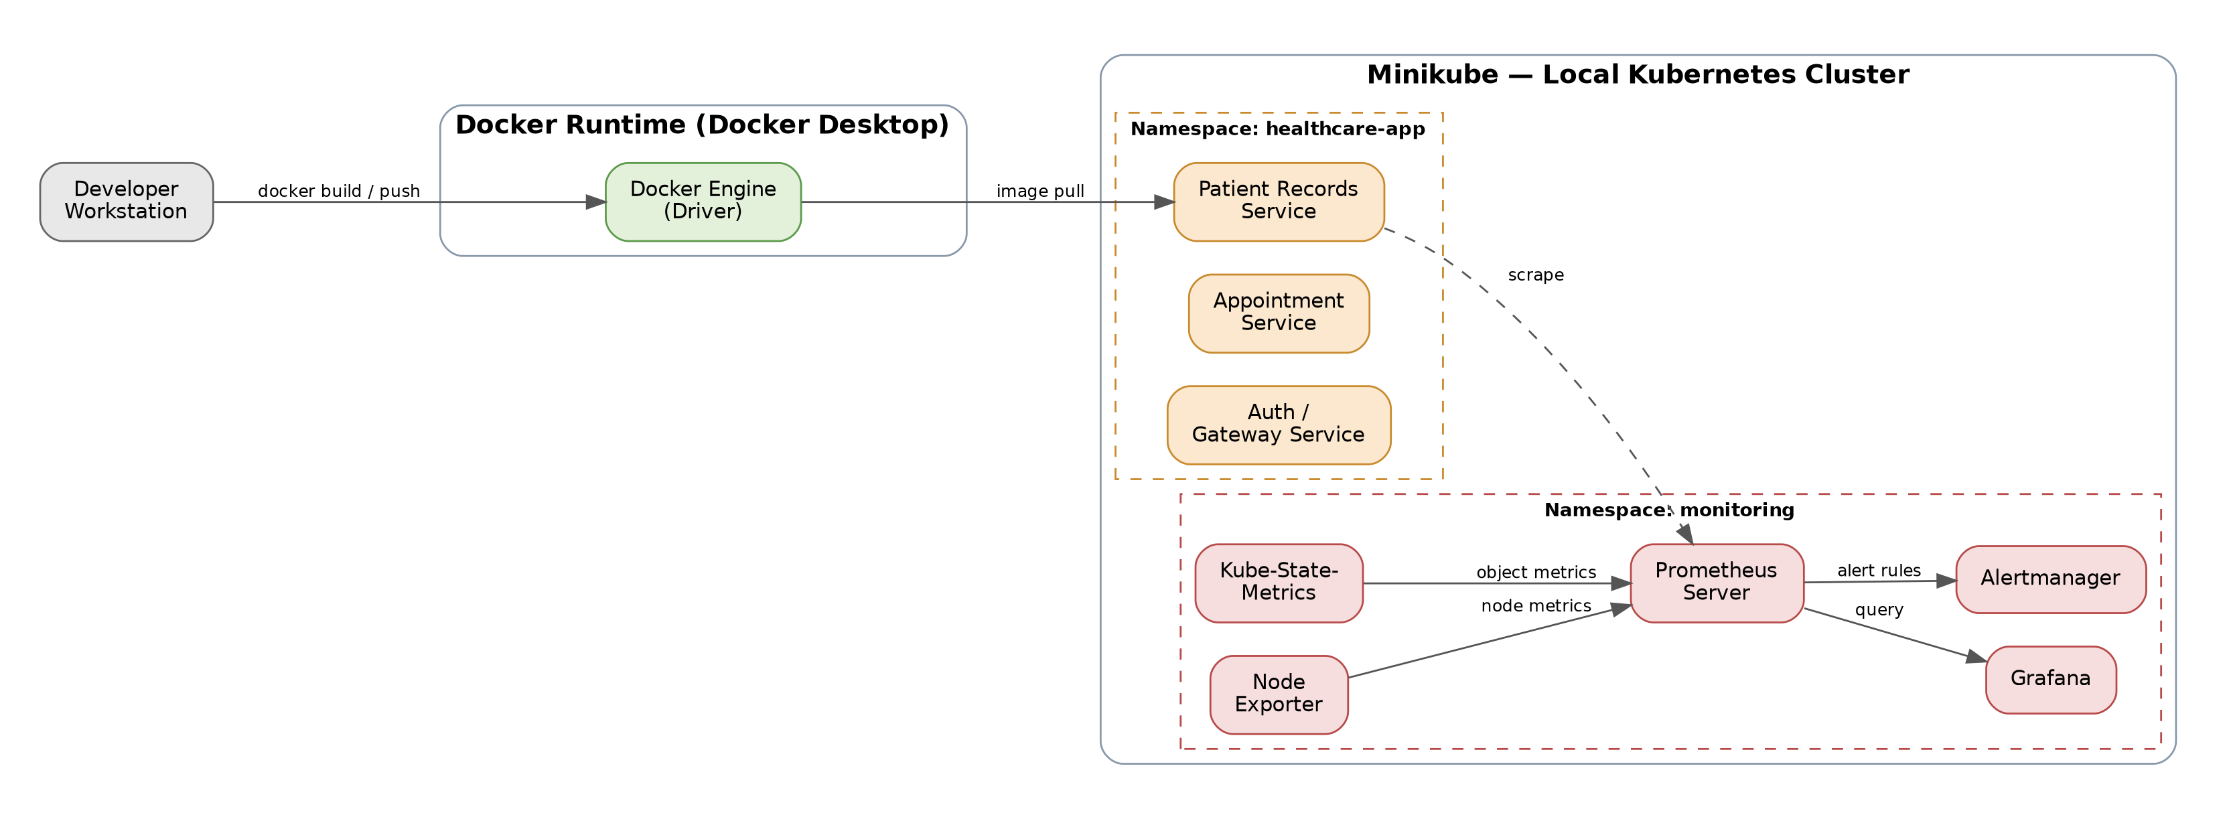
Figure 1. Namespace-segmented cluster architecture with CI-to-runtime image flow and telemetry scrape paths.

3. Pipeline Design & Continuous Integration (CI/CD)

3.1 GitHub Actions Workflow Lifecycle
The CI/CD layer is implemented as a GitHub Actions workflow triggered on push events against protected branches. The workflow lifecycle is structured into discrete, independently auditable jobs: source checkout and dependency resolution, container build and tagging, registry authentication and image push, and manifest update with cluster reconciliation. Each stage is gated on the successful completion of the preceding stage, preventing partially-built artifacts from propagating toward deployment.

3.2 Build-Stage Strategy
- Containerization Pattern: Each microservice maintains its own Dockerfile using a multi-stage build pattern, separating the compilation/dependency-installation layer from the minimal runtime layer to reduce final image size and attack surface.
- Secure Image Tag Structure: Images are tagged using a composite scheme combining semantic version and the short Git commit SHA (e.g., service-name:1.4.0-a1b2c3d), ensuring traceability between a running container and the exact source revision that produced it, while avoiding ambiguous use of the mutable latest tag in deployment manifests.
- Artifact Push to Docker Hub: Authenticated pushes are performed using repository-scoped access tokens stored as encrypted GitHub Actions secrets, rather than embedded credentials, and images are pushed only after build-stage test gates have passed.

3.3 Continuous Deployment Mechanism
Deployment automation operates by updating the image reference field within the relevant Kubernetes Deployment manifest and applying the change through kubectl as an authenticated pipeline step. This triggers a native Kubernetes rolling update: new ReplicaSet pods are created and validated against readiness probes before corresponding old-generation pods are terminated, ensuring zero-downtime transition for healthy deployments and automatic rollback eligibility if the new revision fails to stabilize.
Figure 2. CI/CD pipeline lifecycle from commit to cluster rollout.

4. Telemetry, Observability & Alerting Framework

4.1 Monitoring Layer Architecture
Observability is delivered through the kube-prometheus-stack Helm chart, deployed into the dedicated monitoring namespace described in Section 2.2. This chart provisions Prometheus Server, Kube-State-Metrics, Node Exporter, Grafana, and Alertmanager as a cohesive, version-pinned unit, avoiding the configuration drift that arises from installing each component independently.

4.2 Metric Gathering Protocols
- Node Exporter: Deployed as a DaemonSet, exposing host-level machine metrics — CPU utilization, memory pressure, disk I/O, and network throughput — for every node participating in the cluster.
- Kube-State-Metrics: Queries the Kubernetes API server directly to expose object-level state (pod restart counts, deployment replica status, resource requests/limits) rather than runtime performance, complementing Node Exporter's machine-level view with a control-plane-level view.
- Prometheus Server: Scrapes both exporters on a configured interval, storing time-series data locally and evaluating it against defined recording and alerting rules.

4.3 Visual Telemetry Layout
Grafana is configured with dashboards mapped directly to the Prometheus data source, surfacing cluster-wide and per-namespace panels for resource saturation, pod restart frequency, and request latency where instrumented. Access during the local development phase is established through a port-forward bridge exposing the Grafana service at localhost:3000, avoiding the need for an externally routable ingress in the non-production environment.

4.4 Alert Engineering via Alertmanager
Prometheus Alertmanager is configured with threshold-based alerting rules — sustained CPU or memory saturation, elevated pod restart rates, and node unreachability — routed through defined receiver configurations. In the current phase, alerts are validated internally via the Alertmanager web interface; Section 6 outlines the extension of these receivers to external chat-based notification channels.

5. System Stabilization, Diagnostics & Verification Log

5.1 Incident Summary — Phase 3 Cold-Start Behavior
During a cold-start cycle of the cluster — specifically, the case in which the full node and all workloads are brought up from a stopped state rather than incrementally updated — the Grafana pod exhibited transient Liveness and Readiness probe connection rejections. Root-cause analysis attributed this behavior to Grafana's internal SQLite/database initialization sequence, which had not completed by the time Kubernetes issued its first probe requests against the container's health endpoint. This is a known characteristic of cold-start scenarios rather than an application defect, as no such rejections were observed during subsequent incremental redeployments where the underlying container filesystem state persisted.

5.2 Diagnostic Procedure
Diagnosis was conducted using targeted kubectl inspection rather than broad log aggregation, isolating the failure to the specific pod and container in question:
- kubectl describe was executed against the affected pod, surfacing the probe failure events, associated timestamps, and restart counter, confirming that the container was restarting due to failed readiness checks rather than a crash loop from an application error.
- kubectl logs -c grafana was executed against the same pod to inspect container-scoped log output directly, confirming the specific point at which internal database migration and initialization steps completed and the health endpoint began returning successful responses.
Correlating the timestamps from both commands confirmed that the probe rejections were bounded strictly to the initialization window and resolved without manual intervention once Grafana's internal startup sequence completed.

5.3 Recovery Verification
Full cluster health was verified using the following command sequence, confirming a stabilized 3/3 Ready state across the monitoring namespace with no further probe rejections observed.
Command | Diagnostic Purpose
kubectl get pods -A | Provides a cluster-wide readiness snapshot across all namespaces, used to confirm the Grafana pod's transition to a 3/3 Ready state.
kubectl describe pod <grafana-pod> | Surfaces event-level detail — probe failure timestamps, restart counts, and container state transitions — used to isolate the cold-start dependency.
kubectl logs -c grafana <pod> | Retrieves container-scoped log output, confirming the point at which the internal Grafana database initialization completed and health endpoints began responding.

This verification sequence is retained as the standard post-cold-start health check for future cluster restarts, ensuring the same diagnostic path is followed consistently rather than treated as an ad-hoc response.

6. Conclusion & Production Future Scope

6.1 Evaluation Against Baseline Objectives
Measured against the four objectives established in Section 1, the infrastructure has demonstrated functional automation of the build-to-deploy path, namespace-level scalability boundaries, resilience through probe-driven rolling updates, and a fully operational observability layer capable of surfacing and diagnosing real stabilization events, as evidenced directly by the Phase 3 incident documented in Section 5. The project baseline is considered met for a local-cluster development and validation context.

6.2 Strategic Next Steps for Production Scaling
- Migration to Azure Kubernetes Service (AKS): The existing manifests and Helm-based monitoring stack are structured for direct portability to a managed AKS cluster, replacing the Minikube/Docker Desktop driver layer with Azure's managed control plane and node pools while preserving namespace and deployment topology.
- Managed Secrets Vault Integration: Static Kubernetes Secrets are planned for replacement with Azure Key Vault, accessed via the Secrets Store CSI Driver, removing sensitive credentials (registry tokens, database connection strings) from etcd-persisted objects.
- External Alert Routing: Alertmanager receiver configuration is planned for extension to route threshold and outage alerts to Slack or Microsoft Teams via incoming webhook integrations, converting internally-visible alerts into actively pushed operational notifications.
- Ingress and TLS Termination: The current port-forward access pattern for Grafana is a local-development convenience; a production rollout requires a proper Ingress controller with TLS termination and authenticated access in place of direct port exposure.
Collectively, these next steps represent an incremental hardening path rather than a redesign, reflecting the fact that the underlying architecture was engineered from the outset with production portability as a design constraint rather than an afterthought.

Screenshot :
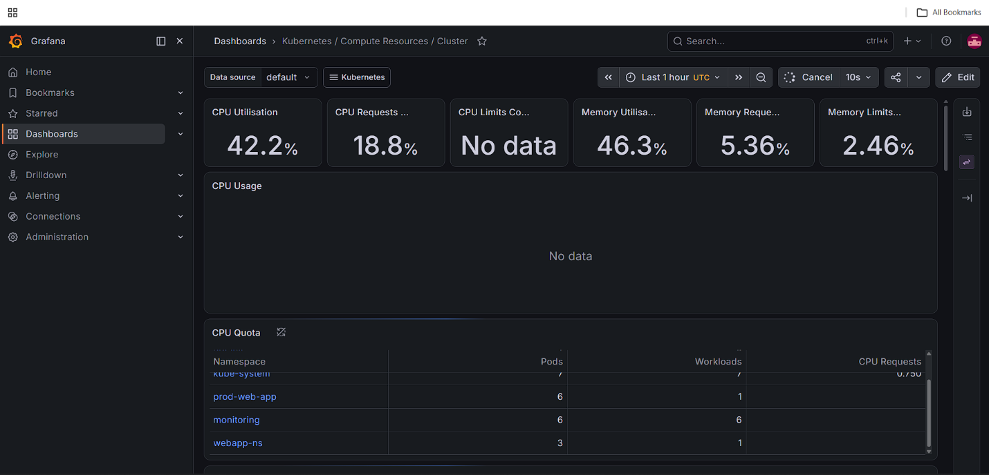
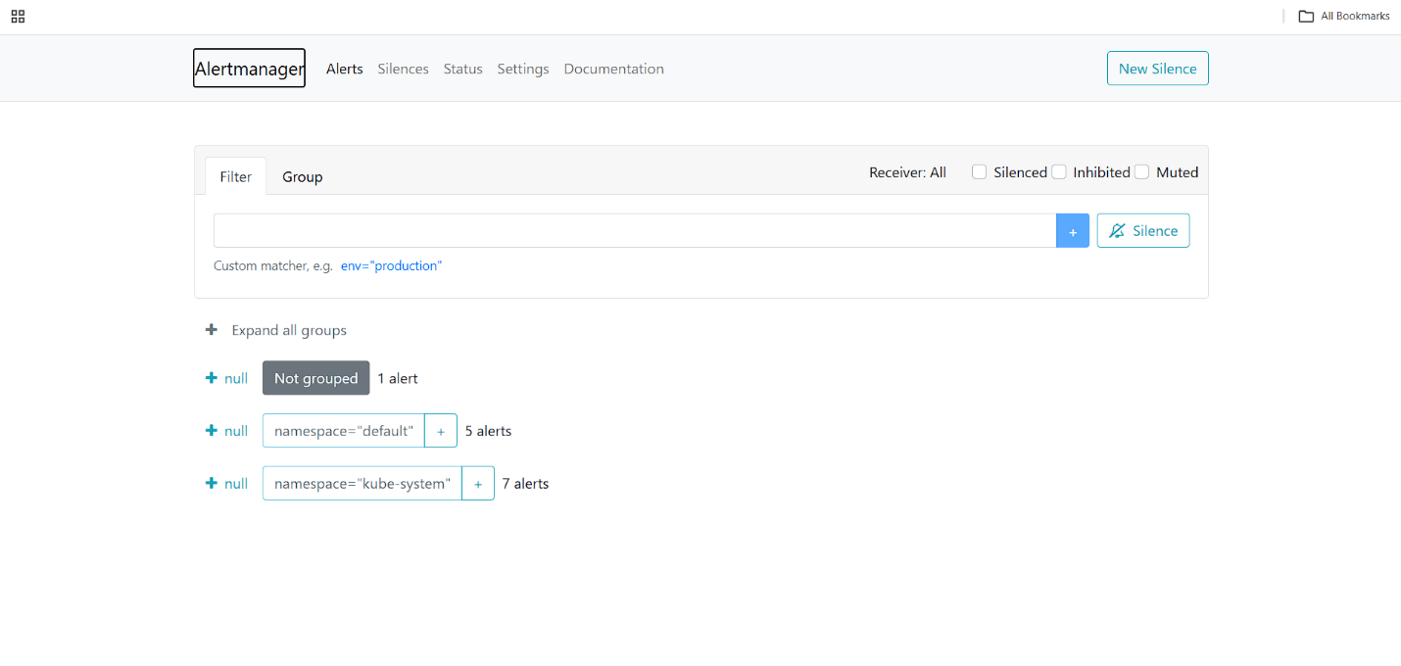
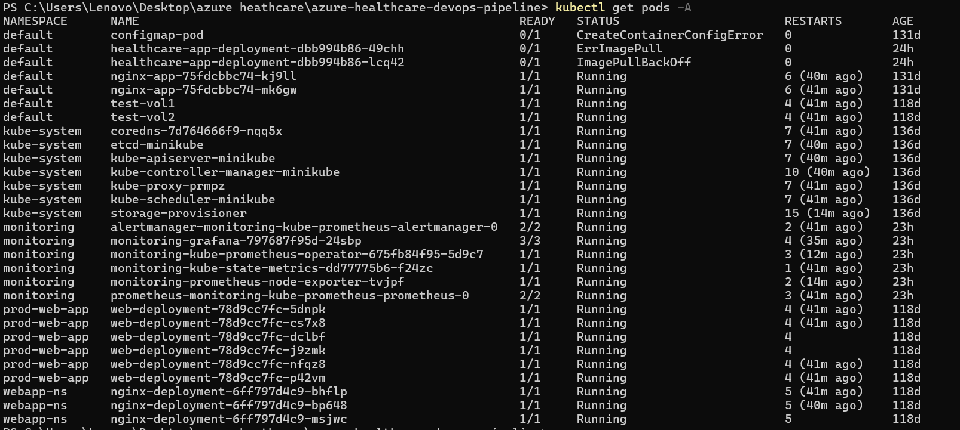

Demo video linkvideo1815899408.mp4

