Sample Fillable PDF Form

Fillable PDF forms can be customised to your needs. They allow form recipients to fill out information on screen like a web page form, then print, save or email the results.



| Name |  | Date | 1 Jan 2012 |
| --- | --- | --- | --- |
| Address |  | | |



What are your favourite activities?

☐Reading

☐Walking

☐Music

☐Other:



What is your favourite activity?

◯Reading

◯Walking

◯Music

◯Other:



These buttons can be printable or visible only when onscreen.

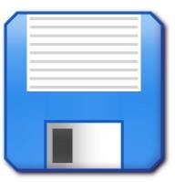

Print Save

[www.worldofprinting.com](http://www.worldofprinting.com/)