**Predictive modelling of non-deterministic human behaviour identification based on their choice of clothing**

**Ms. Muskan Choudhary**

*B.Tech(CSIT)-2020-2024,Symbiois University Of Applied Sciences(M.P,India)*

**INTRODUCTION**

In today's world of developing artificial intelligence to help humans, the primary question in the realm of artificial intelligence development for human assistance is still how to better comprehend a specific person. The study of such non-deterministic human behaviour[1] based on individuals' choices in a variety of daily acts is known as " Behavioural Science." The person's choice of attire serves as a criterion to determine their personality. The choice of dress is a highly variable factor in a nation as diverse as India. India's various regions appear to have their own distinct fashions that more accurately reflect the local culture, religion, and vogue. While deterministic dress standards, such as those for the Indian Army uniform and the Navy dress code, are constant, Indians exhibit non-deterministic behaviour.

We were eager to work in this area of artificial intelligence because of the paucity of knowledge and analysis there. We created a behavioural science system that assists in classifying different personality types based on clothing choices[2]. We created a dataset called NDHBCC (Non-deterministic Human Behaviour Based on the Choice of Clothes) that contains data about a location's fashion and the people who live there.

Our model aims to develop artificial intelligence in a way that can also meet the emotional requirements of a human, which it now lacks. This goal is not far off if artificial intelligence can analyse a personality. Our goal is to identify non-deterministic human behaviour, and our model is a start in that direction.

**NDHBCC DATASET REQUIRED**

The accuracy, completeness, and quality of the data determine how well a model performs. In order to accomplish that, we created a dataset using web crawling, which allowed us to browse social media in various areas and gather the most relevant data for our algorithm. For more accurate findings, this dataset includes information from all regions of India that exhibit a wide range of fashion[3]. Data from male and female citizens of 8 different states—Jammu and Kashmir, Punjab, Rajasthan, Maharashtra, Kerala, Orissa, Assam, and India's capital, Delhi—are included in the dataset. This dataset has an appropriate 50–70 data points for each state, totaling more than 400 values. The month-long pre-processing and cleanup procedures made it possible to use this dataset, which gave more than 300 highly accurate data values. The data collection, cleansing, verification, and other pre-processing tasks took us about one and a half months. This is how we achieved a clean and correct dataset for our predictive model.

**RELATED WORKS**

(D. D. Bourgin, J. C. Peterson, D. Reichman, S. J. Russell, and T. L. Griffiths ) Cognitive Model Priors for Predicting Human Decisions-They have introduced the model for smaller datasets which gave them promising results over smaller iterations, next they are trying to introduce is larger dataset and hoping to get better predictive models[4].

(Andrew Starnes∗, Anton Dereventsov∗, E. Susanne Blazek†, Folasade Phillips† ∗Lirio AI Research, Lirio LLC, Knoxville, TN, USA) Modelling Non-deterministic Human Behaviours in Discrete Food Choices-They developed the model to identify human non-deterministic behaviour according to food choices depending on their demographic features. Their model requires are a large amount of data which is unavailable in surveys.

(S. Turgeon and M. J. Lanovaz. Tutorial) Applying machine learning in behavioural research Perspectives on Behaviour Science-They have developed a theoretical model which makes us understand how effective machine learning algorithms can be in the field of behaviour analysis. They have provided tested, effective algorithms working in smaller datasets under label noise.

(I. Ajzen) From intentions to actions: A theory of planned behaviour-they did a study on how much power an individual has over their internal and external factors, as their choices can change according to the situations from time to time.

(S. Mills) Personalized Nudging Behavioural Public Policy-they had done their research on personalized nudging. Which can be a very important factor that can increase our model accuracy. They have worked towards two segments one is being nudged towards and the method of nudging itself.

(A. Peysakhovich and J. Naecker) Using methods from machine learning to evaluate behavioural models of choice under risk and ambiguity. Journal of Economic Behaviour & Organization-they studied the behaviour of those people who promote health-promoting food choices and also discourage health-discouraging food choices.

(Carlie,B.W.Oleseon )People's clothing behaviour according to external weather and indoor environment- Analysis and recommendations The clothing behaviour has been studied in the current work by taking into account two existing databases. There may be a relationship between clo-value and the outside air temperature. In both HVAC and NV buildings, the clo-value varies throughout the day (difference maximum-minimum, see Figures 4 and 5). The difference for HVAC buildings is approximately 0.20 clo and is independent of the ambient temperature.

# (Emine Koca, Fatma Koç) A Study of Clothing Purchasing Behavior By Gender with Respect to Fashion and Brand Awareness(For a variety of reasons, it has been proposed that male and female customers exhibit noticeably different strategies in their decision-making and purchase behaviour when they shop for clothing. As a result, the focus of this study is on figuring out how much gender influences customers' decisions to buy fashion goods as well as any potential disparities between male and female consumers' choices of apparel. 382 customers were randomly selected to make up the sample group for this study, which attempts to discover the differences between male and female consumers from a gender perspective by studying their purchase behaviour with regard to fashion and brand awareness.

**RESEARCH GAPS**

The issue of data scarcity was the emphasised gap that we discovered in practically all of the prior studies. The accuracy and judgement of the predictive model are impacted by the scarce availability of noisy data. The relevance that should be accorded to the clothing aspect of the research is not mentioned. It maintains its stability in a nation with as much diversity as India, which makes it an important and trustworthy component. These models' theoretical applications might be accurate, but their boundaries aren't being fully evaluated in real-world applications. Our model attempts to prevent noisy data by supplying significance to the choice of clothing among various areas and personalities, taking into account all of these gaps, and applying a model that is being thoroughly tested.

**RESEARCH QUESTIONS**

1. How do behaviour, location, age, and gender affect an individual’s fashion?
2. Will Artificial Intelligence become smart enough to recognize an individual’s personality just from the choices they make in day-to-day life?
3. Why can't the deterministic choices of human behaviour become the factor in finding their personalities?
4. Will Artificial Intelligence[5]ss become a human’s friend?

**STATEMENT OF PROBLEM**

Imagine a universe or setting in which an AI can comprehend a person's personality, reassure them by recognising their nature, and feel compassion for their emotional, social, and physical well-being. Our predictive model aims to understand how to identify a person based on their choices (such as food, dress, and other unstated characteristics) in order to achieve the phenomenon a priori.

**OBJECTIVES**

We have seen in our dataset that each and every parameter, including geography, age, gender, and others, has a significant impact on a person's sense of style. The model would not understand and could not produce the desired results if the variance were absent. The deterministic options fluctuate with personality since they are not variables. The outcomes would be wildly inaccurate if we used it as a component of identification. The ultimate goal is still to create a world in which human intelligence and artificial intelligence can coexist. The ability of artificial intelligence to find a suitable place in the human age will determine its success.

**LIMITATIONS**

* Deterministic behaviour produces a trend that stifles the variance in preferences across various personalities. Artificial intelligence sinks into the abyss of unpredictable erroneous findings with such a non-varying trend.
* Since people's preferences change occasionally, understanding human psychology with any degree of accuracy is impossible[6]. The area of tailored nudging, which can only be understood by a human, is one where artificial intelligence has not yet made any progress.[7]

**TECHNOLOGY, TOOLS & TECHNIQUES**

We were able to discover the fundamentals of the outcome with the use of probability, descriptive statistics, and inferential statistics. We used neural networks, linear regression, and logistic regression techniques, as well as hyperparameter testing, to improve the intelligence and accuracy of our deep learning model[8]. We carried out extraction, analysis, and data visualisation[9] using Python and R (Context Grabber). TensorFlow[10] and Keras were two of the libraries used by the model. Our approach helps make this assumption true by using powerful unsupervised learning techniques like clustering.

**SCHEDULE OF WORK (TOTAL DAYS OF WORK -100)**

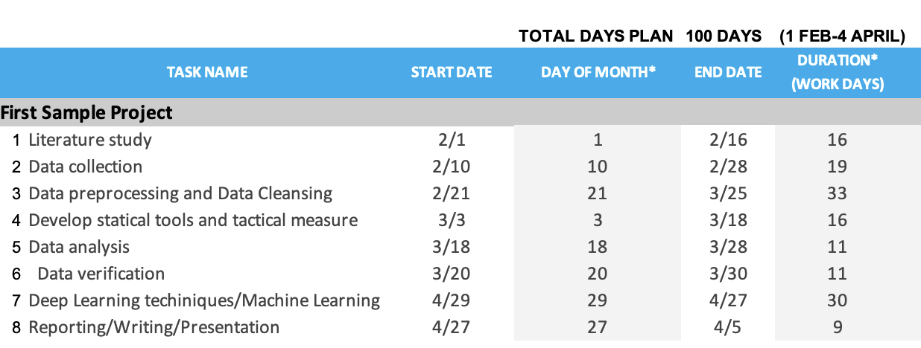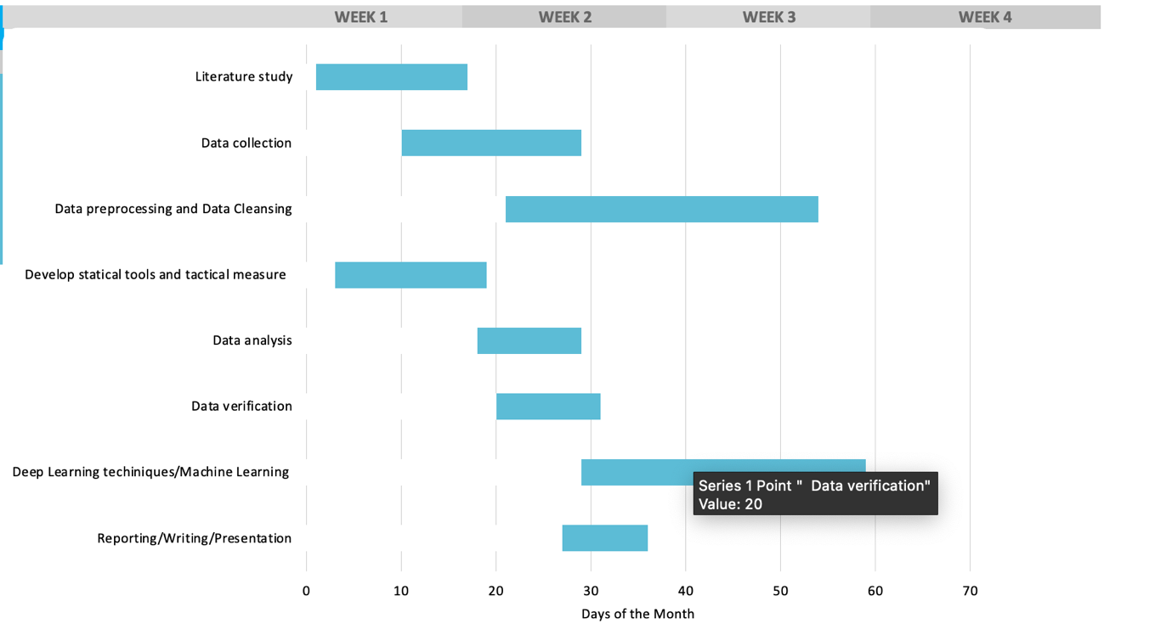

**CONCLUSION**

To sum up all that has been stated so far, fashion is a key factor to identify people and their nature. Creating Artificial Intelligence that can be much smarter and faster than us humans is not impractical now and will be implemented. Although it will be a long time before it is possible to reliably predict human behaviour only based on appearance, this is a step in that direction.

**SUMMARY**

The challenge of predicting non-deterministic human behaviour makes extensive use of behavioural science expertise. Also, it makes use of the NDHBCC, a self-created dataset with more than 300 processed and clean data values. The algorithm employs well-known probabilistic, descriptive, and inferential statistical methods. Hyperparameter testing is also used to generate a large number of precise identification results. The approach takes advantage of the diversity of India to identify distinctive trends in people's regional fashion preferences. It is affordable to obtain reliable results because of India's eight distinct states, which differ greatly in the fashion industry. The long-term objective of this claim is to develop artificial intelligence that is capable of instantly comprehending a person's nature. Achieving such a fiet would mean great to the developing field of Artificial Intelligence.

**REFERENCES**

[1] T. Gateau, C. P. C. Chanel, M. H. Le, and F. Dehais, “Considering human’s non-deterministic behavior and his availability state when designing a collaborative human-robots system,” in *IEEE International Conference on Intelligent Robots and Systems*, 2016, vol. 2016-November. doi: 10.1109/IROS.2016.7759646.

[2] M. C. Jenkins and L. E. Dickey, “Consumer Types Based on Evaluative Cri teria Underlying Clothing Decisions,” *Home Econ. Res. J.*, vol. 4, no. 3, 1976, doi: 10.1177/1077727X7600400301.

[3] N. P. Sil, “Culture and Customs of India.,” *J. Third World Stud.*, vol. 21, 2004.

[4] A. Nandy, C. Duan, and H. J. Kulik, “Audacity of huge: overcoming challenges of data scarcity and data quality for machine learning in computational materials discovery,” *Current Opinion in Chemical Engineering*, vol. 36. 2022. doi: 10.1016/j.coche.2021.100778.

[5] E. Carter and C. Knol, “Chatbots — an organisation’s friend or foe?,” *Res. Hosp. Manag.*, vol. 9, no. 2, 2019, doi: 10.1080/22243534.2019.1689700.

[6] R. Chandra and A. Krishna, “COVID-19 sentiment analysis via deep learning during the rise of novel cases,” *PLoS One*, vol. 16, no. 8 August, 2021, doi: 10.1371/journal.pone.0255615.

[7] R. Kholiya, S. Massey, | Arshia Hussain, and A. Info, “An investigation of Indian consumer’s buying behaviour during COVID-19 towards the purchase of apparel items,” *Artic. Int. J. Mod. Trends Sci. Technol.*, vol. 8, no. 02, 2022.

[8] J. A. Benítez-Andrades, Á. González-Jiménez, Á. López-Brea, J. Aveleira-Mata, J. M. Alija-Pérez, and M. T. García-Ordás, “Detecting racism and xenophobia using deep learning models on Twitter data: CNN, LSTM and BERT,” *PeerJ Comput. Sci.*, vol. 8, 2022, doi: 10.7717/PEERJ-CS.906.

[9] V. A. C. Horta, I. Tiddi, S. Little, and A. Mileo, “Extracting knowledge from Deep Neural Networks through graph analysis,” *Futur. Gener. Comput. Syst.*, vol. 120, 2021, doi: 10.1016/j.future.2021.02.009.

[10] B. Pang, E. Nijkamp, and Y. N. Wu, “Deep Learning With TensorFlow: A Review,” *Journal of Educational and Behavioral Statistics*, vol. 45, no. 2. 2020. doi: 10.3102/1076998619872761.