Step1. Create a Project Folder

- Create a local folder on your system
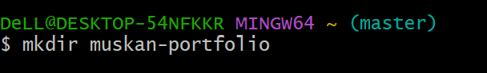
- Create 3 files:
- index.html
- style.css
- script.js
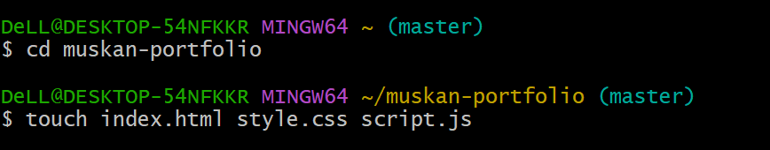

Step2. Initialize Git Repo
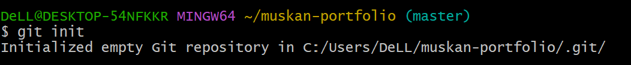

Step 3. Add Your Website Content

- Open index.html and add basic HTML:
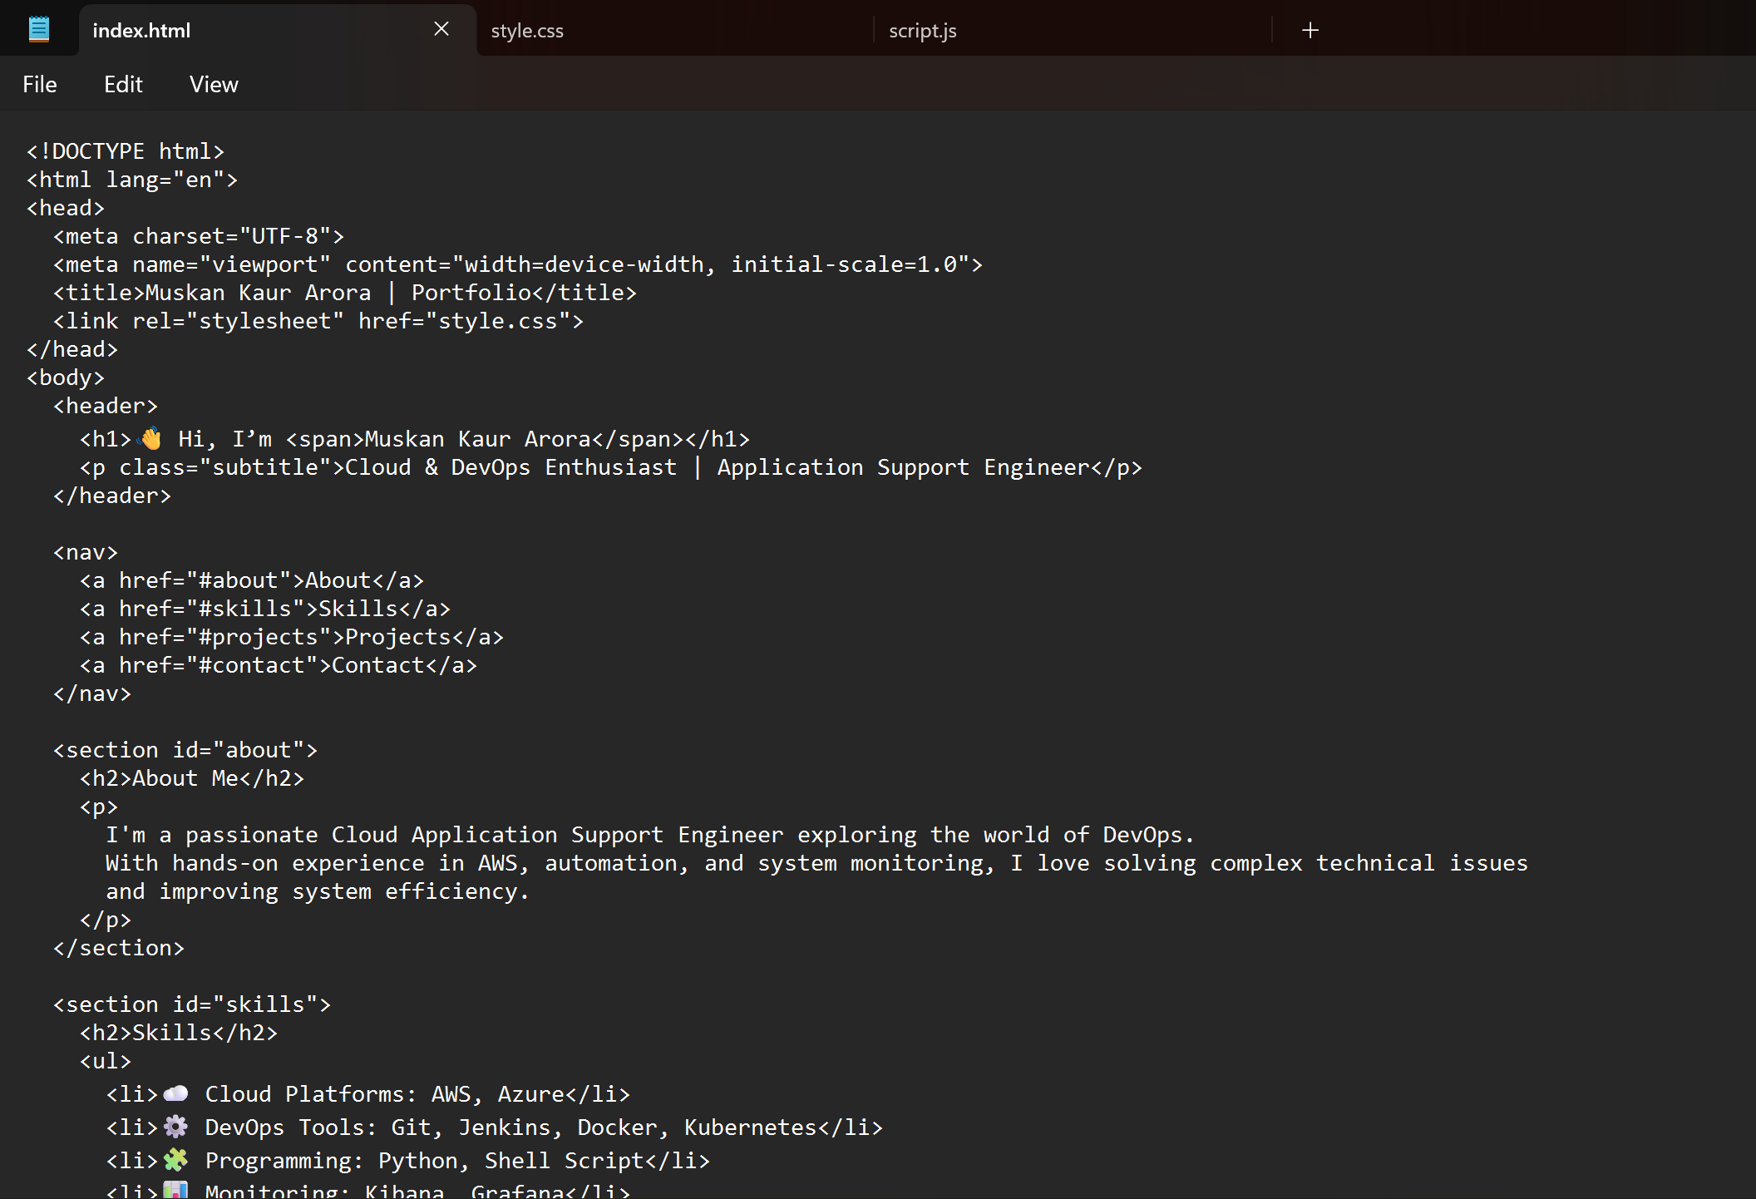

- Open styl.css and add basic CSS:
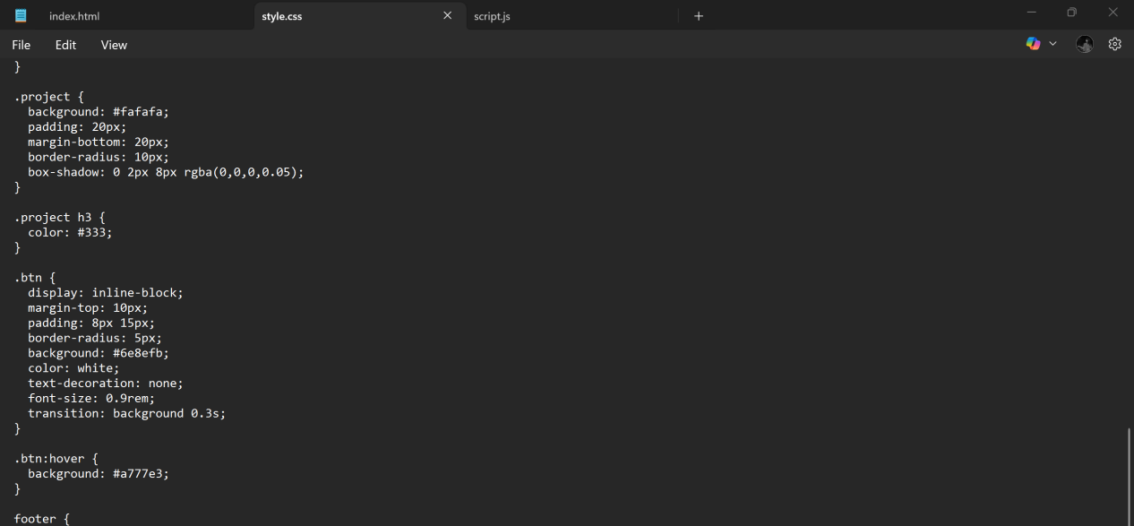?C. Open script.js and add basic JS Script (Optional):
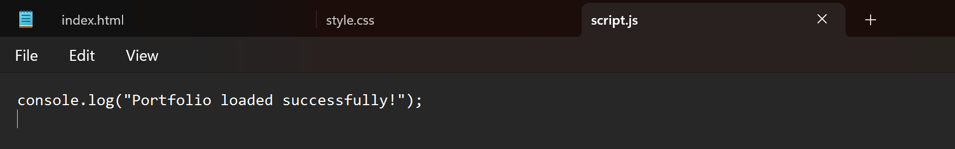

Step 4. Stage & Commit Files
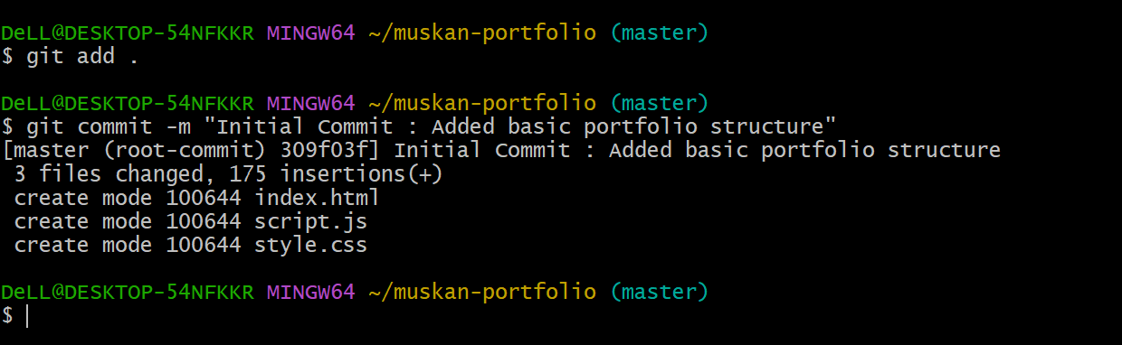

Step 5. Create a GitHub Repository
- Go to https://github.com and click New Repository
- Name it muskan-portfolio .Keep it Public.
- Don’t initialize it with README (since we already have local files).
- Now connect remote:
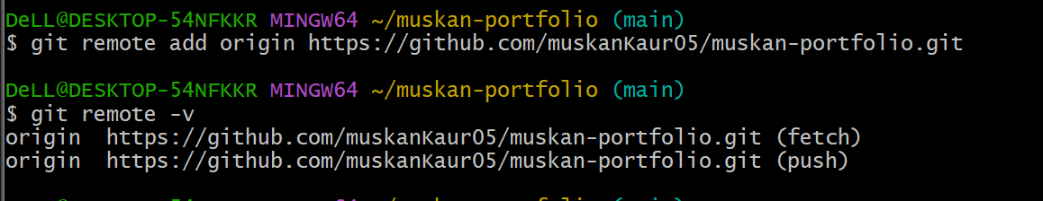

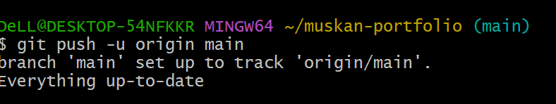

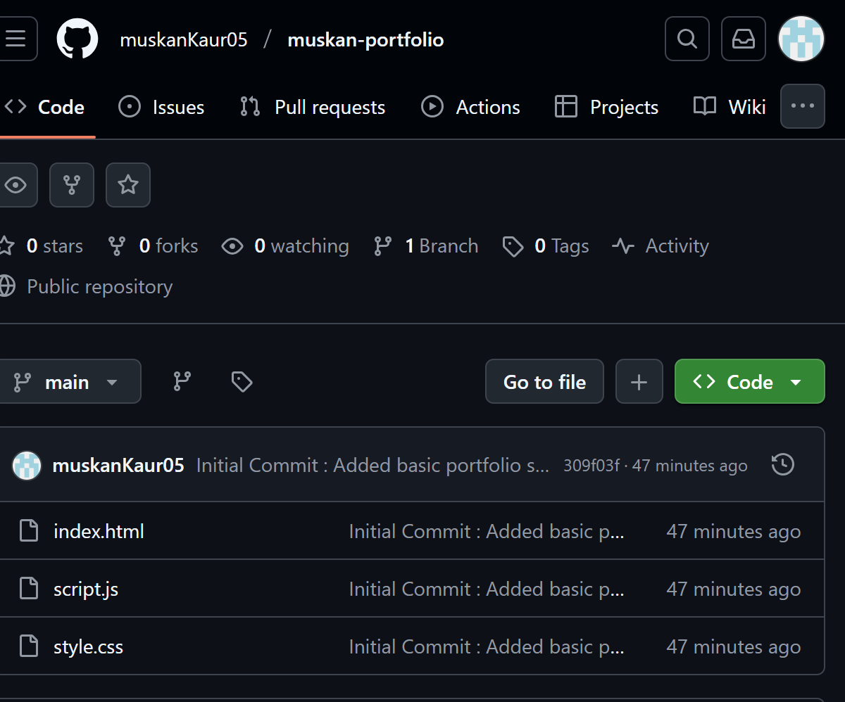

Step 6. Add a New Branch for a Feature
- Created a new branch to change an “About Me” section:
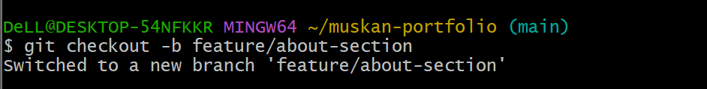
- Edit your index.html:
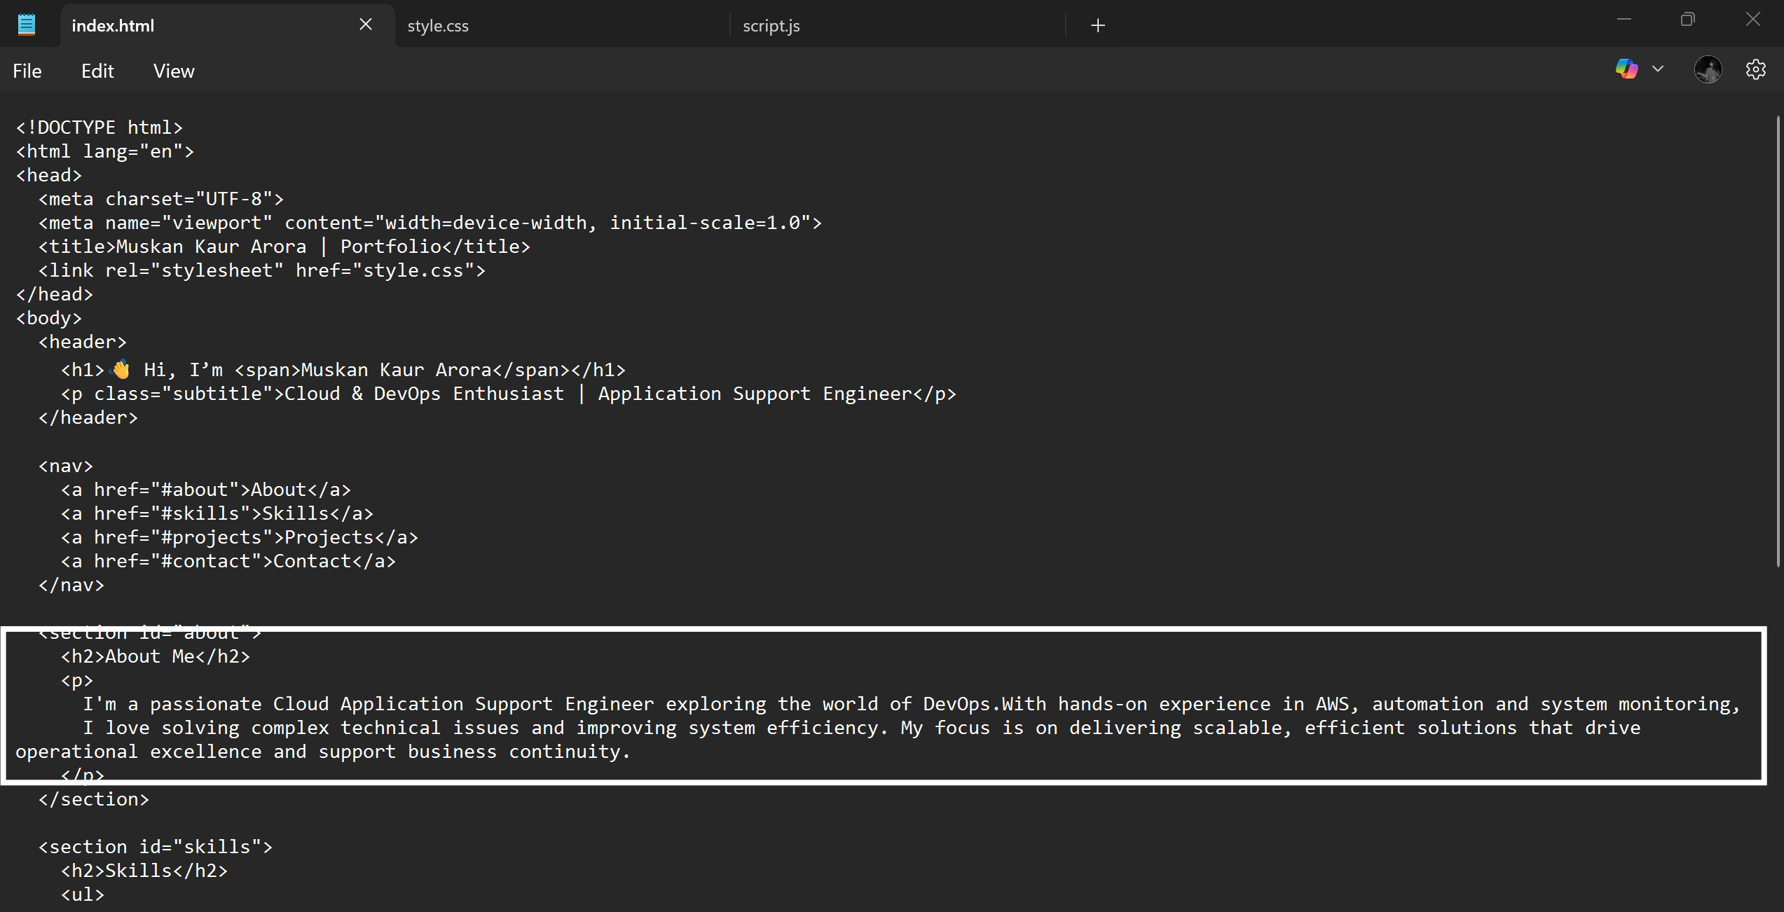

- Check Status:
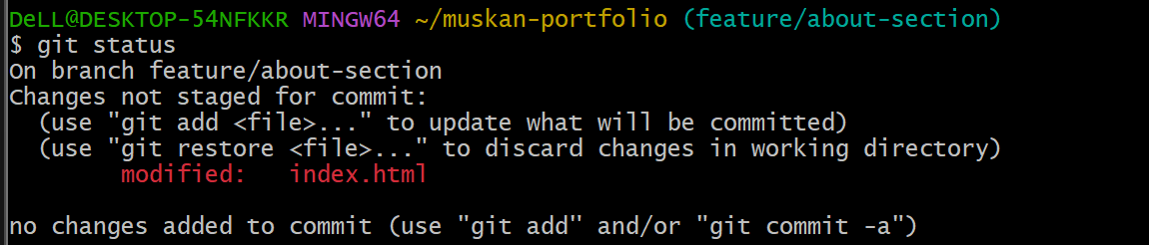
- See if you’re seeing any difference in
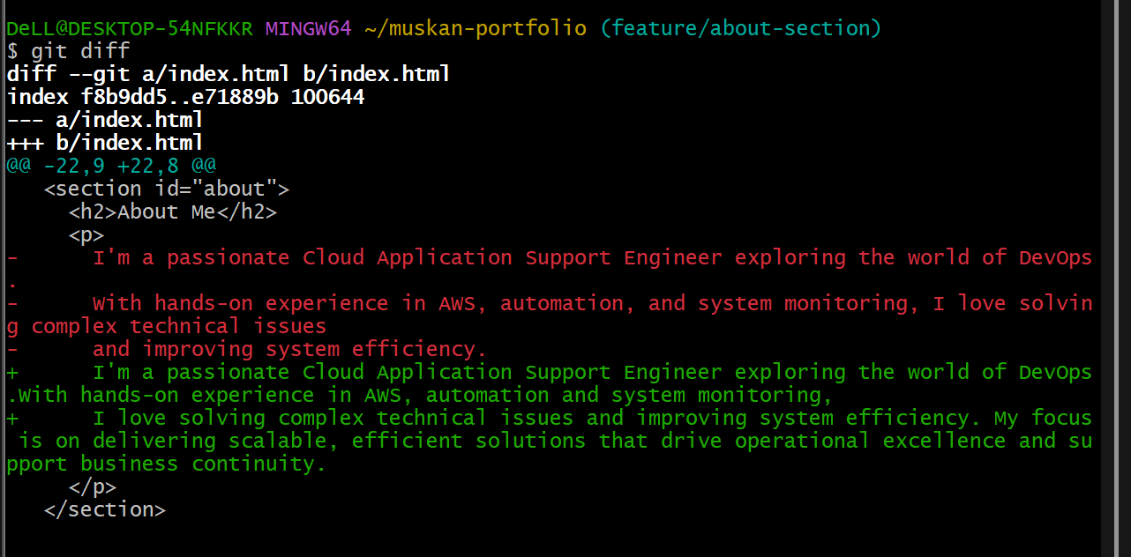
- Stage & commit:
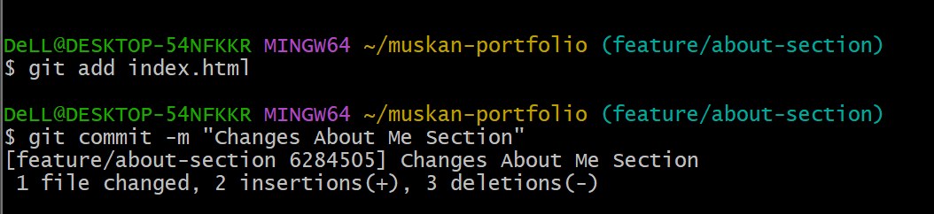
- Push the branch:
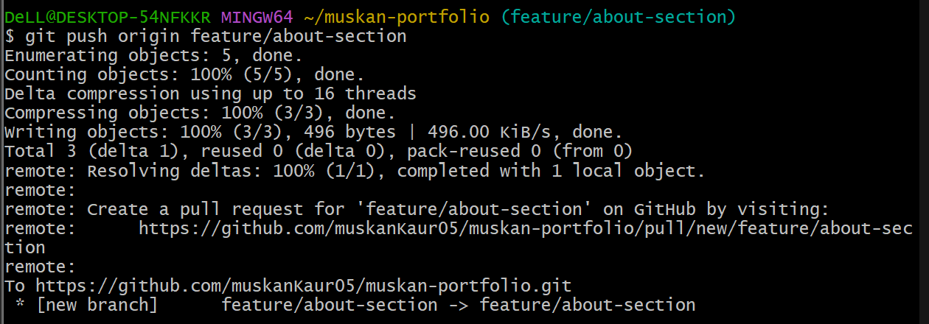

Step 7. Merge the Branch

- Go to GitHub → open your repo → you’ll see a suggestion to create a Pull Request (PR).

- Click Compare & Pull Request
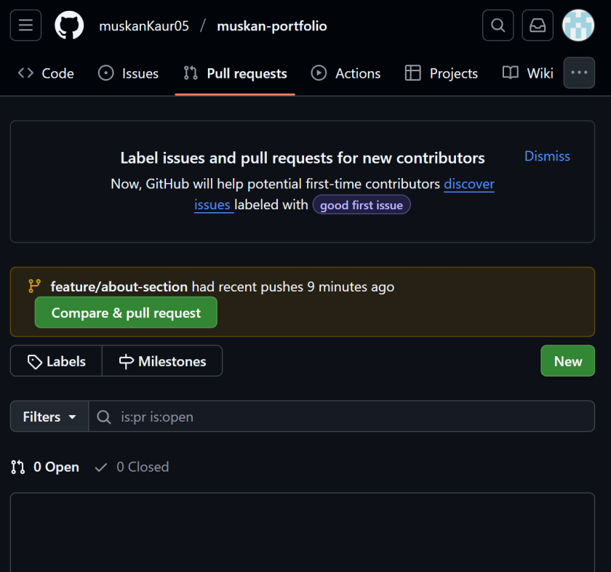

- Add title: “Changes About Me Section”
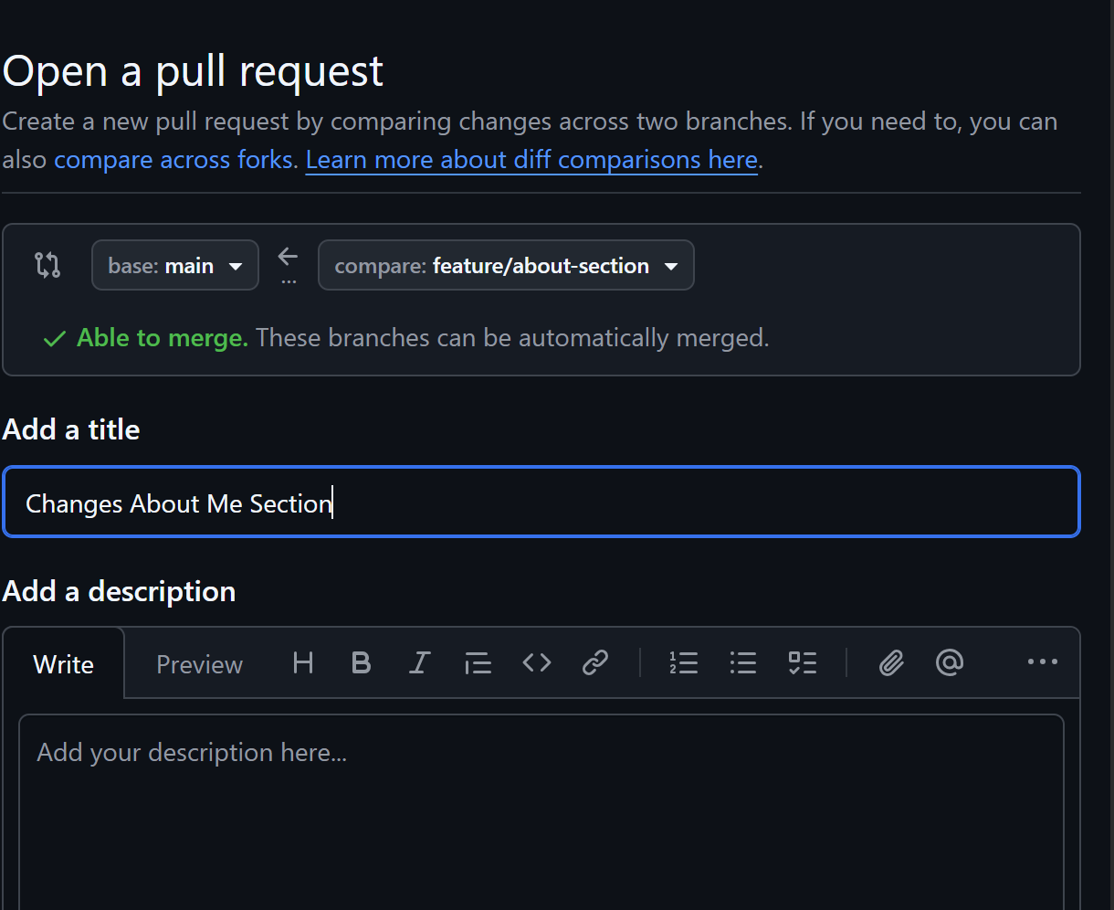

- Merge it into main
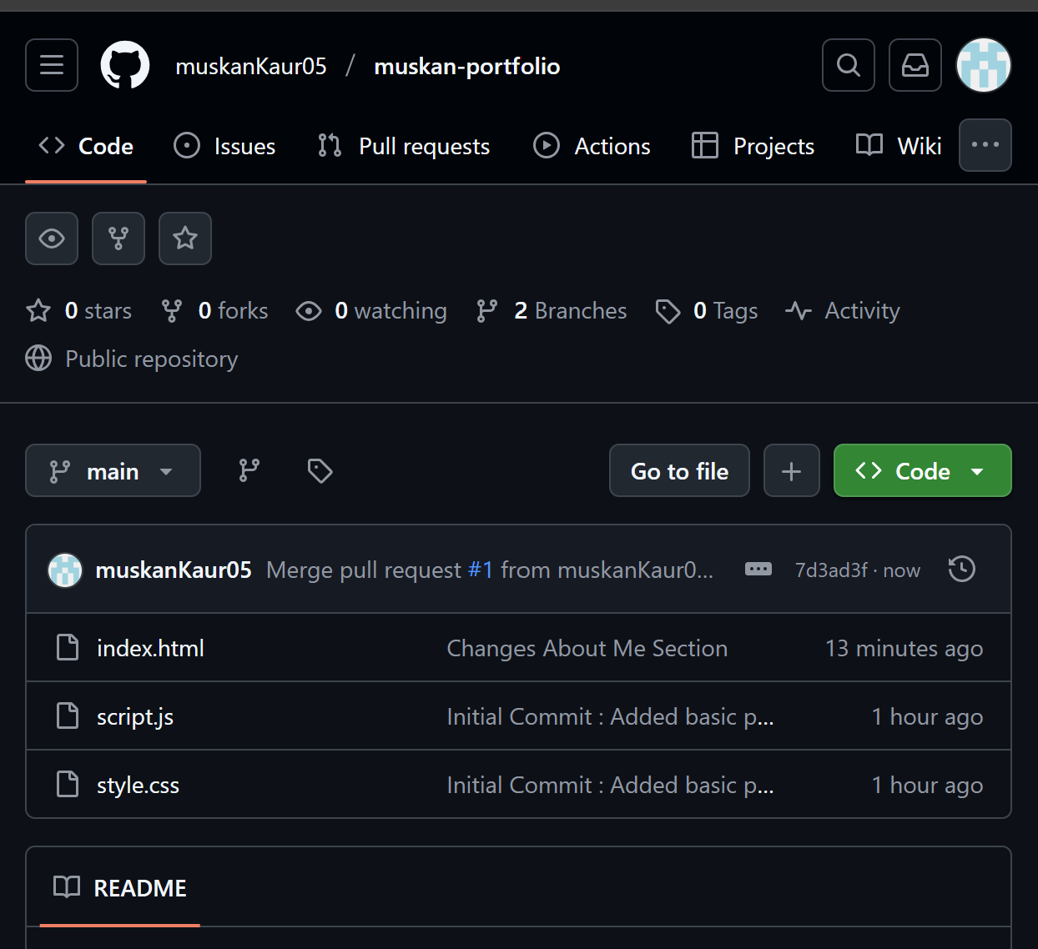

- Now pull the updated main branch locally:
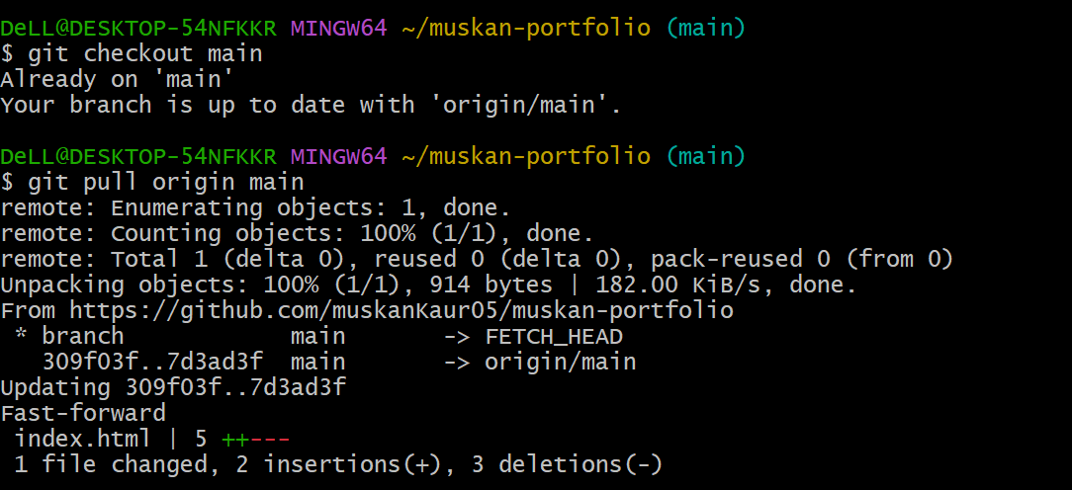

Step 8. Add a Contact Form in Another Branch
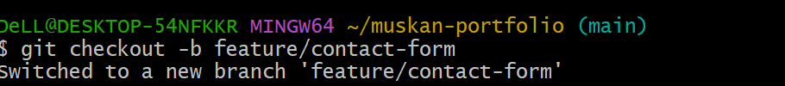

- Add a simple contact form in index.html.
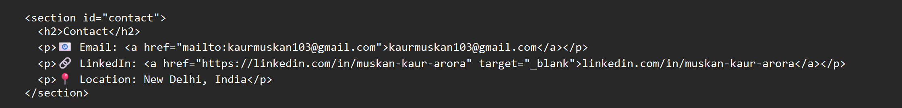

- Commit and merge it like before.
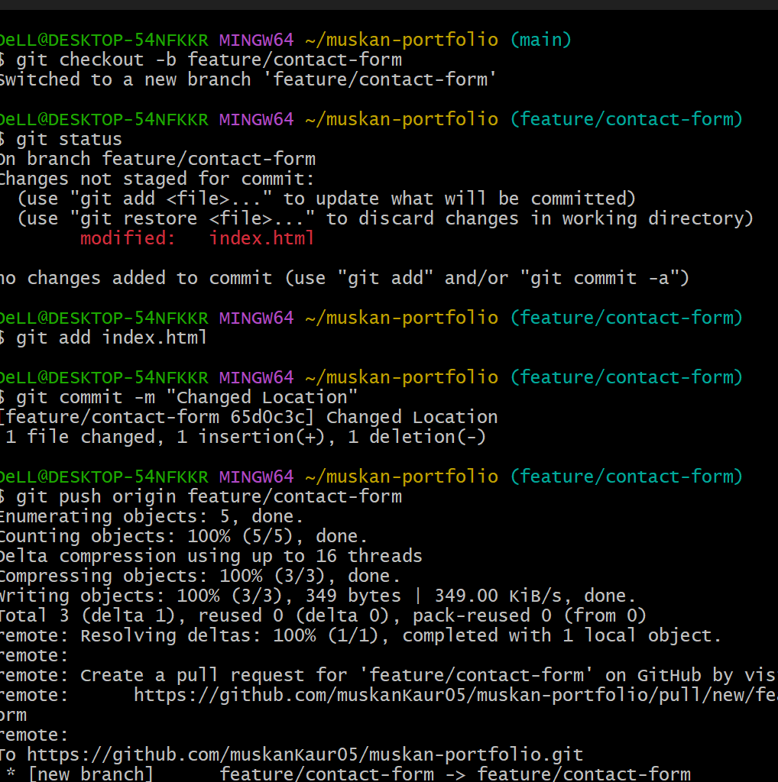
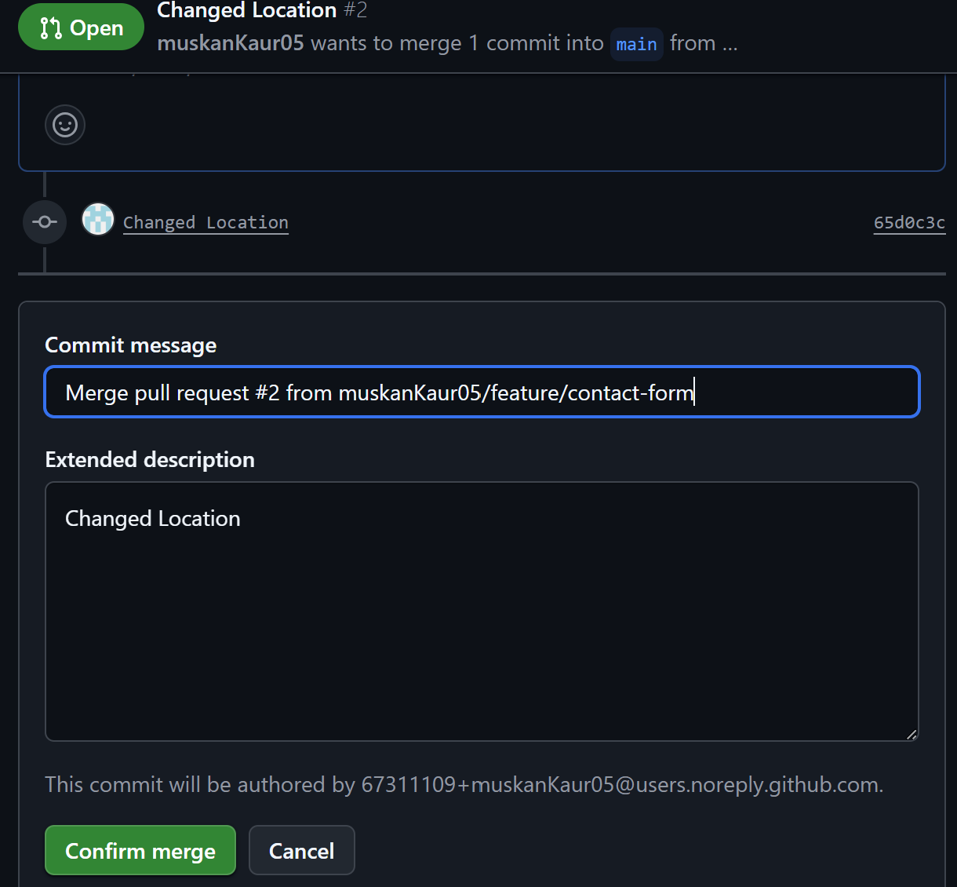
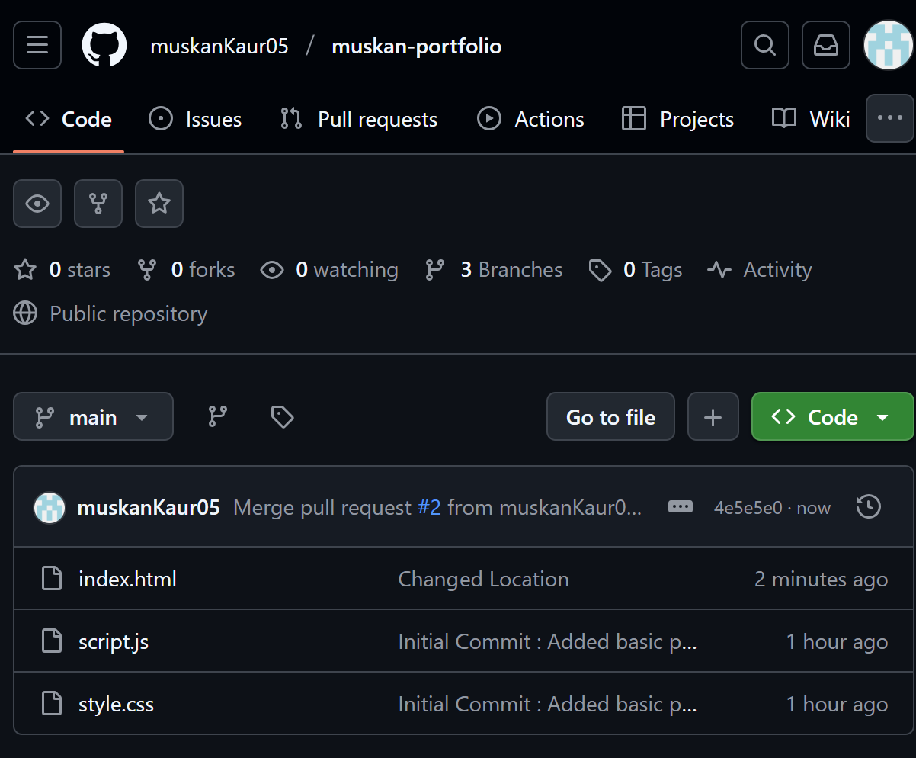
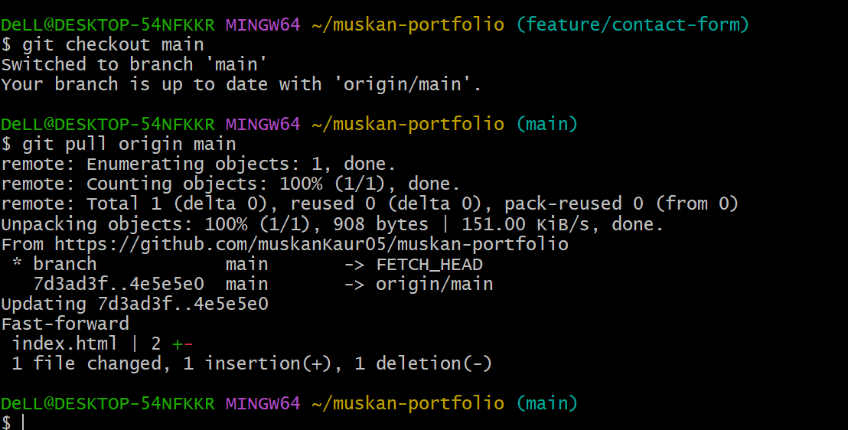

- To check how much branches we have 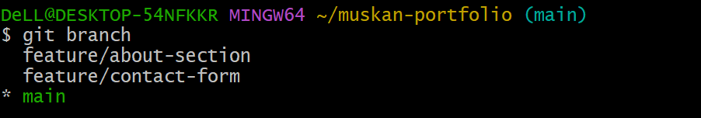

Step 9. Add Version Tag

- Tag your first release:
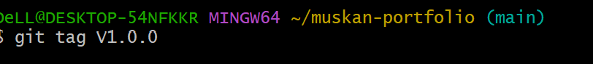

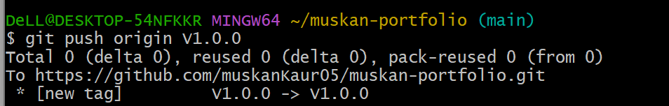

Step 10. Host Using GitHub Pages

- Go to Repo Settings → Pages
- Under “Source”, select Deploy from a branch
- Choose main branch → / (root)
- Click Save
- Your site will be live in 2–3 minutes at:
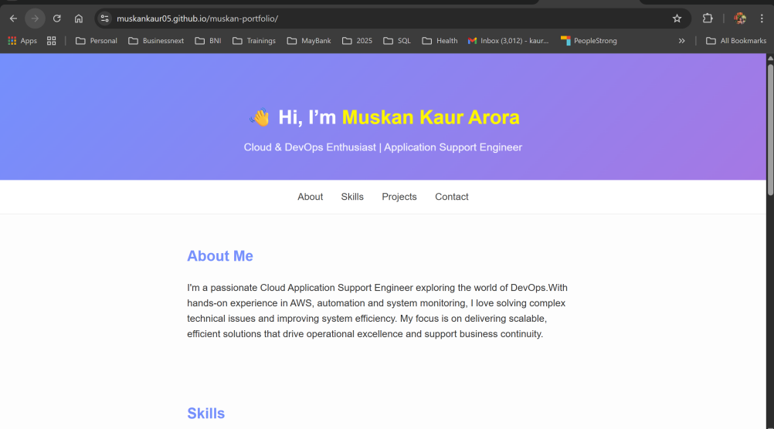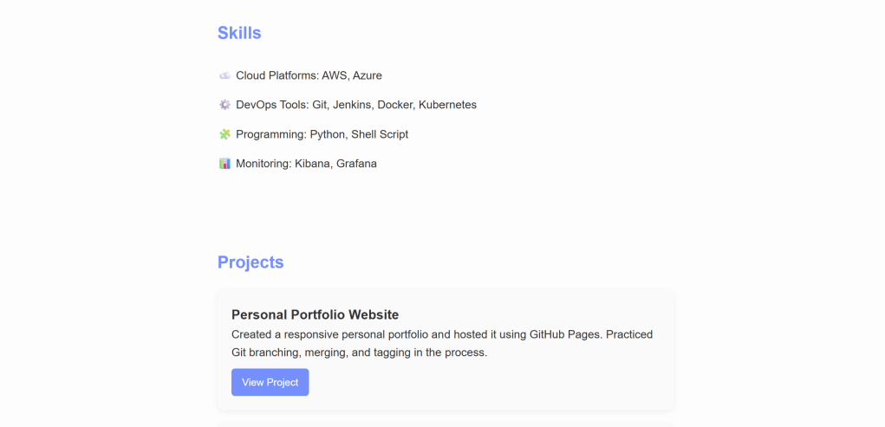
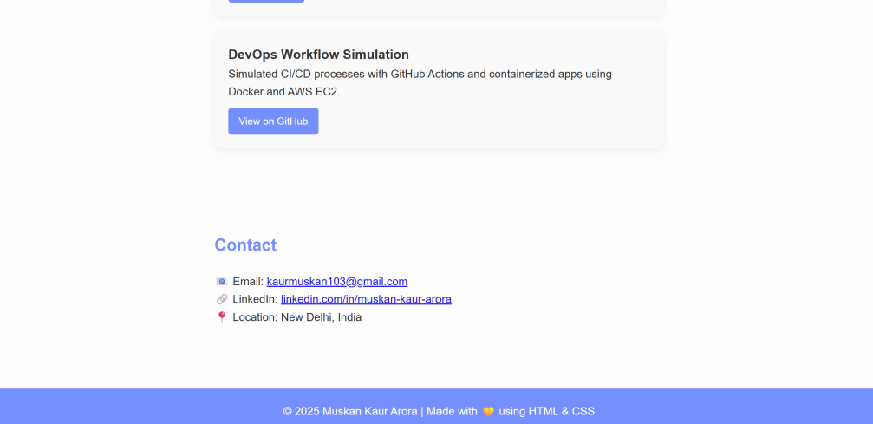

Step 11. Try other GIT commands:

- To View commit history we run below commands:
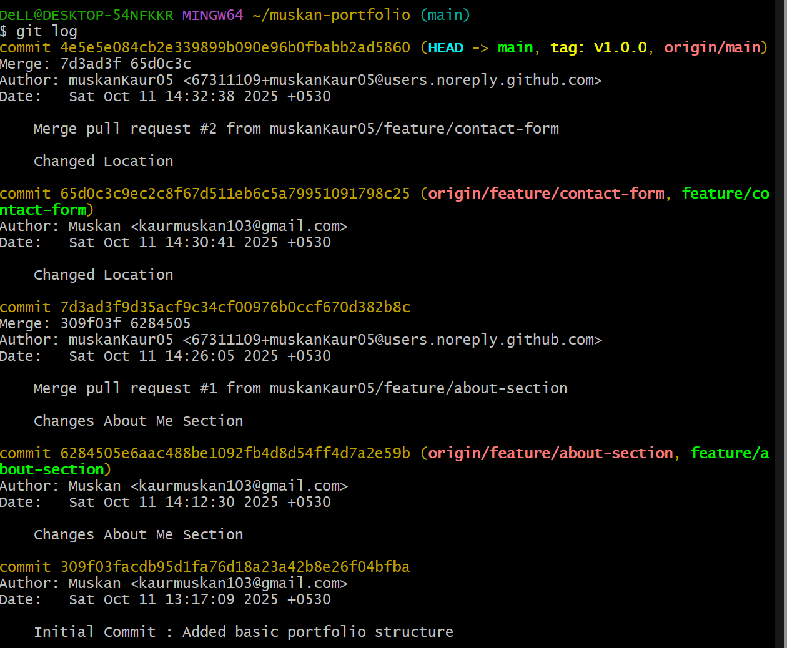

- To Visualize history run below command
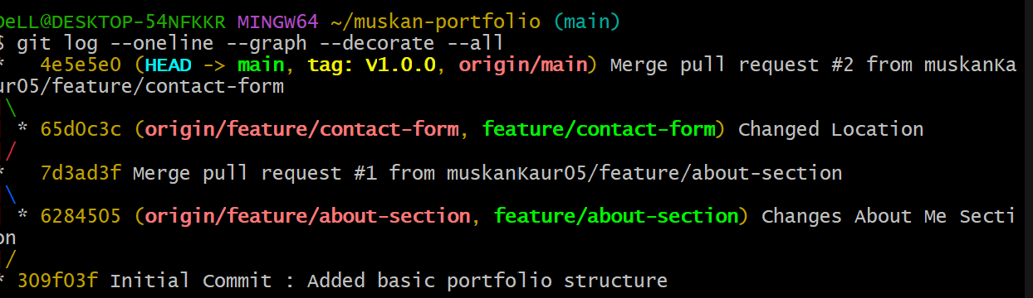

- To check changes between the previous commit (HEAD~1) and the current commit (HEAD).
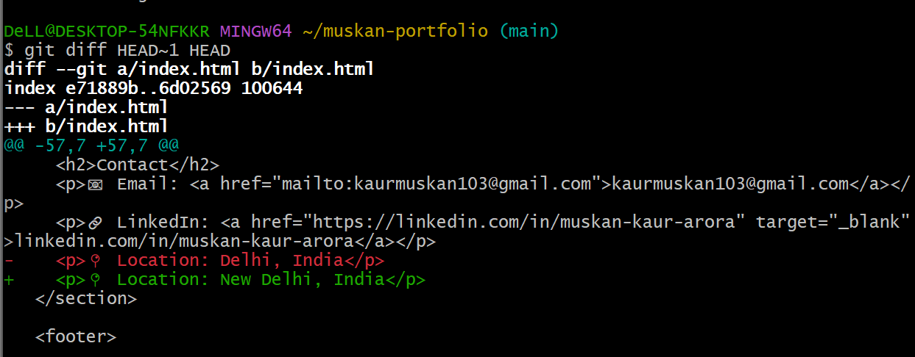

- To Check if any local changes are need to save
