**PERSONAL DETAILS**

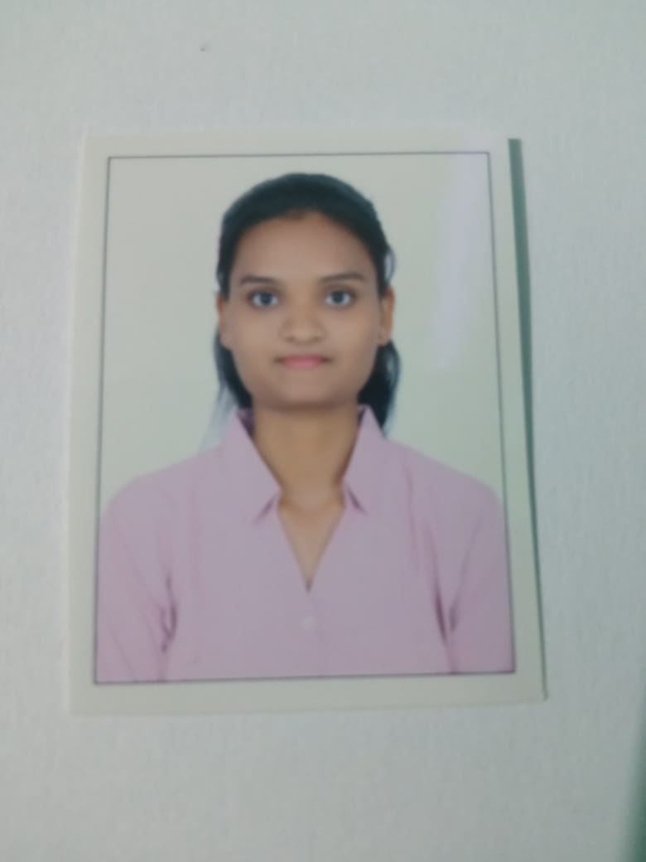

**Name :** Muskan Hemant Balmiki

**Email id**: balmikimushem21bit@student.mes.ac.in

**Contact no**:8779753246

**Address:** Siddhi Residency flat no 201 2nd Floor Vichumbe New Panvel

**LinkedIn URL**: <https://www.linkedin.com/in/muskan-balmiki-367455271>

**CAREER OBJECTIVE**

Seeking an IT Security Consultant position with an outstanding career opportunity that will offer

a rewarding work environment along with a winning team that will fully utilize management skills.

**EDUCATION**

|  |  |  |  |  |
| --- | --- | --- | --- | --- |
| **Degree/course** | **Institute/College** | **University/Board** | **Percentage/CGPA** | **Year of passing** |
| **BSC IT** | **Pillai College of**  **Arts Commerce and science** | **Mumbai** | **8.3CGPA** | **Completed** |
| **12th** | **CKT Junior College** | **State Board** | **82%** | **2021** |
| **10th** | **CKT School** | **State board** | **72%** | **2019** |

**ADDITIONAL CERTIFICATES EXPERIENCE**

* Data Science (Data analyst) FRESHER
* SQL AND NO SQL DATABASE

**INTERNSHIP**

DATA ANALYST

**My PORTFOLIO:**

**SKILLS**

* Programming languages: Data Analysis,HTML5,CSS3,JS ,Bootstrap.
* Basic Database using java, Basic SQL , Basic BI ,
* Communication ,People Management.

**PROJECTS**

* E-Commerce Website using HTM5 CSS3 Boostrap
* Performing EDA on Bank Dataset
* Recommendation system using ML

**HOBBIES**

* Cycling , Listening to Music
* Plantation of trees

**DOB :**16 JULY 2003

**LANGUAGES KNOWN**

* English
* Hindi
* Marathi

**NATIONALITY:** Indian  **Place : New Mumbai**