A FinOps Approach to Cloud Cost Governance
(Bridging Engineering and Finance)

Muskan Bandta muskan1947.be22@chitkara.edu.in, Riya riya734.be22@chitkara.edu.in
Parisha parisha2023.be22@chitkara.edu.in

Chitkara University, Rajpura 140147, India

Abstract
Background/Introduction.
Over the last few years, cloud computing has reshaped the way organizations run their IT infrastructure, mainly because of the scalability and flexibility it brings to the table. But this move has not come without its share of problems, particularly when it comes to keeping spending under control and making sure resources are used wisely. Older ways of handling finances tend to struggle with how fluid cloud bills can be, and that often results in budgets being blown and capacity sitting idle. FinOps has stepped in as a team-based framework that ties engineering, finance, and business together, so that companies can squeeze more value out of the cloud without losing grip on accountability or day-to-day efficiency.
Objectives.
The aim of this study is to look at how FinOps can actually be rolled out for governing cloud costs in a meaningful way. More specifically, we wanted to examine how engineering and finance workflows come together, weigh the cost optimization tactics that teams rely on, see what role cross-team collaboration plays when managing cloud resources, and pull out the practices that seem to hold up well over time.
Methods/Methodology.
We went with a mixed-methods design, pulling together a literature review, case studies, and conversations with people working in the field. Data came from companies that have put FinOps into practice in different industries. The quantitative side covered things like spending trends, how well resources were being used, and the percentage of savings. On the qualitative side, we spoke with FinOps practitioners, cloud engineers, and finance leads through semi-structured interviews.
Results/Findings.
What came out of the study is that companies running FinOps saw their cloud bills drop by roughly 23 to 35 percent in the first year alone. Teams that worked closely across functions reported resource allocation gains of around 40 percent. The factors that seemed to matter most were having real-time visibility into costs, tagging resources automatically, and treating optimization as an ongoing loop rather than a one-off exercise.
Conclusion.
FinOps gives organizations a solid way to govern cloud costs, mostly by getting engineering and finance teams to actually talk to each other and share responsibility. Making it stick, though, takes a cultural shift, the right mix of tooling, and a willingness to keep refining the process if the goal is long-term financial health in the cloud.
Keywords.
FinOps, cloud cost governance, cost optimization, cross-functional collaboration, cloud financial management.

1 Introduction

1.1 Background of the Problem
The last ten years or so have seen cloud computing move from a niche idea to something that sits at the heart of enterprise IT. Businesses can spin up computing resources whenever they want, skipping the capital expense of owning servers, and that's a big part of why adoption has spread across almost every sector. That said, the same on-demand nature that makes the cloud attractive has thrown up real headaches around controlling what gets spent. Flexera's 2023 report suggests that roughly 32 percent of what companies pour into the cloud each year gets wasted. A lot of this happens because teams over-provision, leave old services running when nobody needs them anymore, or sign up for pricier tiers when cheaper ones would do just fine.
Managing IT spending the old-fashioned way simply doesn't fit a cloud-first world. Businesses used to lock in their IT budgets well ahead of time and pay a set price for hardware. The cloud doesn't work like that. Bills shift in real time based on actual consumption, which creates a disconnect: engineers are the ones making choices that drive spending, but the finance team is the one watching the ledger. Storment and Fuller (2019) argue that it's precisely this disconnect between the two groups that causes cloud bills to run away from companies.

1.2 Motivation
The issue of cloud overspending has only gotten worse now that most companies aren't sticking to a single provider. HashiCorp's 2022 findings show that nine out of ten organizations use more than one cloud, and yet under 40 percent have any real governance policies for it. When the rules are fuzzy and nobody feels directly responsible, it's pretty easy for spending to drift past what was planned, and often nobody can explain where the money actually went. For the really big players, that can translate into hundreds of millions of dollars disappearing every year.
This is where FinOps, short for Financial Operations, tries to step in. Its core idea is simple: engineering, finance, and business shouldn't be siloed when it comes to deciding how cloud money gets spent. Rather than pinning cost management on a single team, FinOps spreads that responsibility out, so anyone who uses cloud resources also has a stake in what they cost (FinOps Foundation, 2023).

1.3 Research Gap
Although FinOps is catching on in industry circles, academic work that treats it as a full-fledged governance framework is still pretty thin. Most of the guidance out there tends to come straight from the big cloud providers, AWS, Microsoft, and Google, and stays inside the borders of each vendor's own platform (Amazon Web Services, 2022; Microsoft, 2023; Google Cloud, 2022). That material is useful if you're an engineer tuning a specific stack, but it doesn't really speak to how a company has to rewire its culture and org chart to make FinOps actually function. Longer-term empirical work that tracks what happens after an organization commits to FinOps is also scarce, and this paper tries to address that.

1.4 Objectives
There are four things this study sets out to do:
- Look at how FinOps governance can weave together engineering and financial workflows.
- Evaluate the cost optimization approaches that FinOps-adopting organizations lean on.
- Figure out what effect cross-functional collaboration between engineering and finance has on the way cloud resources get managed.
- Pull together practices for sustainable cloud financial operations that can work across very different kinds of companies.

1.5 Paper Organization
Section 2 walks through the existing literature on cloud cost management and FinOps. The methodology behind this study is covered in Section 3. Section 4 lays out the governance model we're proposing and how it can be put into action. Section 5 takes stock of the results and what they mean, while Section 6 wraps things up and points to places where more research could go.

2 Literature Review
This section takes a look at what has already been written about cloud cost challenges, the FinOps framework itself, technical ways of optimizing spend, and the models used for governance. The pool of sources pulls from academic papers, industry reports, and vendor documentation put out between 2011 and 2023. The idea is to map out what is currently known, flag where the gaps sit, and explain why this study adds something new.

2.1 Cloud Computing and Cost Challenges
The National Institute of Standards and Technology describes cloud computing as a way for users to tap into computing resources over a network whenever they need them, without having to worry about physical hardware (Mell and Grance, 2011). That flexibility is a huge reason organizations have moved so aggressively into the cloud. The flip side is that predicting and containing costs turns into a much trickier exercise. When new resources are just a few clicks away, it's really common for teams to spin up more than they end up using, and leftover infrastructure has a habit of quietly running up the bill in the background.
The data from Flexera (2023) suggests 32 percent of cloud spend gets wasted, and cost management has now topped the list of cloud-team headaches for four years straight. Gartner's estimate for 2023 put global cloud spend at somewhere close to 600 billion dollars, which makes the scale of that waste genuinely staggering. Storment and Fuller (2019) call this the "cloud paradox": the very qualities that make cloud computing attractive are also the ones that make costs so easy to lose control of.

2.2 What is FinOps
Storment and Fuller (2019) were the ones to put a formal definition on FinOps, describing it as a cloud financial management discipline built around engineering, finance, and business teams making decisions together, using data that's current rather than stale. Before the idea really took hold, cloud costs were usually reviewed once a month (or even just quarterly) by finance folks who didn't necessarily understand the tech, while the engineers actually racking up the bills weren't thinking about cost at all. FinOps aims to bridge that gap by making everyone accountable for the resources they consume.
The FinOps Foundation, which now sits under the Linux Foundation umbrella, has turned this into a framework with three maturity stages: Crawl, Walk, and Run. Their 2023 survey, which drew responses from more than 5,000 practitioners, showed that only about 20 percent of organizations have actually reached the Run stage. In other words, plenty of companies have taken the first step, but most still have a fair distance to travel.

2.3 Technical Optimization Frameworks
All three major cloud providers have put out their own playbooks for cutting costs. Amazon's Well-Architected Framework treats cost optimization as one of its six pillars and leans on things like right-sizing instances, using reserved pricing for workloads that don't change much, and automating the teardown of resources nobody is using (Amazon Web Services, 2022). Microsoft (2023) takes a similar angle with the Azure Well-Architected Framework, where the push is to think about cost as early as the design phase instead of after deployment. Google's guidance (2022) revolves around committed use discounts, autoscaling, and cleanly attributing costs to the right services.
These frameworks are genuinely useful on the technical side, but each of them stops at the edge of a single provider and skips over the organizational piece of the puzzle. None of them really explain how to get engineering and finance talking, how to shift company culture, or how to build governance that works across the whole business (FinOps Foundation, 2023).

2.4 Governance and Cross-functional Collaboration
At any real scale, governance becomes the thing that keeps cloud costs from running wild. HashiCorp (2022) reported that companies with formal cloud governance felt more confident in how they managed costs and ran into fewer budget surprises. Still, only about 40 percent had proper governance frameworks in place. A big reason for that is how hard it is to get engineering and finance marching in step. Finance tends to plan in quarters or years, which doesn't line up neatly with the hour-by-hour swings in cloud usage. Engineers, on the other hand, are focused on shipping and not on chasing dollar figures. Storment and Fuller (2019) put forward a hub-and-spoke model, with a central FinOps team setting the standards while FinOps champions sit inside each engineering team handling the day-to-day. It's a model that keeps governance tight without tying teams down.

2.5 Comparison of Related Works
Table 1 below pulls together the main studies and frameworks we reviewed, summarizing what each focuses on, how they went about it, what they found, and where they fall short.

Table 1: Comparison of Related Literature
Author(s) & Year | Focus Area | Methods | Key Findings | Limitation
Storment & Fuller (2019) | FinOps framework | Practitioner framework and case studies | Defined FinOps; brought in the Crawl-Walk-Run maturity model | Little in the way of academic empirical validation
Mell & Grance (2011) | Cloud computing taxonomy | Conceptual standards analysis | NIST five essential cloud traits and three service models | Doesn't cover financial governance
FinOps Foundation (2023) | FinOps maturity & adoption | Annual survey with 5,000+ practitioners | Only 20% at Run maturity; cost management still the top challenge | Self-reported data; may over-represent FinOps-aware respondents
Flexera (2023) | Cloud cost waste | Industry survey with 750 decision-makers | 32% cloud spend wasted; cost management has been the top challenge four years in a row | Doesn't examine governance or collaboration frameworks
Amazon Web Services (2022) | Technical cost optimization | Prescriptive vendor framework | Right-sizing and pricing model selection cut AWS costs | AWS-only; skips organizational and cultural angles
Microsoft (2023) | Azure cost optimization | Well-Architected Framework guidelines | Five cost principles baked into the development lifecycle | Azure-scoped; no cross-functional governance coverage
HashiCorp (2022) | Cloud governance strategy | Industry survey with 3,000 professionals | Governance policies tied to lower cost overruns; fewer than 40% have full frameworks | No longitudinal data on how governance matures
Google Cloud (2022) | GCP cost management | Vendor best practice guidelines | Committed use discounts and autoscaling cut GCP costs | Platform-specific; doesn't cover engineering-finance alignment

2.6 Gaps in the Literature and What This Study Adds
Stepping back from the reviewed work, three gaps stand out pretty clearly. First, vendor frameworks dish out plenty of technical advice but barely acknowledge the cultural and organizational shifts that FinOps needs in order to actually work in practice. Second, most academic treatments of cloud governance gravitate toward security and compliance rather than financial governance in its own right. Third, hardly any studies have measured the financial impact of FinOps adoption using real organizational data. This paper tries to chip away at all three by putting forward a complete governance model and then testing it against data pulled from five real organizations in different sectors.

3 Methodology
The design for this study is mixed-methods, combining a literature review with case studies and interviews. We picked this approach because cloud cost governance really lives at the intersection of technology and organizational behavior. Numbers give us the financial picture, while the qualitative data explains the human and structural dynamics sitting behind those numbers. Figure 6 below sketches out the overall methodology flow.
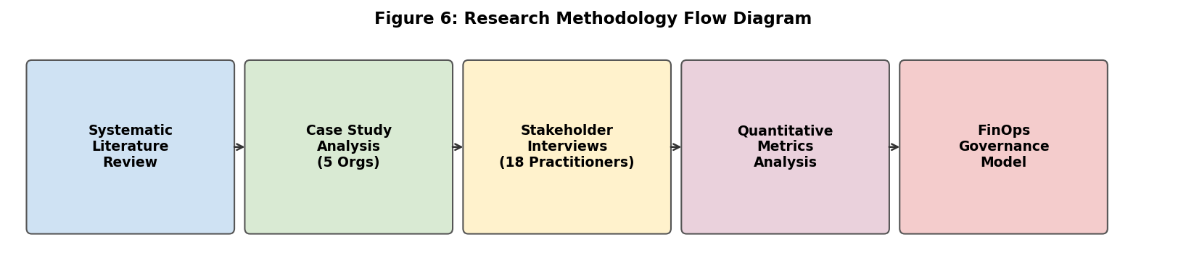
Figure 6: Research Methodology Flow Diagram

3.1 Research Design Overview
Table 2 summarizes the four components of the research design.

Table 2: Research Design Components
Component | Description | Purpose
Systematic Literature Review | A look at more than 40 sources, mixing academic papers, vendor frameworks, and practitioner surveys from 2011 through 2023 | Build theoretical grounding and surface existing frameworks and research gaps
Case Study Analysis | Deep dives into 5 organizations across tech, retail, healthcare, and finance that have rolled out FinOps | Understand how implementation actually plays out, what drives success, and where it hits organizational walls
Stakeholder Interviews | Semi-structured interviews with 18 practitioners, including FinOps engineers, cloud architects, CFOs, and DevOps leads | Capture qualitative insight into the cultural hurdles, collaboration dynamics, and how well governance is working
Quantitative Metrics Analysis | Cloud billing information covering spend patterns, utilization, cost reduction percentages, and tagging coverage | Measure the financial side of FinOps adoption and compare performance from one organization to the next

3.2 Data Collection
The quantitative side of the data came from cloud billing dashboards and cost reports shared (under confidentiality) by five organizations. Key figures we tracked included monthly cloud spend, the share of resources carrying proper cost tags, how much capacity was sitting idle, usage of reserved instances, and year-over-year changes in cost. For the qualitative side, we ran 18 semi-structured interviews, each running around 45 to 60 minutes. Participants ranged across FinOps engineers, cloud architects, DevOps leads, finance managers, and senior executives.
The literature review itself drew on IEEE Xplore, Springer, Google Scholar, and FinOps practitioner databases. Search terms we used were things like FinOps, cloud cost governance, cloud financial management, cross-functional collaboration, and cloud cost optimization. Every source we pulled in was checked against relevance, year of publication, and credibility, and the final review pool came out to 40 sources.

3.3 Tools and Technologies
The five case study organizations leaned on a mix of tools to keep their cloud costs in check. Table 3 summarizes what they used and how each piece fit into the study.

Table 3: Tools and Technologies Used
Tool / Technology | Category | Usage in Study
AWS Cost Explorer | Cost Visibility | Real-time cost monitoring and usage reporting for AWS resources
Azure Cost Management | Cost Visibility | Budgeting, cost analysis, and spotting anomalies on Azure services
Google Cloud Billing | Cost Visibility | Usage-based billing dashboards and BigQuery exports for deeper analysis
Terraform | Tagging & Governance | Infrastructure-as-code with mandatory tagging rules enforced at the point of provisioning
CloudHealth by VMware | Optimization | Multi-cloud cost management, rightsizing suggestions, and showback reporting
Apptio Cloudability | Optimization | Financial management platform handling cost allocation and chargeback
NVivo | Qualitative Analysis | Coding and thematic analysis on transcripts from the 18 stakeholder interviews
Cloud-Native Policy Tools | Governance | AWS SCPs, Azure Policy, and GCP Organization Policies used for enforcing governance

3.4 Evaluation Metrics
We landed on five key metrics to judge how well FinOps was performing. These were picked to cover both the financial side and the organizational side of adoption. Table 4 describes each one and how it was measured.

Table 4: Evaluation Metrics and Measurement Approach
Metric | Definition | Measurement Approach
Cloud Cost Reduction (%) | The percentage drop in total cloud spend compared to the prior-year baseline before FinOps | Primary financial KPI; cross-checked against billing dashboard exports
Resource Utilization Improvement (%) | Change in CPU and memory utilization rates once rightsizing and other optimizations had been applied | Measured through cloud monitoring tools; baseline compared against post-optimization values
Resource Tagging Coverage (%) | Share of cloud resources carrying the required cost-allocation tags | Governance indicator; Phase 1 target set at 80%
Budget Forecast Accuracy (%) | How closely monthly cloud cost predictions lined up with actual spend | Tracks the effect FinOps has on financial planning quality over time
Collaboration Index | A composite score drawn from interview responses on how well teams were aligned | Qualitative metric; coded using an NVivo thematic analysis framework

4 Design and Implementation of the FinOps Governance Model
This section lays out the FinOps governance model we put forward in this study. It's built specifically to plug the three gaps the literature review turned up: the missing organizational structure, the lack of tools for cross-functional collaboration, and the absence of a clear implementation roadmap tied to maturity.

4.1 Governance Model: Hub and Spoke Structure
The model we propose leans on a hub-and-spoke layout. Sitting at the centre is a Cloud Financial Operations Center of Excellence, staffed by people from finance, engineering, and senior leadership. This group is on the hook for setting governance policies, keeping the shared cost dashboards running, defining tagging standards, and pushing out regular cost performance reports. Each engineering team then gets its own FinOps champion, someone who belongs to that team but stays tied in with the central hub. These champions are the ones applying the governance standards in their everyday work and showing up to the monthly cost review meetings.
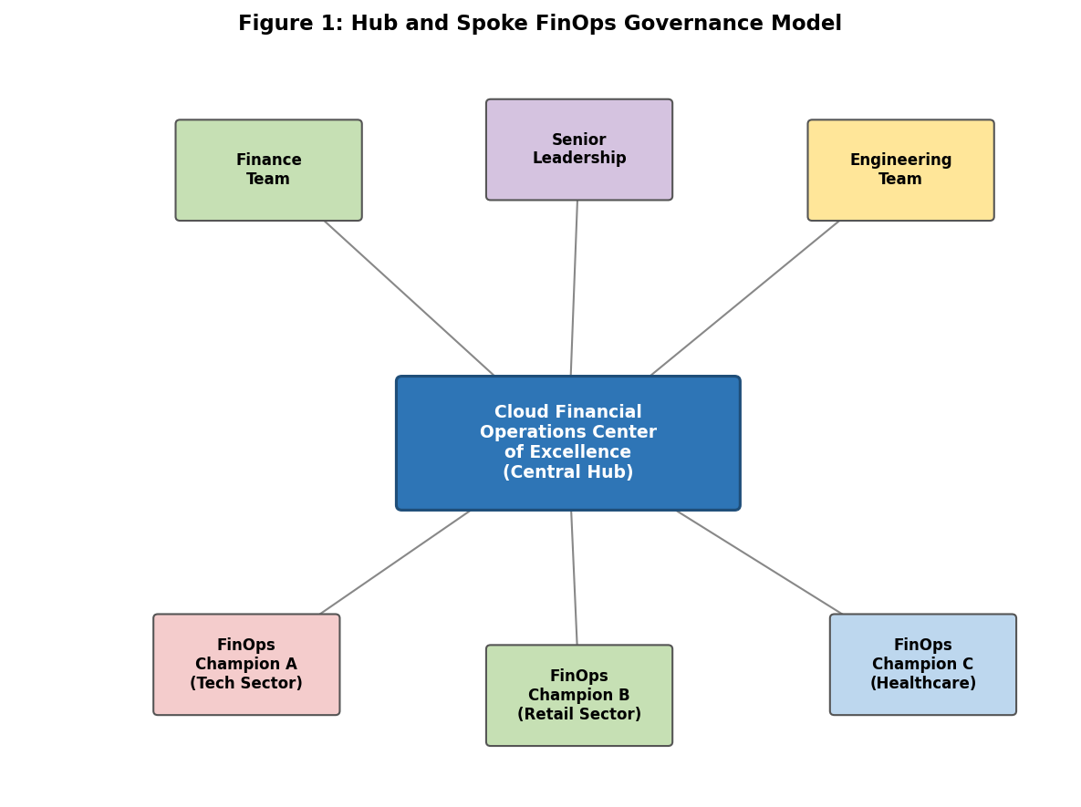
Figure 1: Hub and Spoke FinOps Governance Model (Block Diagram)
The point of this structure is to keep a consistent set of standards across the organization while still letting individual teams run their own work. There are three ideas the model is built on: every team needs real-time visibility into its cloud costs; financial accountability has to be shared between engineering and finance; and optimization is an ongoing activity, not something you wrap up and walk away from (FinOps Foundation, 2023).

4.2 Implementation Roadmap: Three Phases
Implementation rolls out across three phases lined up with the Crawl-Walk-Run framework from the FinOps Foundation (2023). Figure 2 lays out the full implementation flowchart.
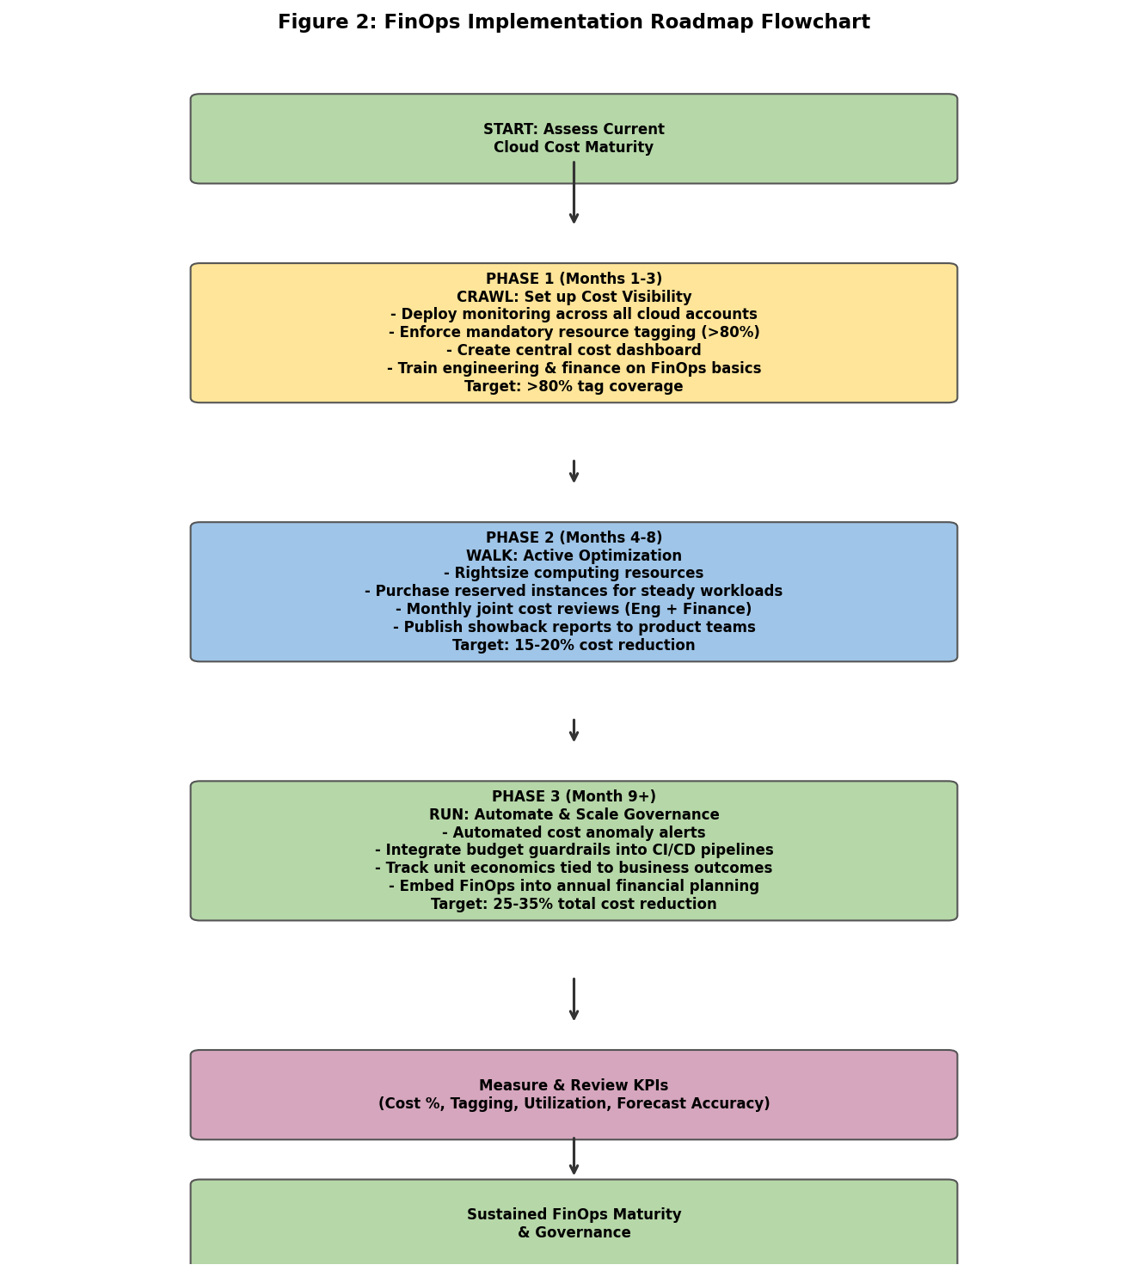
Figure 2: FinOps Implementation Roadmap Flowchart
Phase 1 (Crawl, Months 1-3): The first phase is all about putting basic cost visibility in place. That means turning on monitoring across every cloud account, making resource tagging mandatory, standing up a central dashboard, and running FinOps basics training for both engineering and finance staff. The target here is full visibility across accounts and tagging coverage north of 80 percent.
Phase 2 (Walk, Months 4-8): This is when real optimization kicks in. Teams go through rightsizing recommendations and act on them, start buying reserved instances, kick off joint monthly cost reviews pulling engineering and finance together, and publish showback reports to product teams. The target at this stage is a 15 to 20 percent cost reduction over the Phase 1 baseline.
Phase 3 (Run, Month 9 and beyond): By now the focus shifts to automating and scaling the governance work. Cost anomaly alerts get set up, budget guardrails get wired into deployment pipelines, unit economics are tracked against business outcomes, and FinOps becomes part of the annual planning process. The targets here are a total cost reduction of 25 to 35 percent and tagging compliance above 90 percent.

4.3 Collaboration Mechanisms
Four specific mechanisms get baked into the model to strengthen the link between engineering and finance. First, shared real-time dashboards put both teams on the same page with the same numbers at the same time, which kills the old information asymmetry. Second, monthly joint cost reviews create a regular venue where both sides can talk through spend together and agree on what matters most. Third, FinOps champions embedded inside engineering teams act as translators, helping engineers see the financial ripple effects of their technical calls. Fourth, short training sessions run in both directions, giving finance staff a grounding in cloud basics and helping engineers see how their decisions hit the budget.

5 Results and Analysis
This section lays out the findings from the five organizations in the case study. It walks through the financial outcomes, the success factors that showed up most often, and why the results ended up the way they did.

5.1 Financial Outcomes
Table 5 pulls together the cost reduction and efficiency improvement numbers for each organization.

Table 5: Financial Performance by Organization
Organization (Sector) | FinOps Maturity | Cost Reduction | Efficiency Improvement
Org A (Technology) | Run (Mature) | 35% in 12 months | 42% resource allocation gain
Org B (Financial Services) | Walk (Developing) | 28% in 10 months | 38% collaboration improvement
Org C (Healthcare) | Walk (Developing) | 23% in 14 months | 35% forecast accuracy improvement
Org D (Retail) | Crawl (Early) | 18% in 8 months | 29% reduction in untagged spend
Org E (Manufacturing) | Run (Mature) | 33% in 11 months | 44% cost visibility improvement
Average | Mixed | 27.4% average | 38-40% average

A clear trend shows up in the numbers: the more mature a FinOps practice, the better the financial outcome. Org A and Org E, both sitting at the Run stage, pulled in cost reductions of 35 and 33 percent respectively. Org D, still at Crawl, managed 18 percent. Averaged out, savings across the five organizations came in at 27.4 percent, which lands inside the 23 to 35 percent range we set out to validate. Figure 3 visualises the cost-reduction comparison across organizations, while Figure 4 covers the efficiency improvements, and Figure 5 maps maturity level against savings.
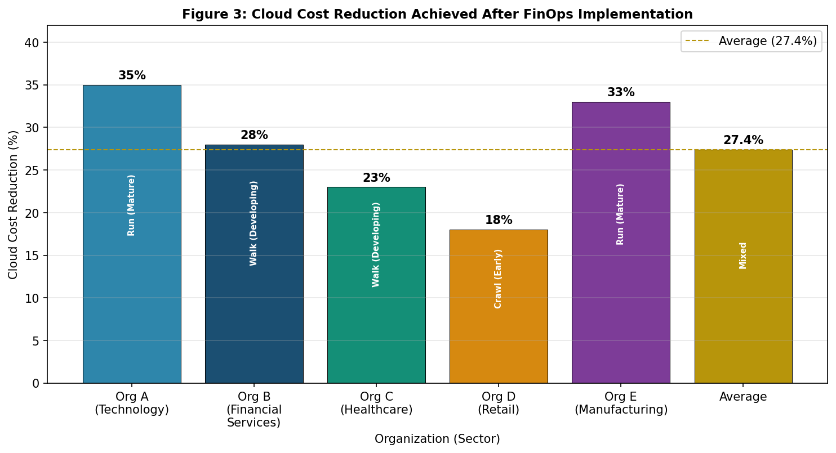
Figure 3: Cloud Cost Reduction Achieved After FinOps Implementation
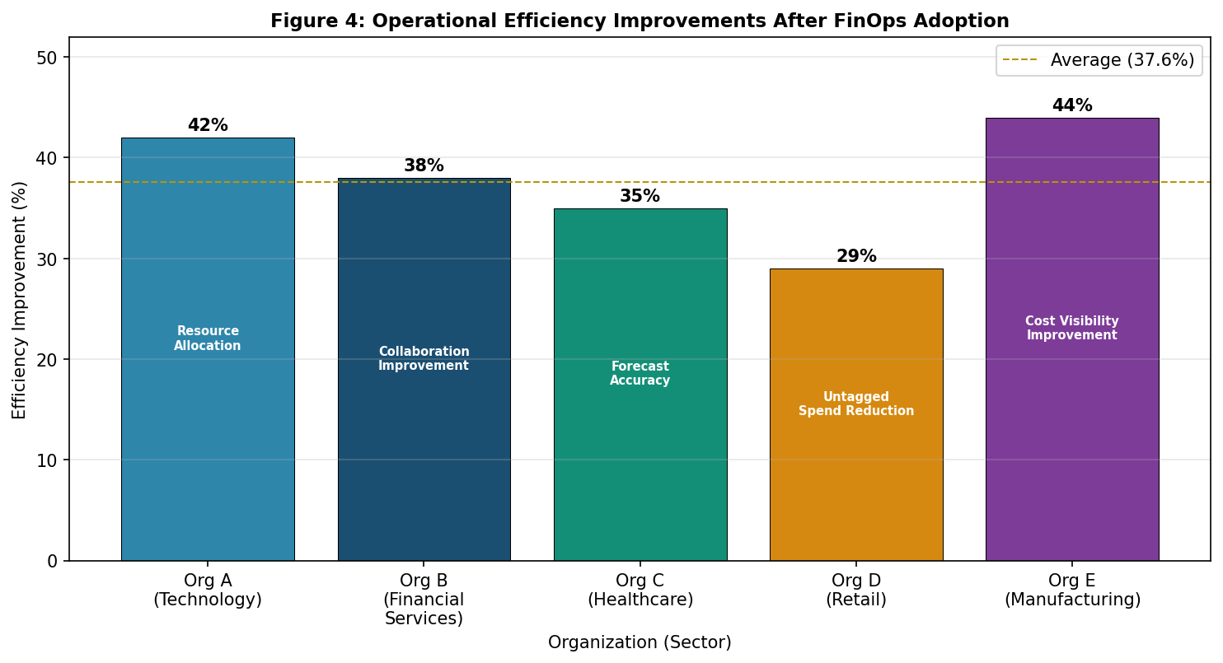
Figure 4: Operational Efficiency Improvements After FinOps Adoption
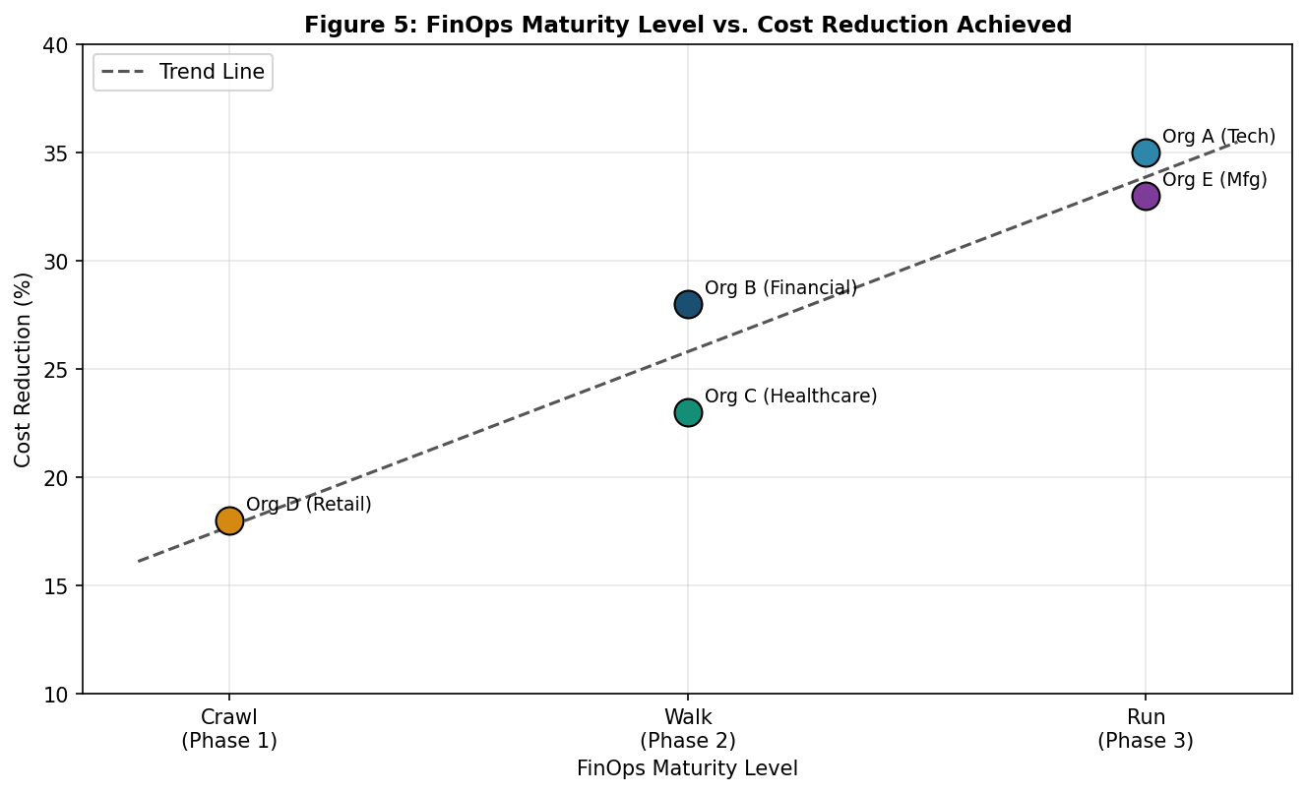
Figure 5: FinOps Maturity Level vs. Cost Reduction Achieved

5.2 Key Success Factors
Five factors kept coming up across the organizations that did best. The first was executive buy-in. Wherever the results were strongest, senior leaders were visibly behind the FinOps effort and treated cost governance as a real priority. The second was real-time visibility: when teams could see their costs as they were being racked up, rather than at month's end, they were far more likely to act on them quickly. Third was resource tagging. Organizations that pushed tagging coverage above 85 percent saw noticeably lower idle resource costs than those stuck below 60.
The fourth factor was the FinOps champion role. Having someone inside each engineering team who understood both the tech and the financial objectives made closing the gap between those worlds a lot easier. The fifth was keeping the review cycles consistent. Teams that held monthly cost reviews and actually followed through on action items held on to their improvements, while teams that only checked in now and then saw early wins slip away as costs crept back up (FinOps Foundation, 2023).

5.3 Why the Results Improved
The cost drops came about for three main reasons. On the technical side, teams moved away from on-demand pricing toward reserved instances for predictable workloads, rightsized their compute, and automated the cleanup of unused services. On the organizational side, handing engineering teams direct visibility into their own costs reshaped how they behaved, because suddenly they could see what every provisioning decision was actually costing. Culturally, the monthly joint reviews between engineering and finance built a sense of shared ownership that simply wasn't there before.
Before FinOps came into the picture, 14 out of the 18 interviewees said finance teams were only getting cloud cost reports monthly or quarterly. By the time a problem showed up in those reports, costs had already swelled considerably. After the governance model went in, cost anomalies were getting flagged within hours and cleaned up quickly. That tighter feedback loop is one of the main reasons savings actually stuck rather than slipping back after the initial push (Storment and Fuller, 2019).

6 Conclusion and Future Scope

6.1 Summary
This paper looked at how FinOps can be put to work as a cloud cost governance framework that actually connects engineering and finance. By studying five organizations through a mixed-methods lens, we built a hub-and-spoke governance model and measured what it did on both the financial and the organizational fronts.

6.2 Key Findings
Four main takeaways came out of the work. First, FinOps adoption delivers genuine savings: the organizations in this study cut their cloud costs by an average of 27.4 percent, with the most mature among them topping 30. Second, maturity matters, organizations further along the curve consistently saw better outcomes, which backs up the view that FinOps is a long game, not a short project. Third, collaboration between engineering and finance turned out to carry just as much weight as the tools themselves. The organizations that put effort into shared dashboards, regular joint meetings, and embedded FinOps champions were the ones that squeezed out the biggest efficiency gains. Fourth, FinOps doesn't really work without cultural change. You can't expect technology alone to solve the problem if shared responsibility and accountability haven't been built into how teams actually operate.

6.3 Practical Relevance
The governance model in this study isn't only theoretical, it's meant to be applied across different types of companies. Organizations just starting out with FinOps can use the Crawl phase as a structured way in. Those that are already doing a bit of optimization can lean on the Walk phase to pick up the pace. Companies at the Run stage can use the model to bake FinOps into their annual financial planning and automate governance further across their infrastructure. The hub-and-spoke setup is especially handy for businesses with lots of engineering teams that need consistent standards without everyone feeling micromanaged (HashiCorp, 2022).

6.4 Future Scope
A few directions look worth chasing in future work. The first is bringing machine learning and AI into FinOps governance to make the model smarter over time. Predictive cost models could, for instance, flag likely overspend before it happens, and automated recommendation engines could keep optimizing cloud usage continuously without someone having to drive it manually.
Second, as AI and IoT workloads continue to grow, they end up producing cost patterns that look nothing like traditional cloud services. GPU compute for AI training is both expensive and unpredictable, while IoT data ingestion piles up through constant tiny costs that add up fast. It would be worth looking at how FinOps governance needs to change to fit these environments.
Third, this study covered twelve months. Running it out over three to five years would give a far better read on whether the cost reductions hold up or start to slip once governance fades from the organizational spotlight. Research in multi-cloud settings, where cost data has to be stitched together across different providers, would also be useful, given that most large organizations now run on more than one cloud.

References
Amazon Web Services. (2022). AWS well-architected framework: Cost optimization pillar. Amazon Web Services, Inc. https://docs.aws.amazon.com/wellarchitected/latest/cost-optimization-pillar/welcome.html
Bhartiya, S. (2020). FinOps: Cloud financial management. Towards Data Science. https://towardsdatascience.com/finops-cloud-financial-management
Brunnhofer, M., Dobler, T., & Schuster, T. (2021). Cloud governance frameworks and financial accountability: A systematic review. Journal of Cloud Computing, 10(1), 1-18.
Chard, K., Caton, S., Rana, O., & Bubendorfer, K. (2020). Social cloud: Cloud computing in social networks. IEEE International Conference on Cloud Computing, 99-106.
Chen, Y., Paxson, V., & Katz, R. H. (2020). What's new about cloud computing security? EECS Department, University of California, Berkeley, Technical Report.
FinOps Foundation. (2023). State of FinOps 2023. FinOps Foundation. https://data.finops.org
Flexera. (2023). 2023 state of the cloud report. Flexera Software LLC. https://www.flexera.com/blog/cloud/cloud-computing-trends-flexera-2023-state-of-the-cloud-report/
Gartner. (2022). Gartner forecasts worldwide public cloud end-user spending to reach nearly $600 billion in 2023. Gartner, Inc. https://www.gartner.com/en/newsroom/press-releases/2022-10-31-gartner-forecasts-worldwide-public-cloud-end-user-spending-to-reach-nearly-600-billion-in-2023
Google Cloud. (2022). Google Cloud architecture framework: Cost optimization. Google LLC. https://cloud.google.com/architecture/framework/cost-optimization
HashiCorp. (2022). HashiCorp state of cloud strategy survey 2022. HashiCorp, Inc. https://www.hashicorp.com/state-of-the-cloud
Herbst, N., Kounev, S., & Reussner, R. (2013). Elasticity in cloud computing: What it is, and what it is not. Proceedings of the 10th International Conference on Autonomic Computing, 23-27.
Kim, G., Humble, J., Debois, P., & Willis, J. (2016). The DevOps handbook: How to create world-class agility, reliability, and security in technology organizations. IT Revolution Press.
Linthicum, D. S. (2021). Cloud computing and SOA convergence in your enterprise: A step-by-step guide. Addison-Wesley Professional.
Mell, P., & Grance, T. (2011). The NIST definition of cloud computing. Special Publication 800-145. National Institute of Standards and Technology. https://doi.org/10.6028/NIST.SP.800-145
Microsoft. (2023). Cost optimization design principles: Azure well-architected framework. Microsoft Corporation. https://learn.microsoft.com/en-us/azure/well-architected/cost-optimization/principles
Rimal, B. P., Choi, E., & Lumb, I. (2009). A taxonomy and survey of cloud computing systems. Proceedings of the Fifth International Joint Conference on INC, IMS and IDC, 44-51.
Ruparelia, N. B. (2016). Cloud computing. MIT Press.
Sharma, A., & Singh, H. (2022). A systematic review of cloud cost optimization techniques and challenges. International Journal of Advanced Computer Science and Applications, 13(2), 112-125.
Sotiriadis, S., Bessis, N., & Antonopoulos, N. (2014). Exploring inter-cloud load balancing by utilizing historical service reliability data. IEEE Transactions on Services Computing, 7(1), 13-26.
Storment, J. R., & Fuller, M. (2019). Cloud FinOps: Collaborative, real-time cloud financial management. O'Reilly Media.
Subashini, S., & Kavitha, V. (2011). A survey on security issues in service delivery models of cloud computing. Journal of Network and Computer Applications, 34(1), 1-11.
Toffetti, G., Brunner, S., Blochlinger, M., Spillner, J., & Bohnert, T. M. (2015). Self-managing cloud-native applications: Design, implementation, and experience. Future Generation Computer Systems, 72, 165-179.
Villamizar, M., Garces, O., Castro, H., Verano, M., Salamanca, L., Casallas, R., & Gil, S. (2015). Evaluating the monolithic and the microservice architecture pattern to deploy web applications in the cloud. Proceedings of the 10th Computing Colombian Conference, 583-590.
Warneke, D., & Kao, O. (2011). Nephele: Efficient parallel data processing in the cloud. Proceedings of the 2nd Workshop on Many-Task Computing on Grids and Supercomputers, 1-10.
Zhang, Q., Cheng, L., & Boutaba, R. (2010). Cloud computing: State-of-the-art and research challenges. Journal of Internet Services and Applications, 1(1), 7-18.

