**OUTPUT**

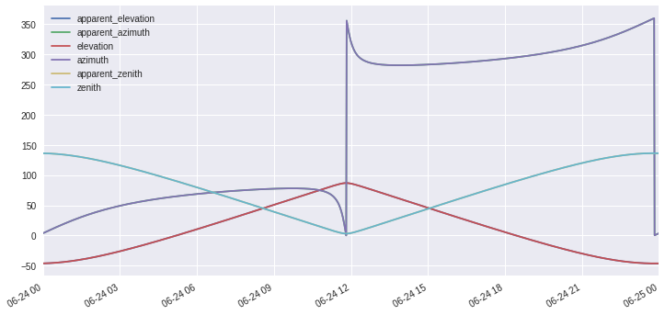

Fig.1: Based on Data of Bhubaneswar, Frequency 1 min

x-axis: time and date

y-axis: angle

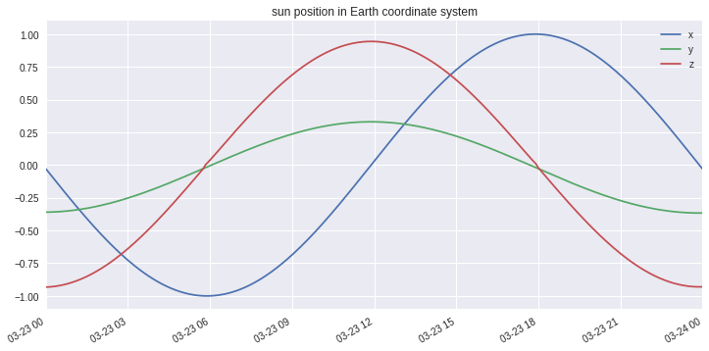

Fig.2: Based on data of Bhubaneswar, Frequency 5 min

x-axis: time and date

az = apparent_azimuth - 180

apparent_elevation = 90 - apparent_zenith

x = cosd(apparent_elevation) * sind(az)

y = cosd(apparent_elevation) * cosd(az)

z = sind(apparent_elevation)

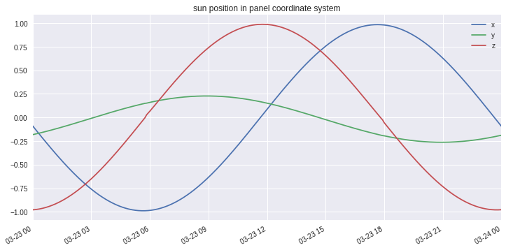

Fig 3: Based on Data of Bhubaneswar, Frequency 5 Min

x-axis: time and date

x1 = x*cosd(axis_azimuth_south) - y*sind(axis_azimuth_south);

y1 = (x*cosd(axis_tilt)*sind(axis_azimuth_south) +

y*cosd(axis_tilt)*cosd(axis_azimuth_south) -

z*sind(axis_tilt))

z1 = (x*sind(axis_tilt)*sind(axis_azimuth_south) +

y*sind(axis_tilt)*cosd(axis_azimuth_south) +

z*cosd(axis_tilt))

where x,y,z are coordinate in Earth coordinate system and x1,y1,z1 are x,y,z, respectively shown in figure

**For Single-Axis Tracking:**

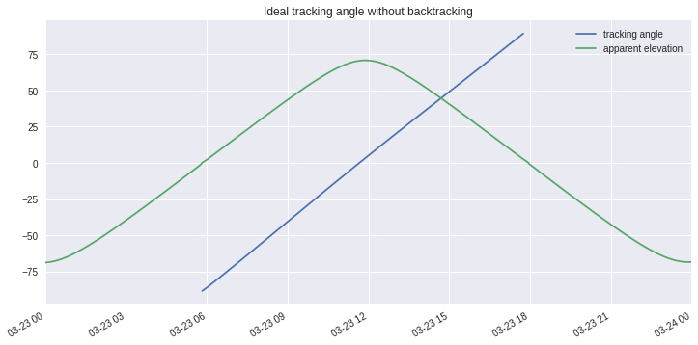

Fig.4: Ideal tracking angle without backtracking for single axis tracking system based on Bhubaneswar database

x-axis:time and date

y-axis: angle

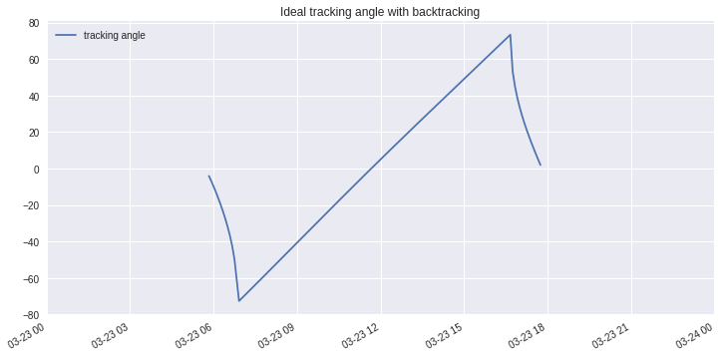

Fig.5: Ideal tracking angle with backtracking for single axis tracker based on Bhubaneswar database

x-axis:time and date

y-axis: angle

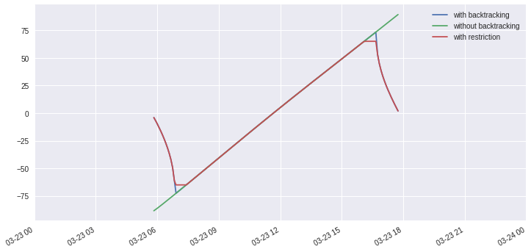

Fig.6: Ideal tracking angle with backtracking and restriction on maximum angle for single axis tracker based on Bhubaneswar database,

x-axis:time and date

y-axis: angle

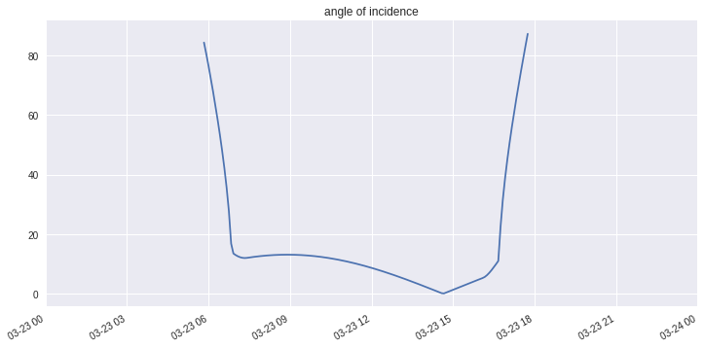

Fig.7: angel of incidence based on Bhubaneswar database,

x-axis:time and date

y-axis: angle

**Based on Sandia National Laboratory Database:**

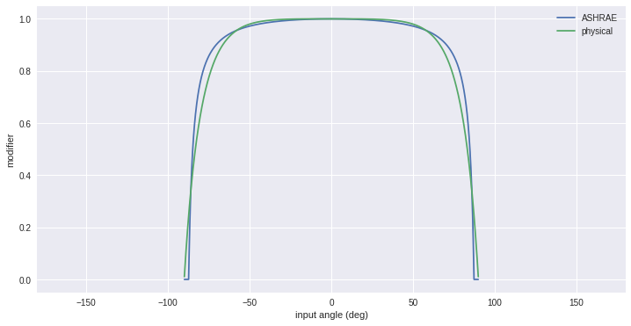

Fig.8: Comparison of ASHRAE and physical modifier

x-axis: input angle, y-axis: modifier value

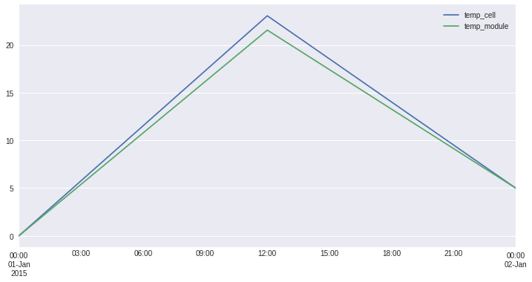

Fig.9: Comparison of cell and module temperature

x-axis: date and time

y-axis: temperature in Celsius 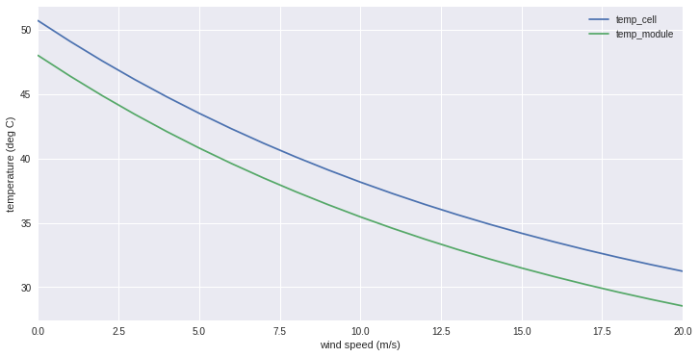

Fig.10: temperature versus wind speed comparison between cell and module

x-axis: wind speed (m/s)

y-axis: temperature (deg C)

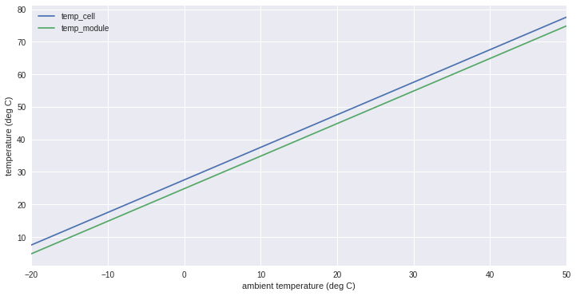

Fig.11: temperature versus ambient temperature comparison between cell and module

x-axis & y-axis: temperature (deg C) 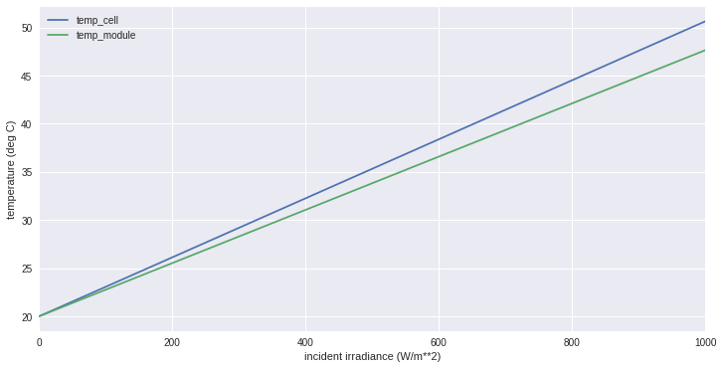

Fig.12: temperature versus incident irradiance comparison of cell and module

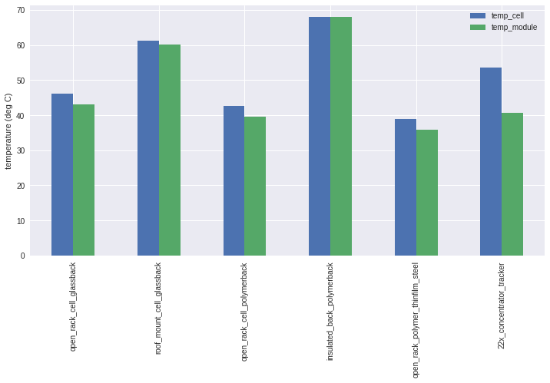

Fig.13: comparison between cell and module temperature for various models

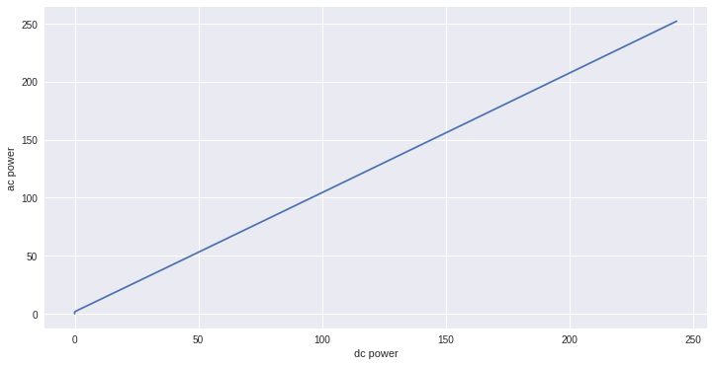

Fig.14: ac power output versus dc power output

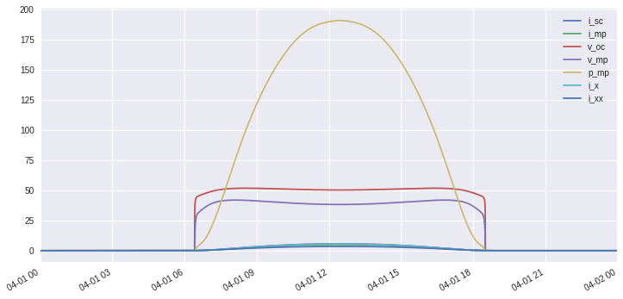

Fig.15: Comparison of various parameters

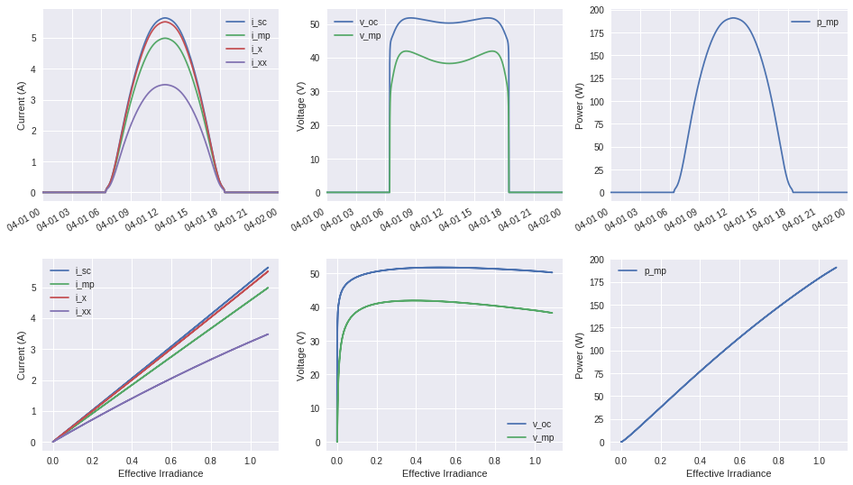

Fig.16: Comparison of various parameters

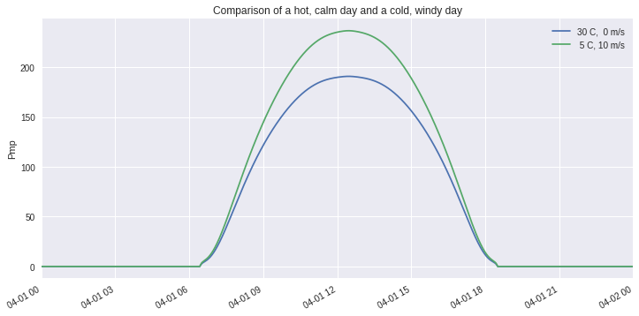

Fig.17: Comparison between two instances

Pmp= Power at maxima point

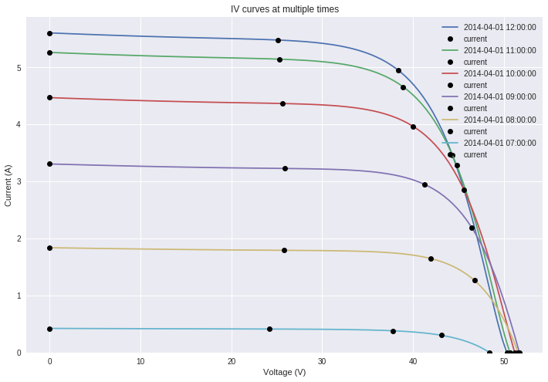

Fig.18: VI curve for solar cell